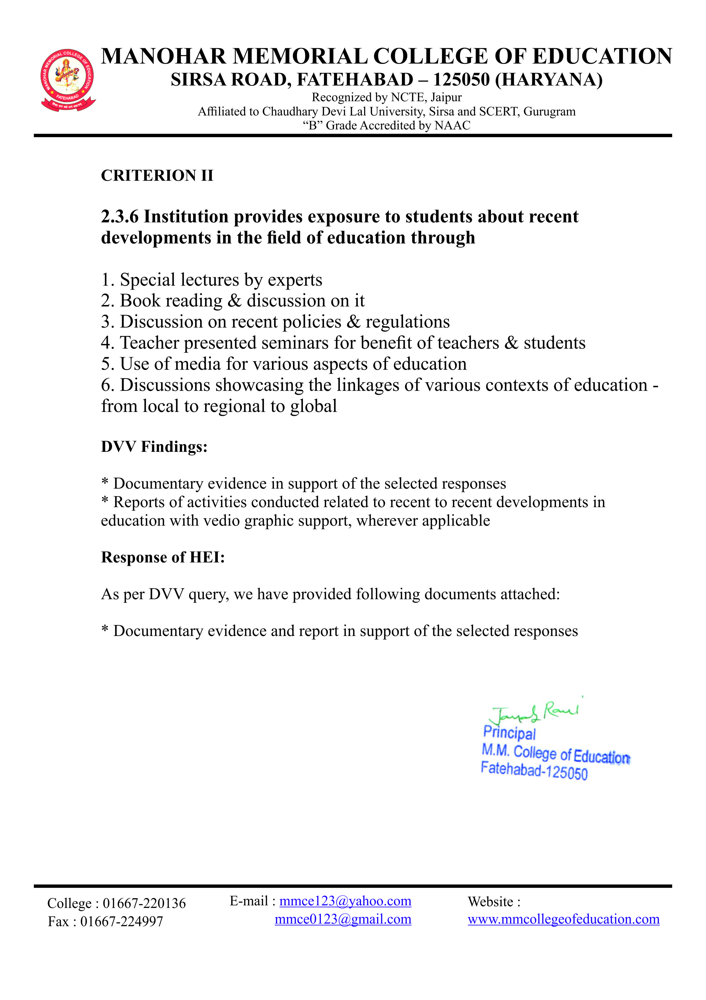MANOHAR MEMORIAL COLLEGE OF EDUCATION,
FATEHABAD HARYANA 125050
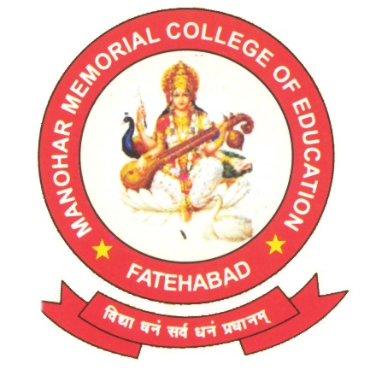

CRITIRION –II

2.3.6 Institution provides exposure to students about recent developments in the field of education through
Sr. No. | Particulars
1 | Special Lectures by experts
2 | Book reading& discussion on it
3 | Discussion on recent policies & regulations
4 | Teacher presented seminars for benefit of teachers & students
5 | Media impact for various aspects of education
6 | Discussions showcasing the linkages of various context of education from local to regional to national to global

2.3.6 (I) Documentary Evidence in support of the selected response of activities
- Special Lectures by Experts

1.1 Extension Lecture on Inter Disciplinary Approach in
Research & Education by
Dr. Vijay Goyal(18.11.2022)

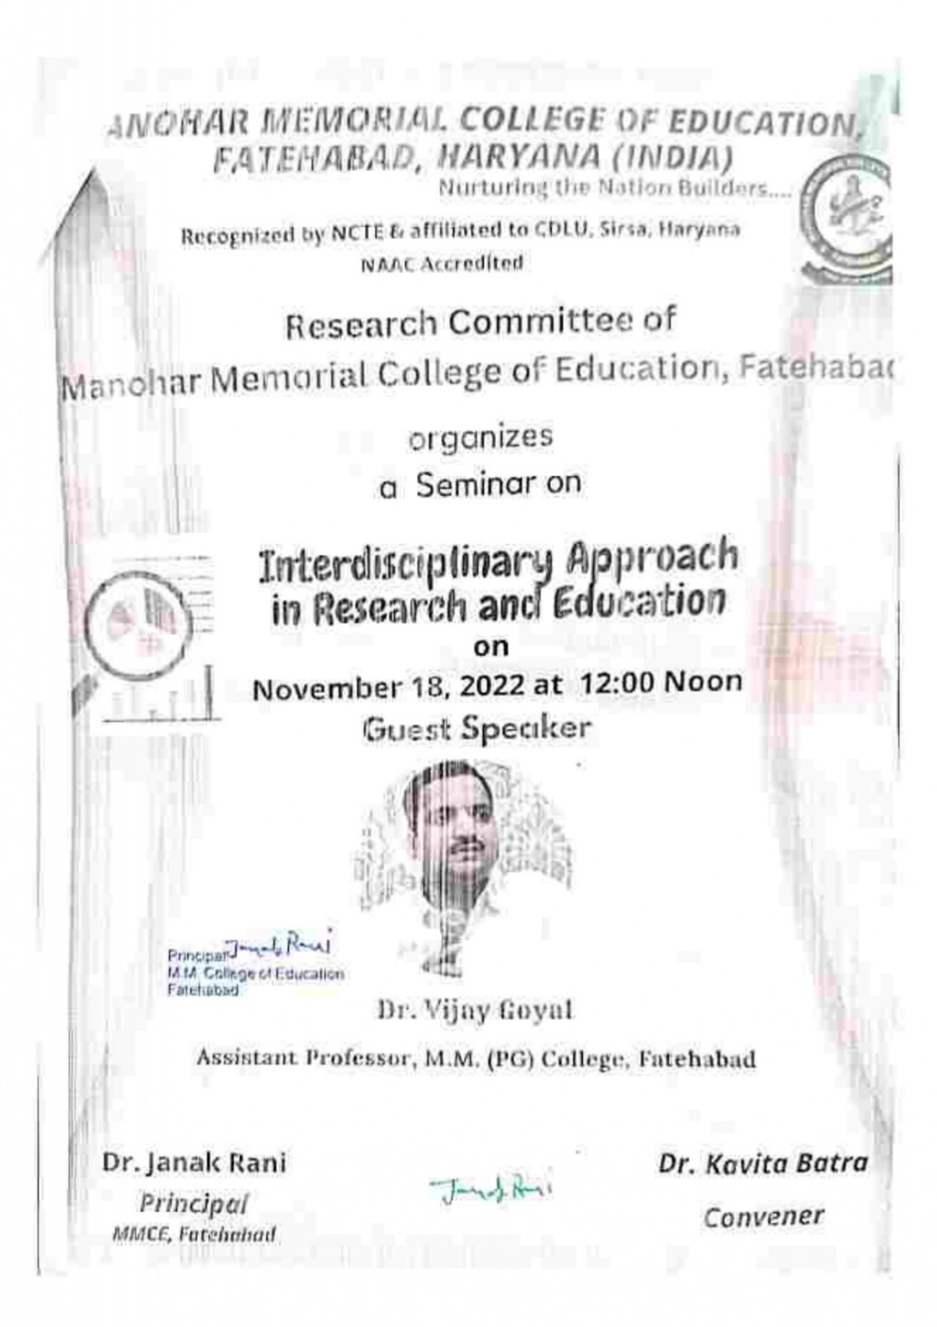
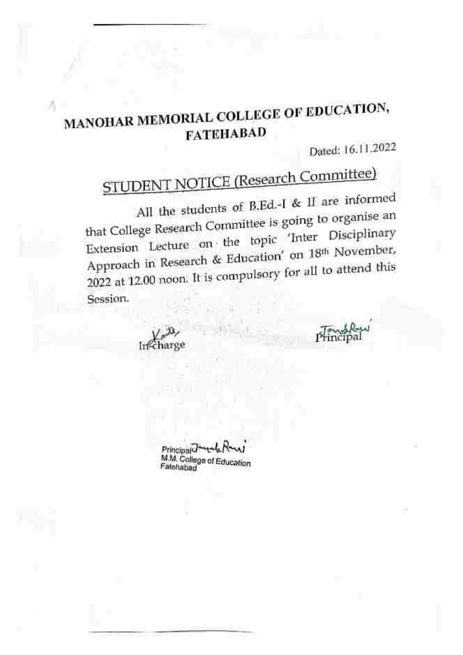

1.2 Action Research by
Dr. Kiran Lata(01.12.2022)

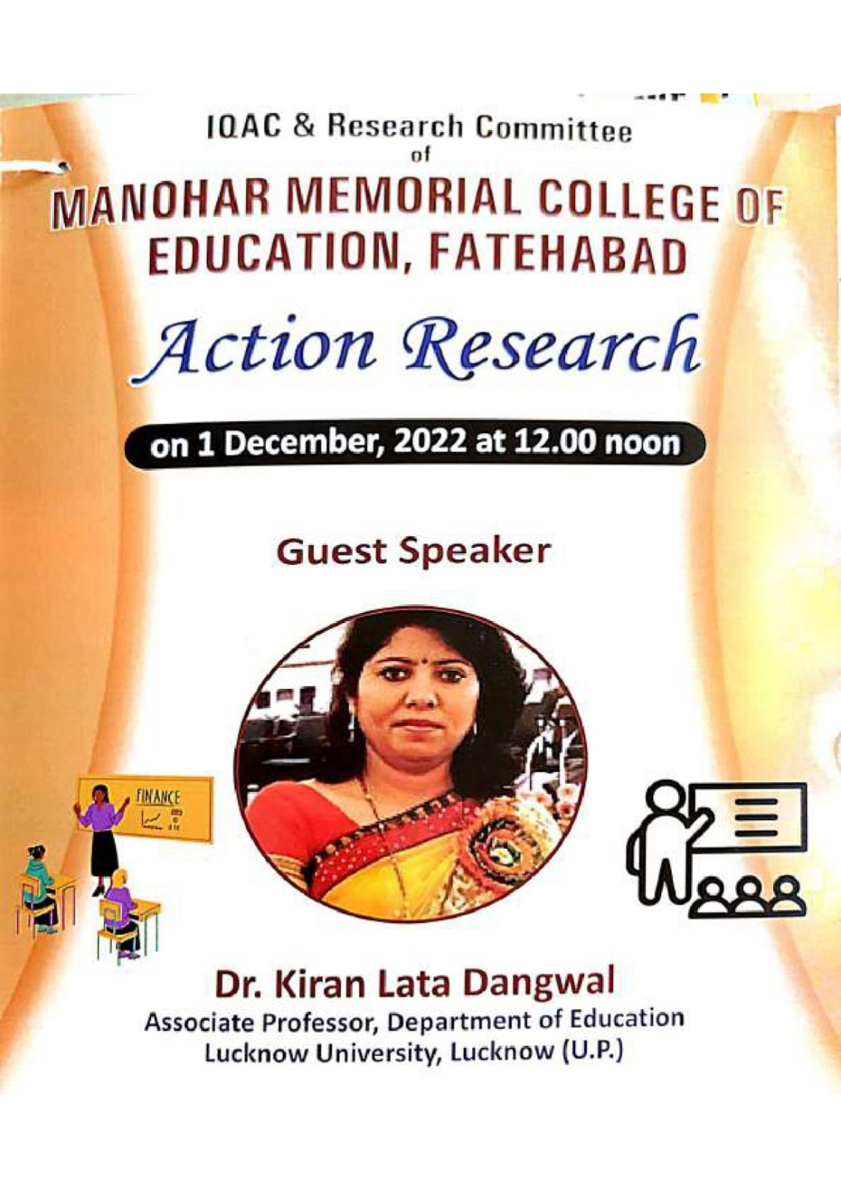

Photos of Action Research

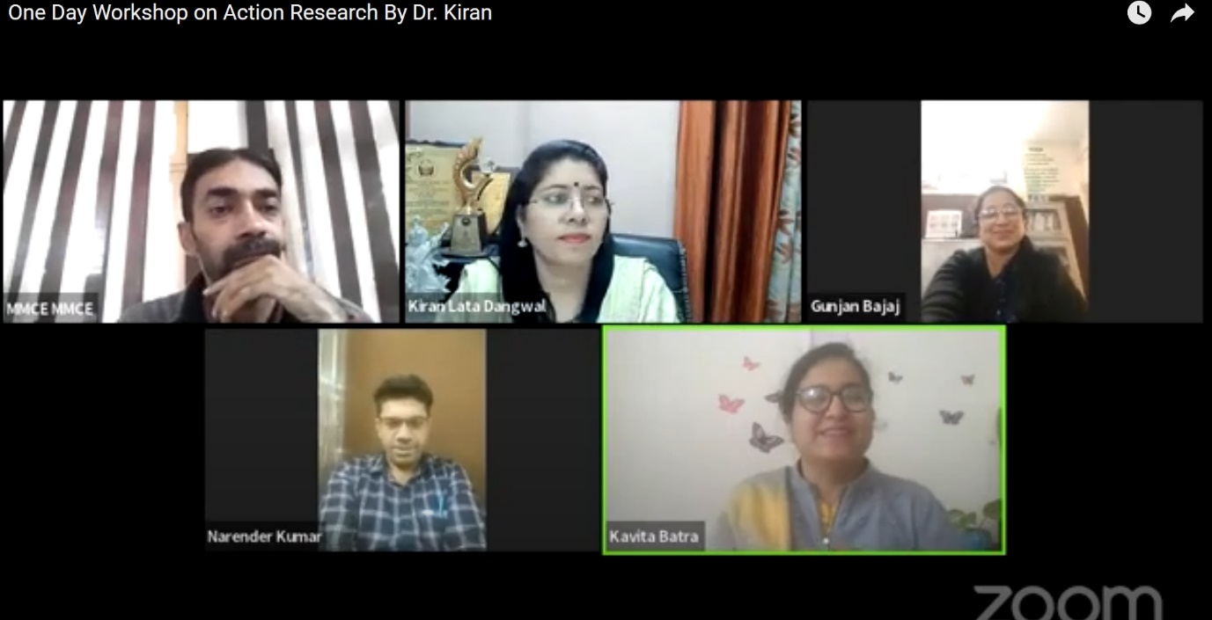

1.3 Extension Lecture on Outcome based Education by
Dr. Raj Kumar (16.12.2022)

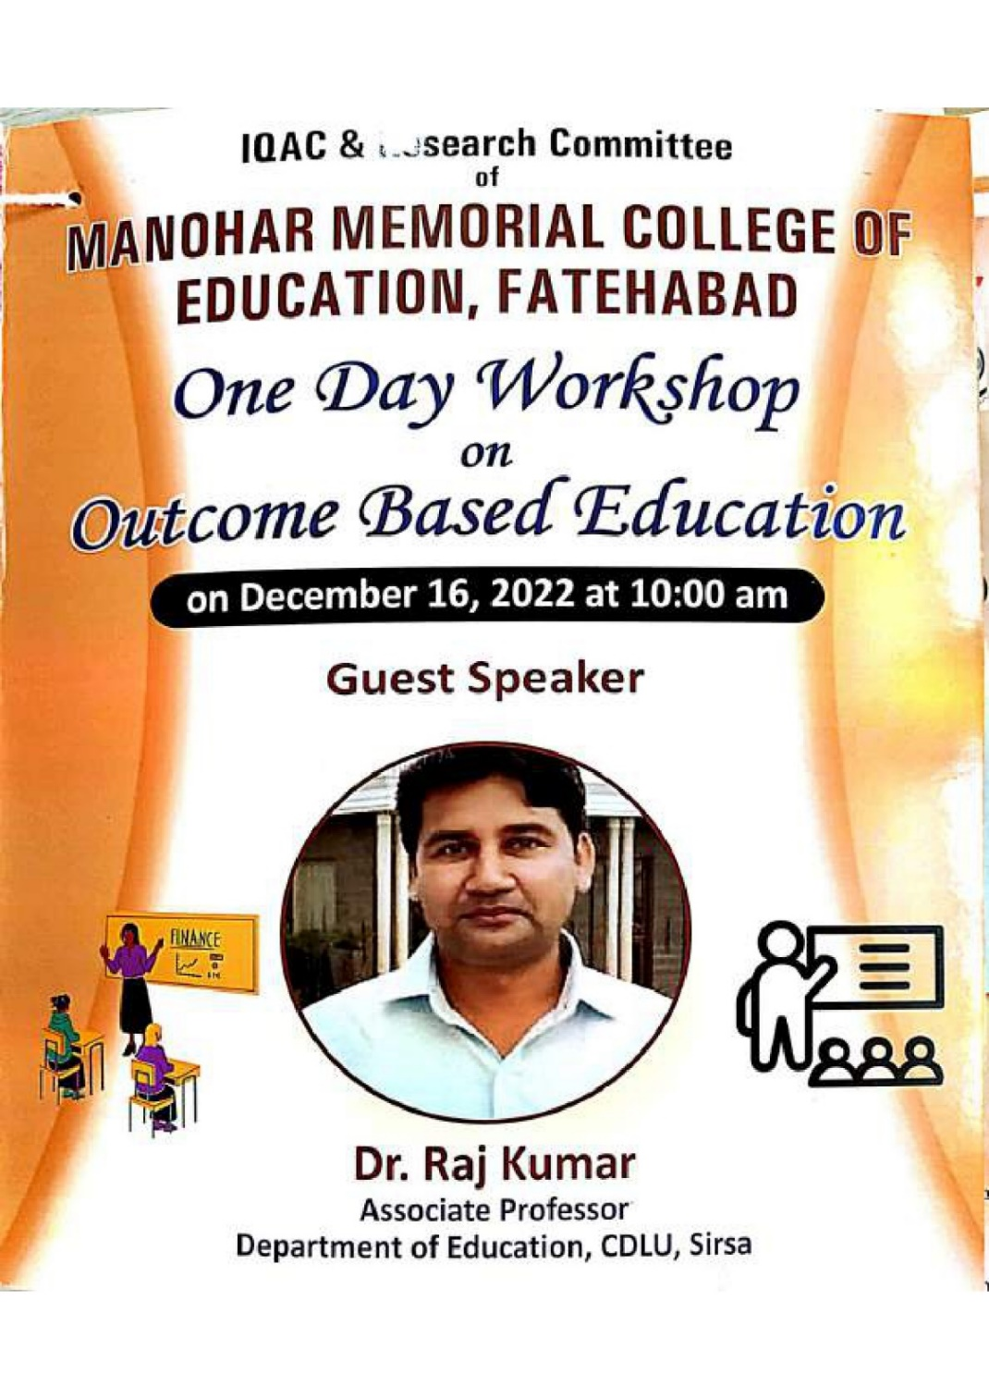

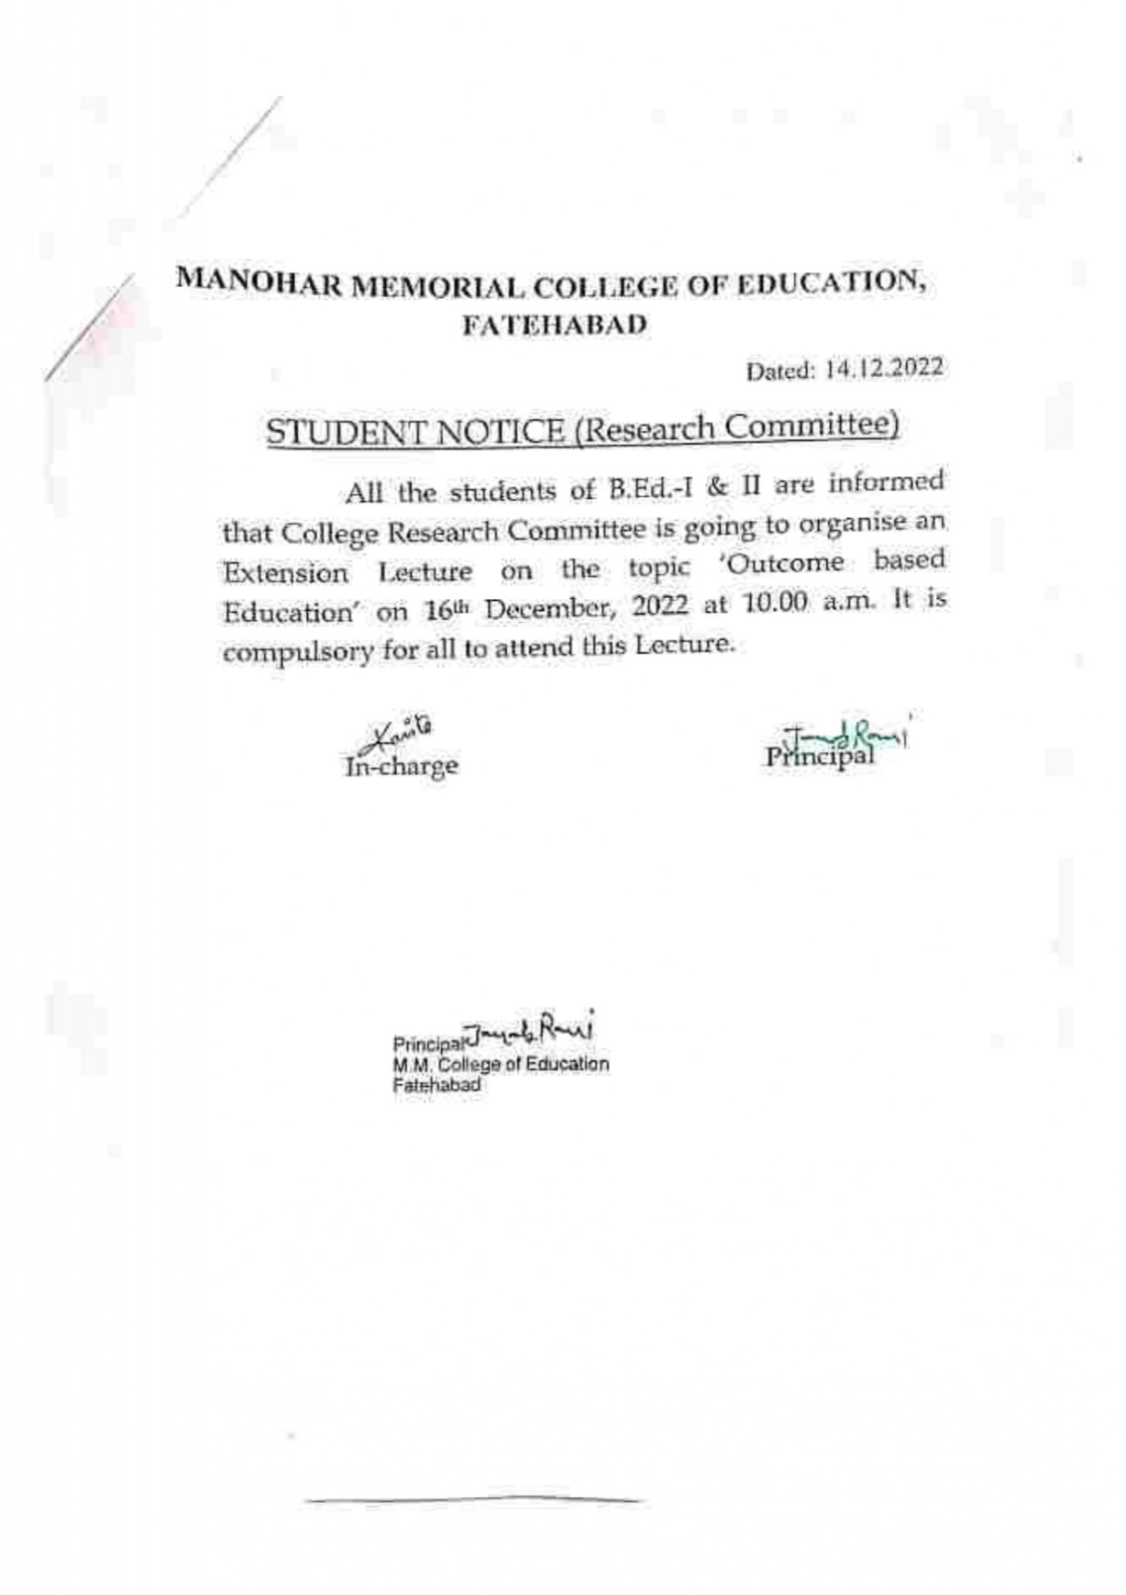

Photos of Extension Lecture on Outcome based Education
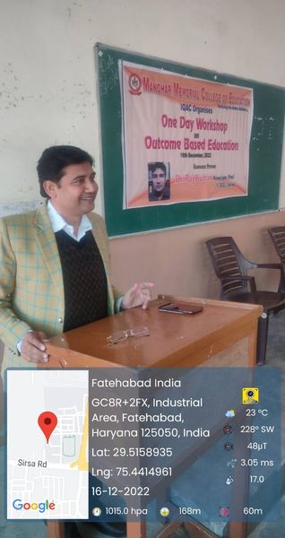

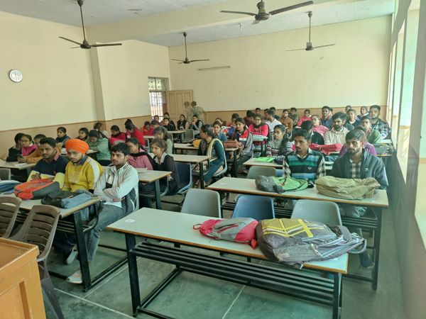

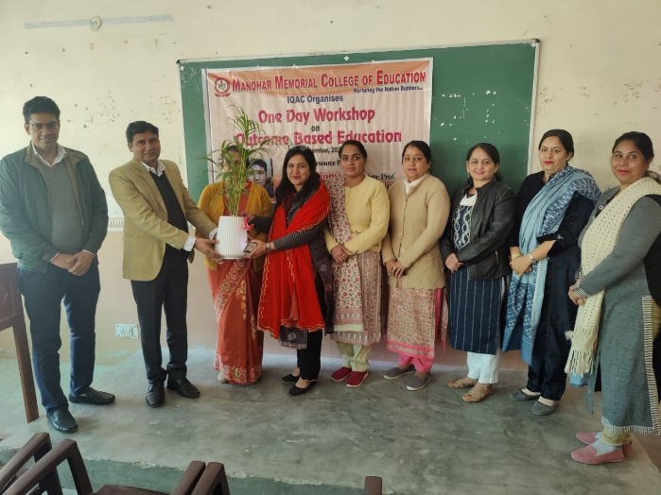
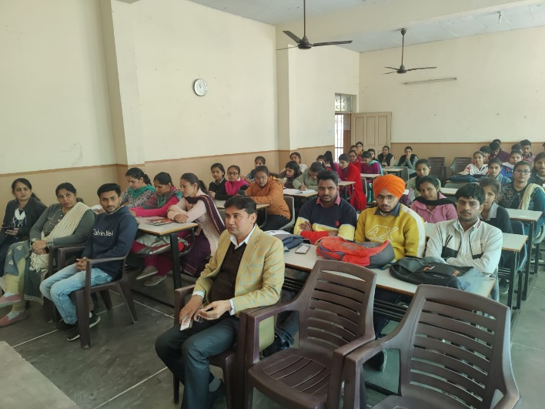
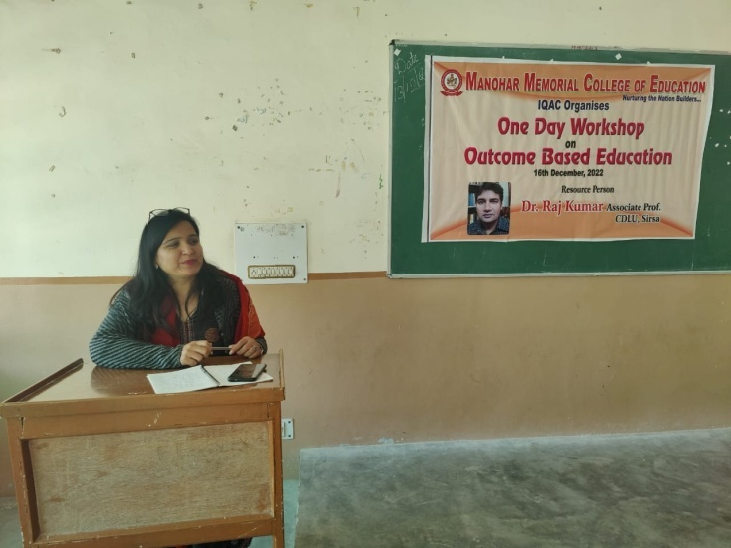

1.4 Extension Lecture on Gender Sensitivity on International Women’s Day by
Mrs. Harbans Kaur (06.03.2023)

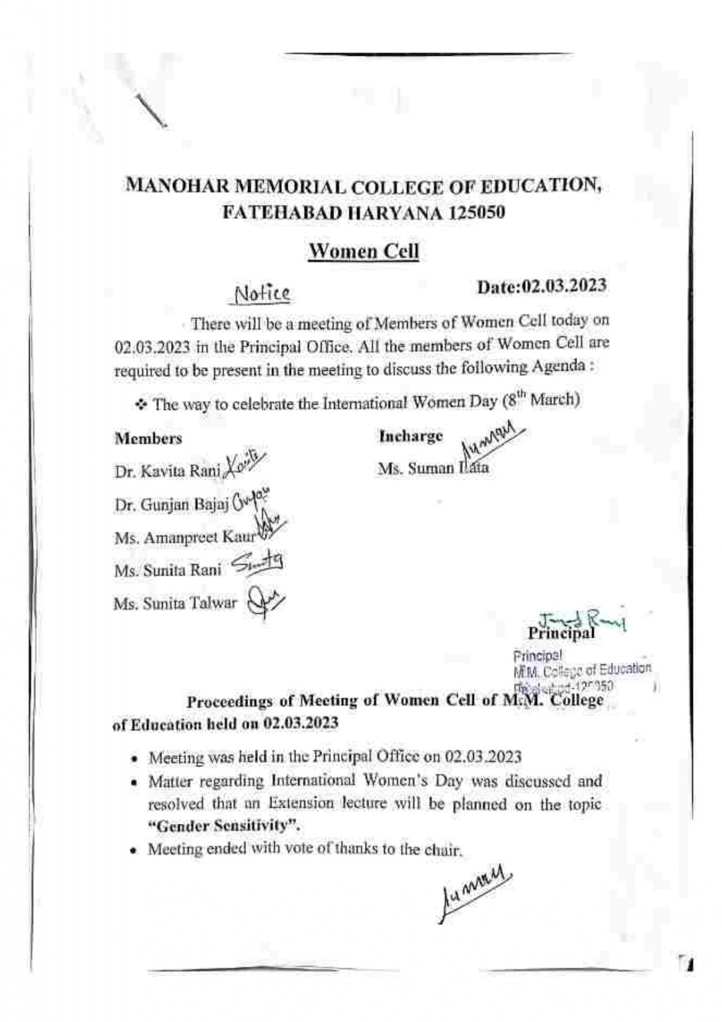
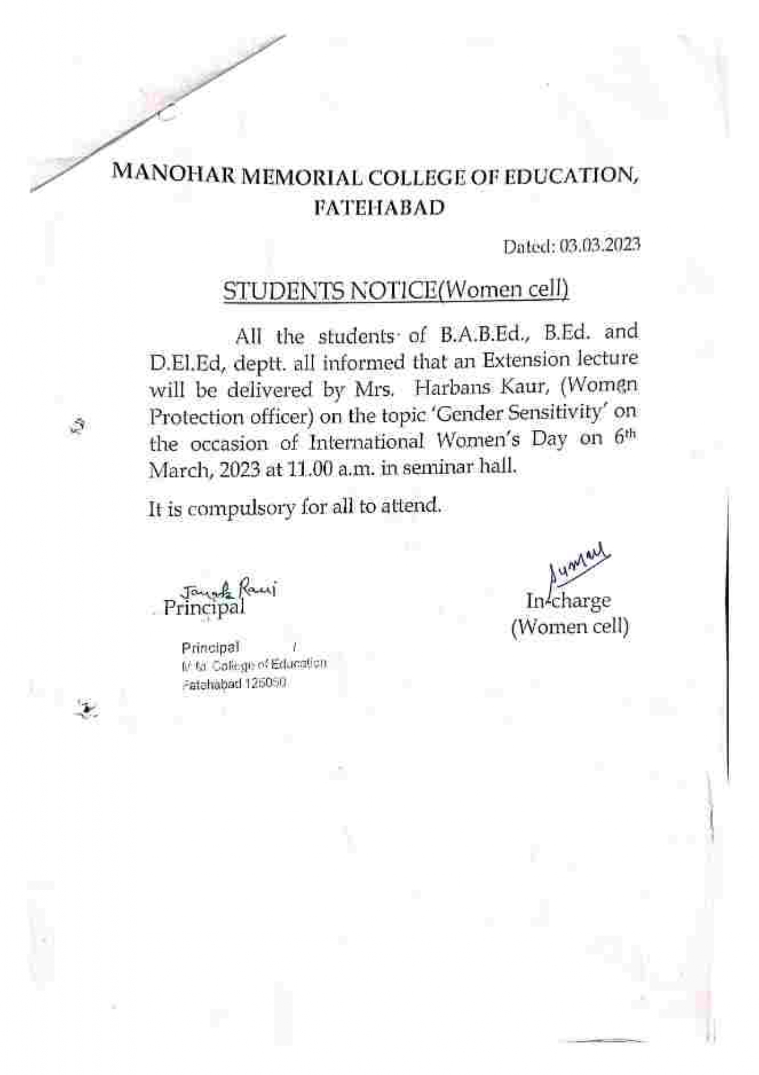

Photo of Extension Lecture on Gender Sensitivity on International Women’s Day
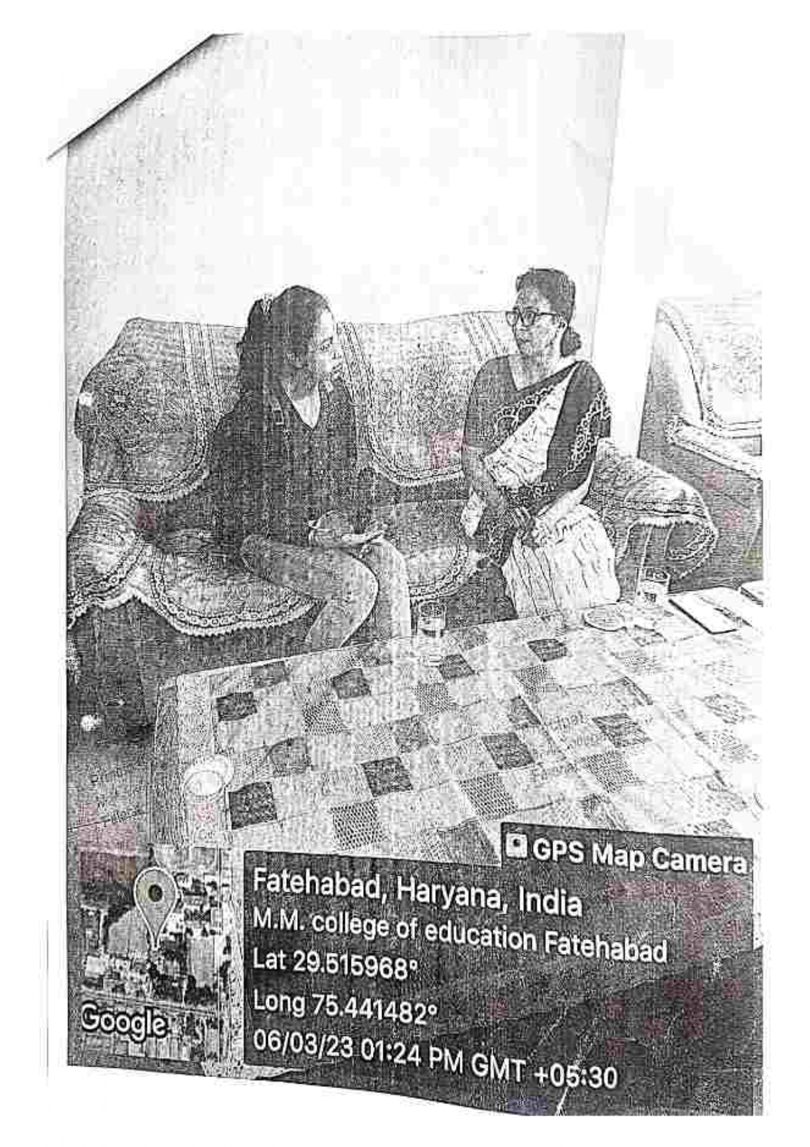
1.5 Extension Lecture on Strategies for promoting active learning the classroomby
Dr.Gurcharan Das (19.04.2023)

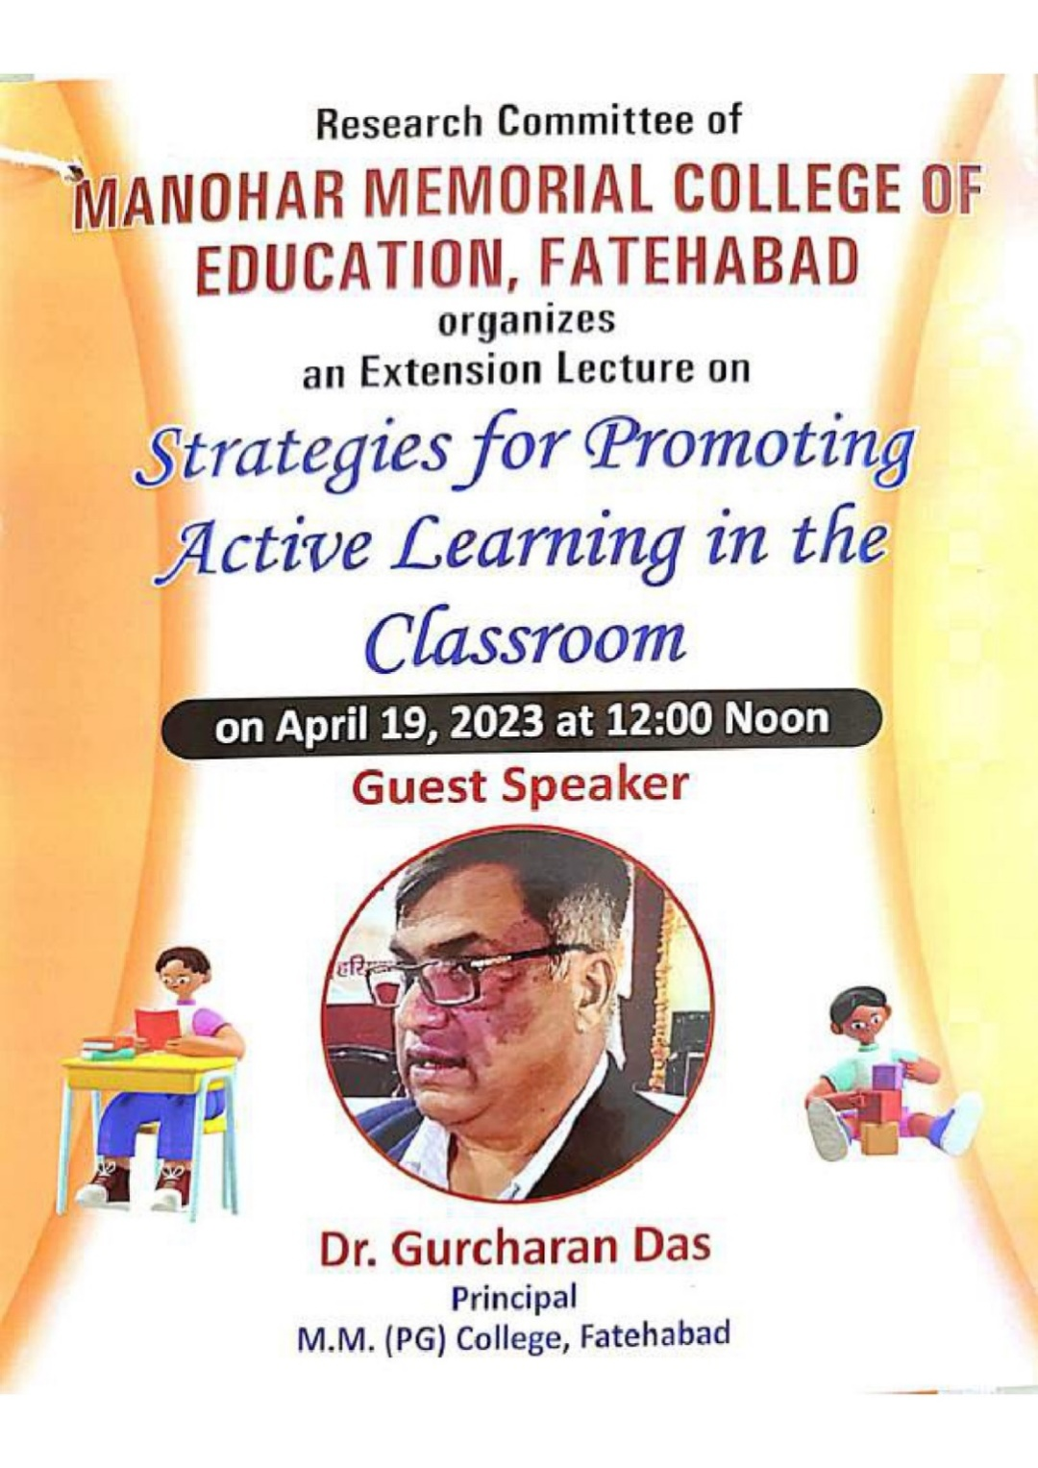
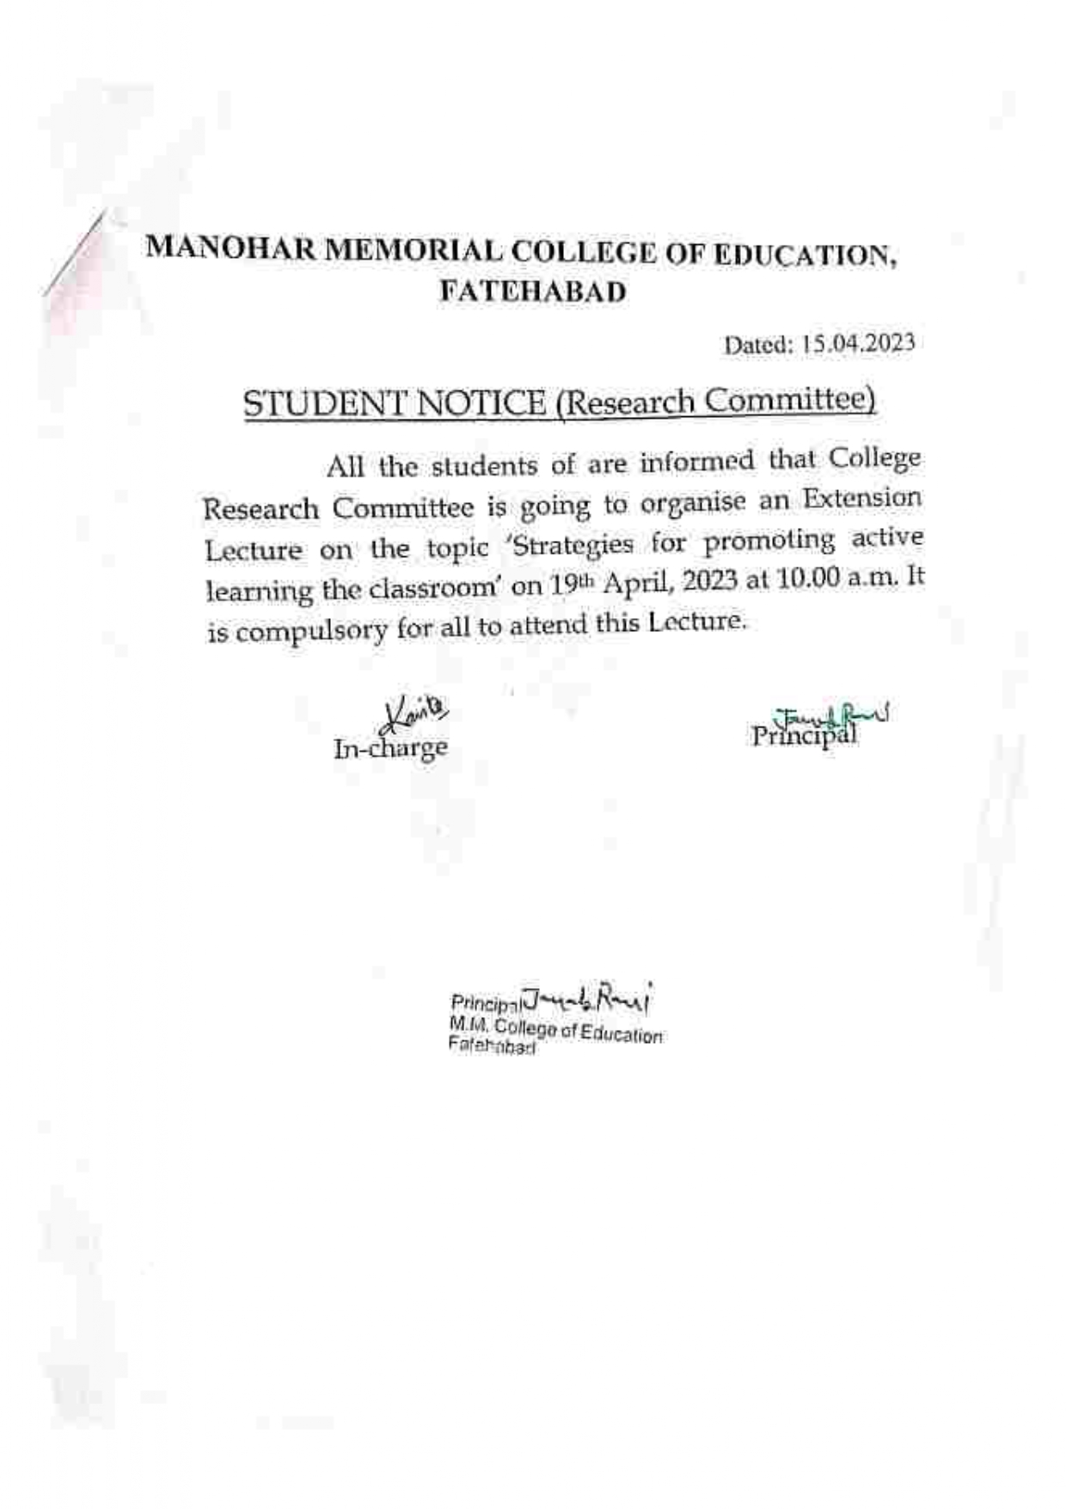

1.6 Extension Lecture on Spiritualism & Education by
Dr.ParthSarthi(29.04.2023)

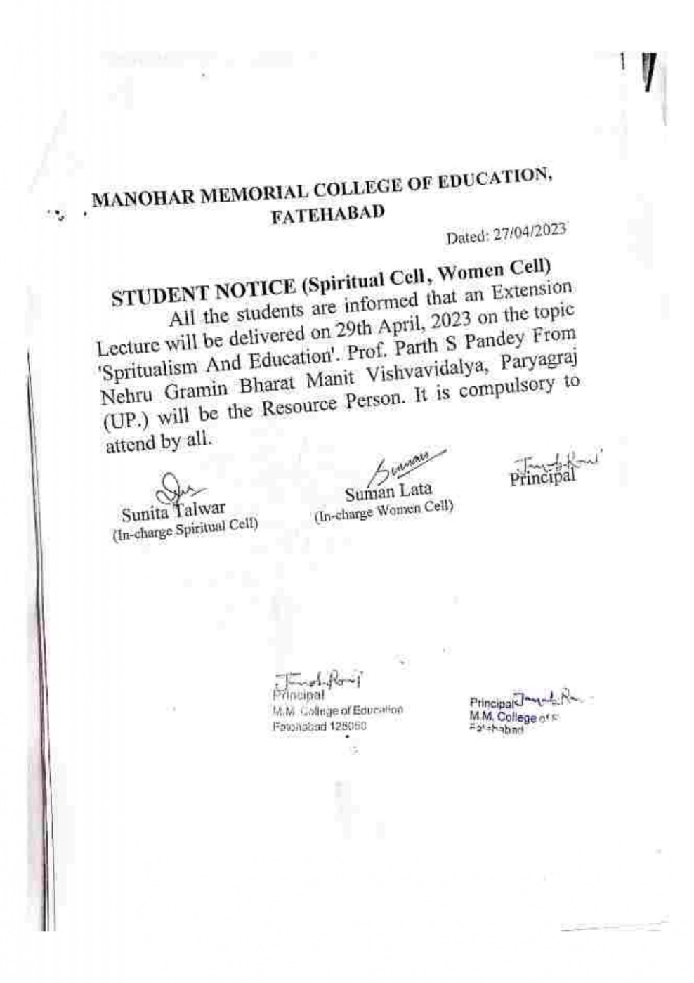
Photo of Extension Lecture on Spiritualism & Education
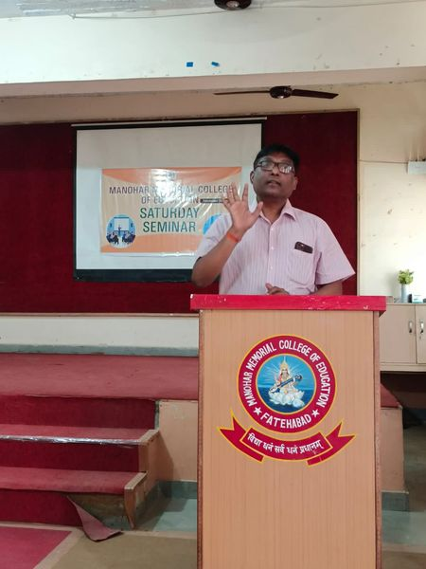
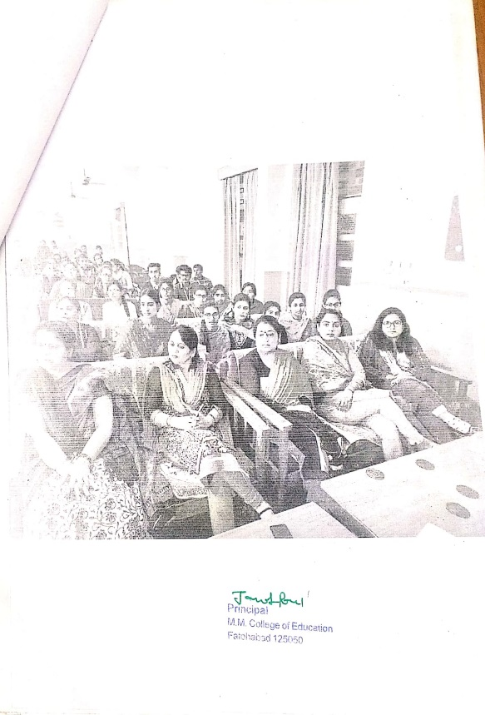

1.7 International Webinar on web 2.0 tools for Education Journalism by
Mr. IssacMulolani(06.05.2023)
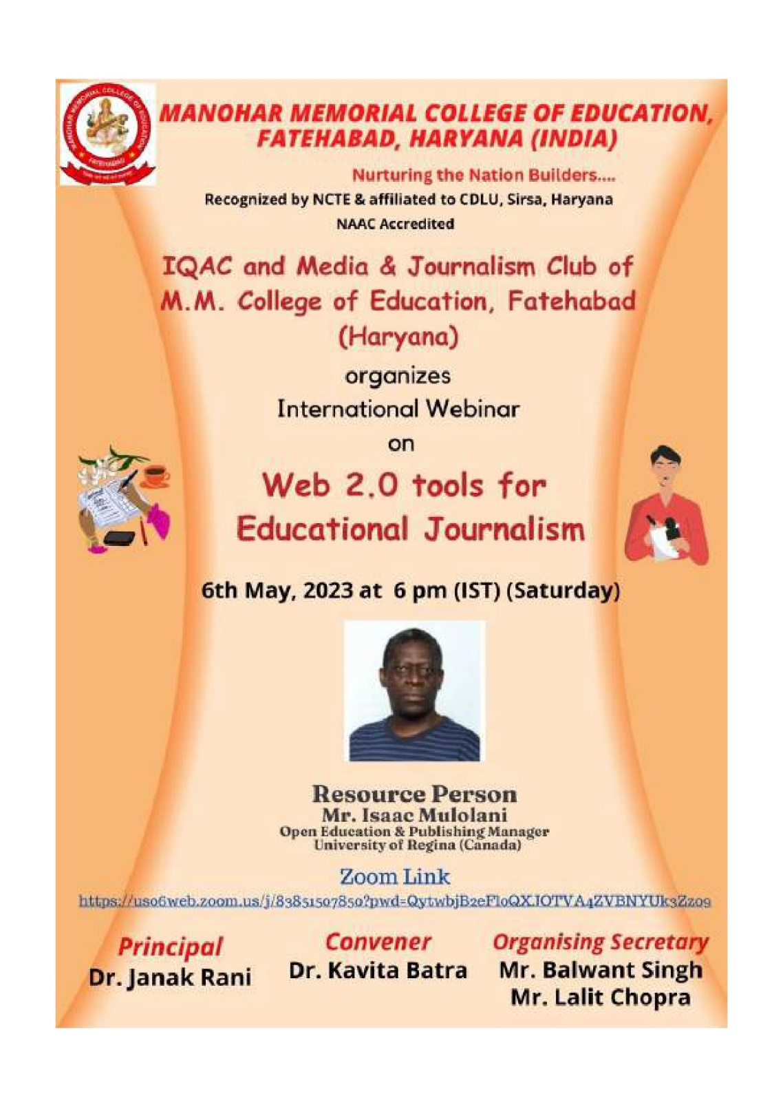

Photos of International Webinar on web 2.0 tools for Education Journalism
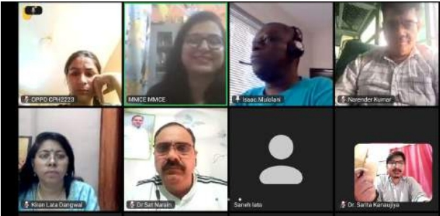
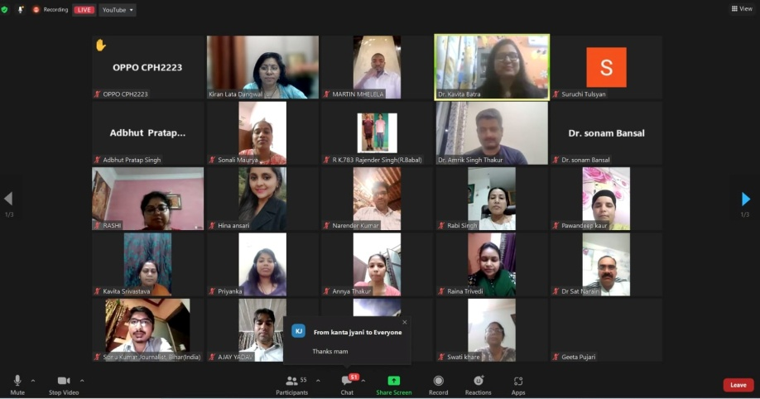
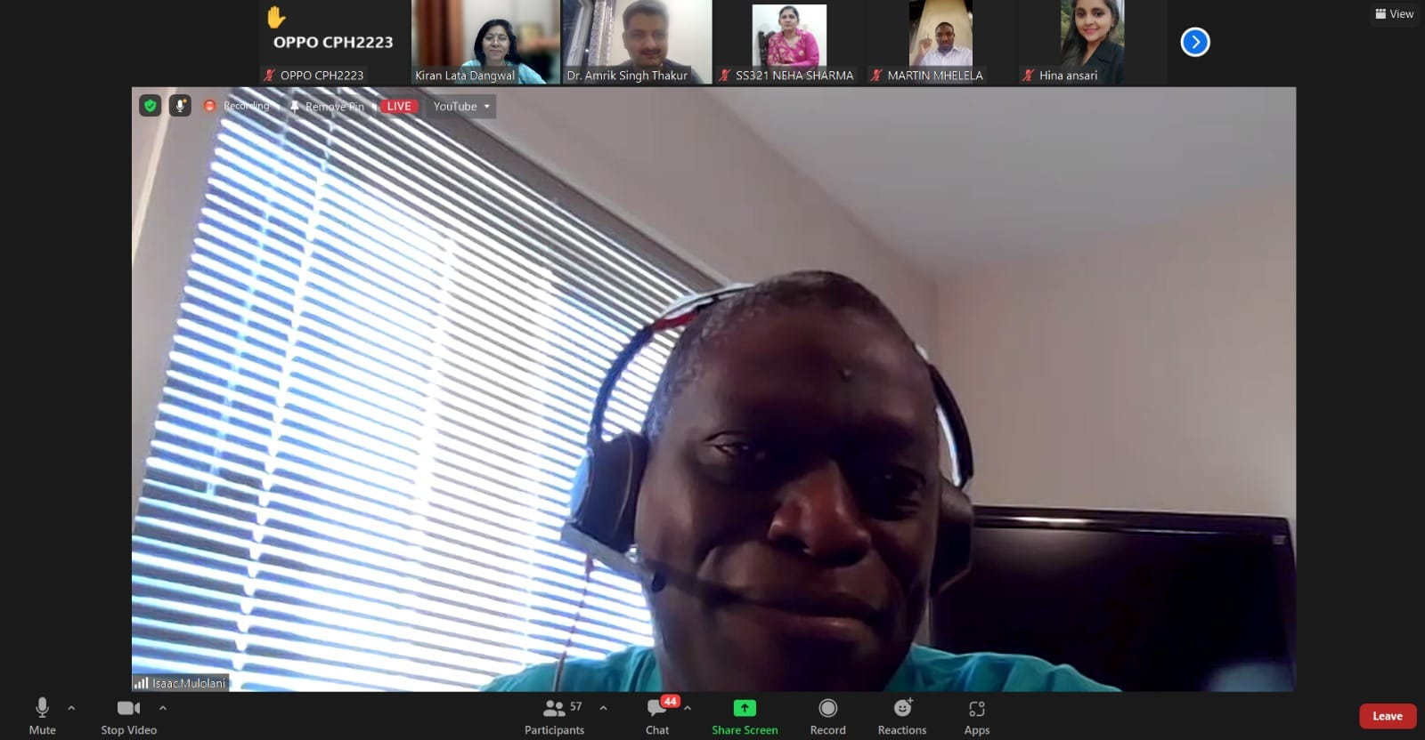

- Book Reading & Discussion on it

A Books Reading Competition at M.M. College of Education in Fatehabad sounds like a fantastic event. Competitions like these often foster a love for reading and learning among students
Benefits of the books reading
Promotion of Reading Habit: Competitions encourage students to read more books, explore different genres, and discover new authors. This helps in cultivating a lifelong habit of reading
Stress Reduction and Relaxation: Engaging in reading as a hobby can serve as a stress-relieving activity, promoting mental well-being and relaxation
Improvement in Vocabulary and Language Skills: Reading diverse books enhances vocabulary and language proficiency. Students learn new words, phrases, and idiomatic expressions that enrich their communication skills.

Book Reading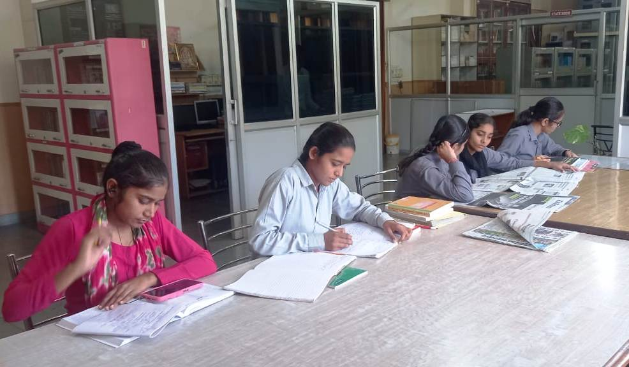
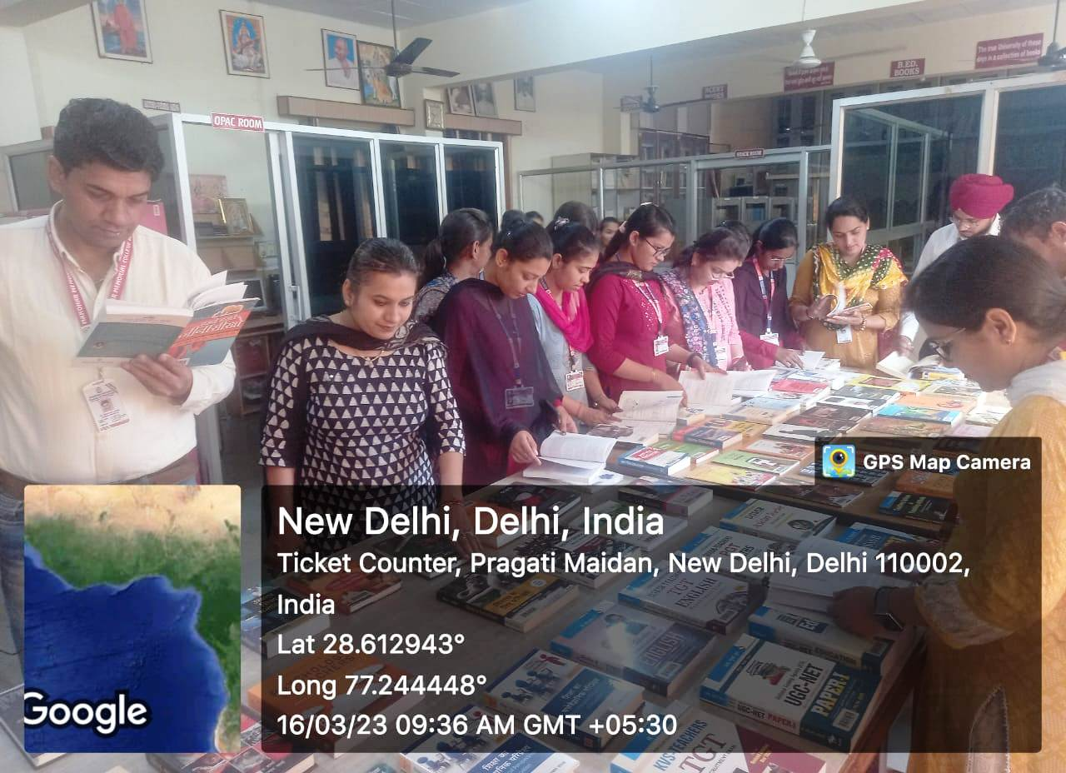
Book Exihibition

WALL MAGAZINE COMPETITION IN COLLEGE CAMPUS

Wall magazine competition was organized on April 24, 2023, at M.M. College of Education, Fatehabad, The competition was based on some theme like Awareness about the harmful effects of drug abuse, Highlighting the negative impacts of dowry on society, Promoting the benefits of a cashless economy, Tips for waste management and maintaining cleanliness in public space, Celebrating achievements of women in various fields. Many students participated in this event and they show their talent on charts.

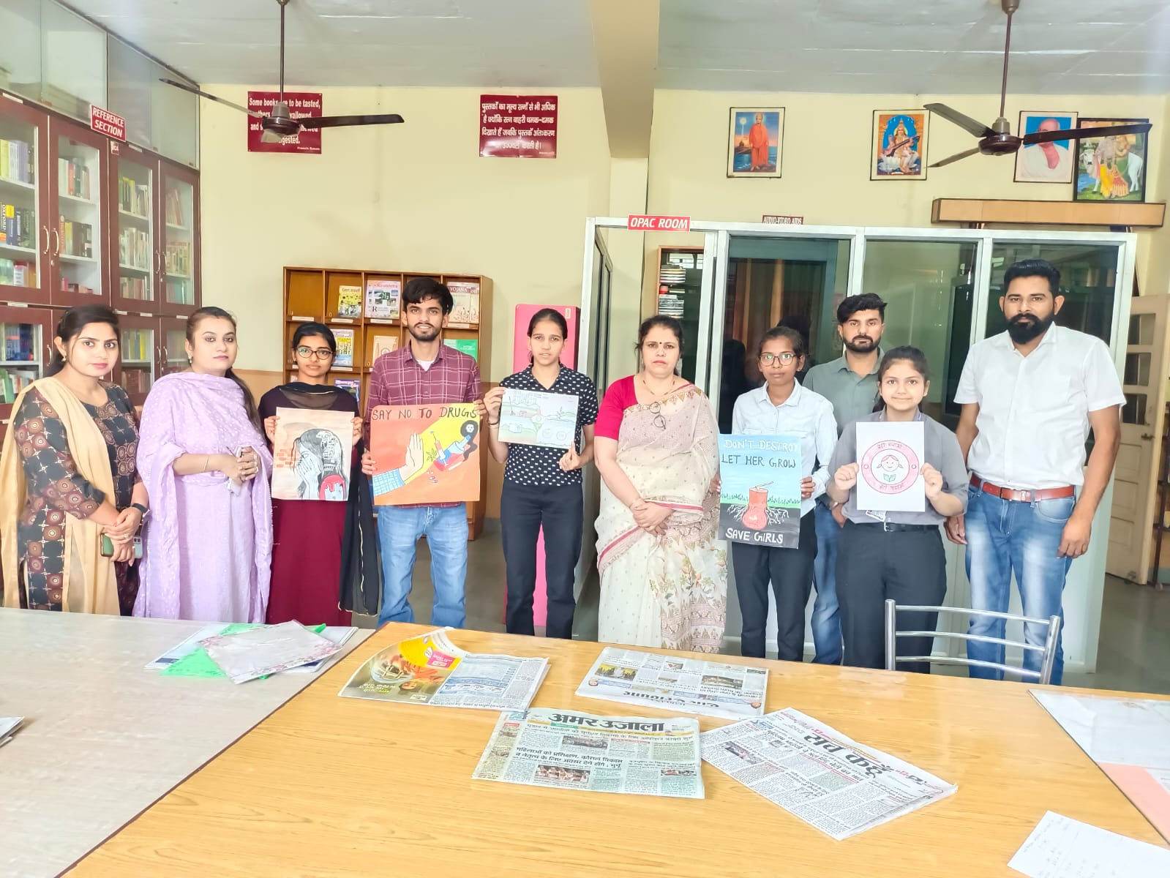
Poster Making

- Discussion on recent policies & regulation

3.1 Workshop on Action Research by
Dr. Kiran Lata(01.12.2022)
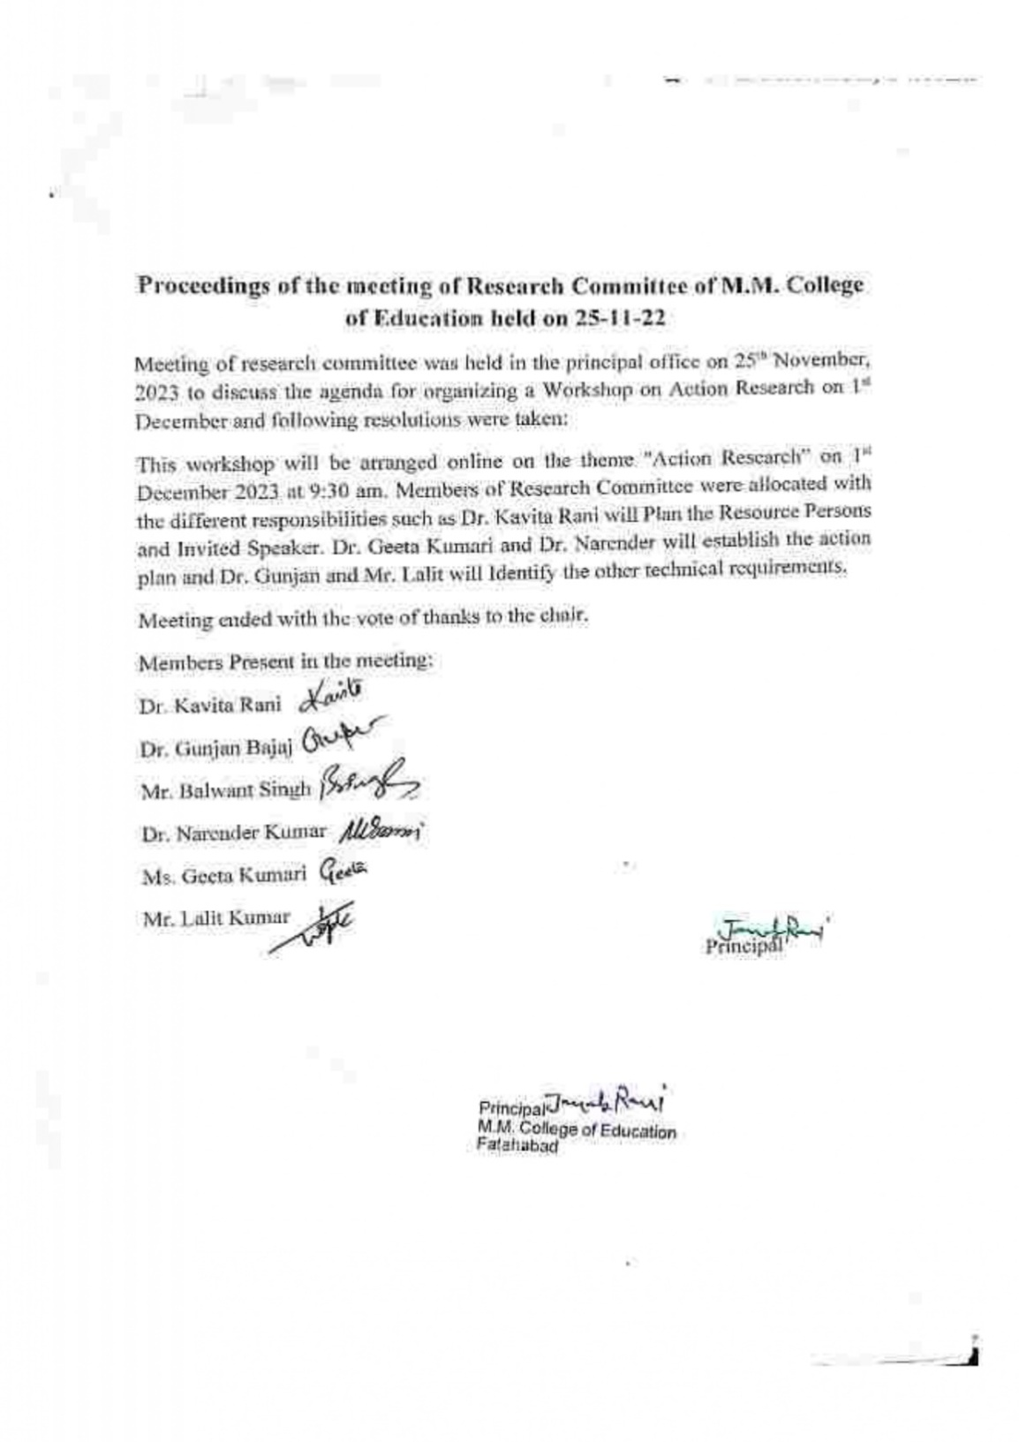

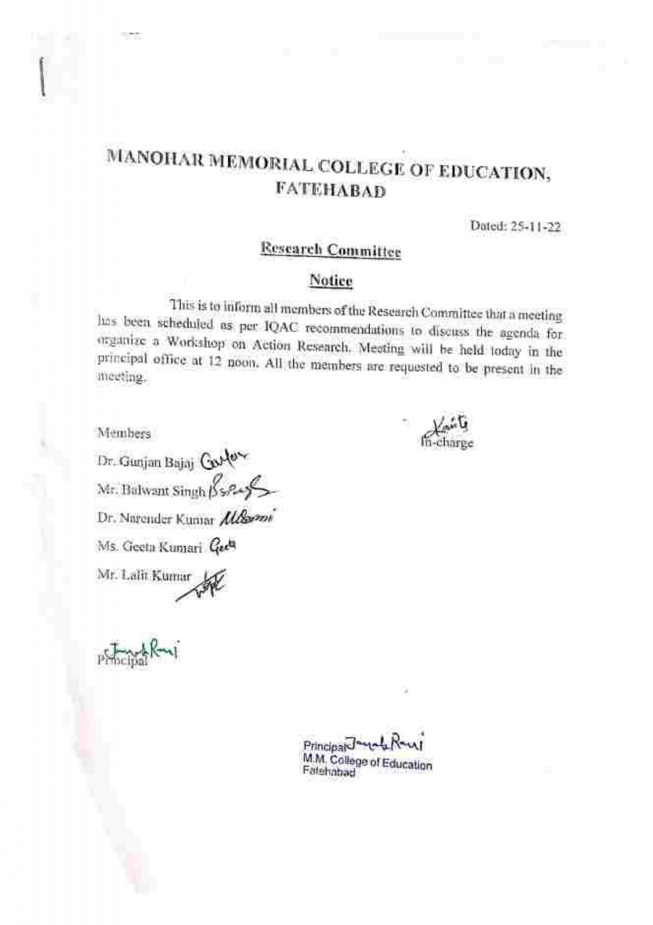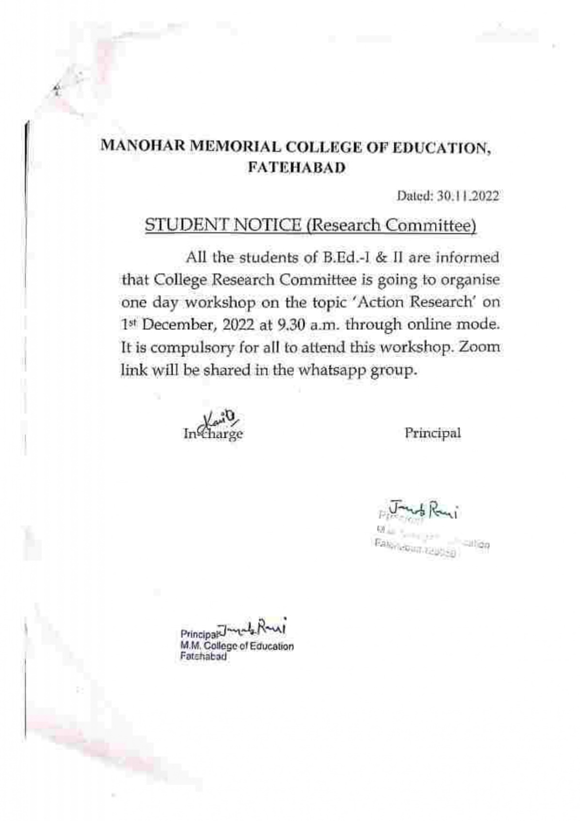

Photos of Workshop on Action Research
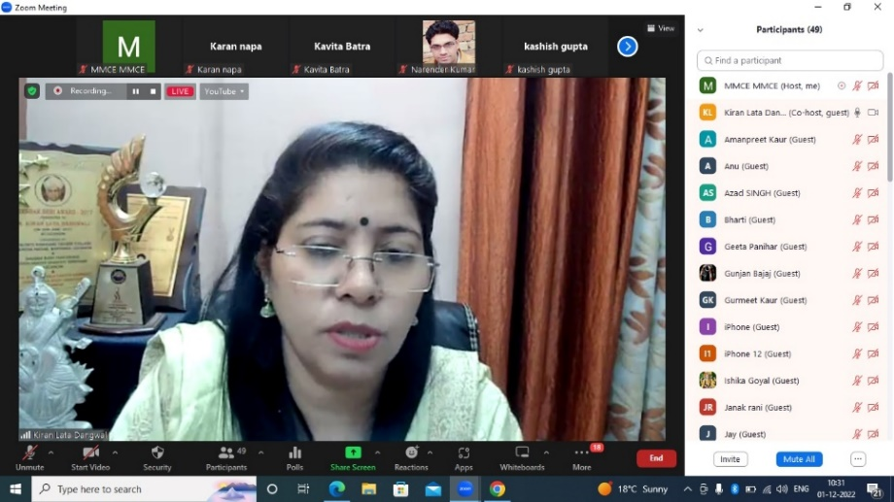
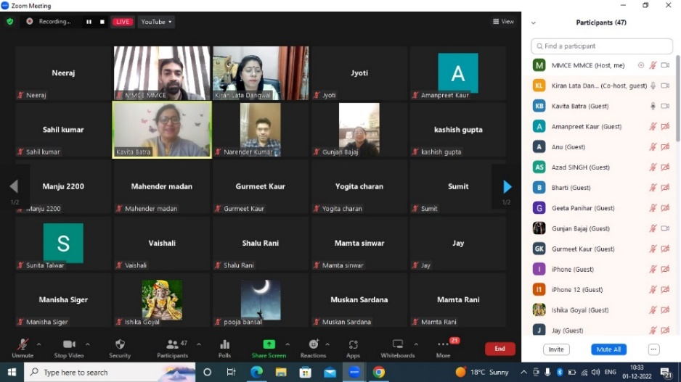
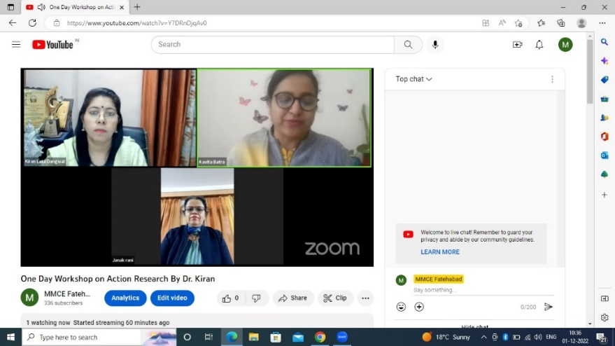

3.2 Workshop on Social Responsibilities by
Dr.Charanpreet Kaur(14.01.2023)

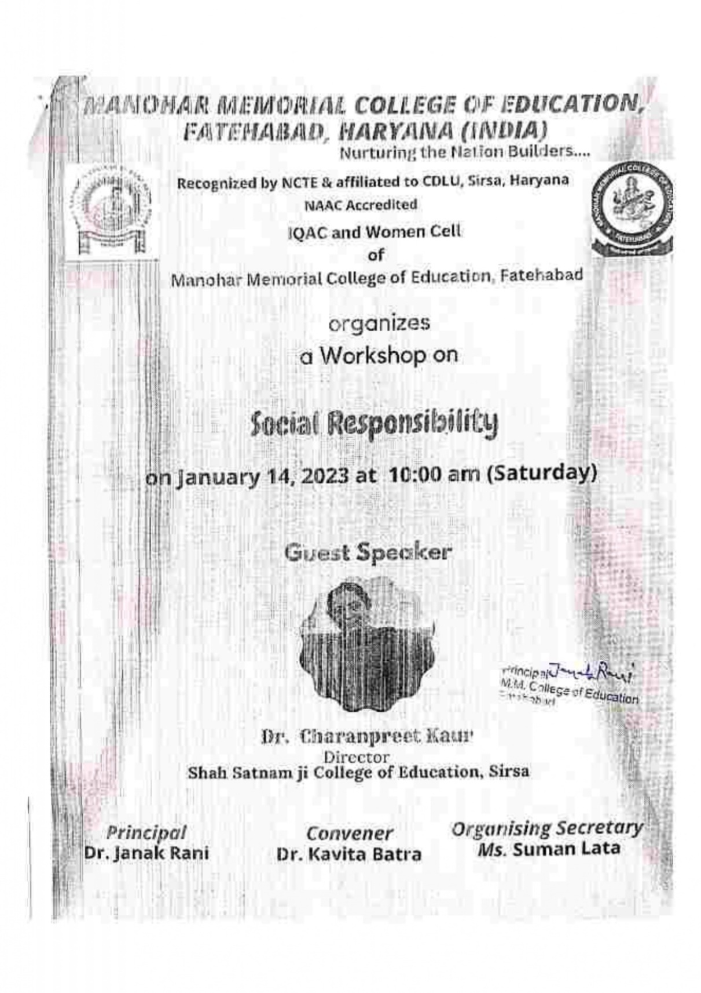
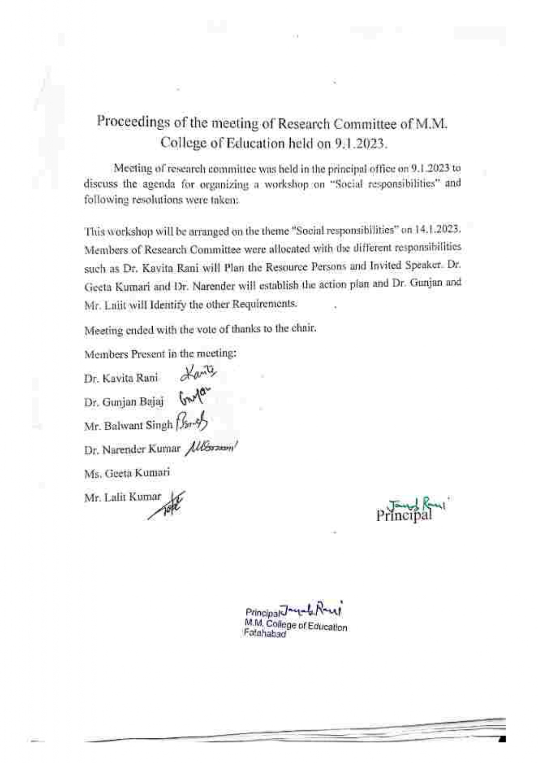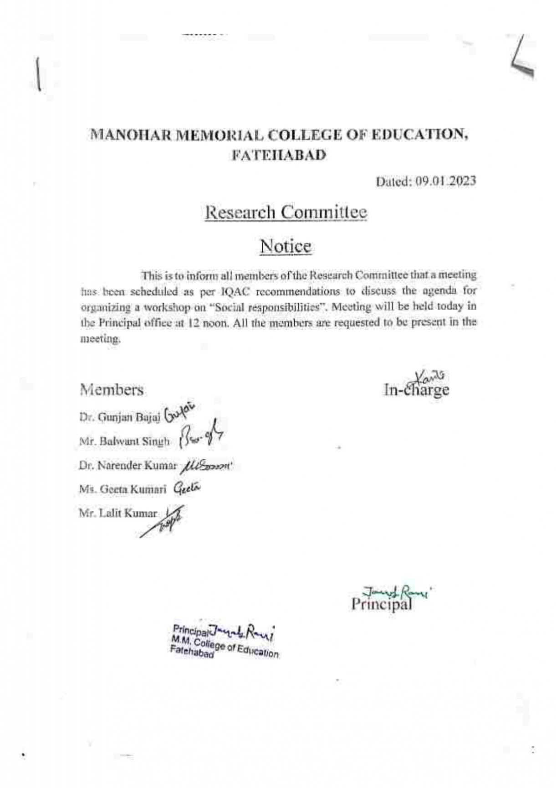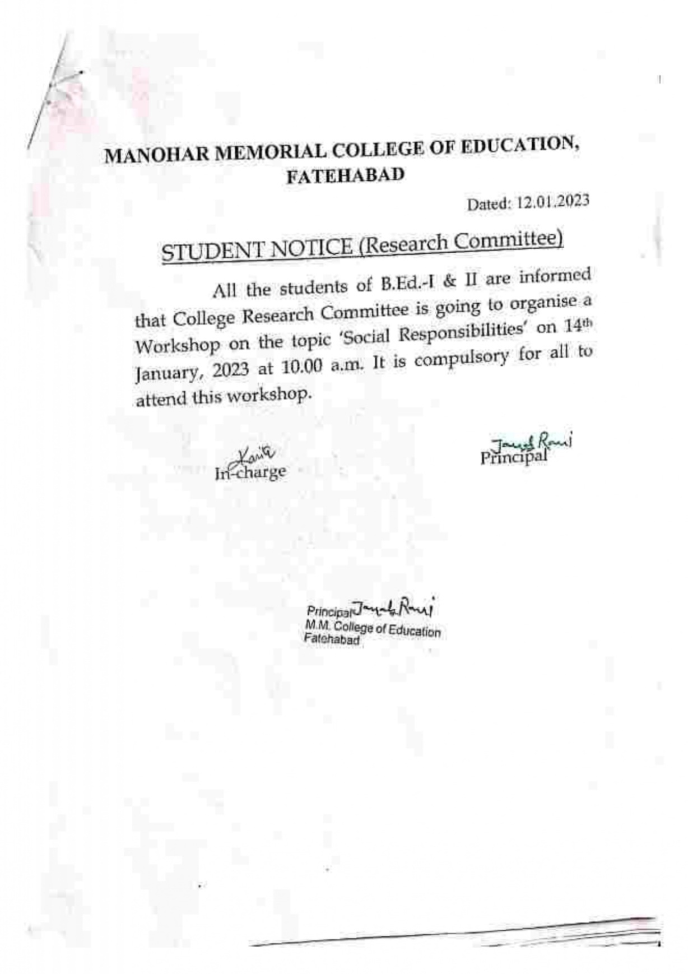

3.3 Workshop on Development of Communication Skills in Indian Languages (19.01.2023 to 21.01.2023)

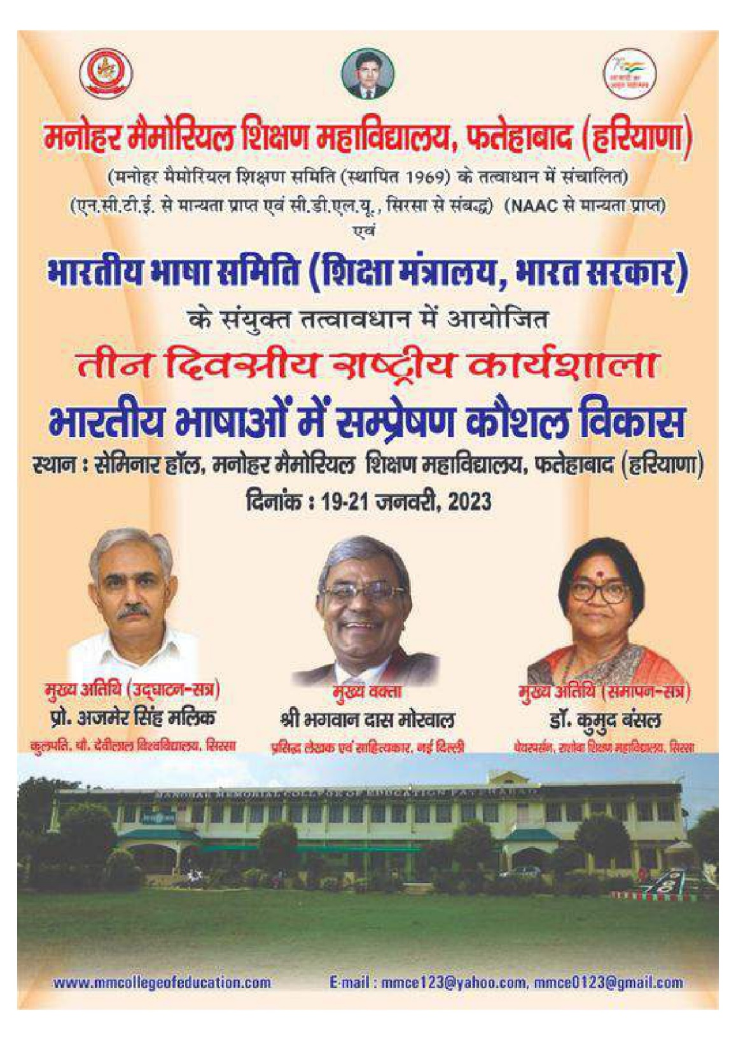

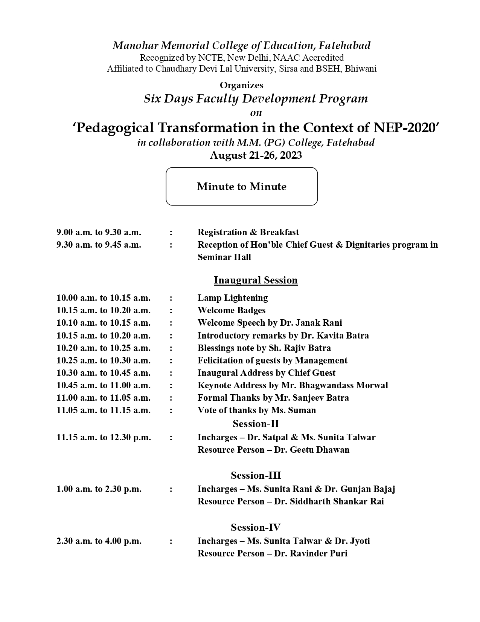

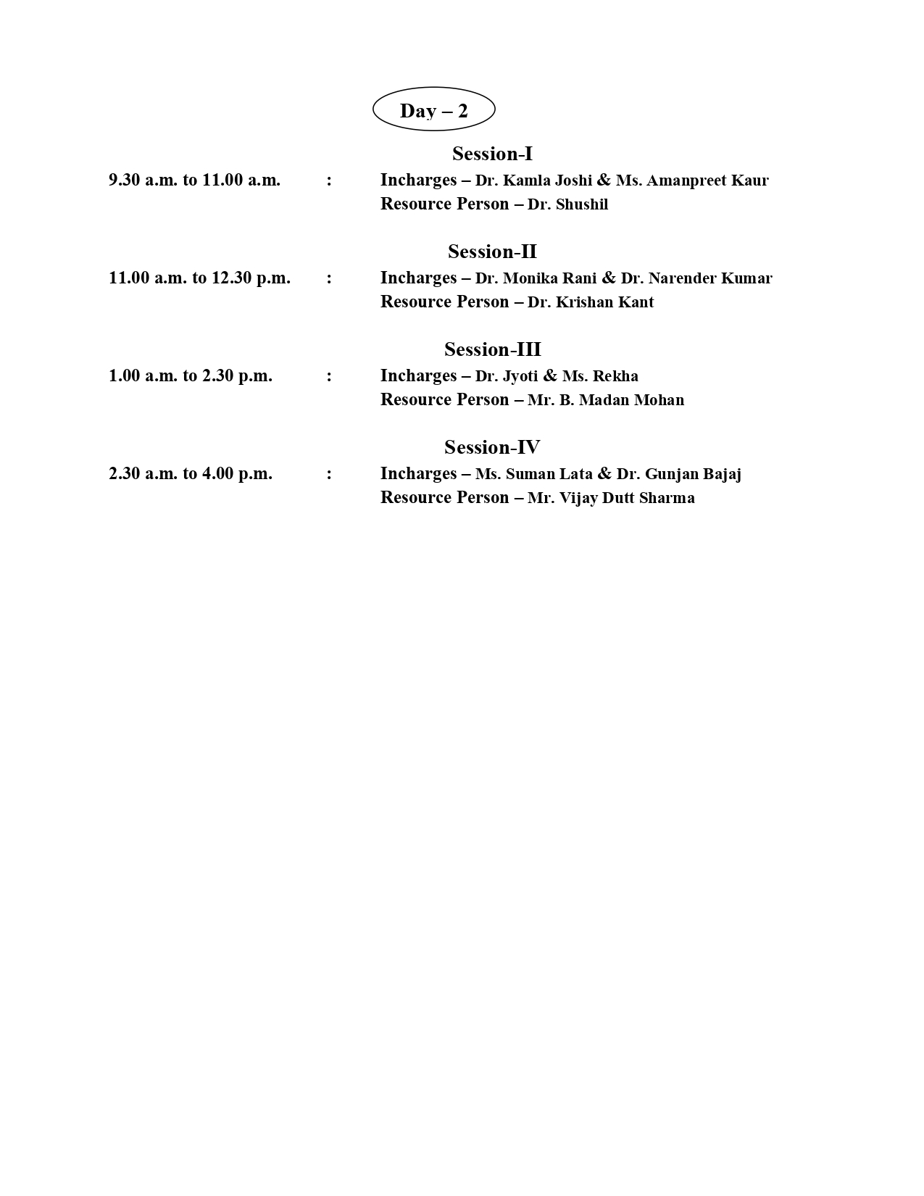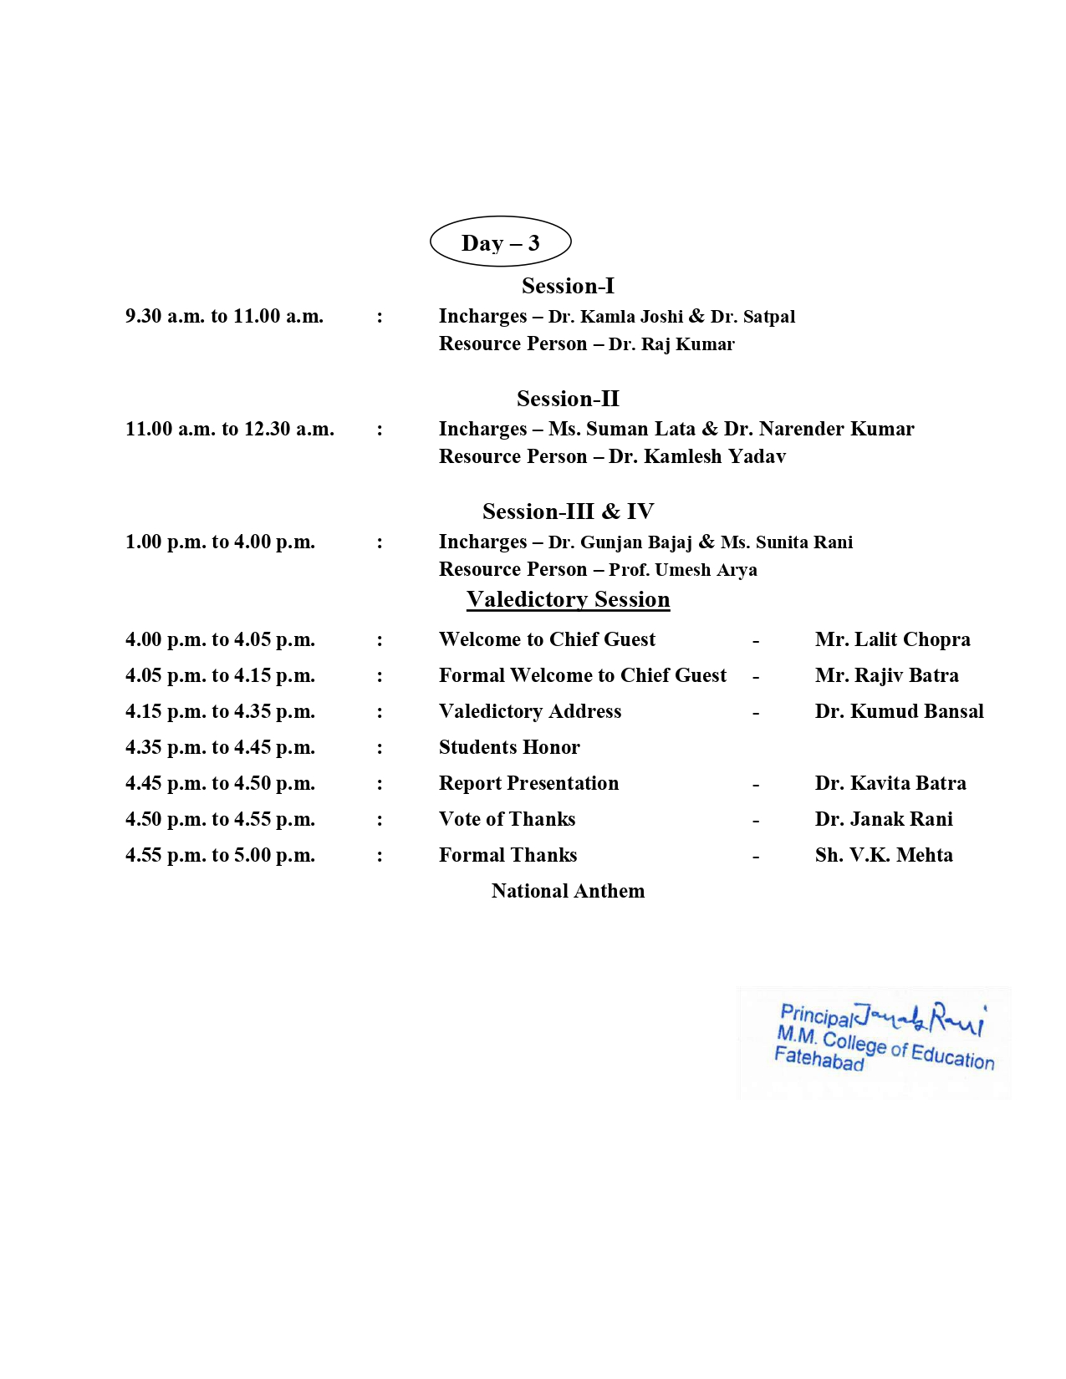

Photo of Workshop on Development of Communication Skills in Indian Languages
Day 1
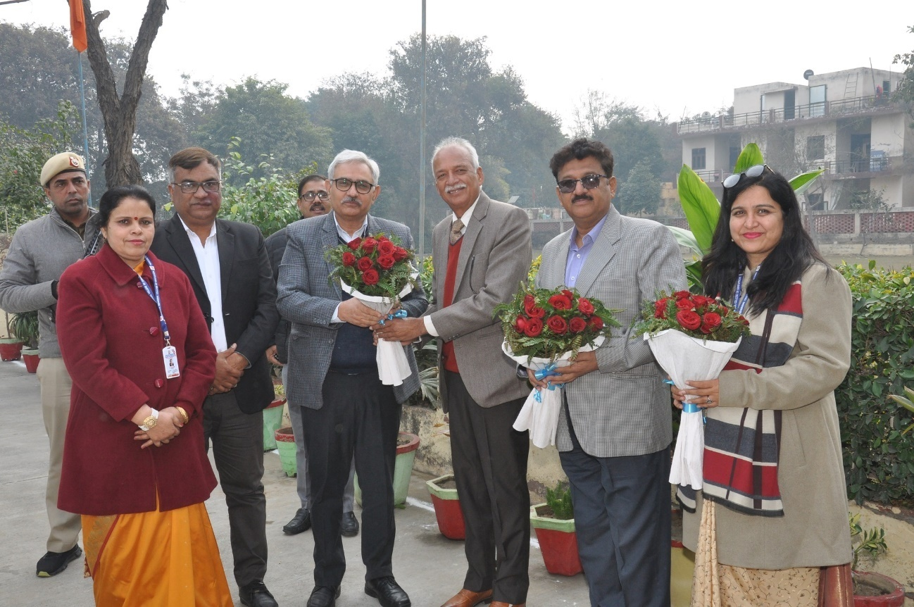
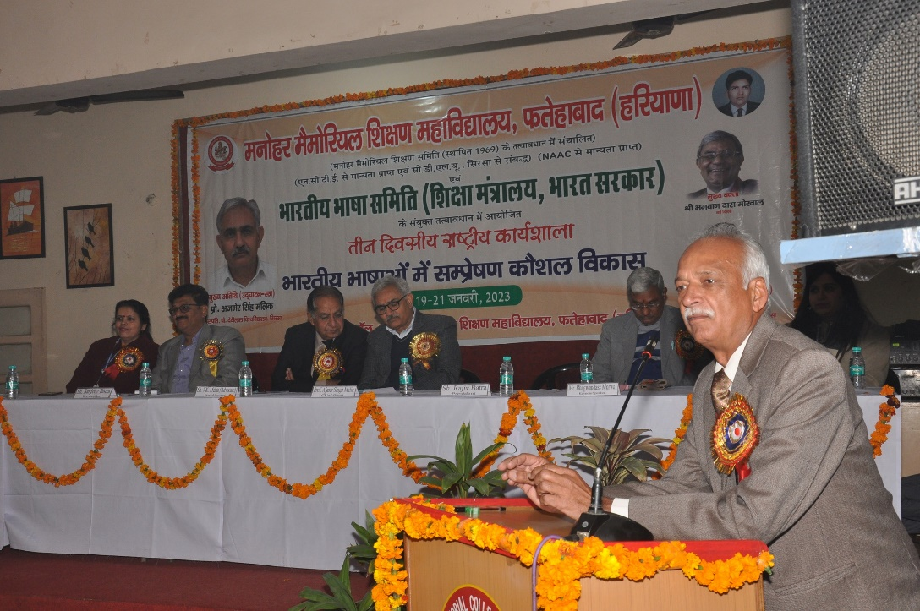
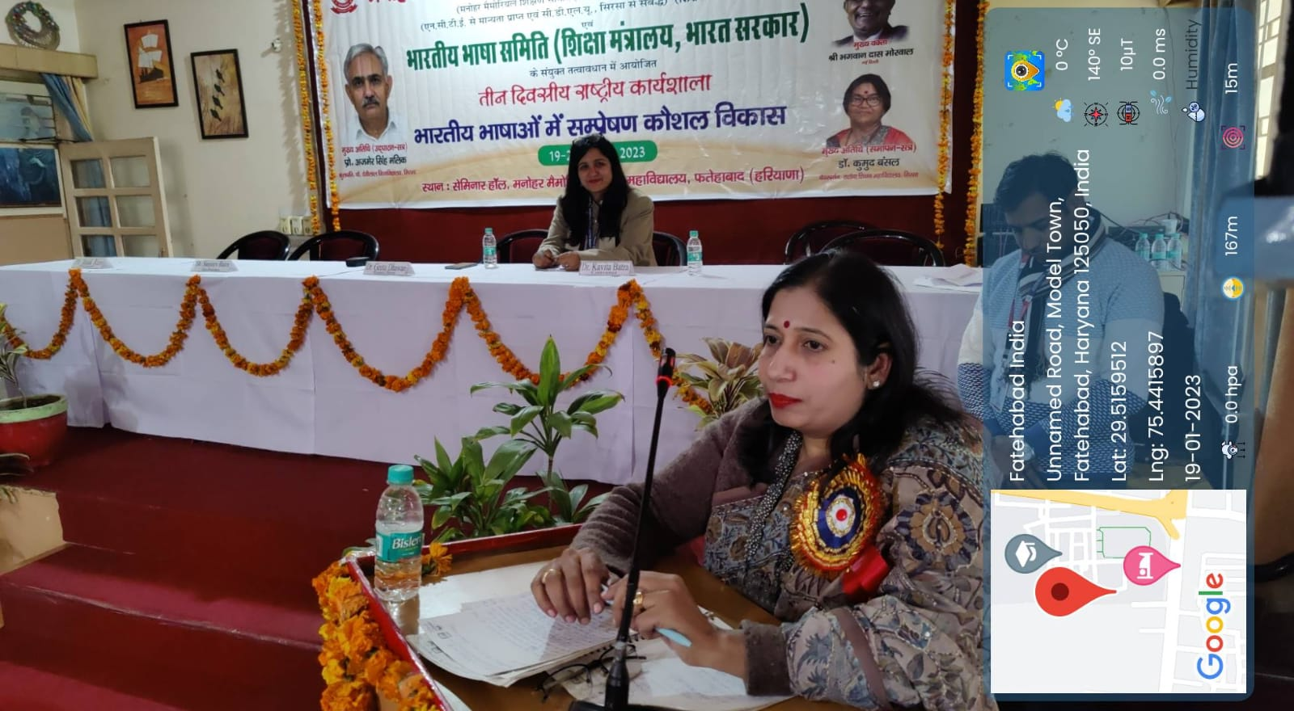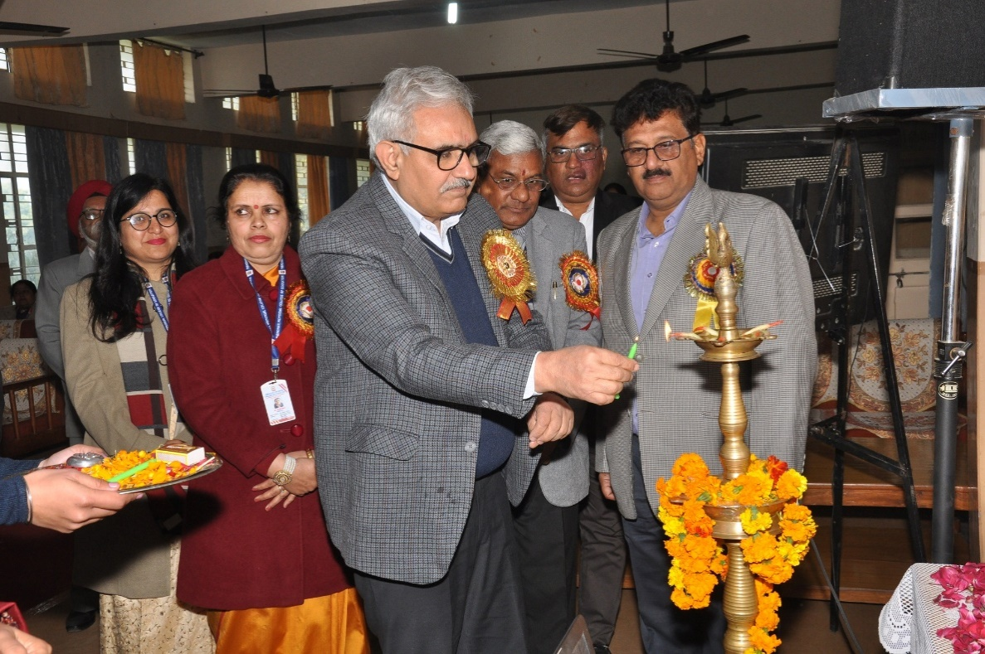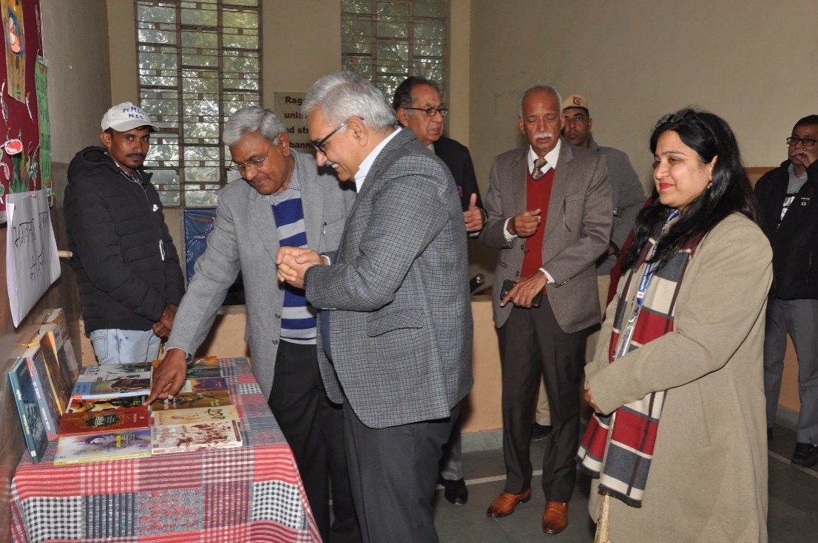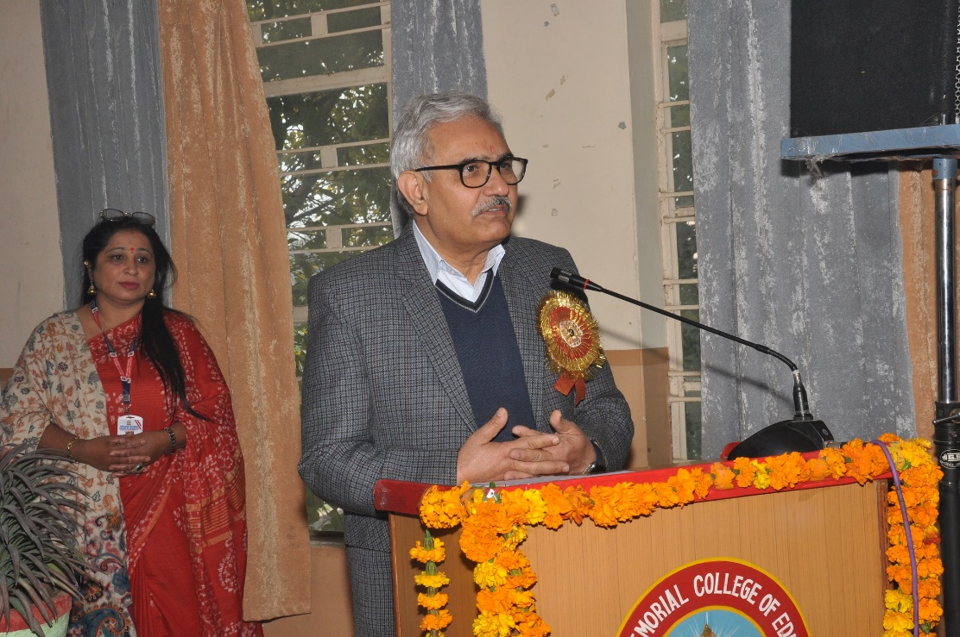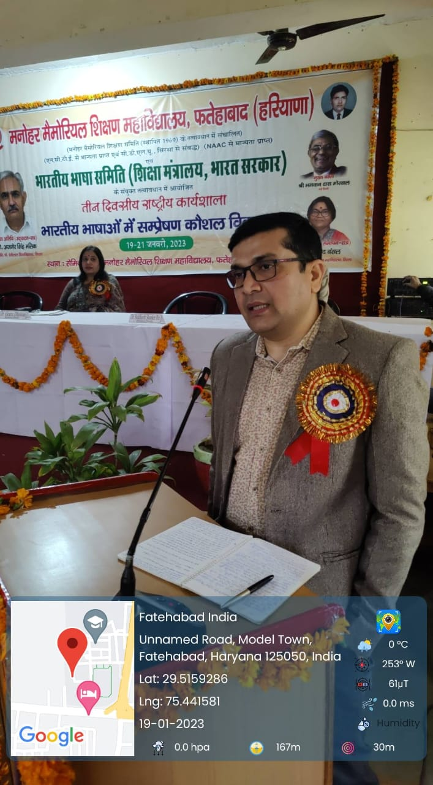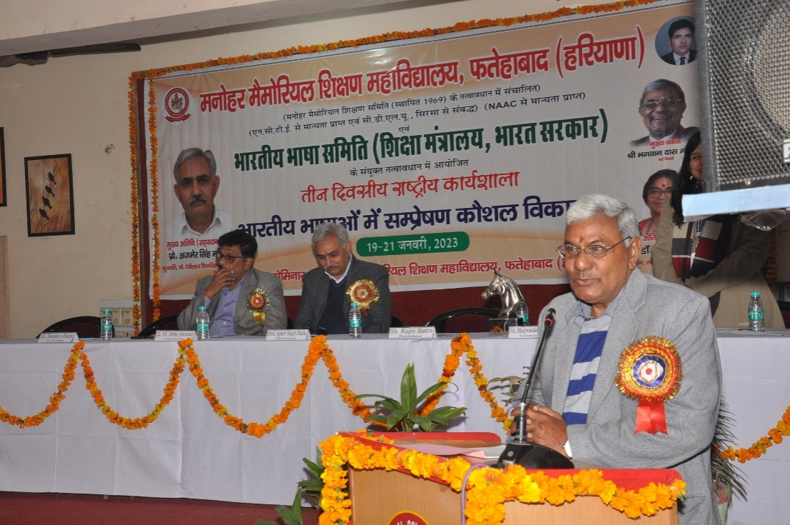
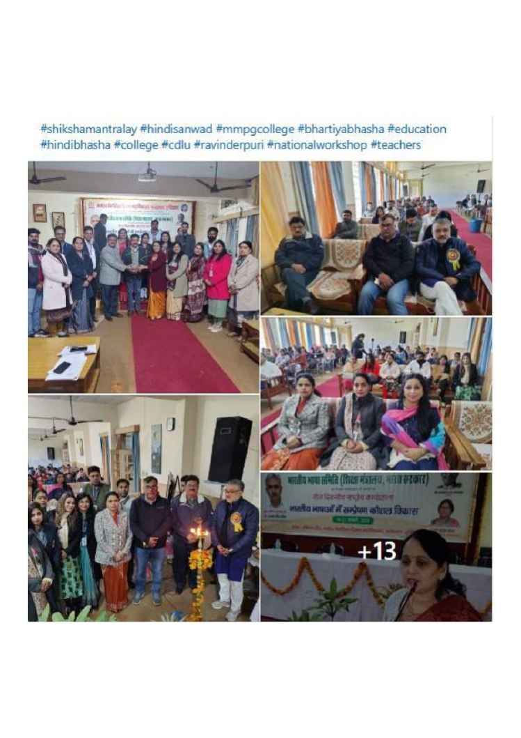

Day 2

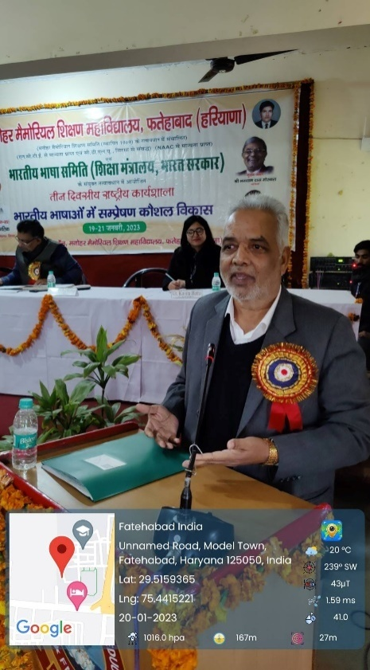
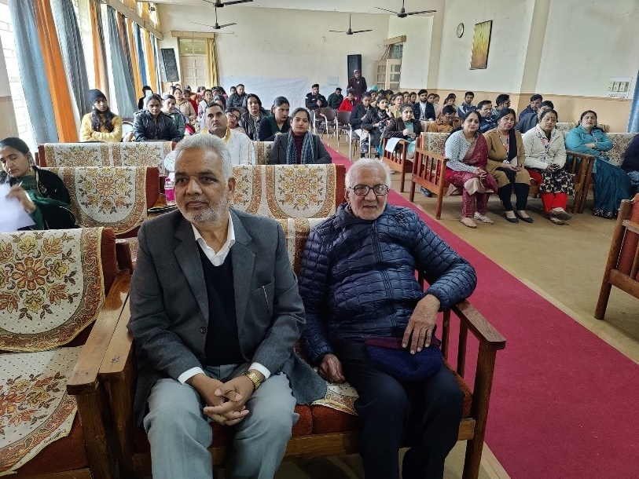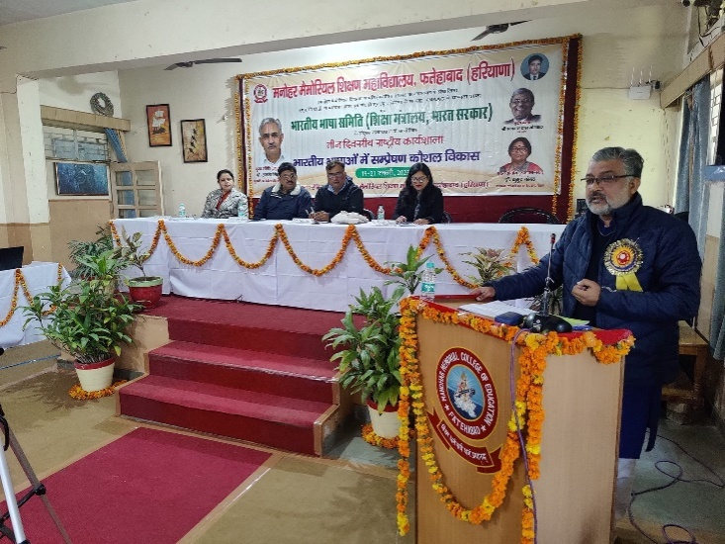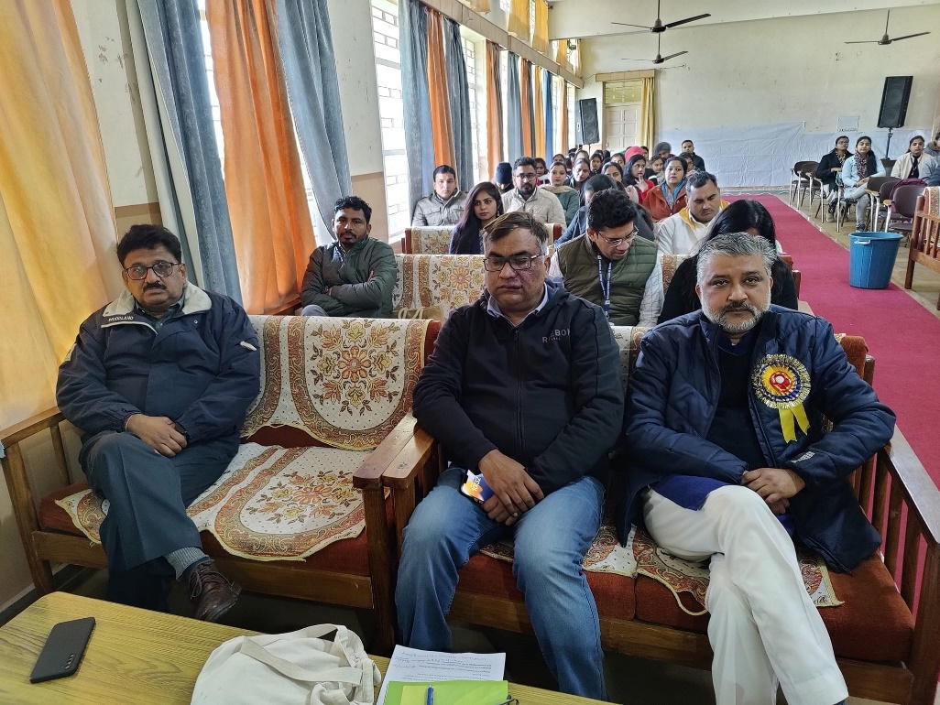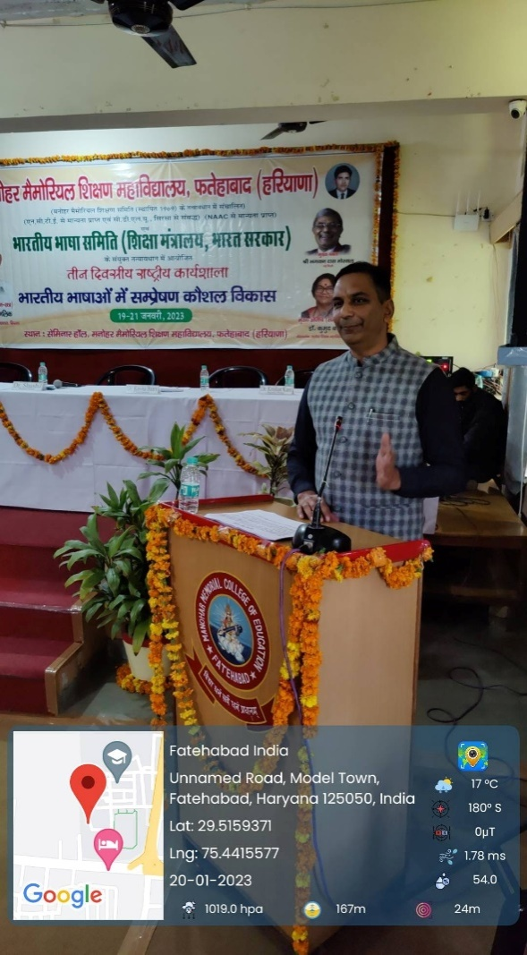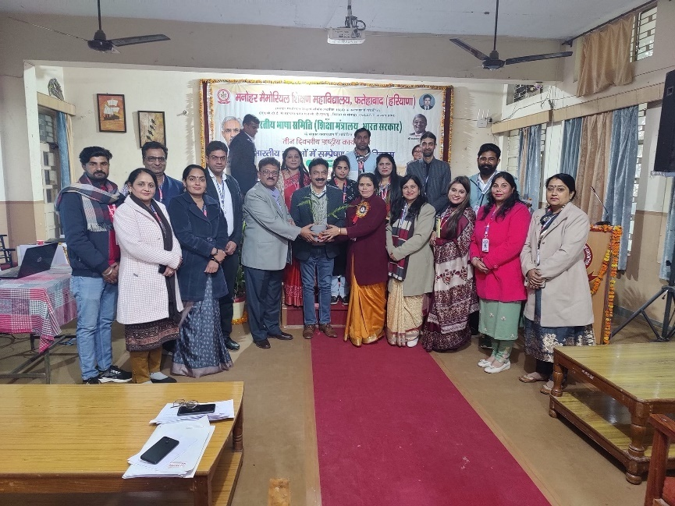

Day 3
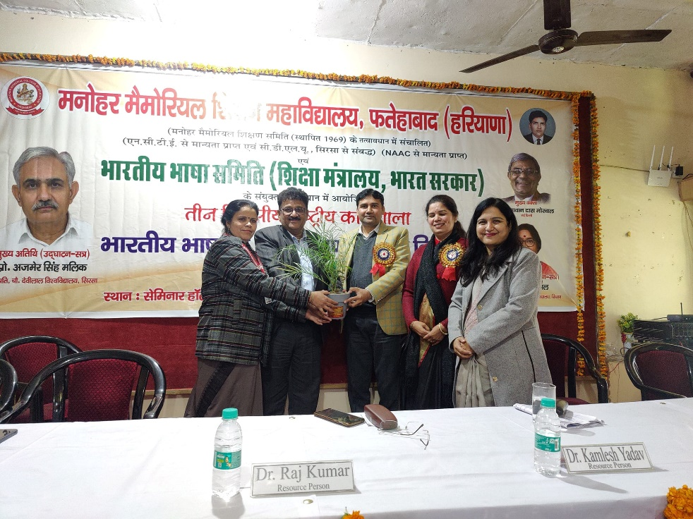
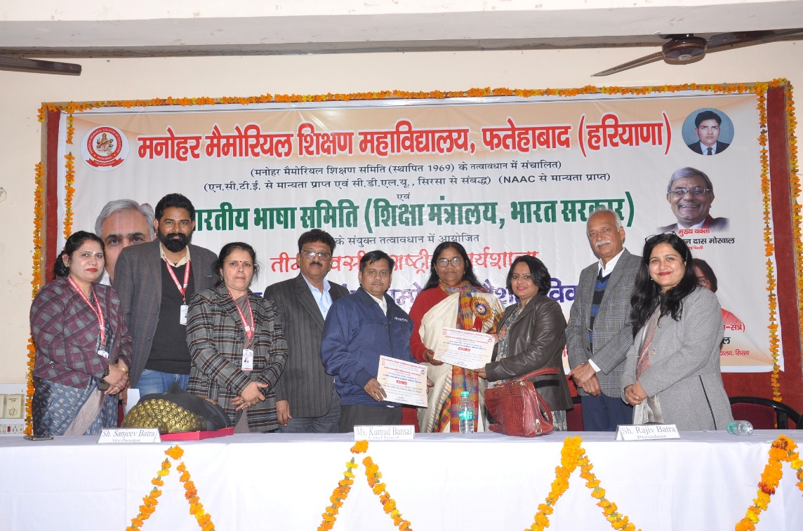
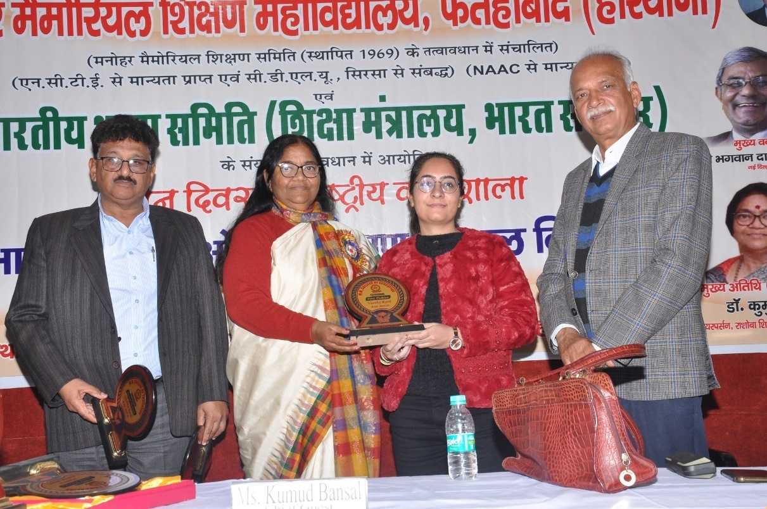
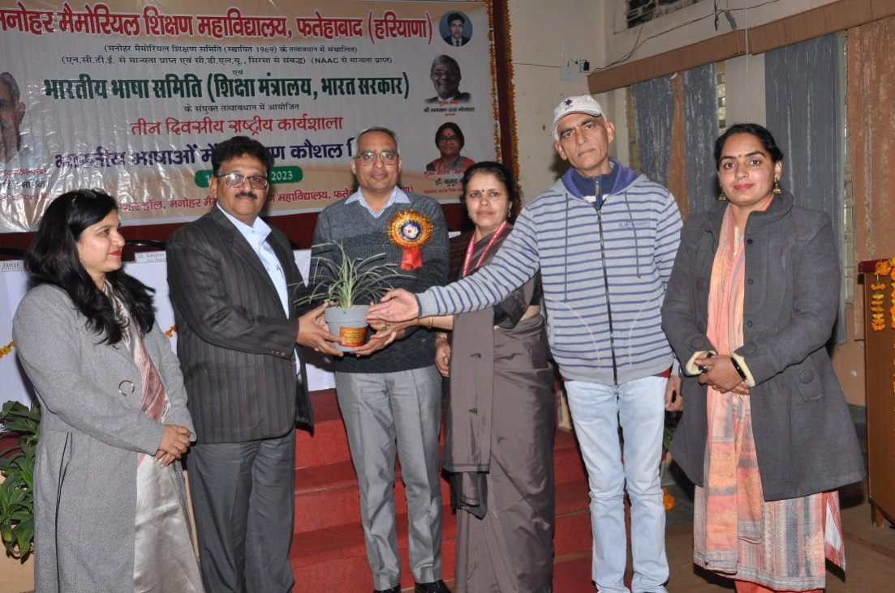

3.4 Workshop on Effective Lesson Planning by
Dr. Vinod Kumar (07.02.2023)

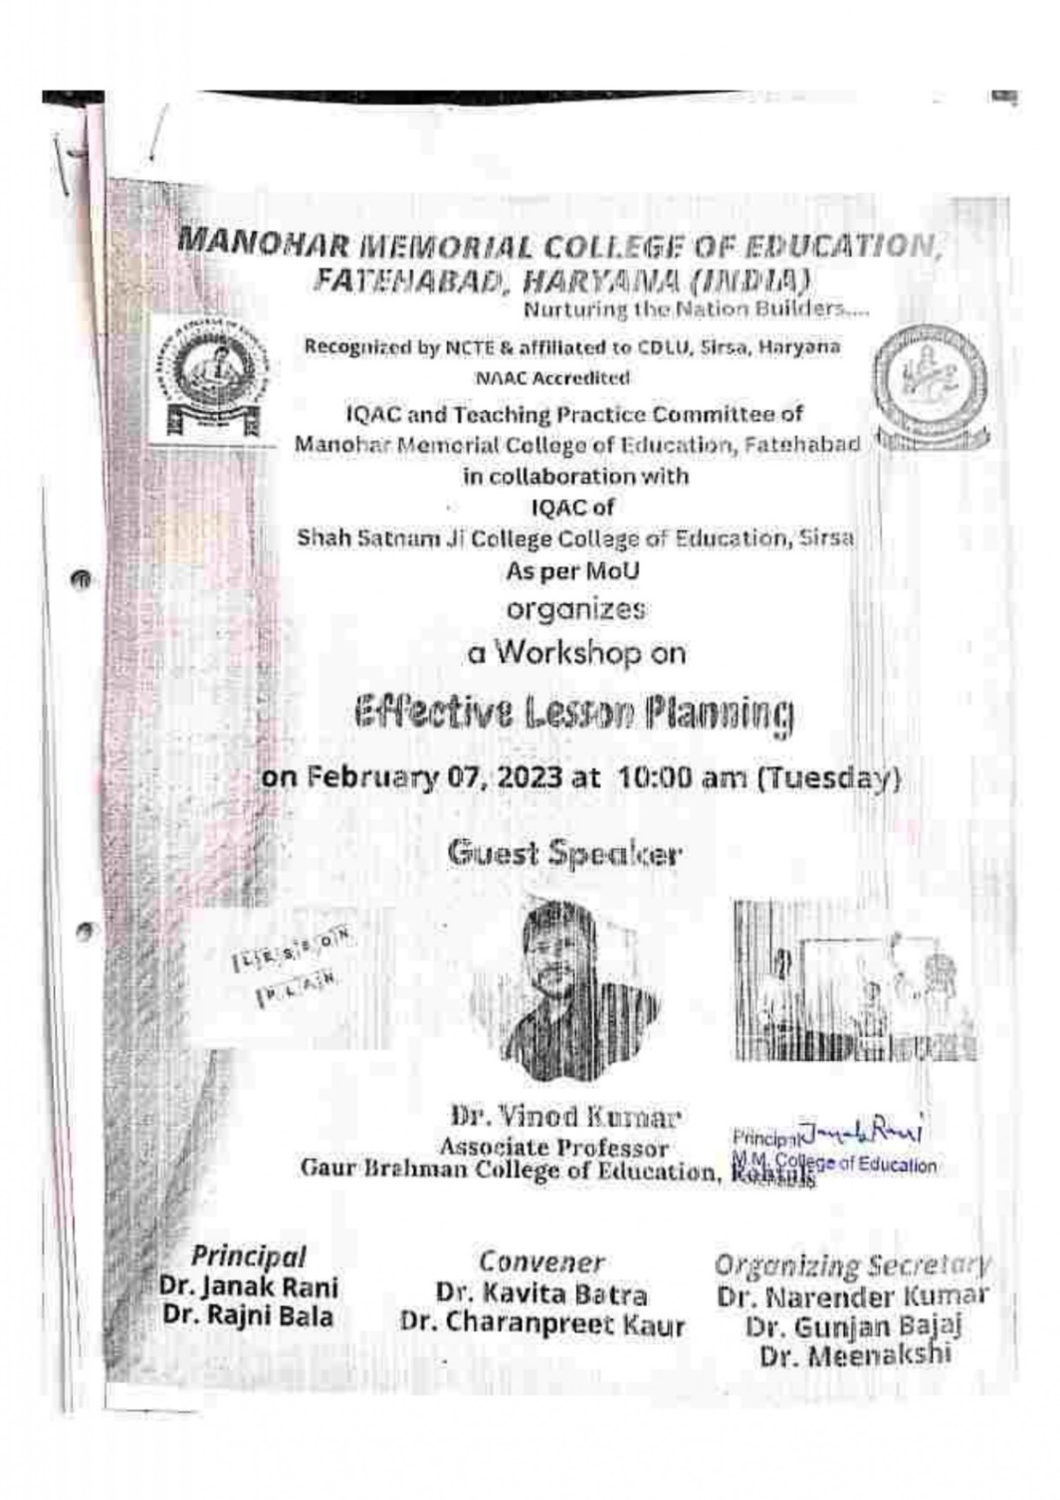

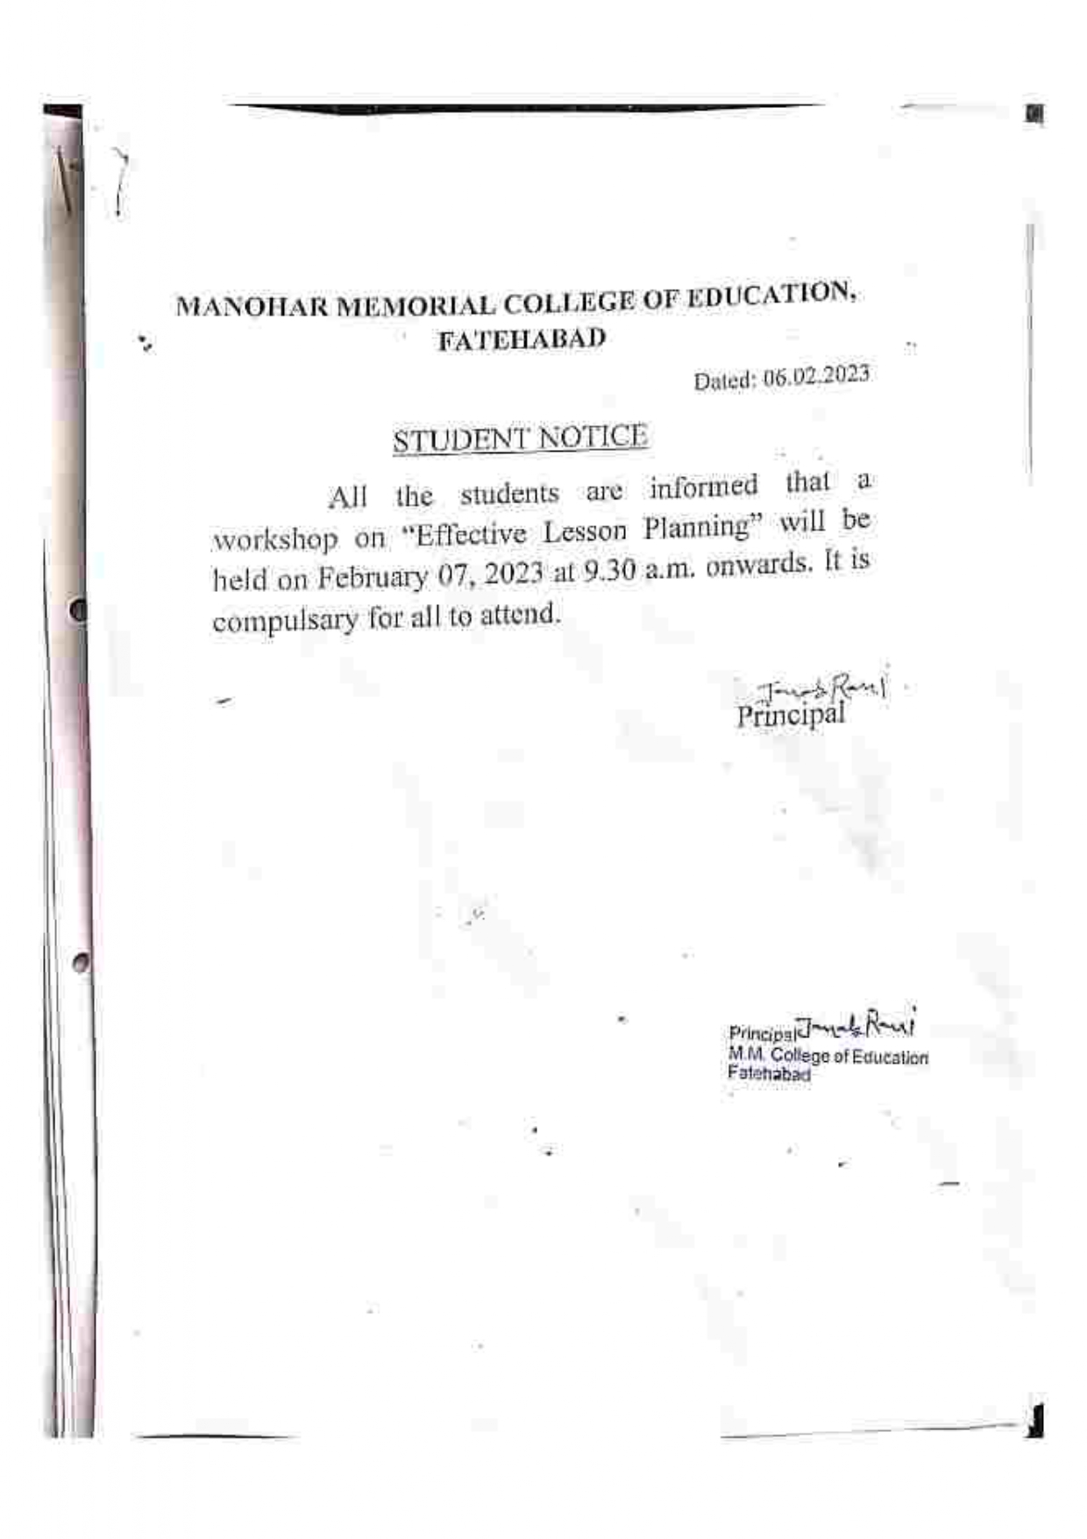
Photos of Workshop on Effective Lesson Planning
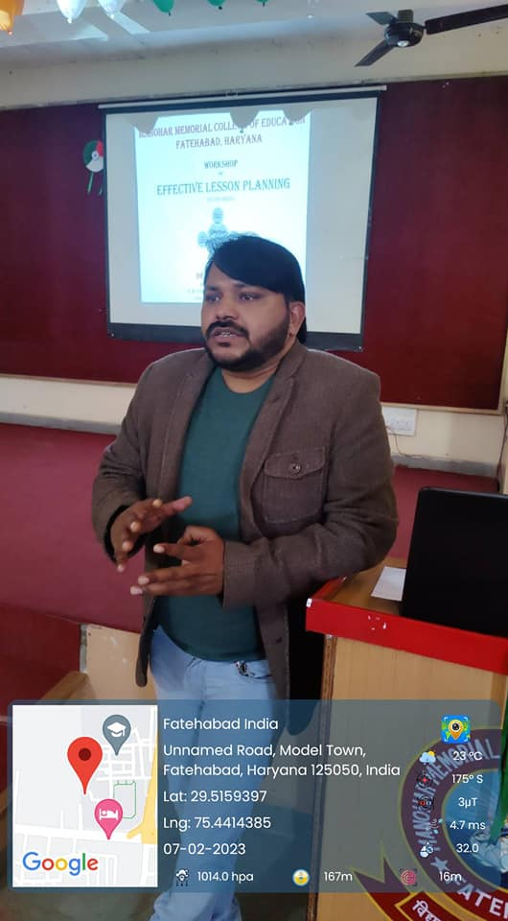
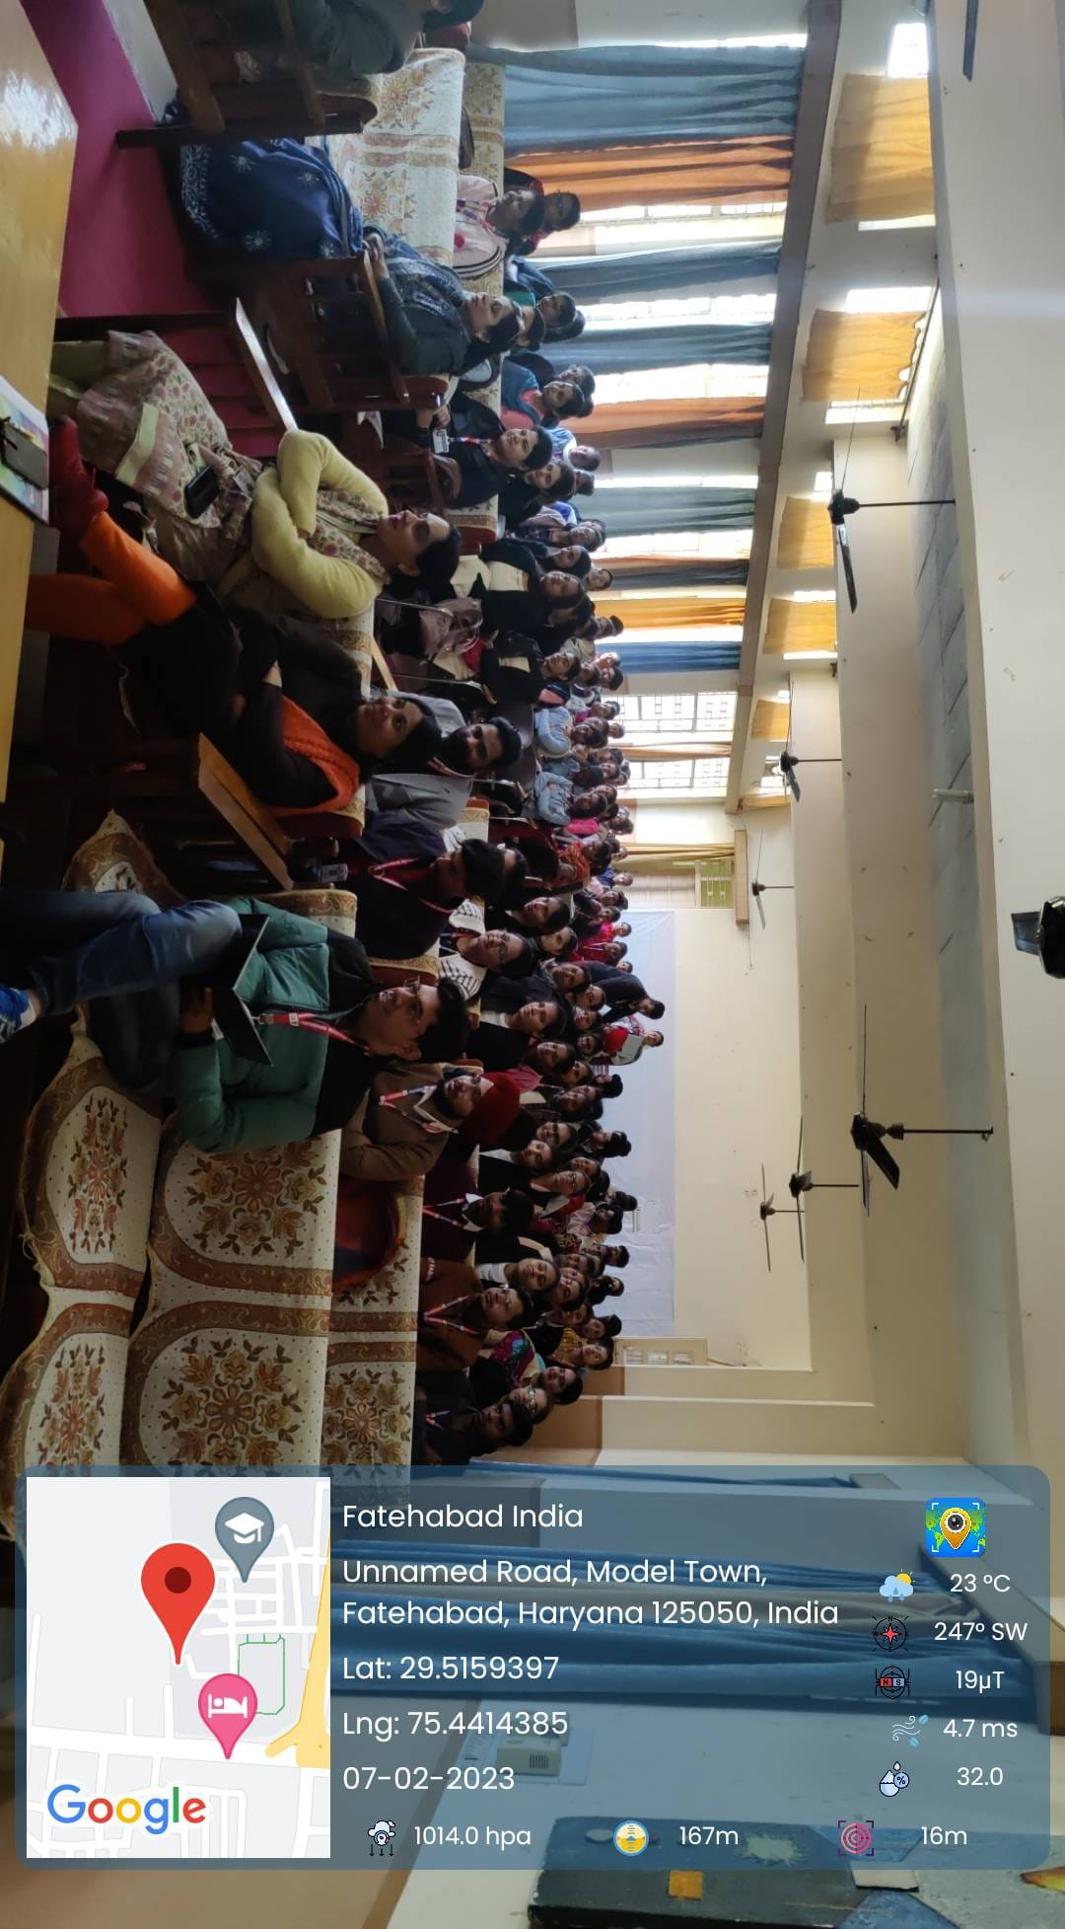
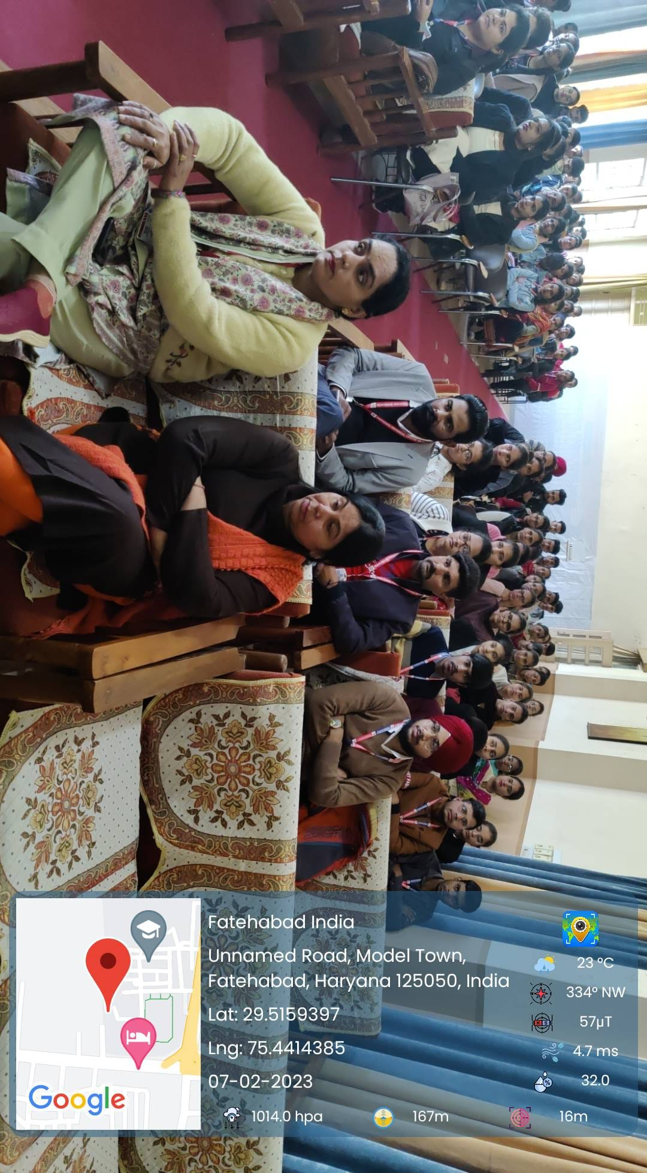

3.5 NAAC Awareness Workshop by
Dr. Kiran Lata(20.02.2023 to 21.02.2023)

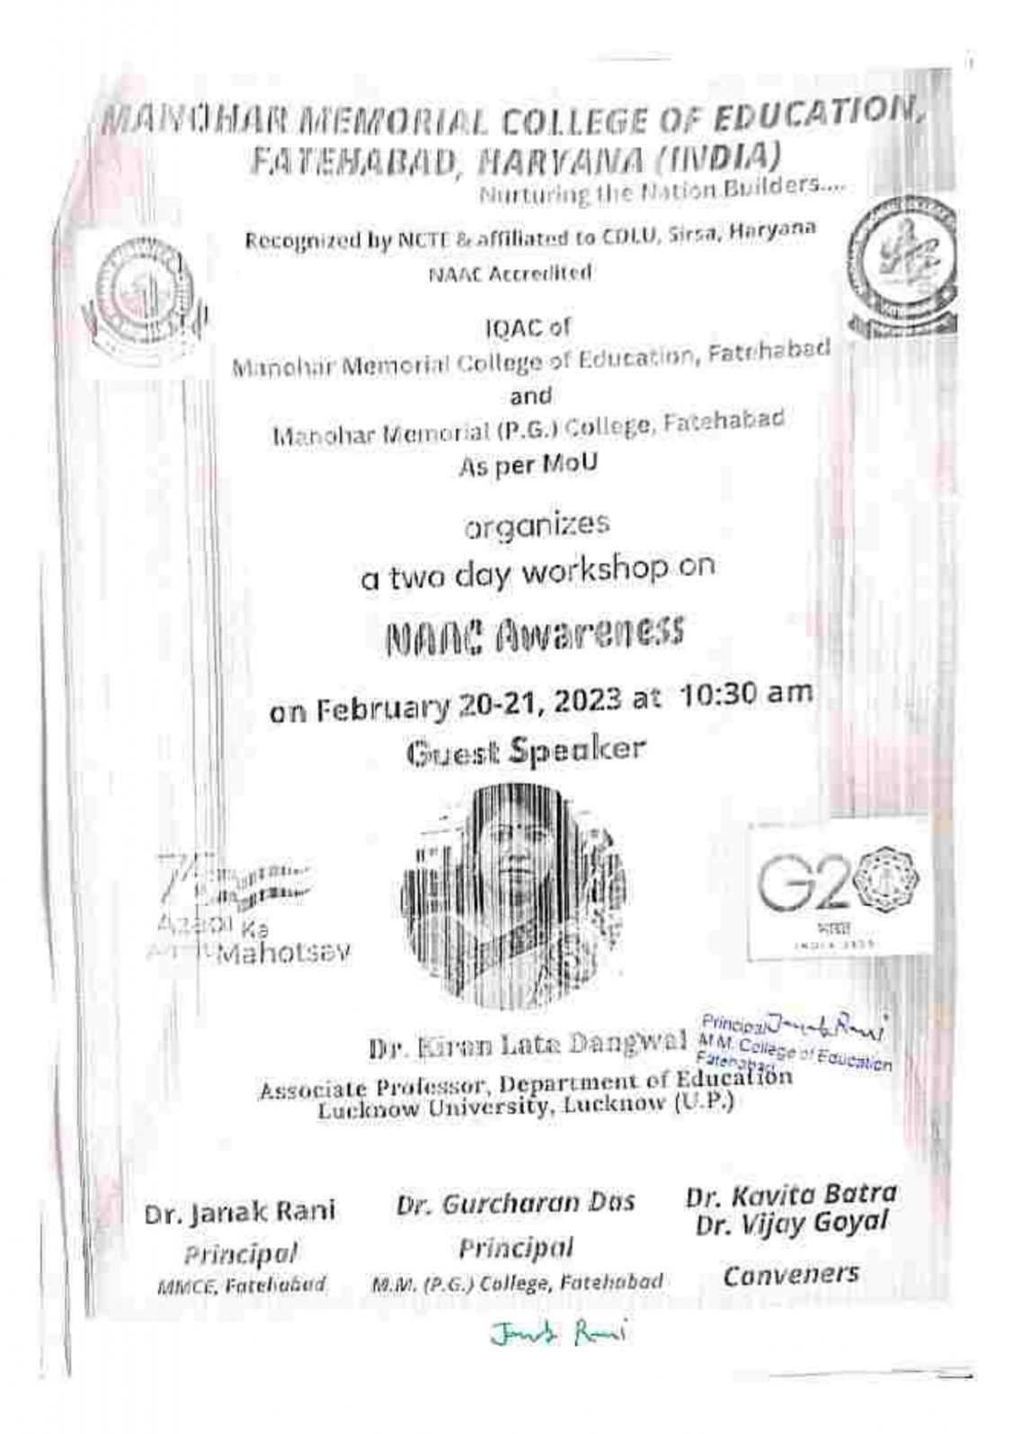

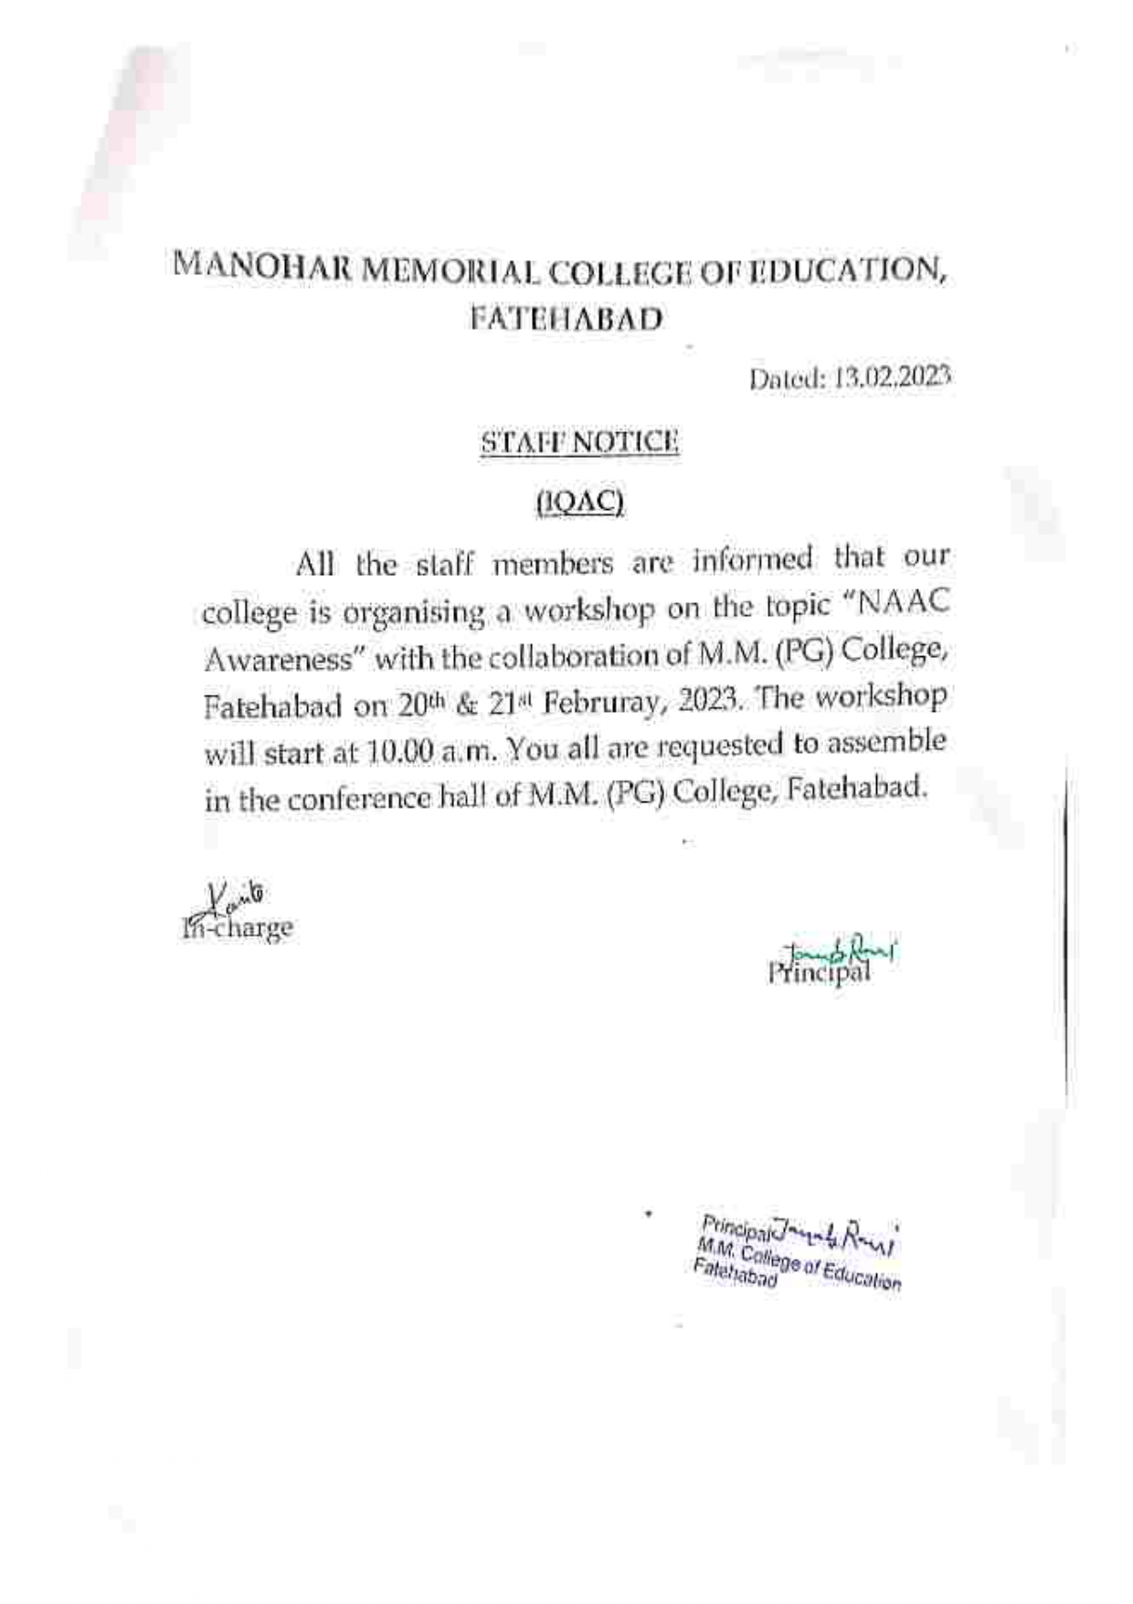

Photos of NAAC Awareness Workshop

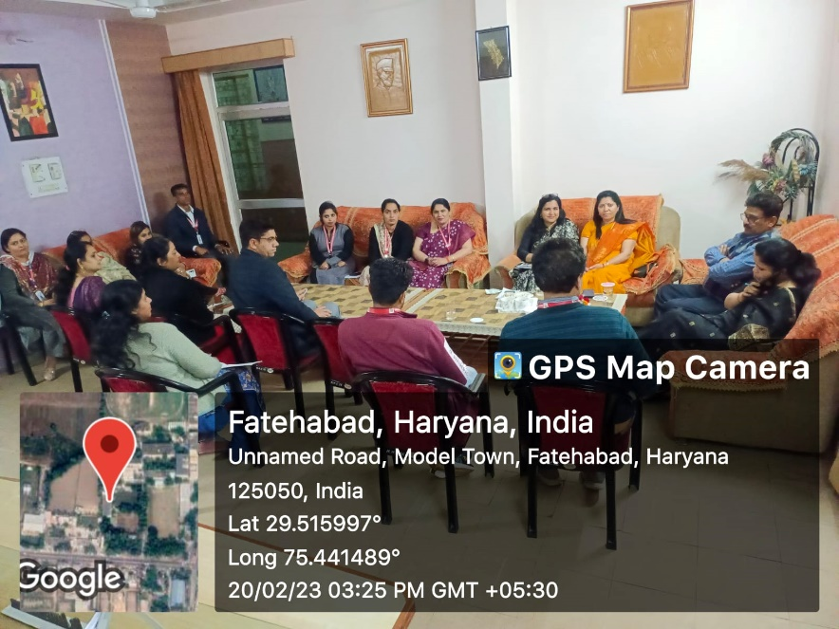
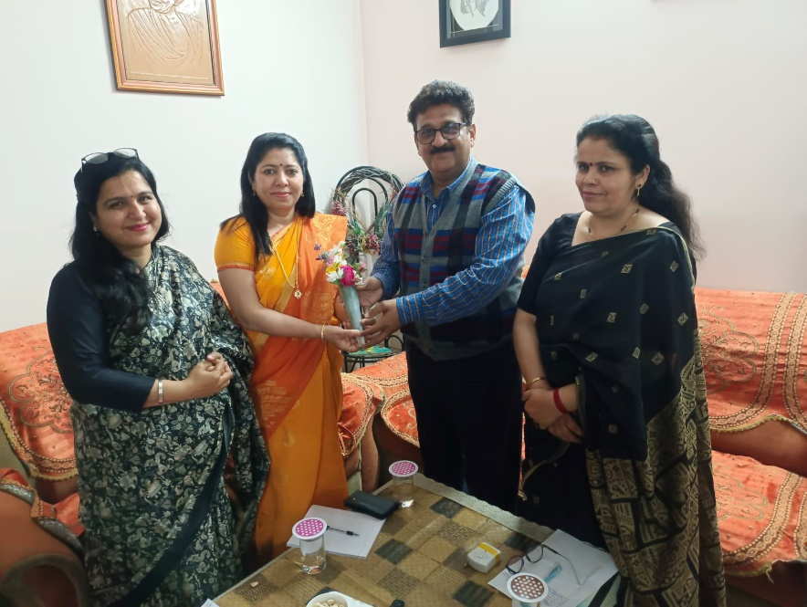

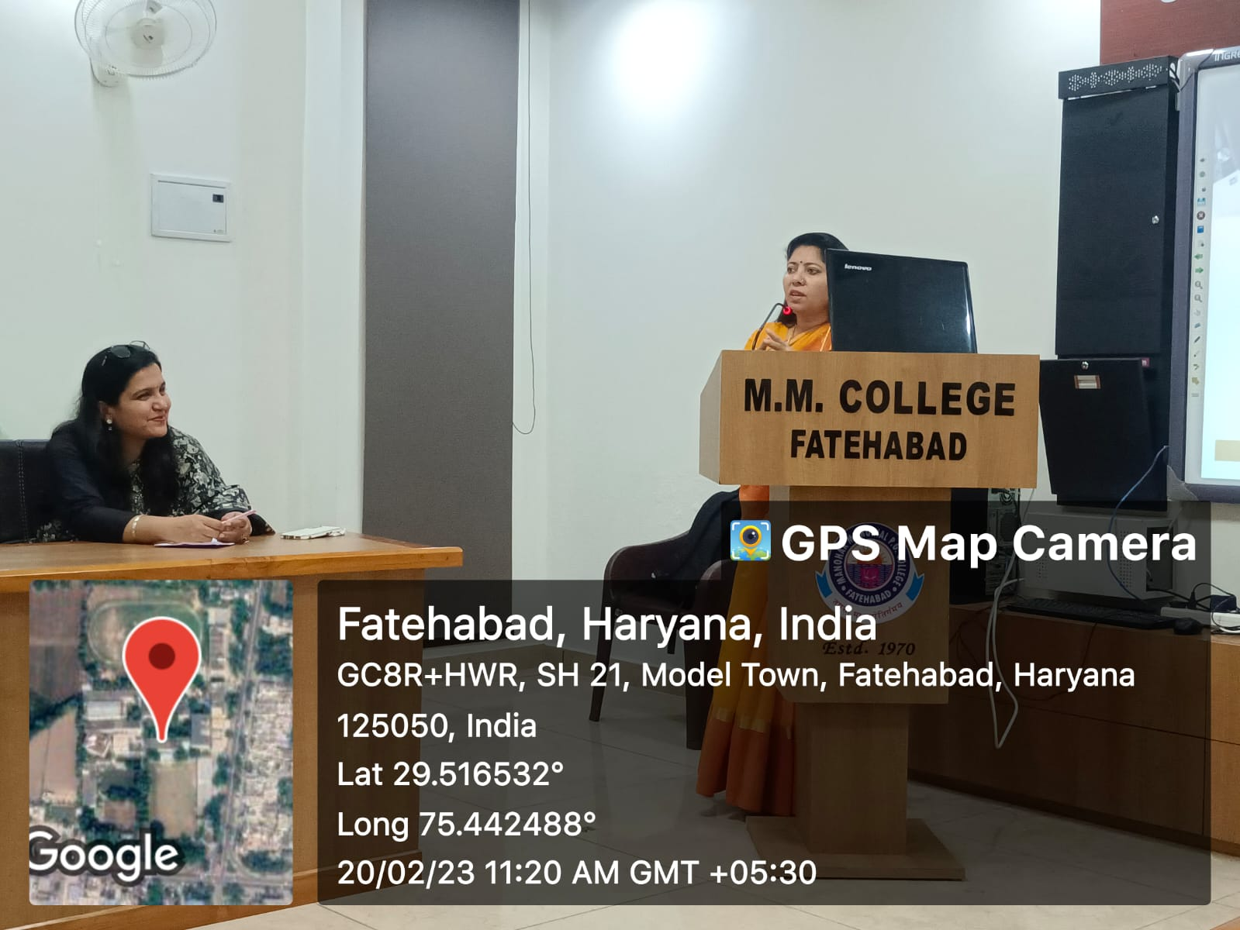

3.6Two Days Workshop on Interview Skillsby
Mrs. Nivedita(14.03.2023 to 15.03.2023)

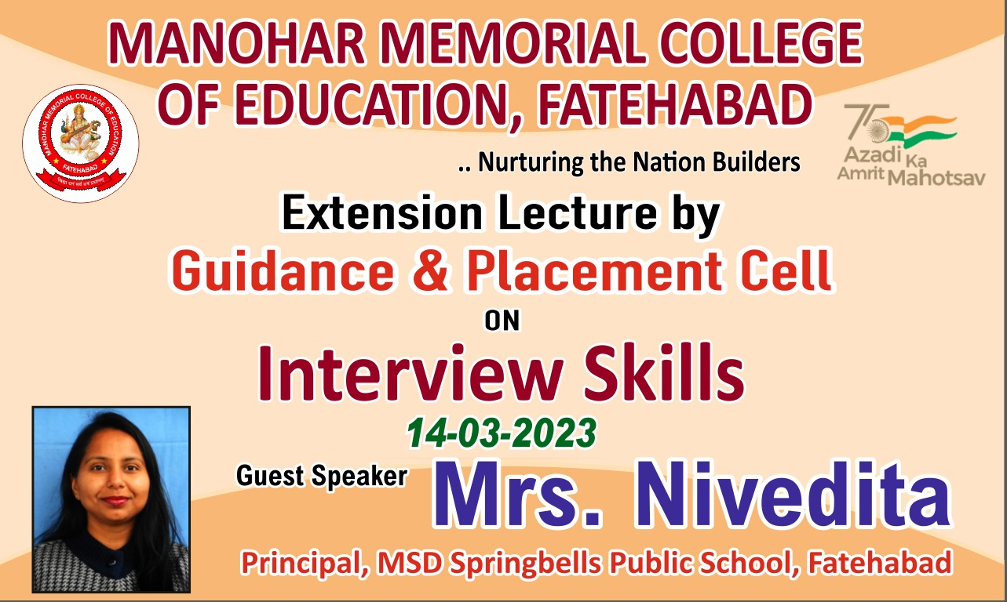

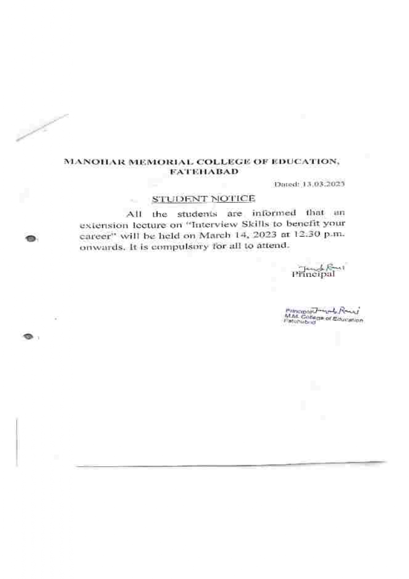
Photos of Workshop on Interview Skills 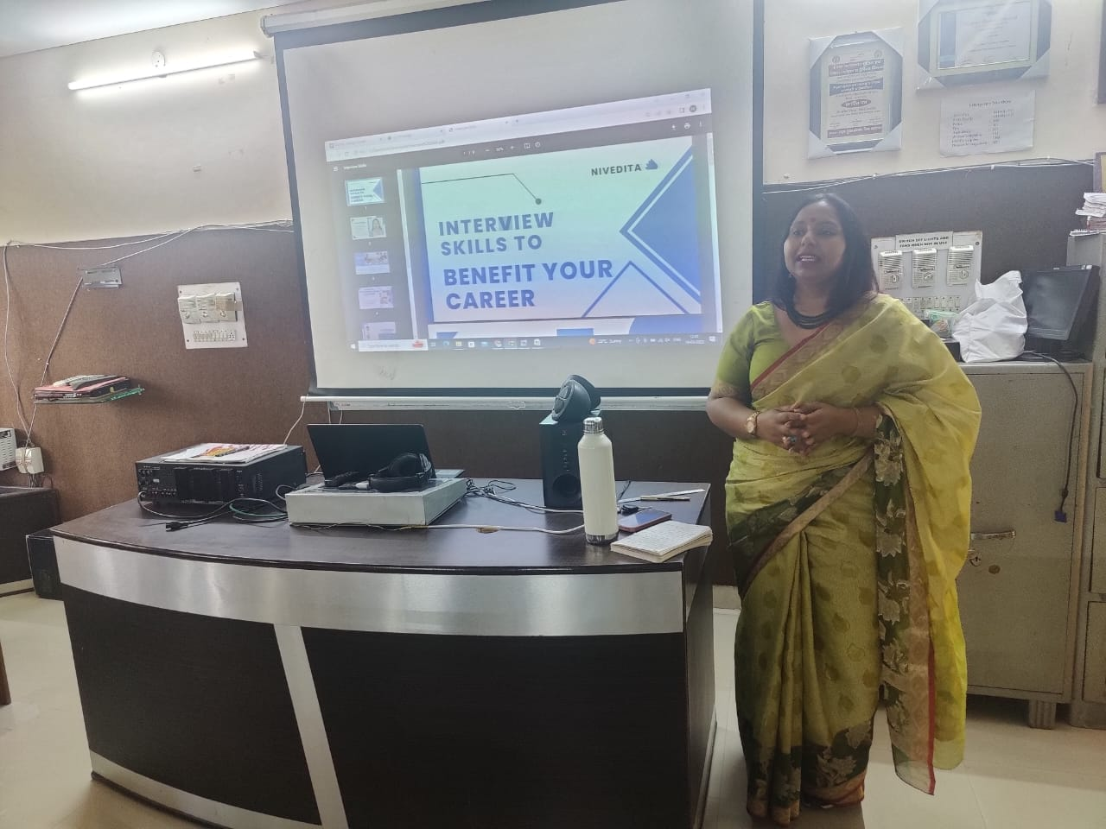
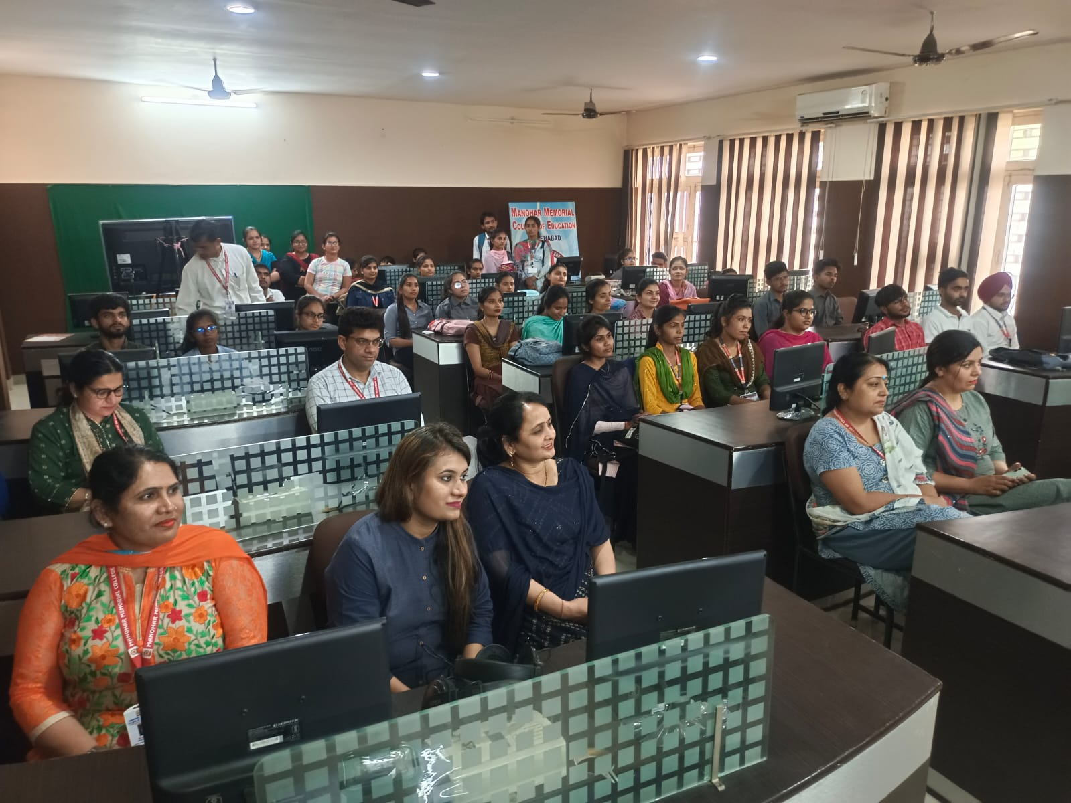

3.7(a) Workshop on Effective Communication by
Dr. Suman Chabra(27.04.2023)

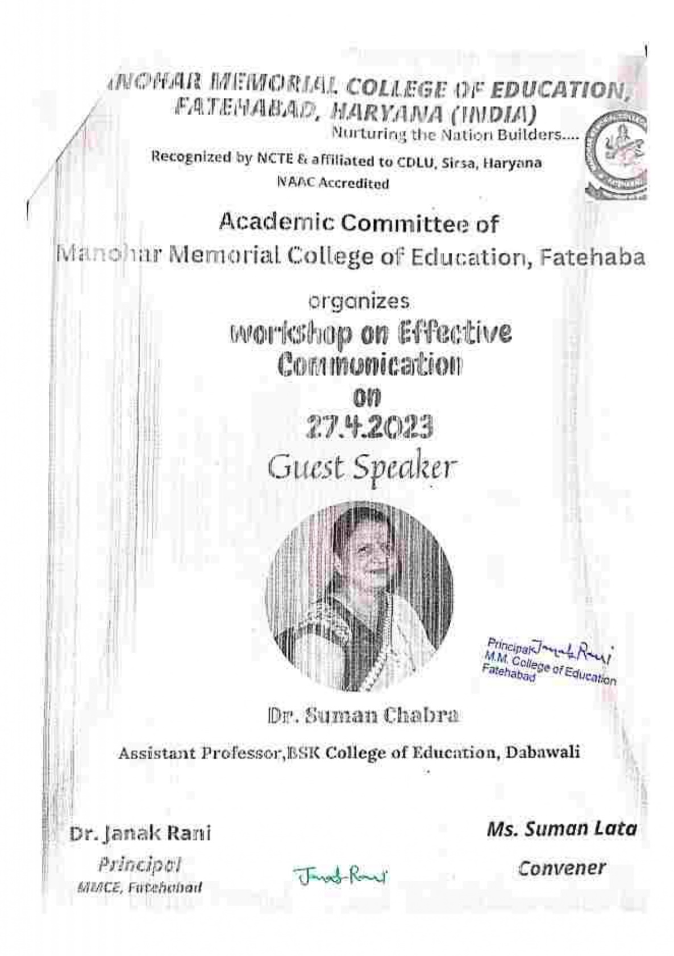
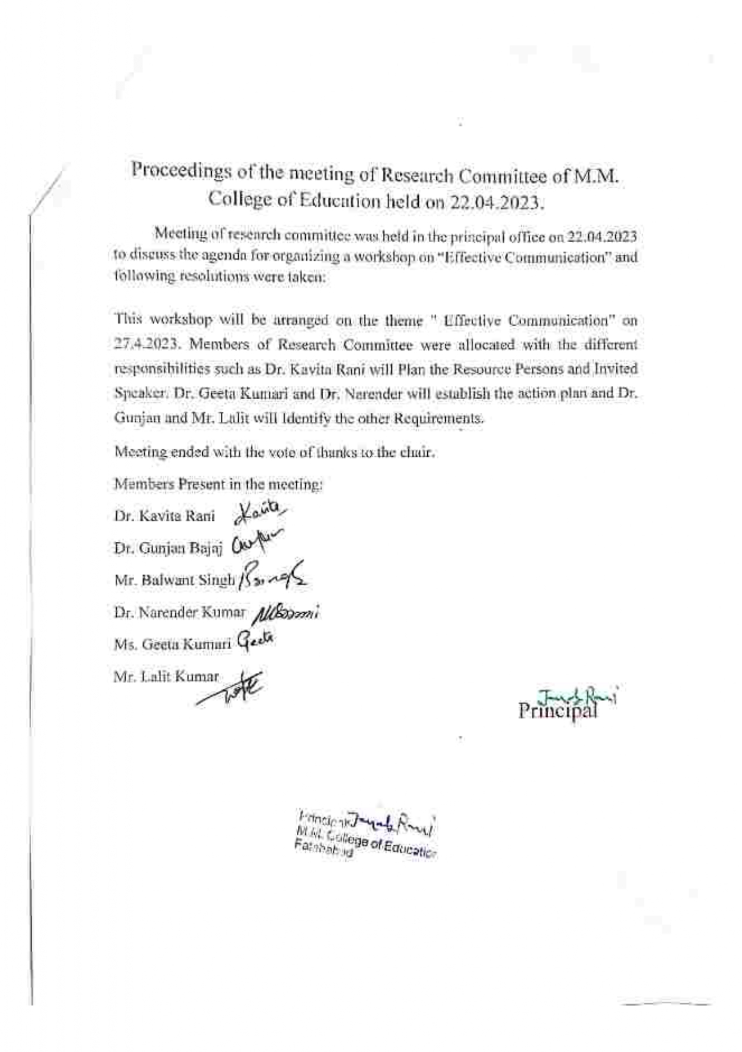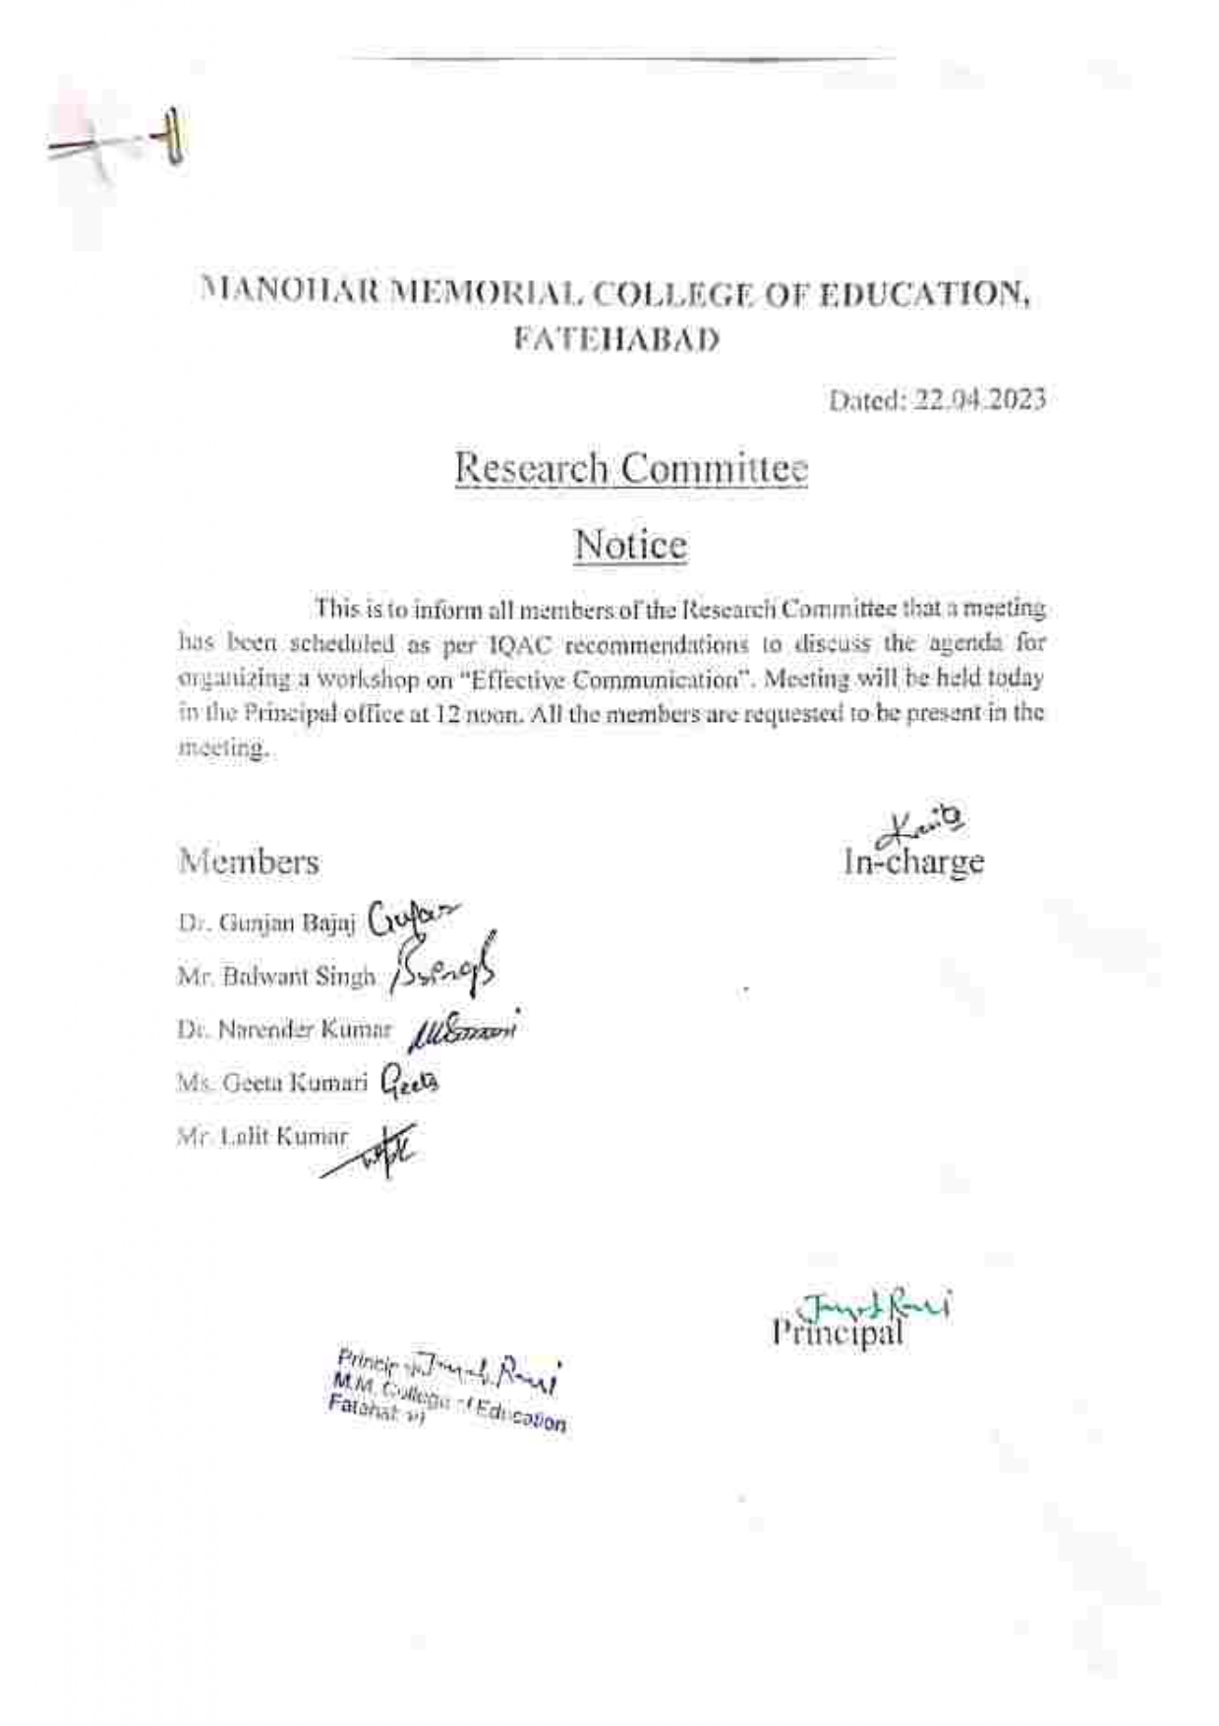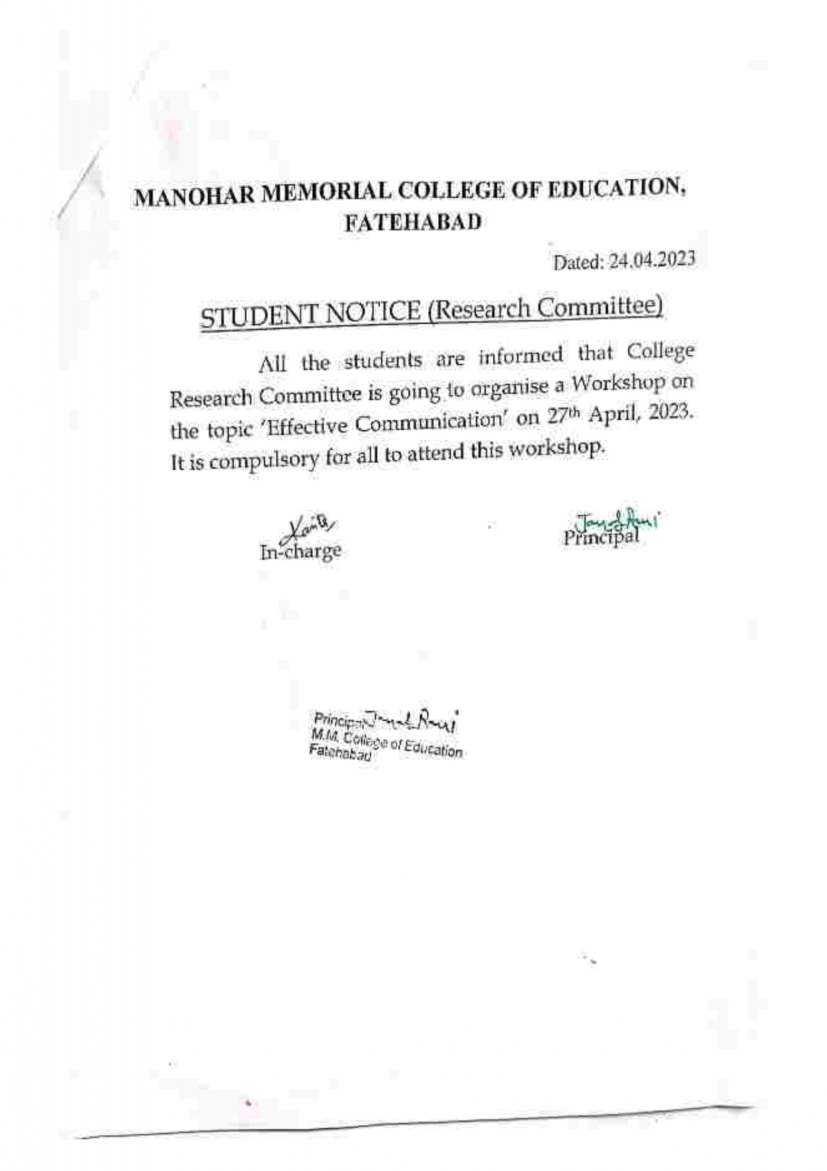

3.7(b) Workshop on Physical Fitness by
Dr.Narender Kumar (27.04.2023)
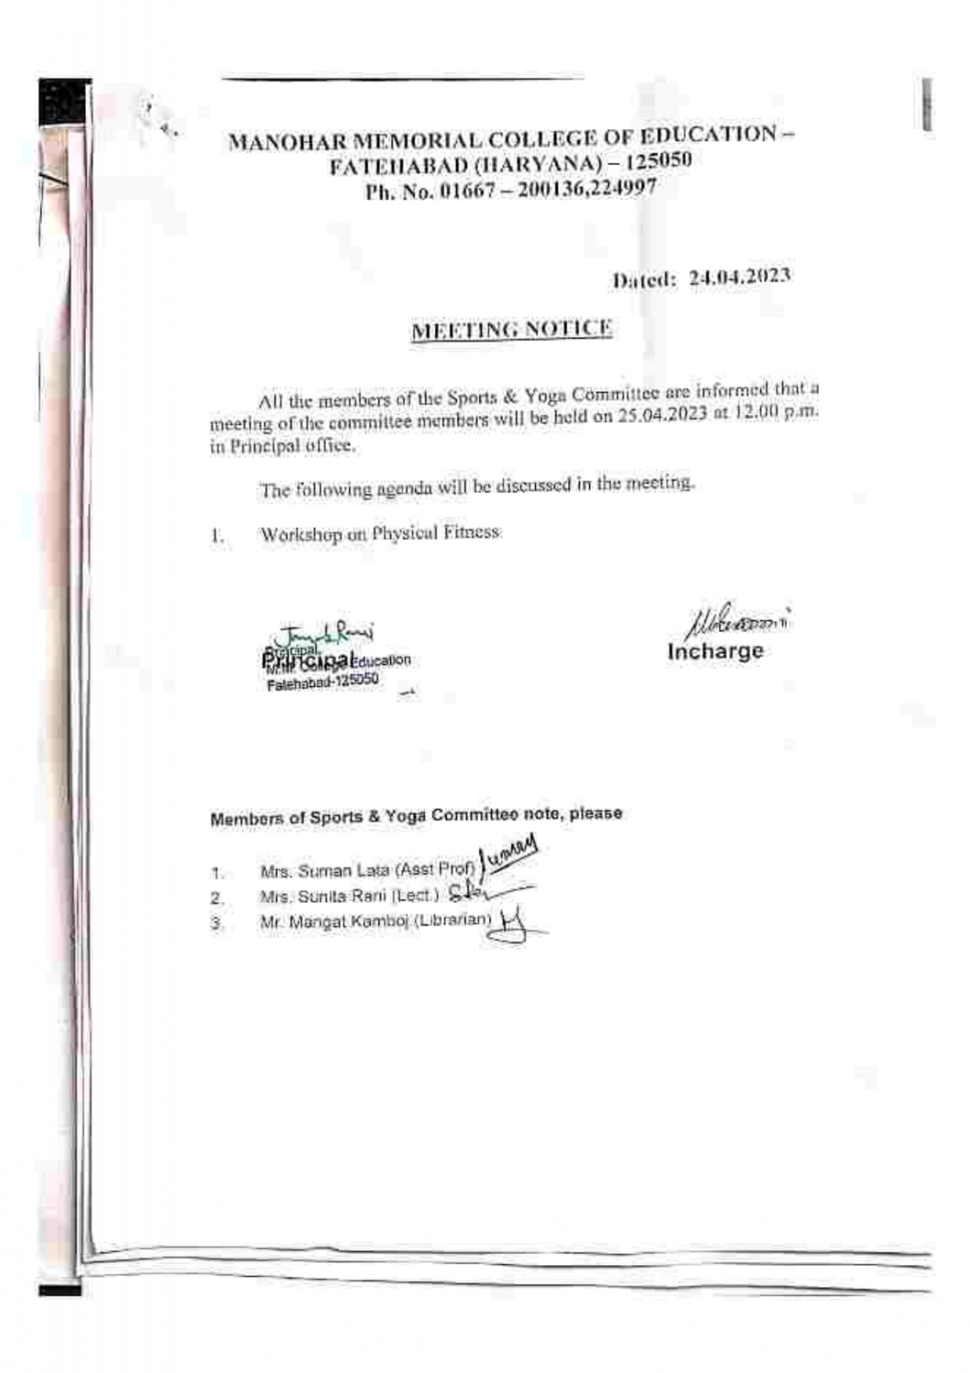

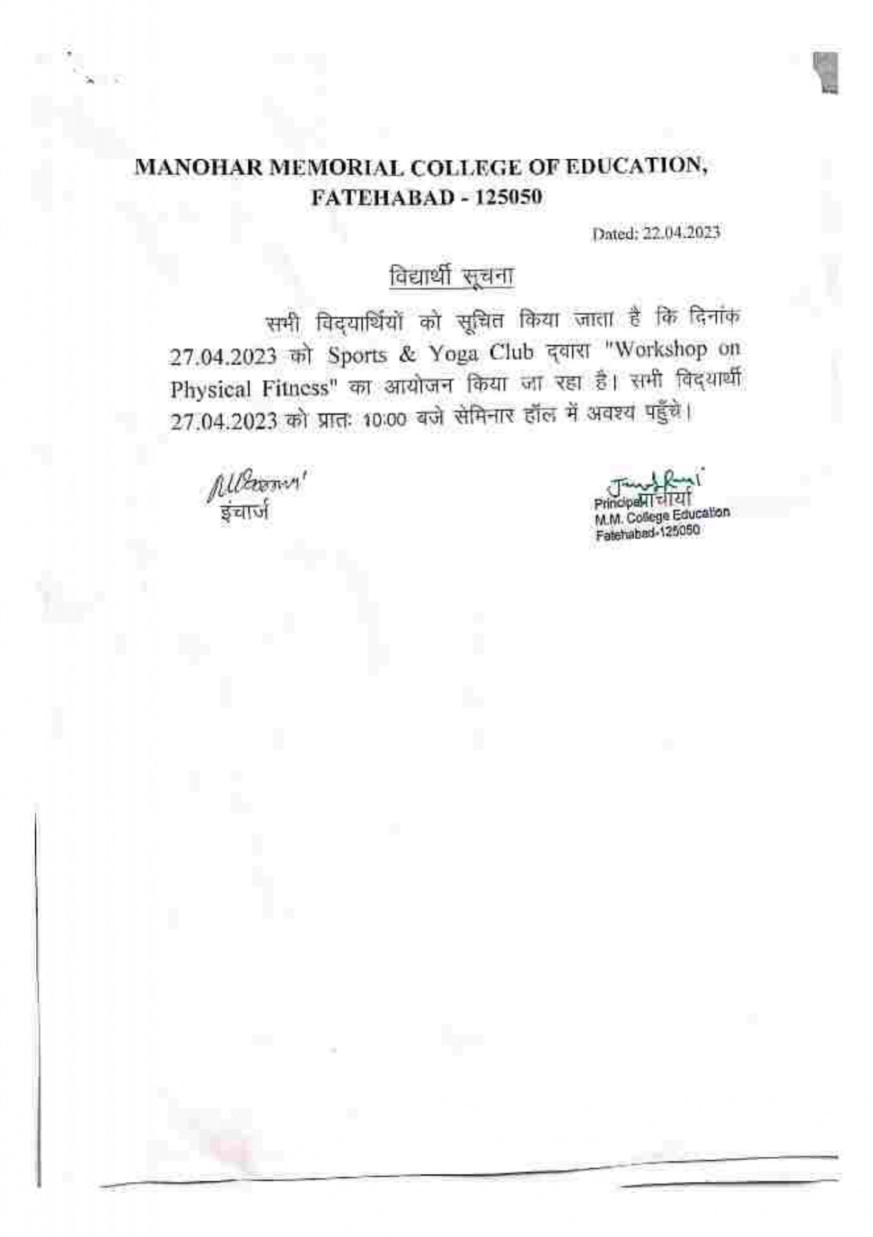

Photos of Workshop on Physical Fitness
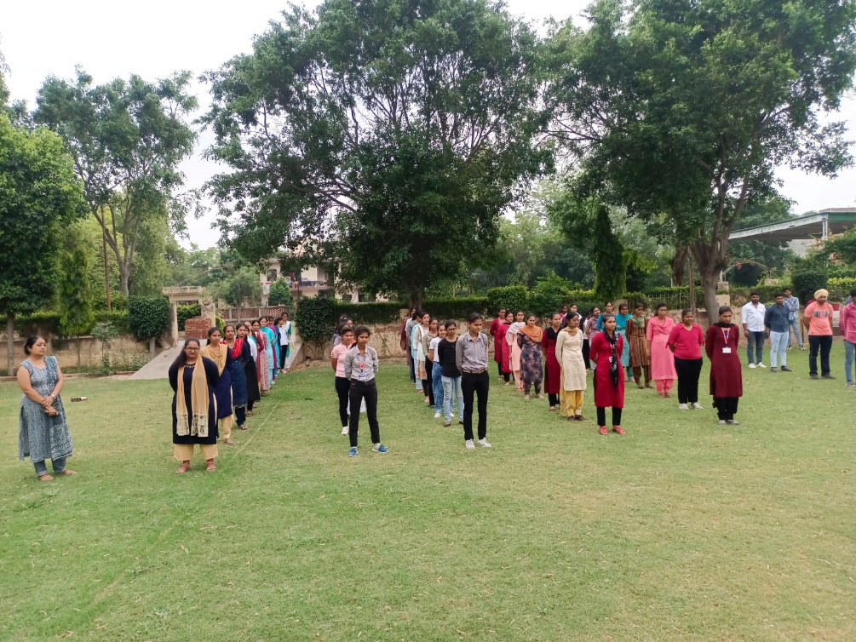

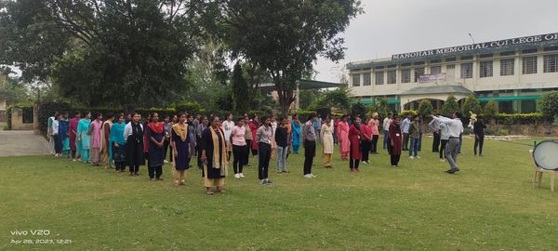
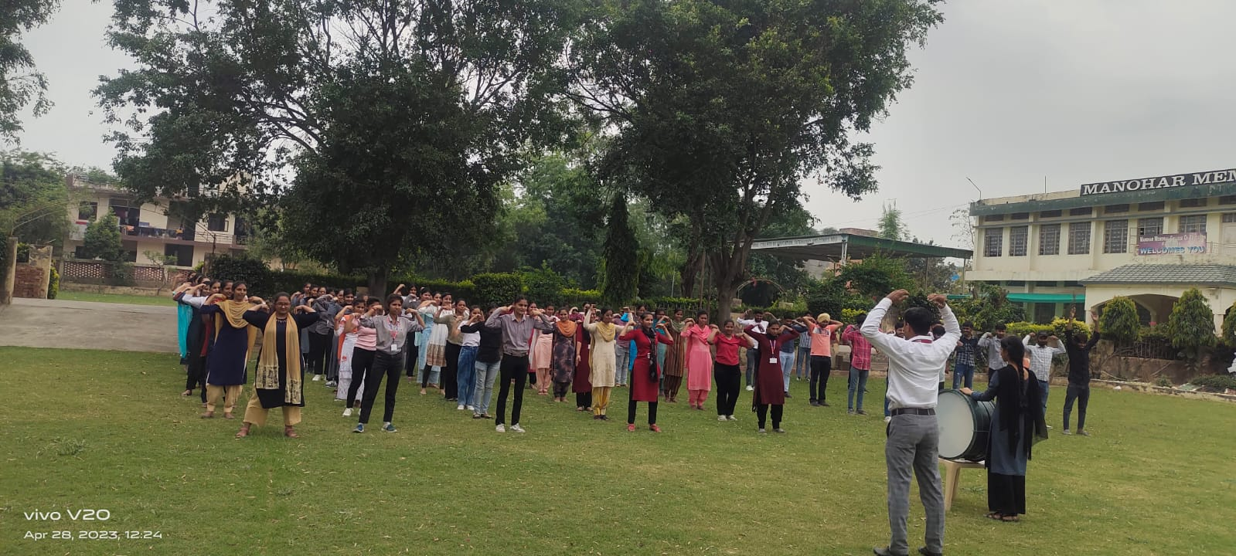

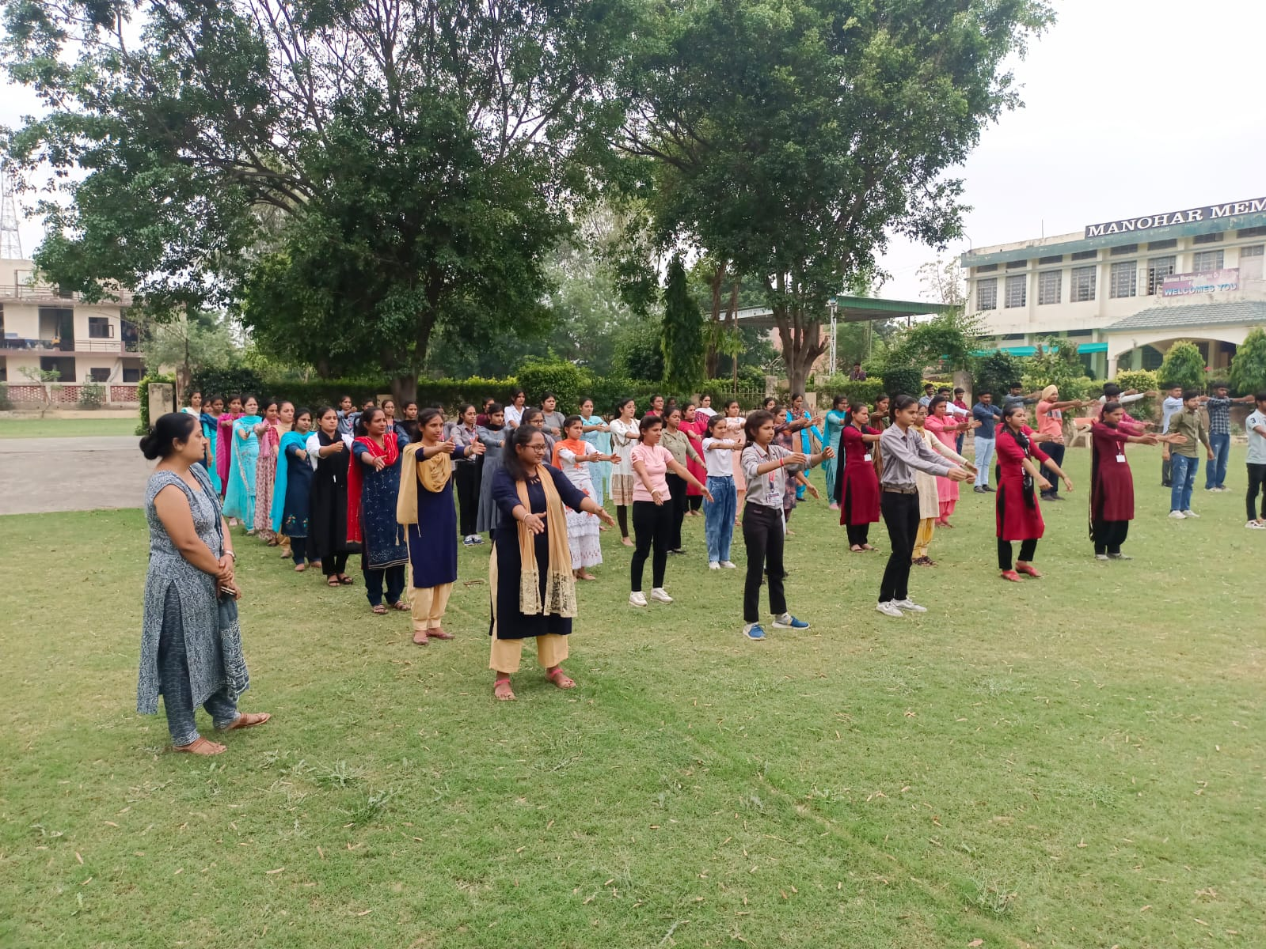

3.8 Awareness Lecture on Environment Day by
Ms. Amanpreetkaur& Ms. Sunita Rani (05.06.2023)
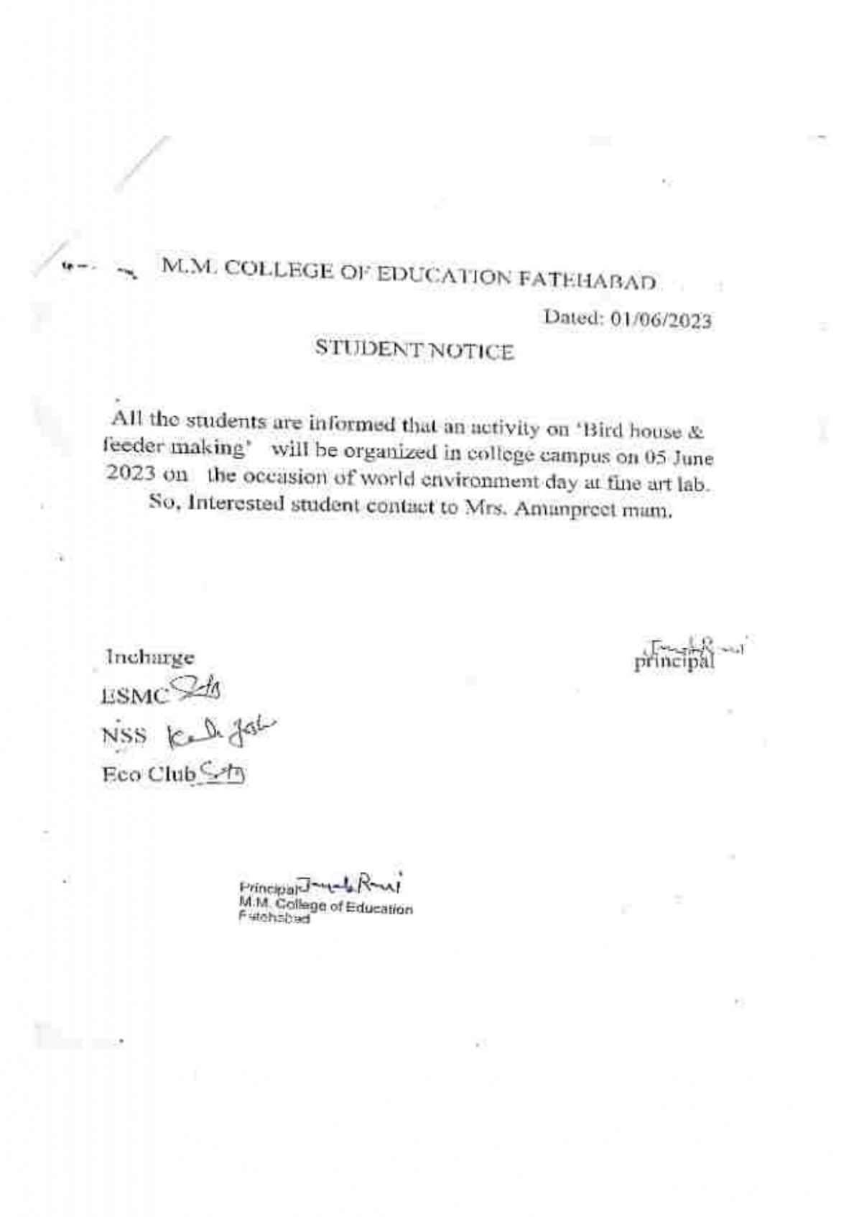

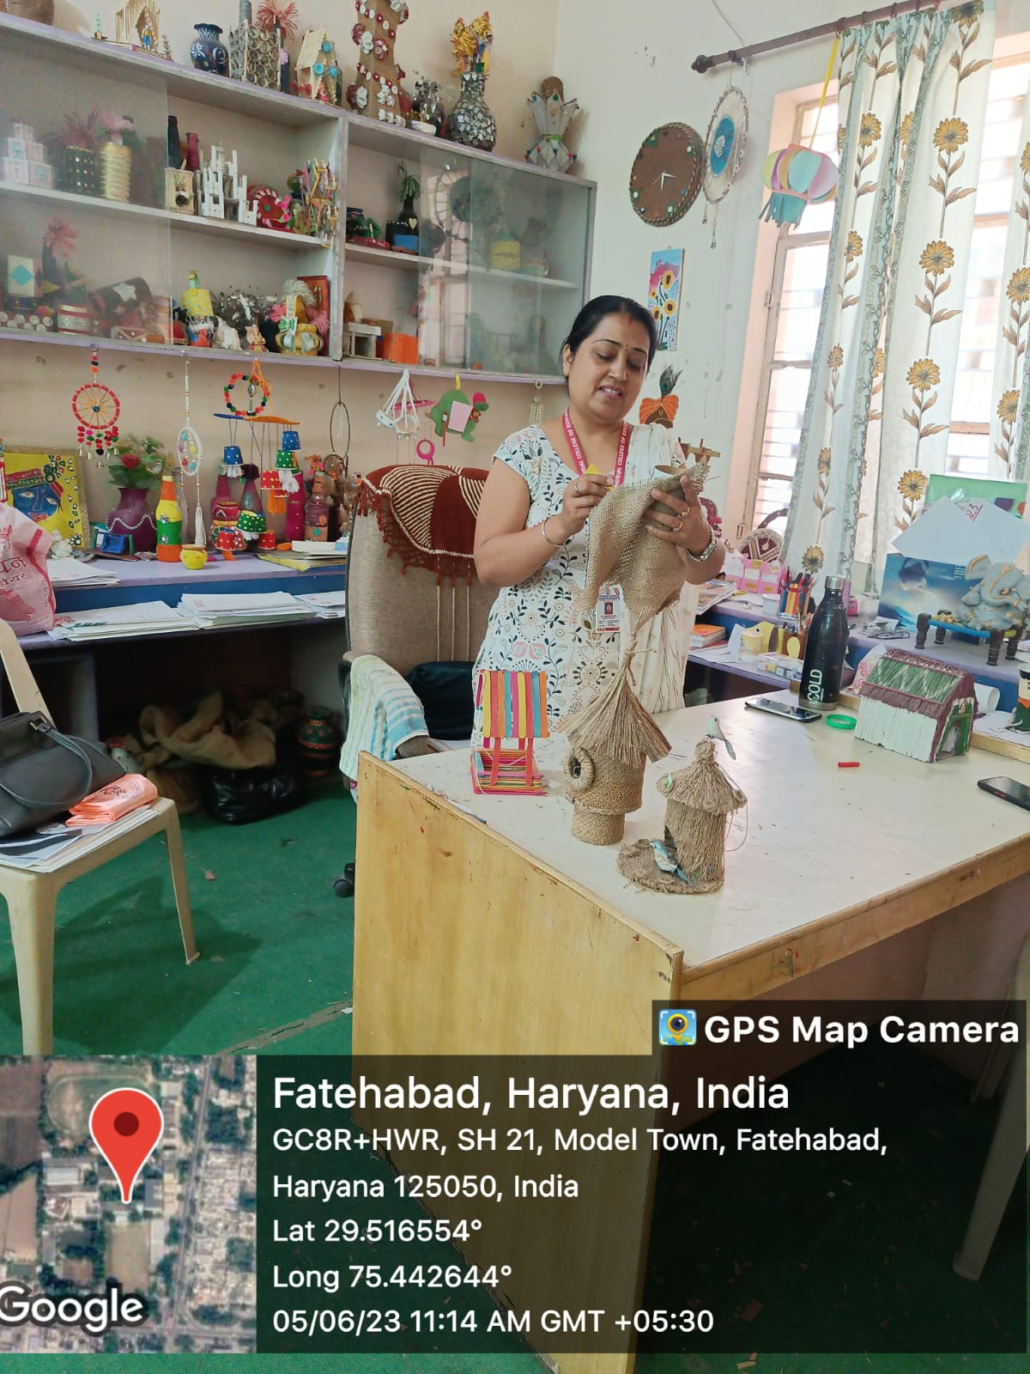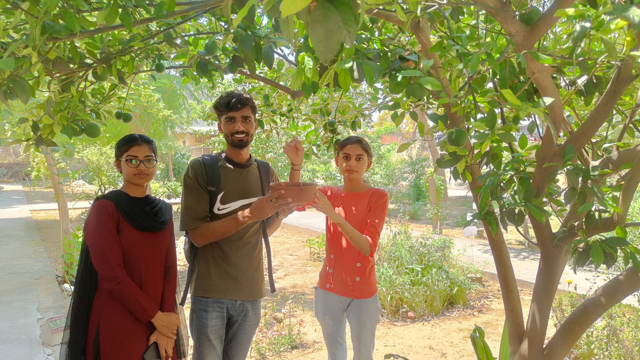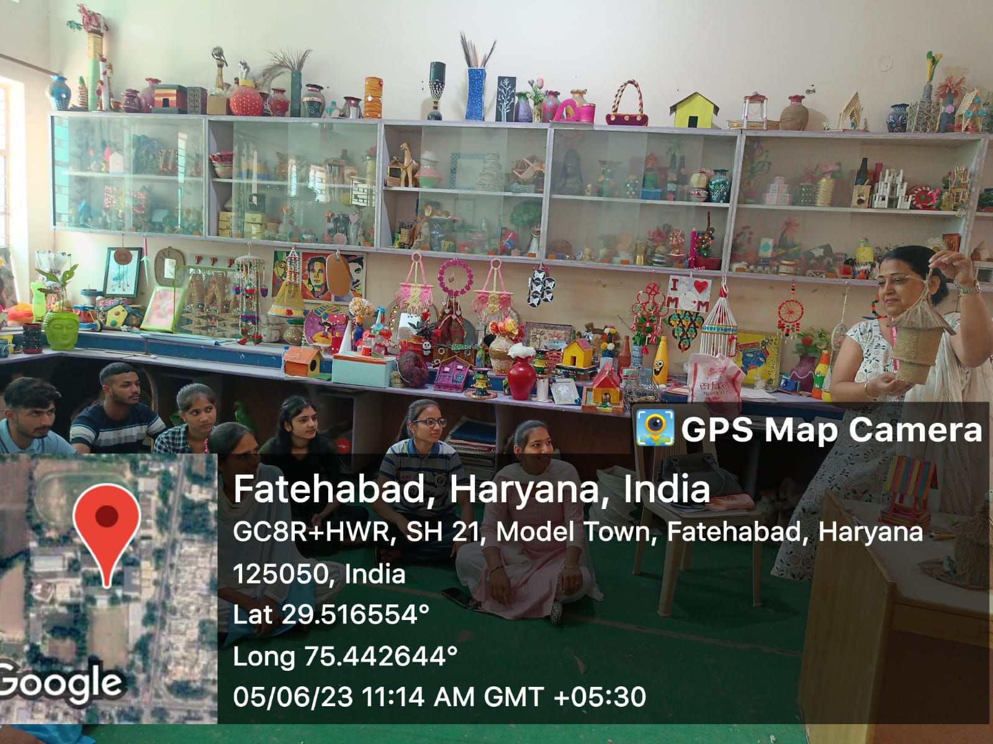

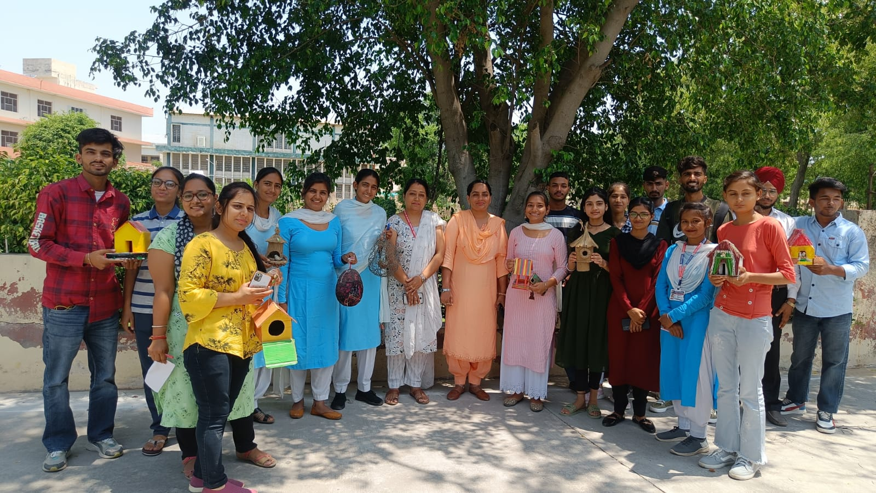

- Teacher Presented seminars for benefit of Teachers & Students

4.1 Webinar on Revolutionizing Education Exploring the power of ICT in the classroom by
Dr. Kiran Lata(11.05.2023)

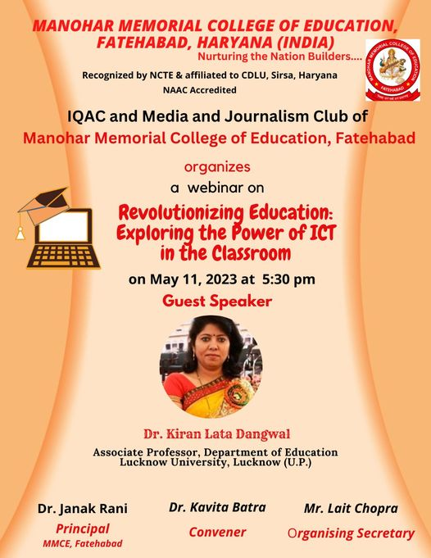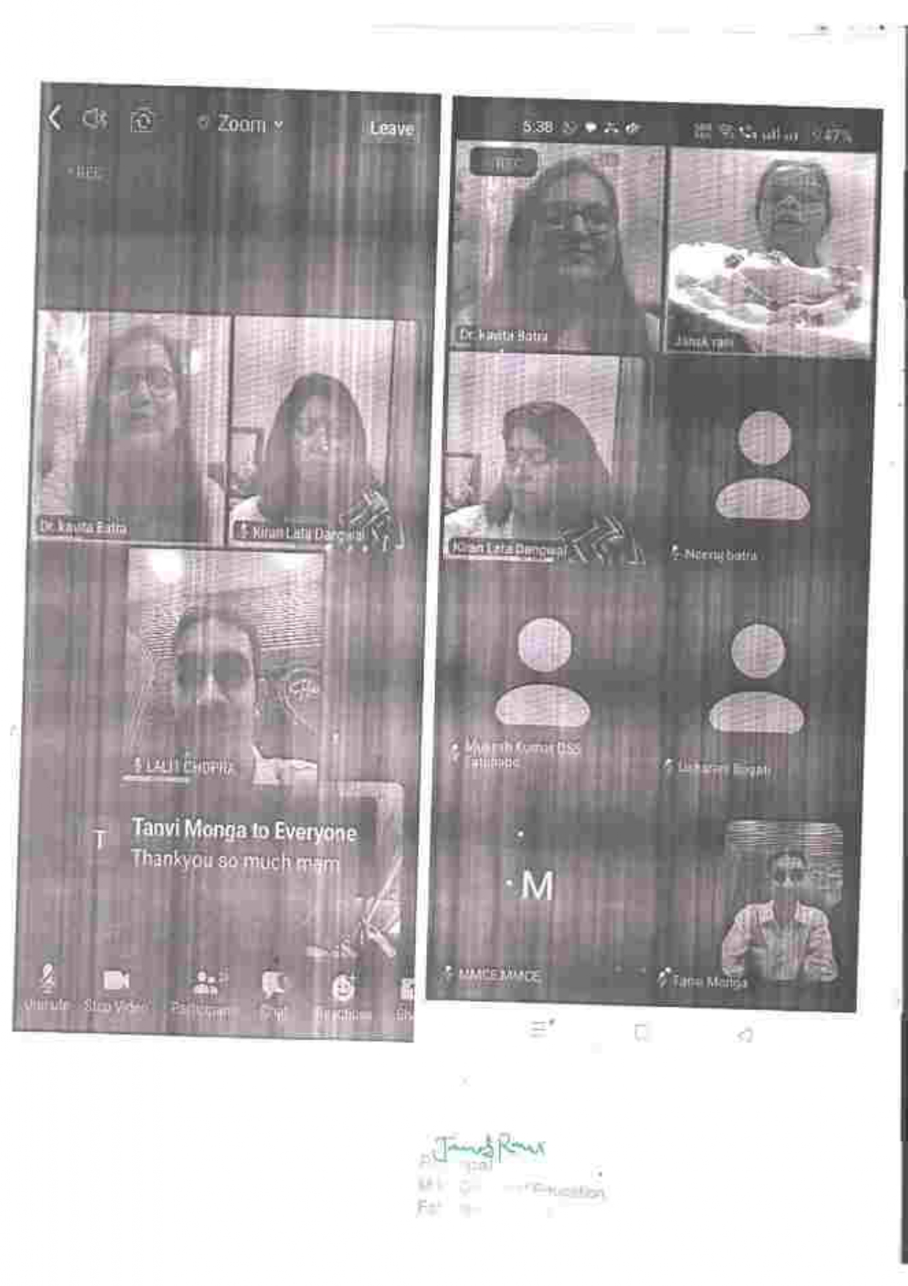
4.2 International Webinar on assessment & an open practice for disposable to renewable assessment by
Dr.Jako Olivier (18.05.2023)

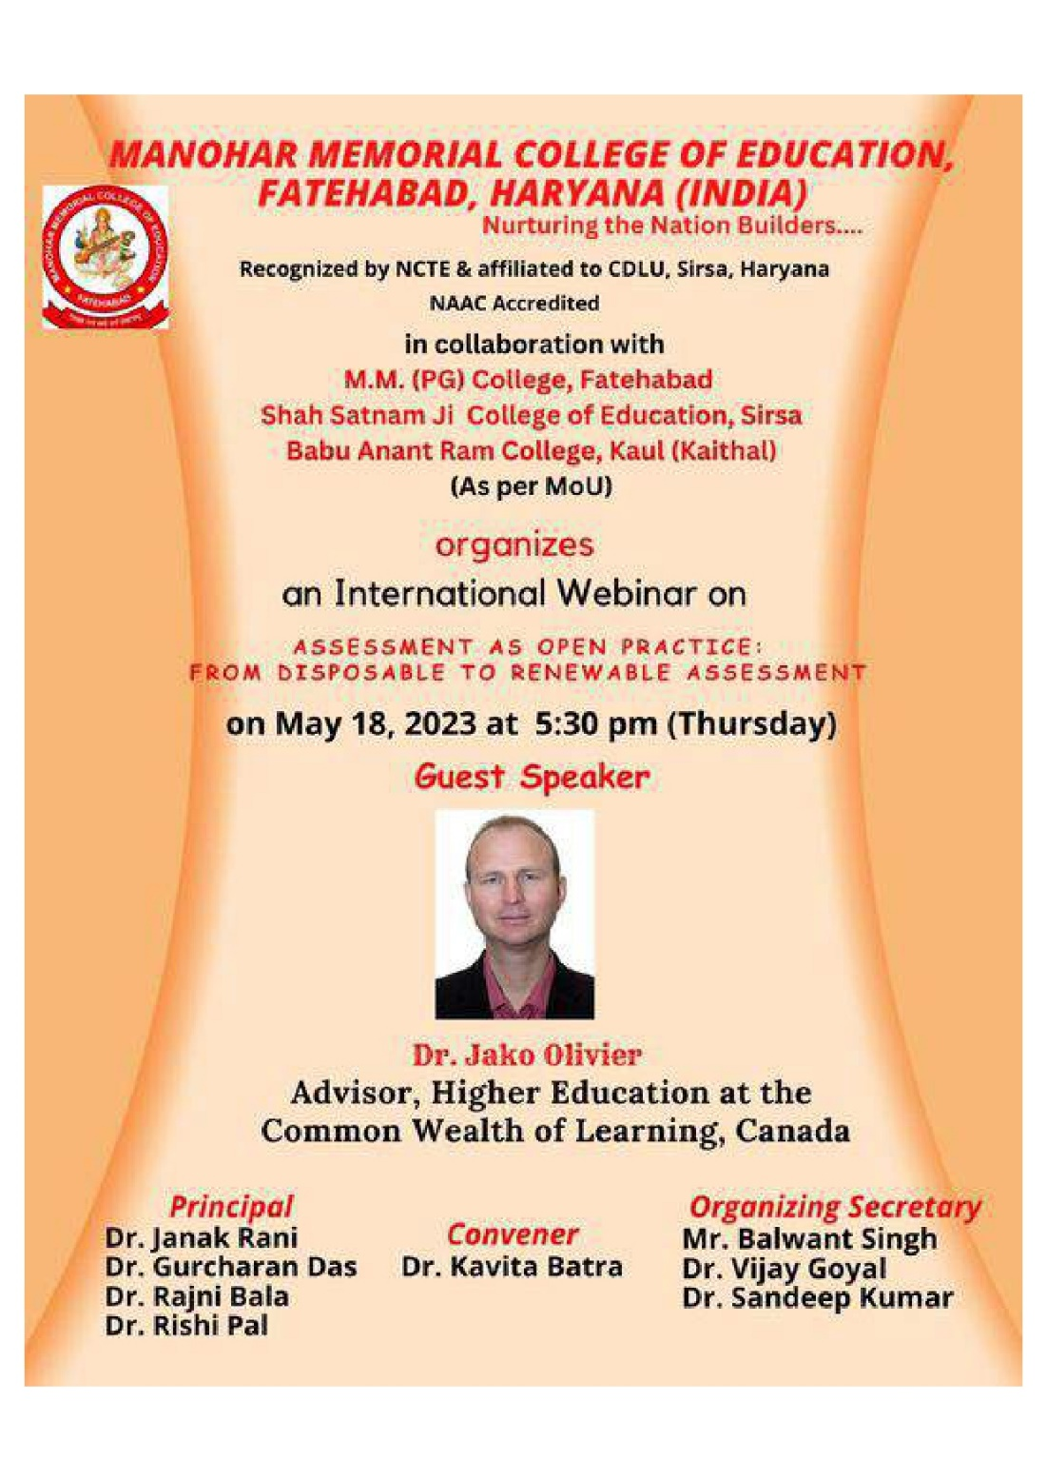

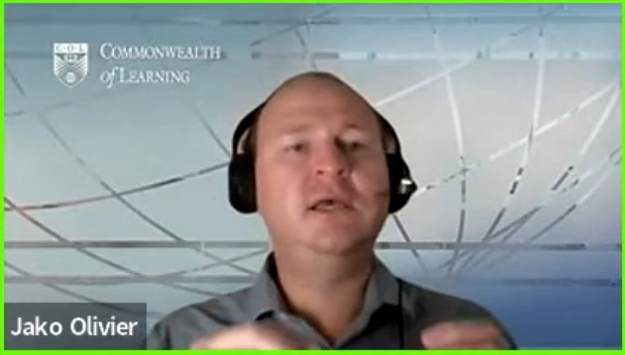

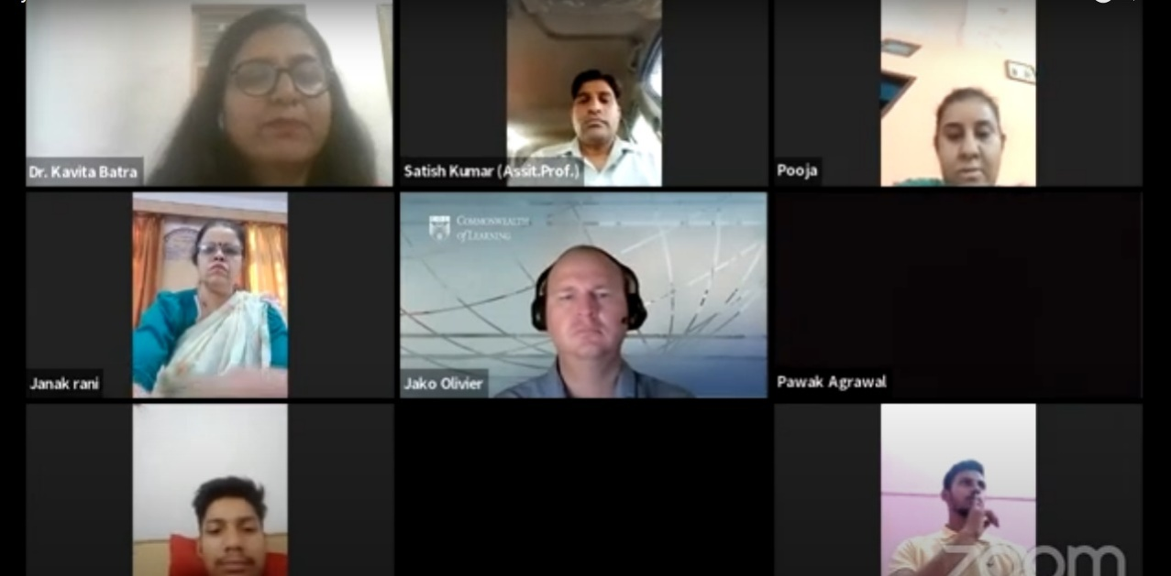

- Media Impact for various aspects of Education

Self Defence Training by
Neha Mittal (13.05.2023)

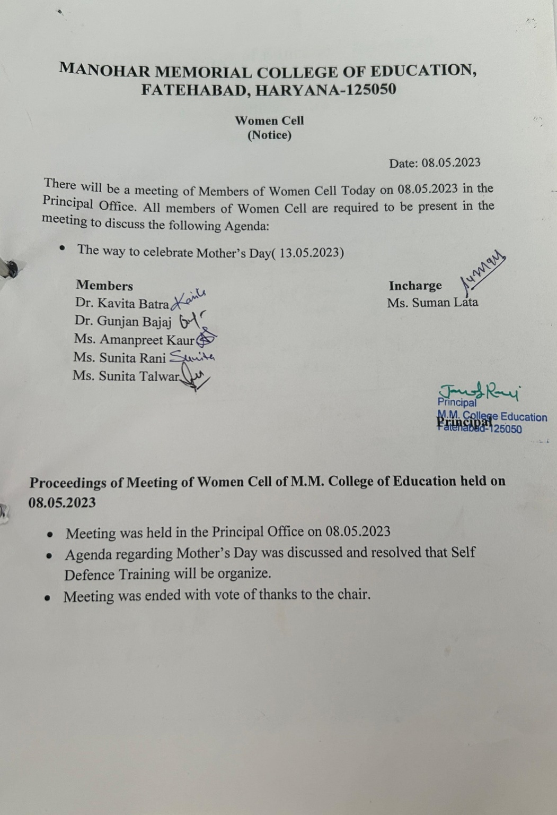
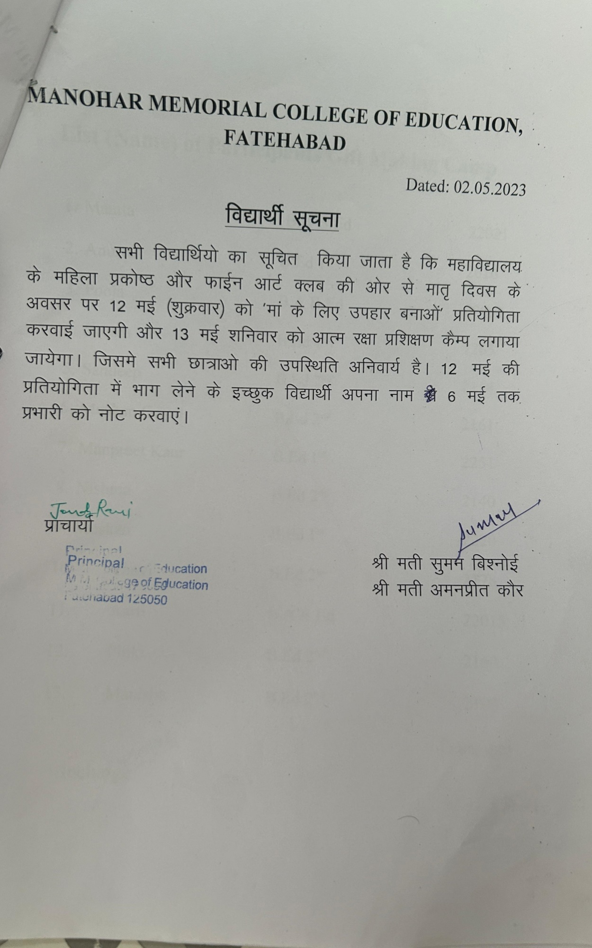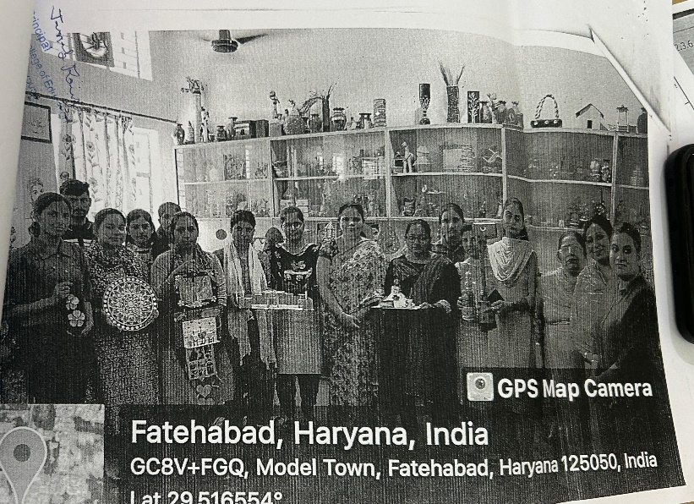

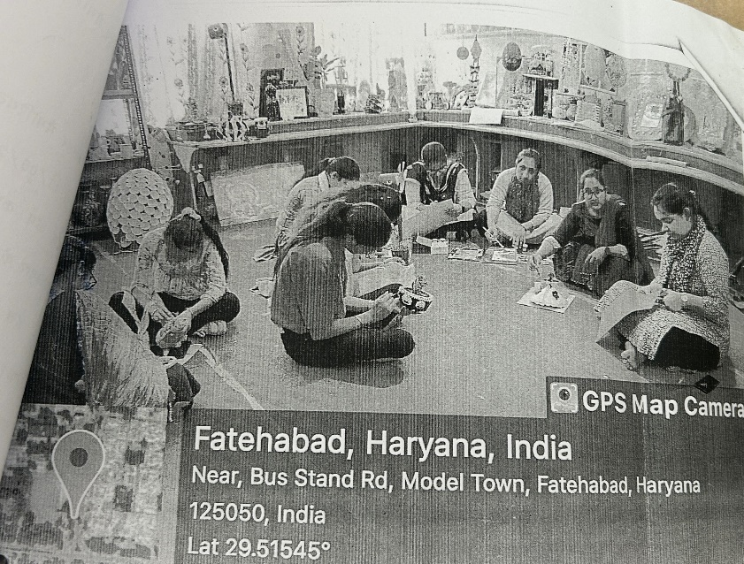

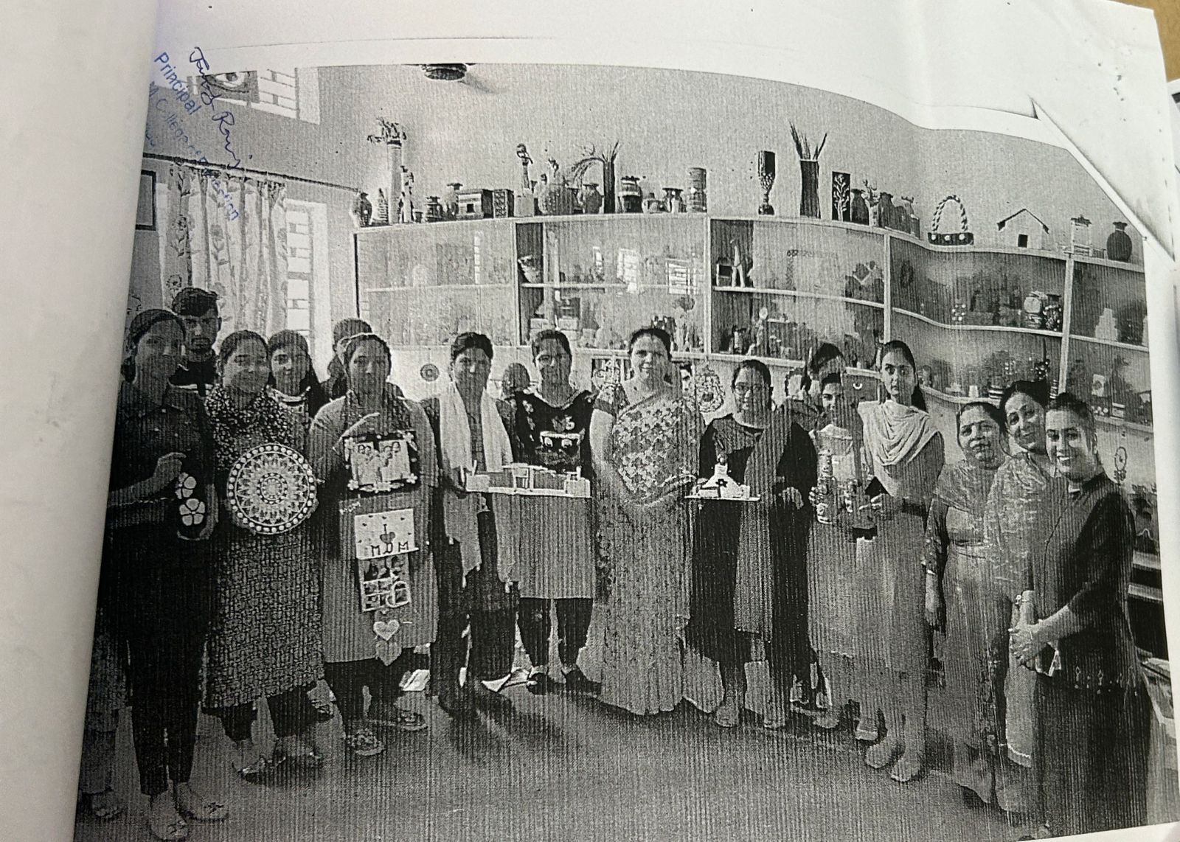

- Various context of education from local to regional to national to global

Webinar on Revolutionizing Education Exploring the power of ICT in the classroom by
Dr. Kiran Lata(11.05.2023)

2.3.6 (II) Reports of activities conducted related to recent developments in education with Reports & Links
REPORTS

Special Lectures by Experts

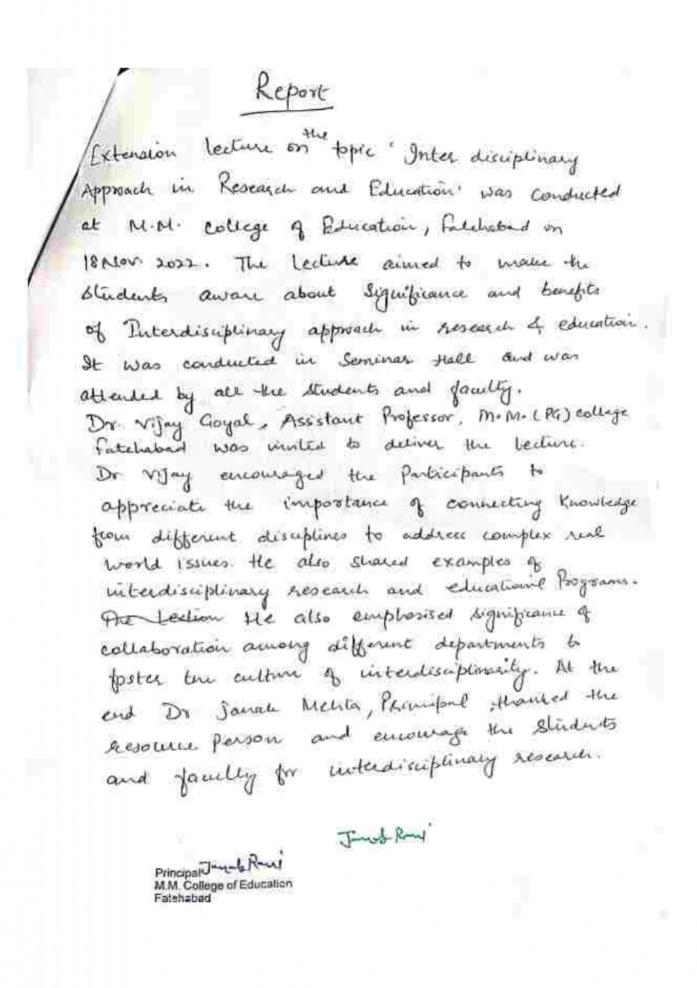
Extension Lecture on Inter Disciplinary Approach in Research & Education by Dr. Vijay Goyal (18.11.2022)

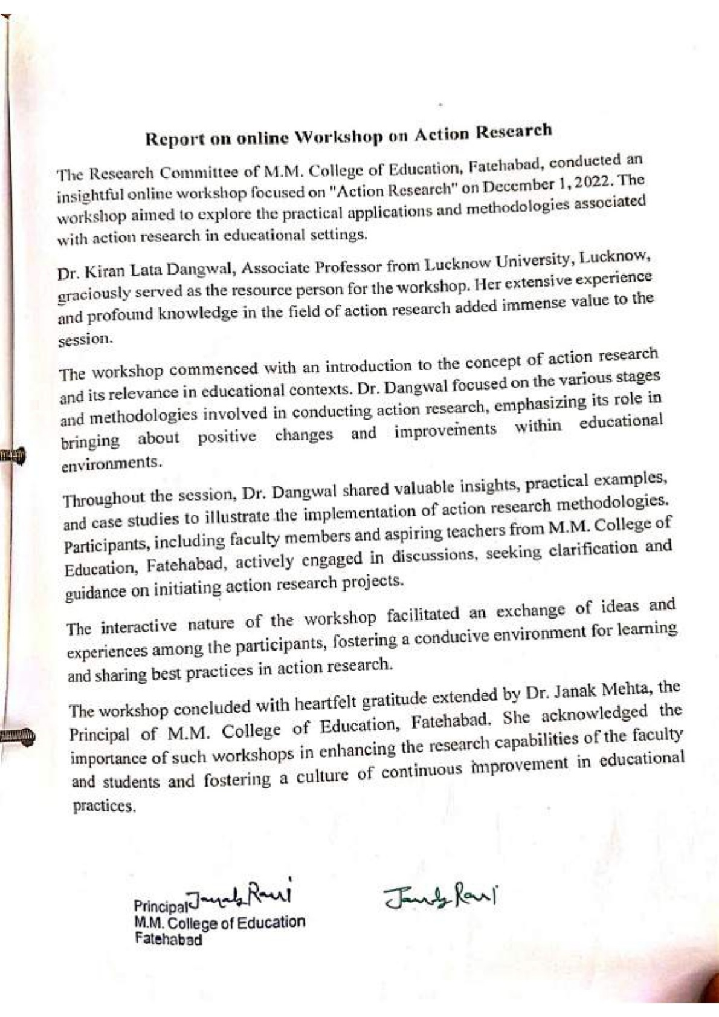
Action Research by Dr. Kiran Lata (01.01.2023)

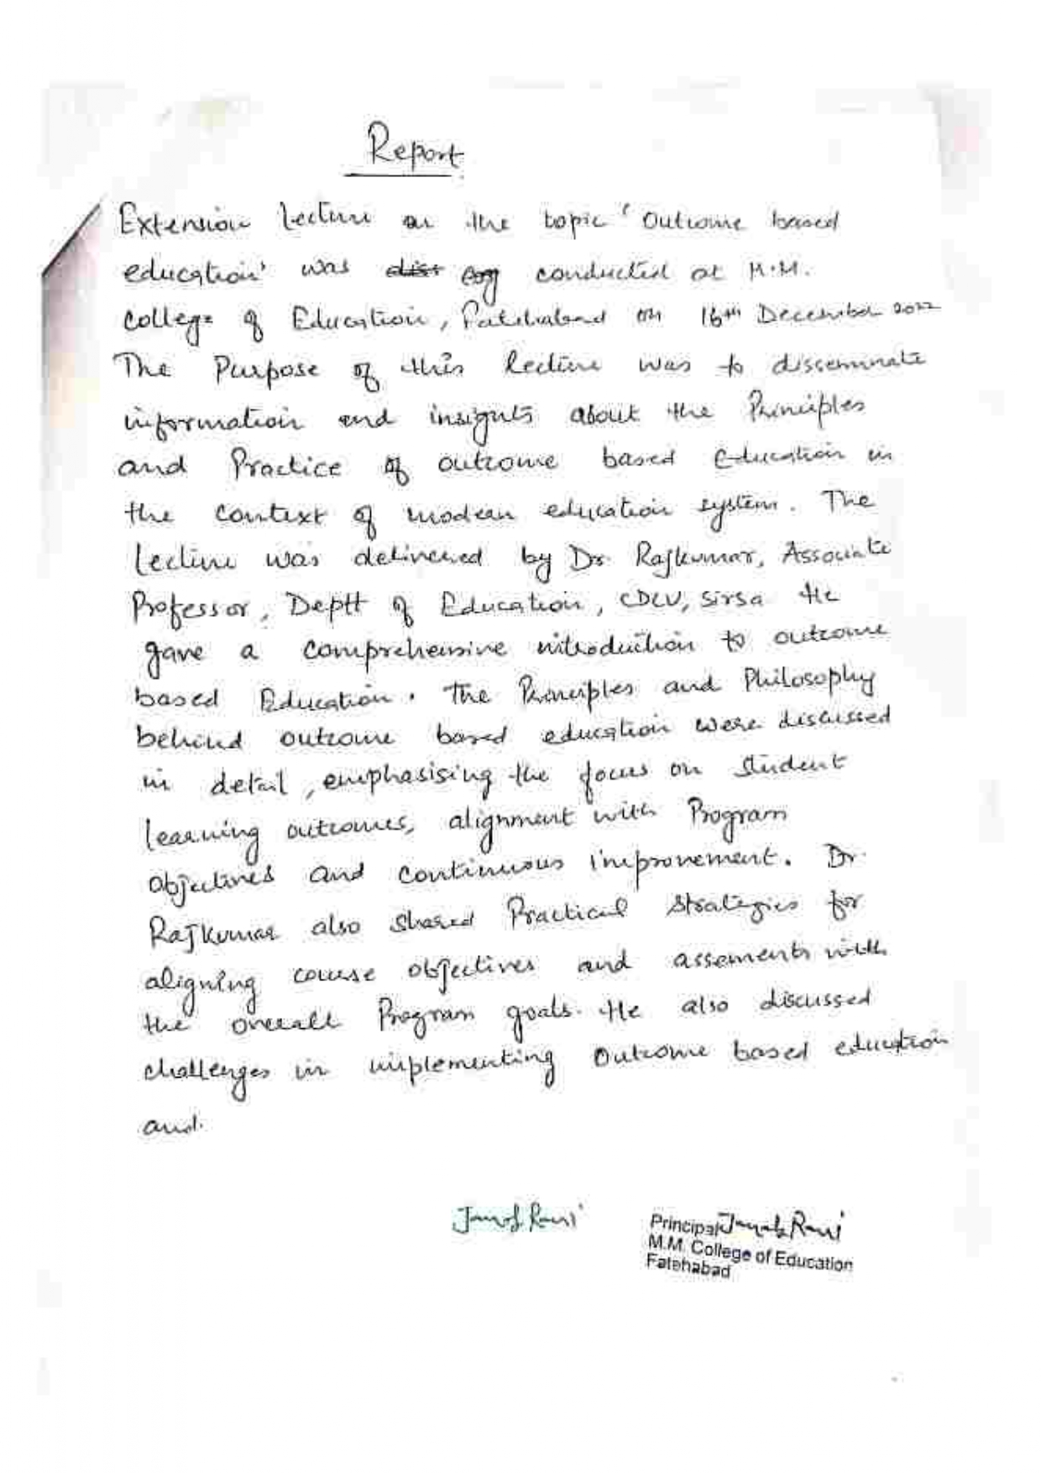
Extension Lecture on Outcome based Education by
Dr. Raj Kumar (16.12.2022)
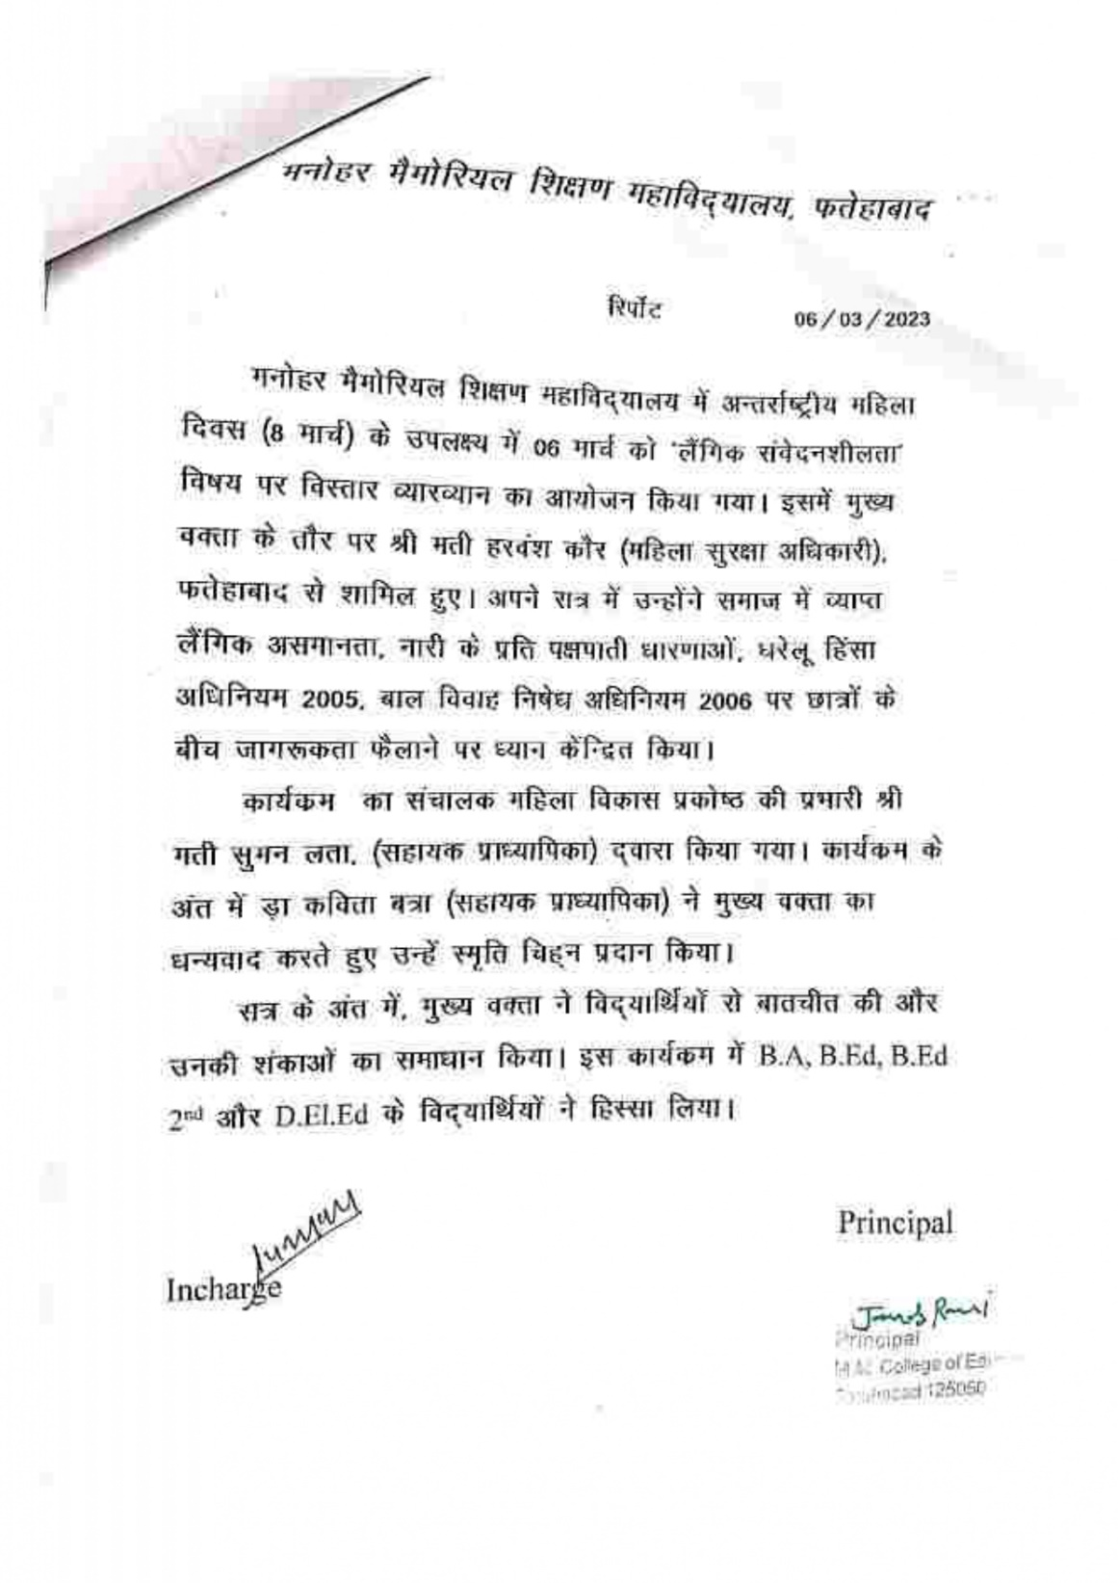
Extension Lecture on Gender Sensitivity on International Women’s Day by Mrs. Harbans Kaur (06.03.2023)

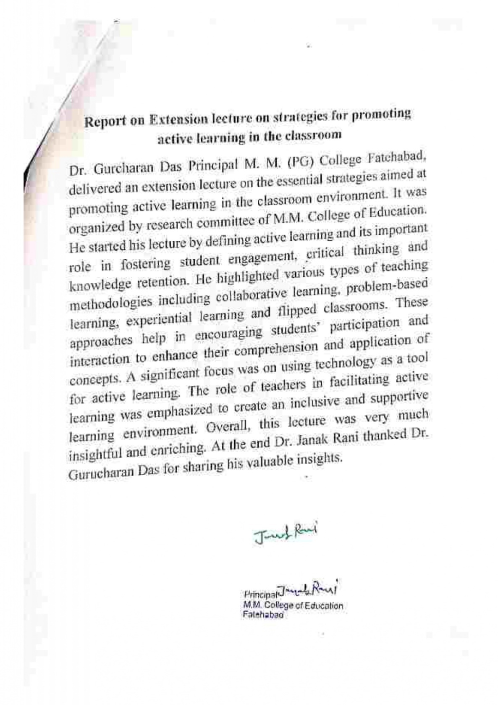
Extension Lecture on Strategies for promoting active learning the classroom byDr.Gurcharan Das (19.04.2023)

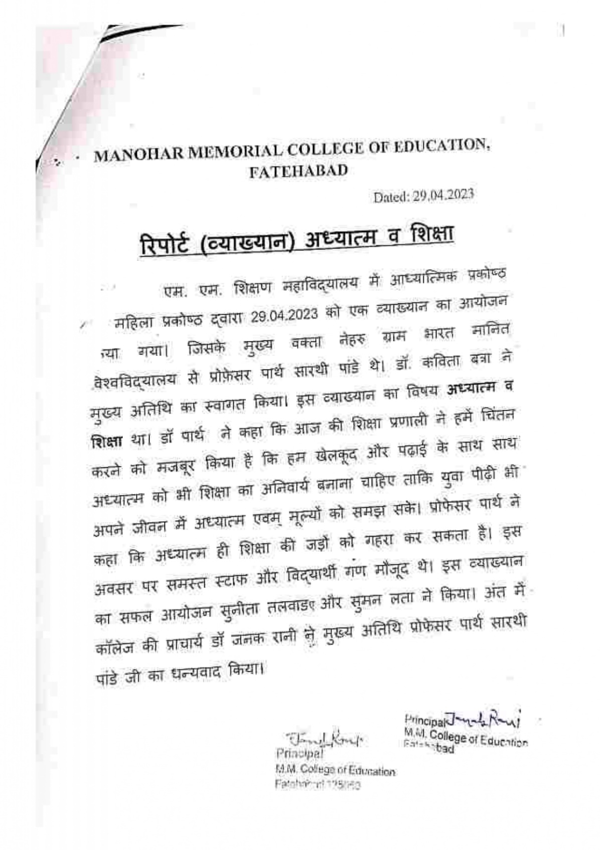
Extension Lecture on Spiritualism & Education by Dr.ParthSarthi (29.04.2023)

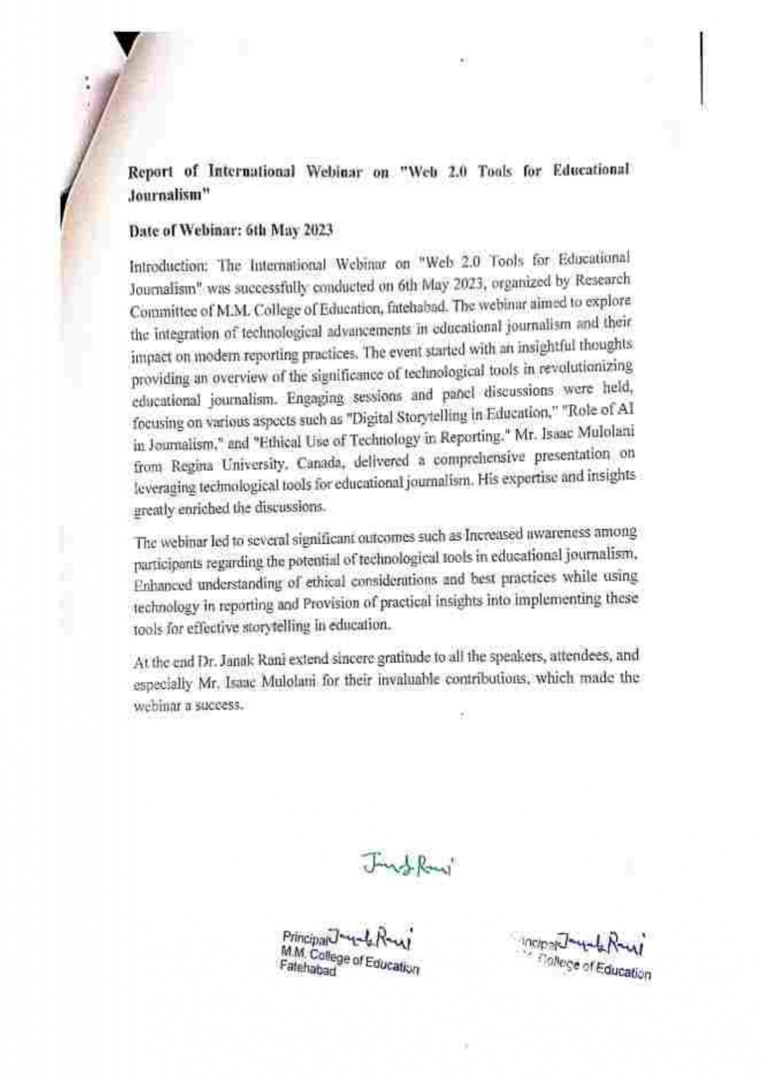
International Webinar on web 2.0 tools for Education Journalism by
Mr. IssacMulolani (06.05.2023)

Book reading and discussion on it

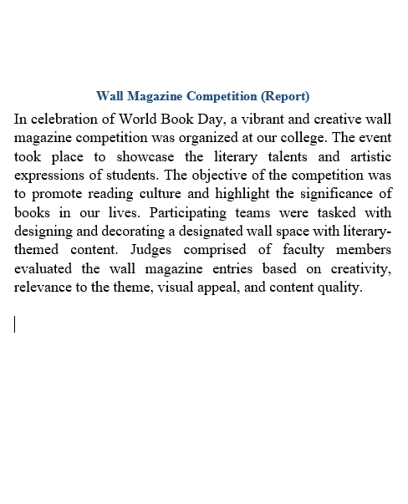
Wall Magazine Competition in College Campus (24.04.2023)

Discussion on Recent policies & regulations
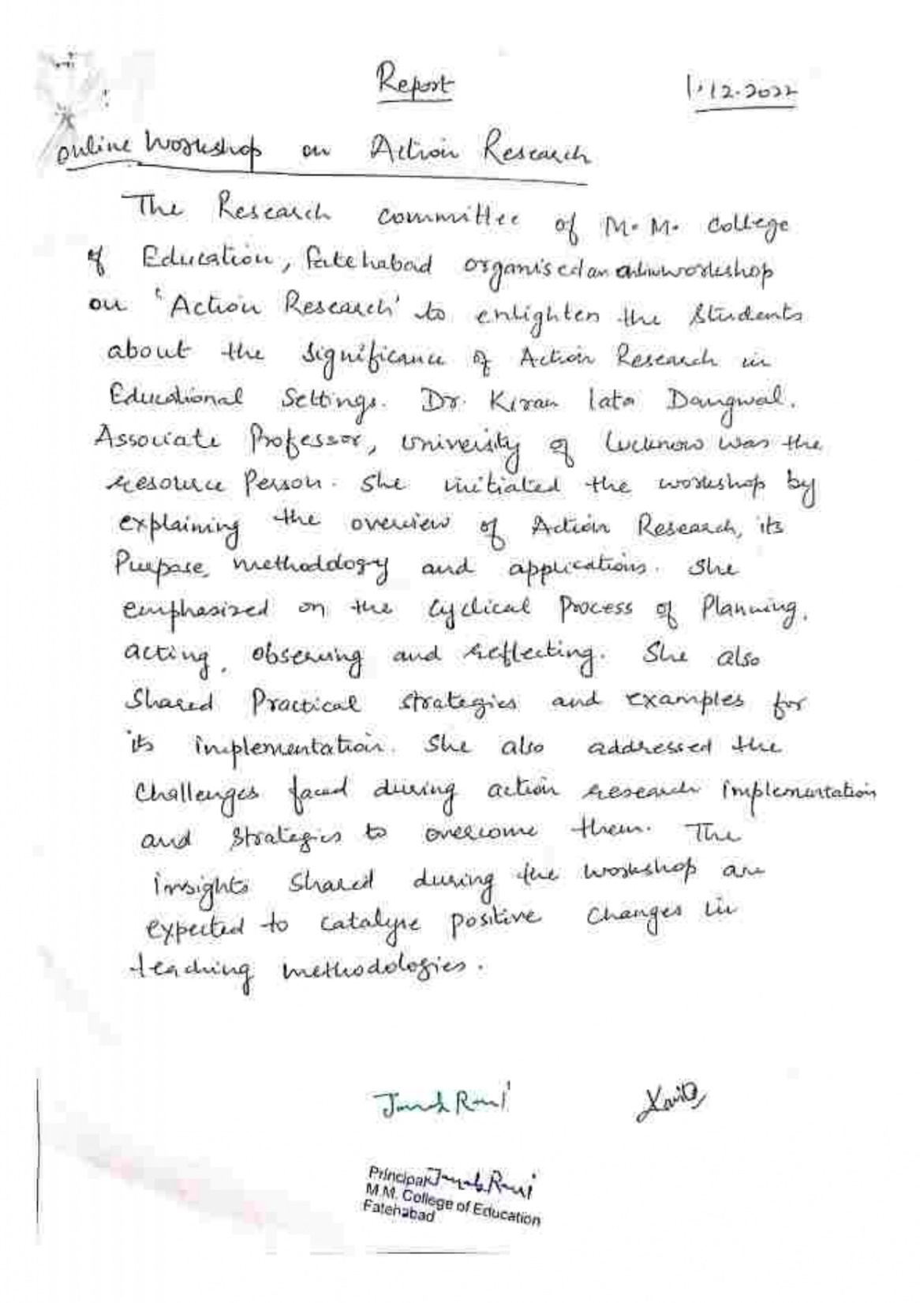
Workshop on Action Research byDr. Kiran Lata (01.12.2022)

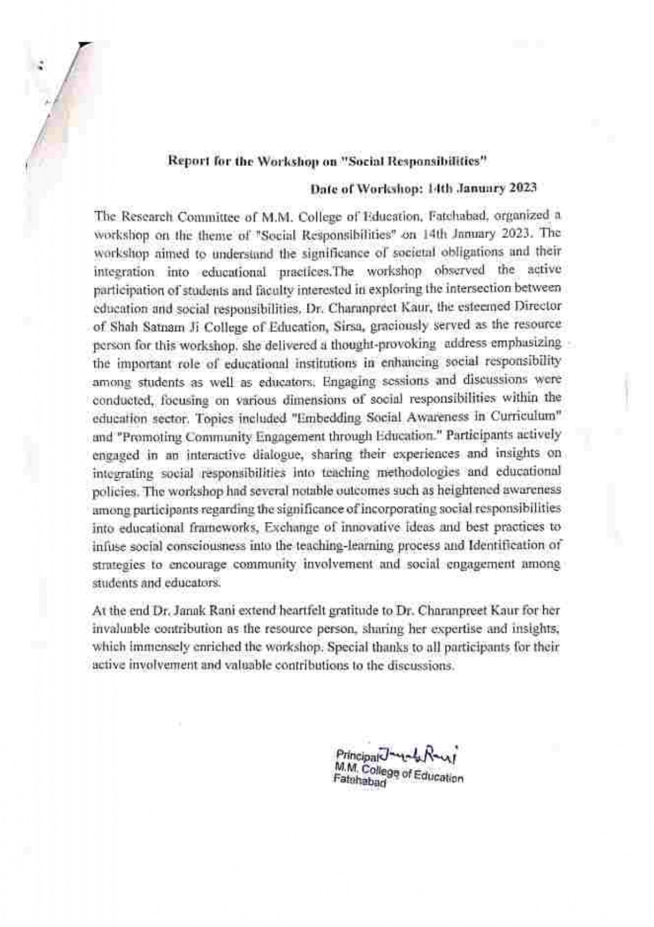

Workshop on Social Responsibilities byDr.Charanpreet Kaur (14.01.2023)

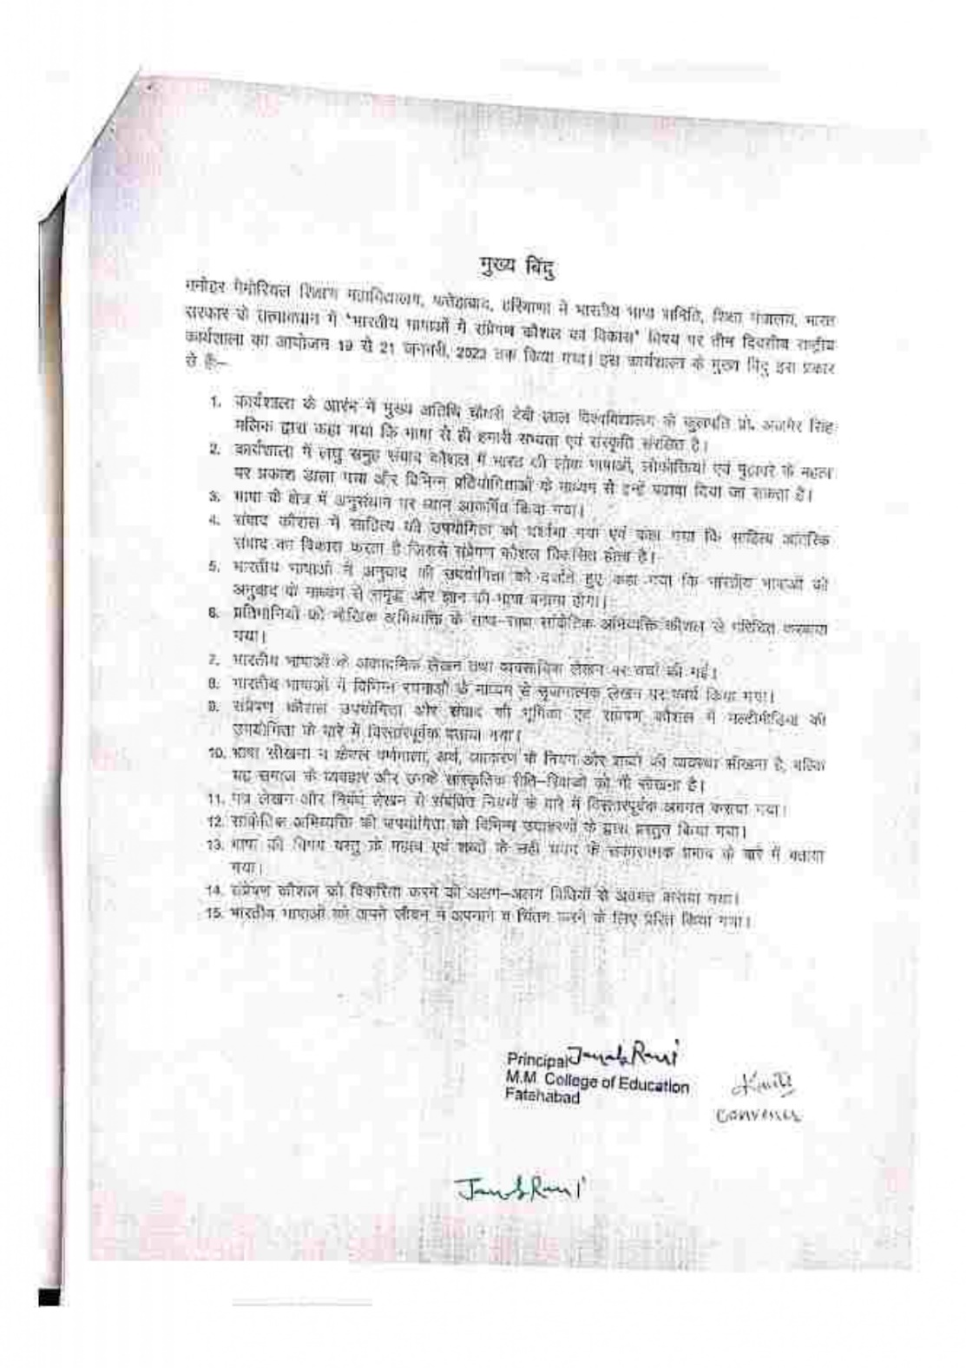
(Day 1) Workshop on Development of Communication Skills in Indian Languages (19.01.2023 to 21.01.2023)

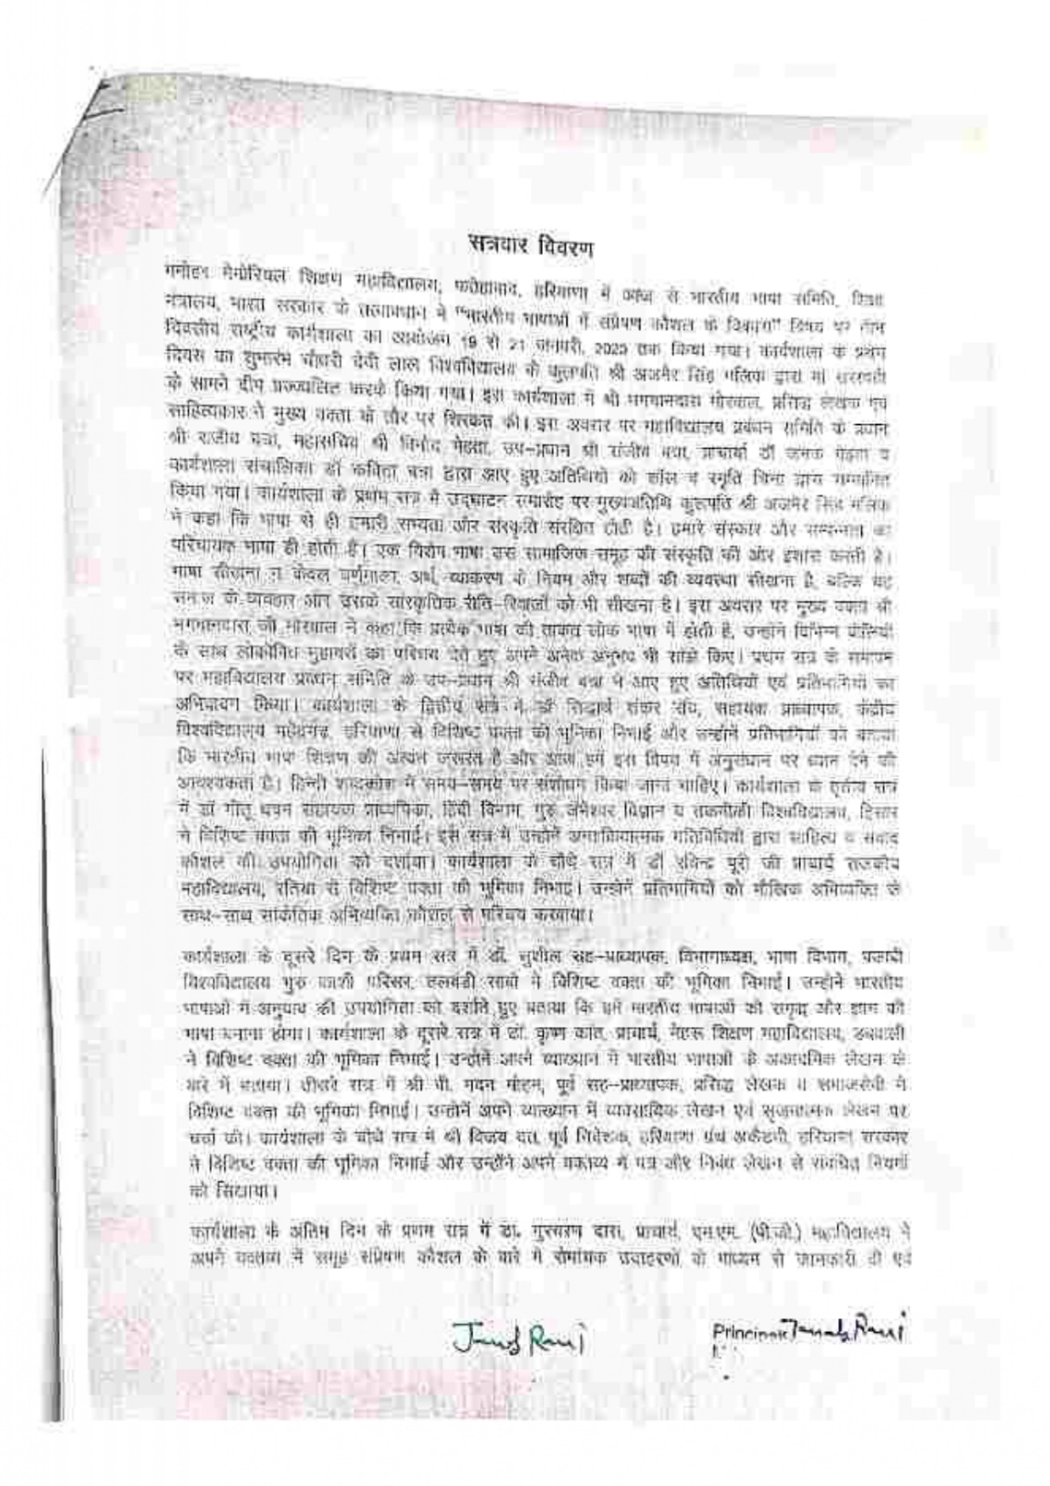
(Day 2) Workshop on Development of Communication Skills in Indian Languages (19.01.2023 to 21.01.2023)

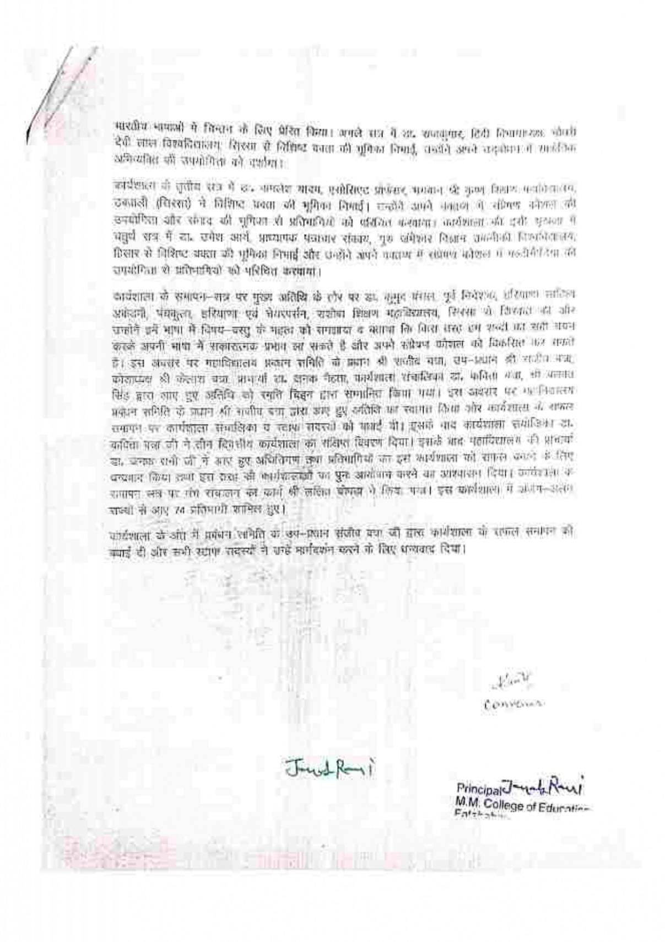
(Day 3) Workshop on Development of Communication Skills in Indian Languages (19.01.2023 to 21.01.2023)

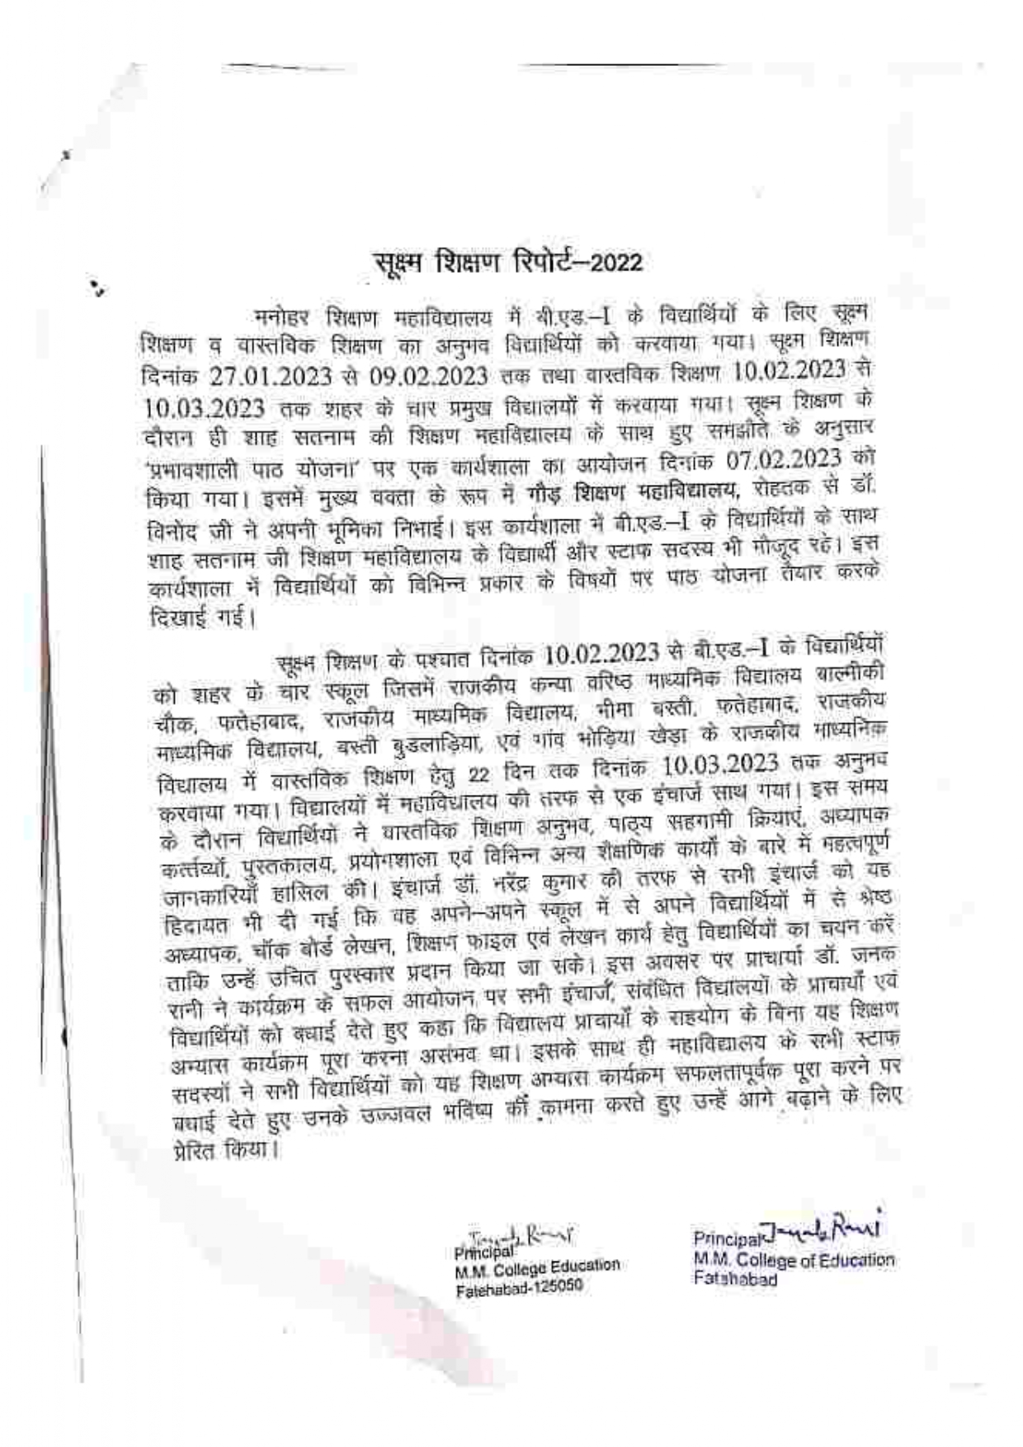
Report on Workshop of Effective Lesson Planning by Dr. Vinod Kumar (07.02.2023)

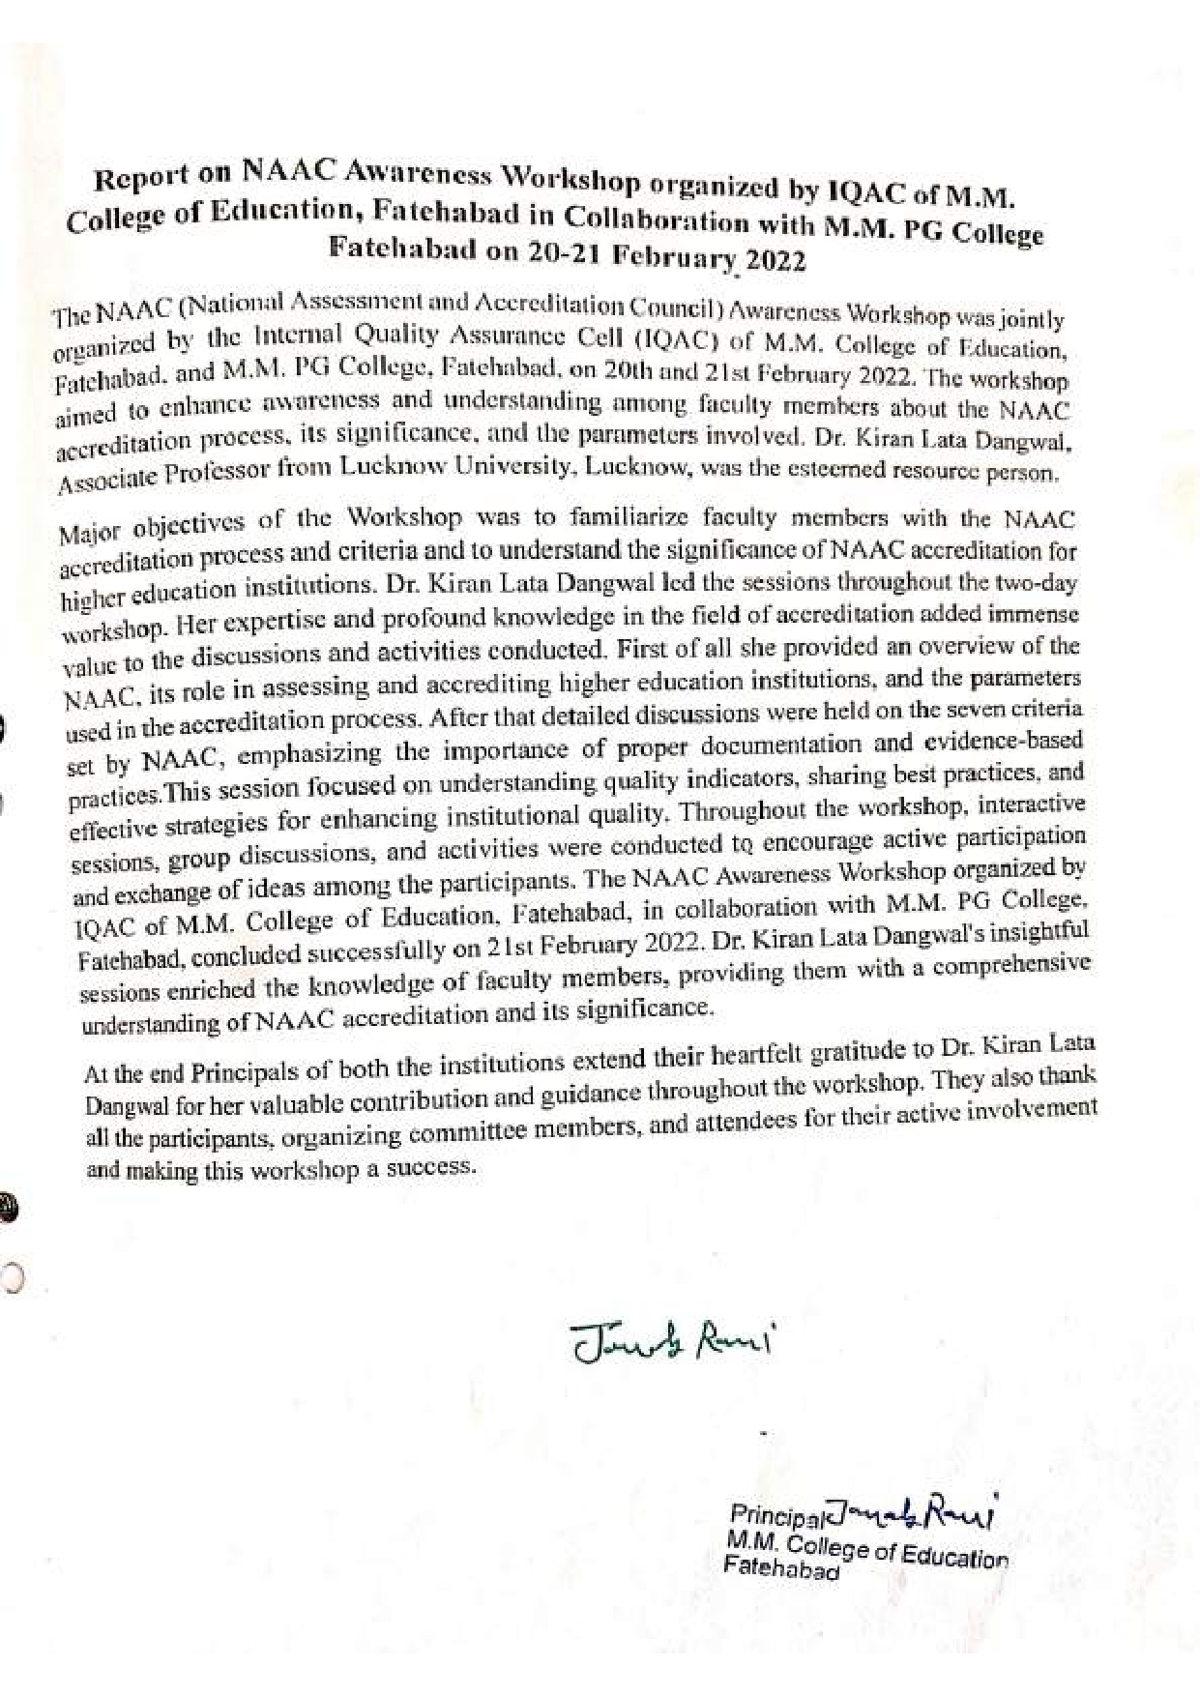
NAAC Awareness Workshop byDr. Kiran Lata (20.02.2023 to 21.02.2023)

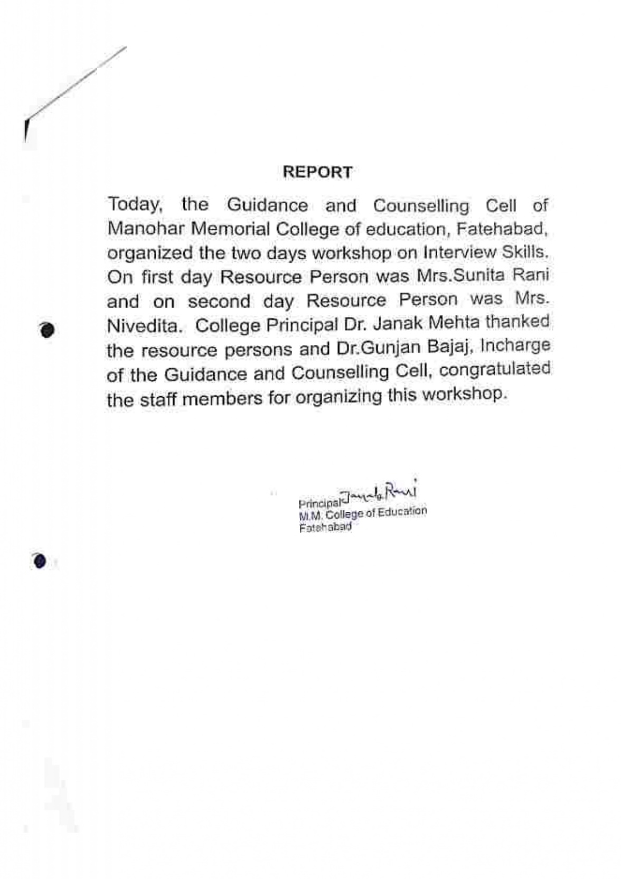
Two Days Workshop on Interview Skills by Mrs. Nivedita
(14.03.2023 to 15.03.2023)

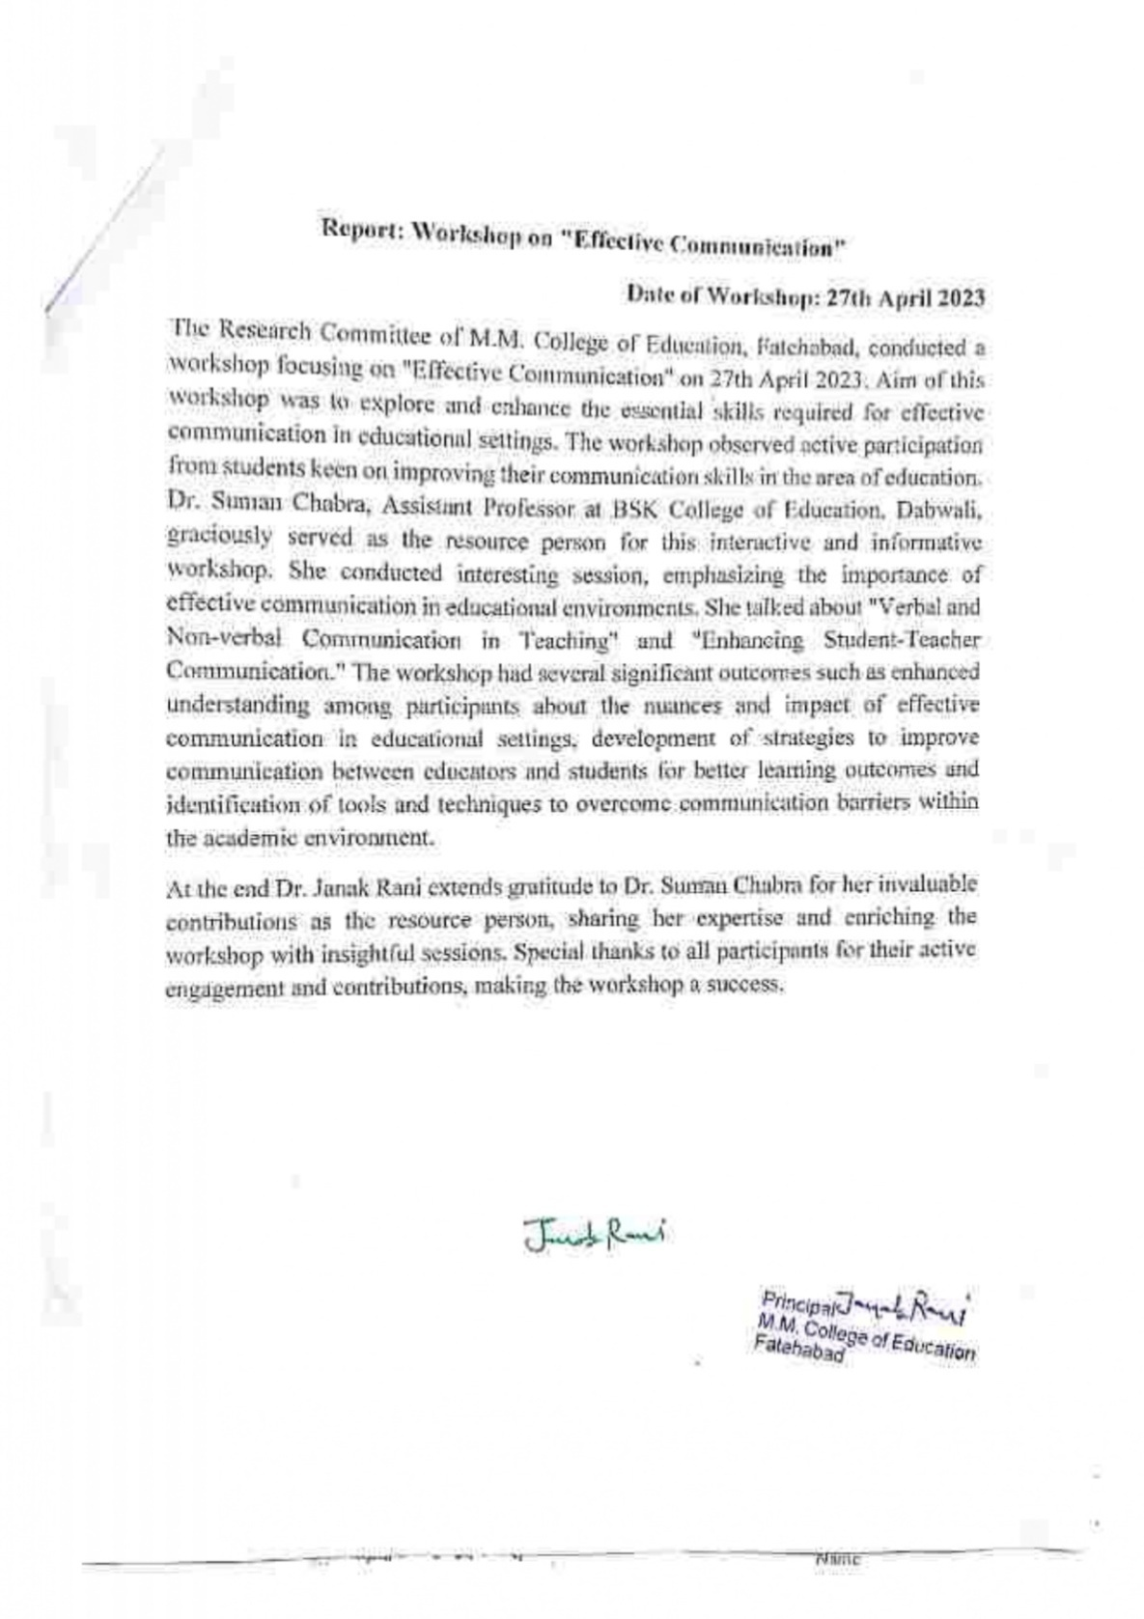
Workshop on Effective Communication byDr. Suman Chabra (27.04.2023)

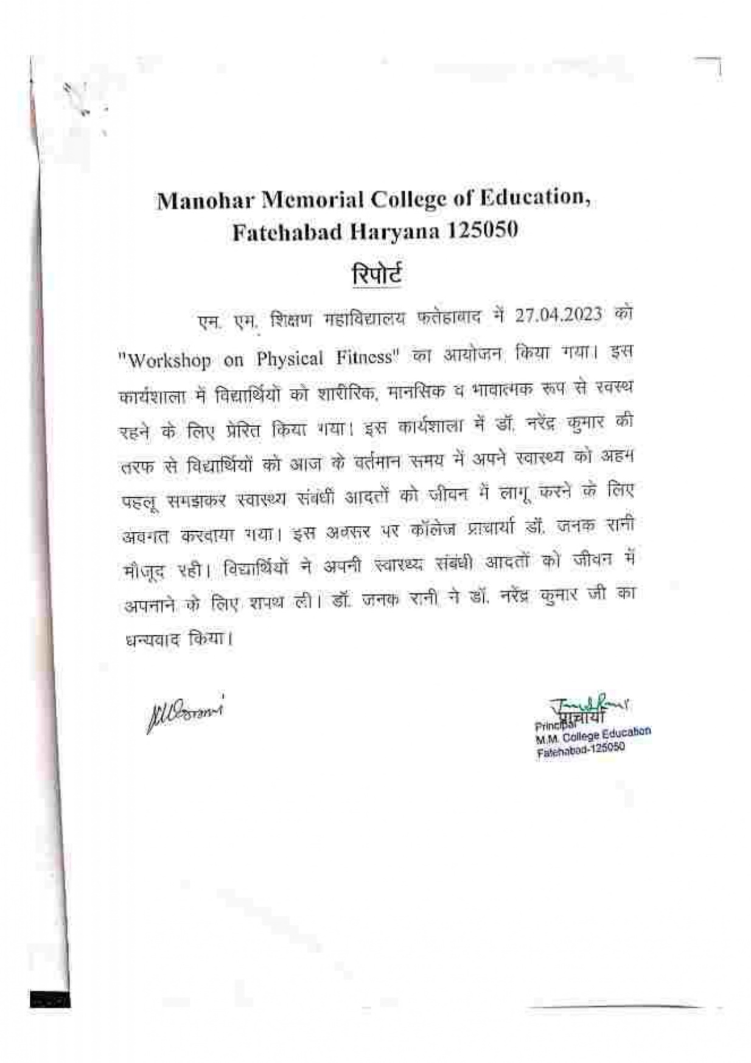
Workshop on Physical Fitness byDr.Narender Kumar (27.04.2023)

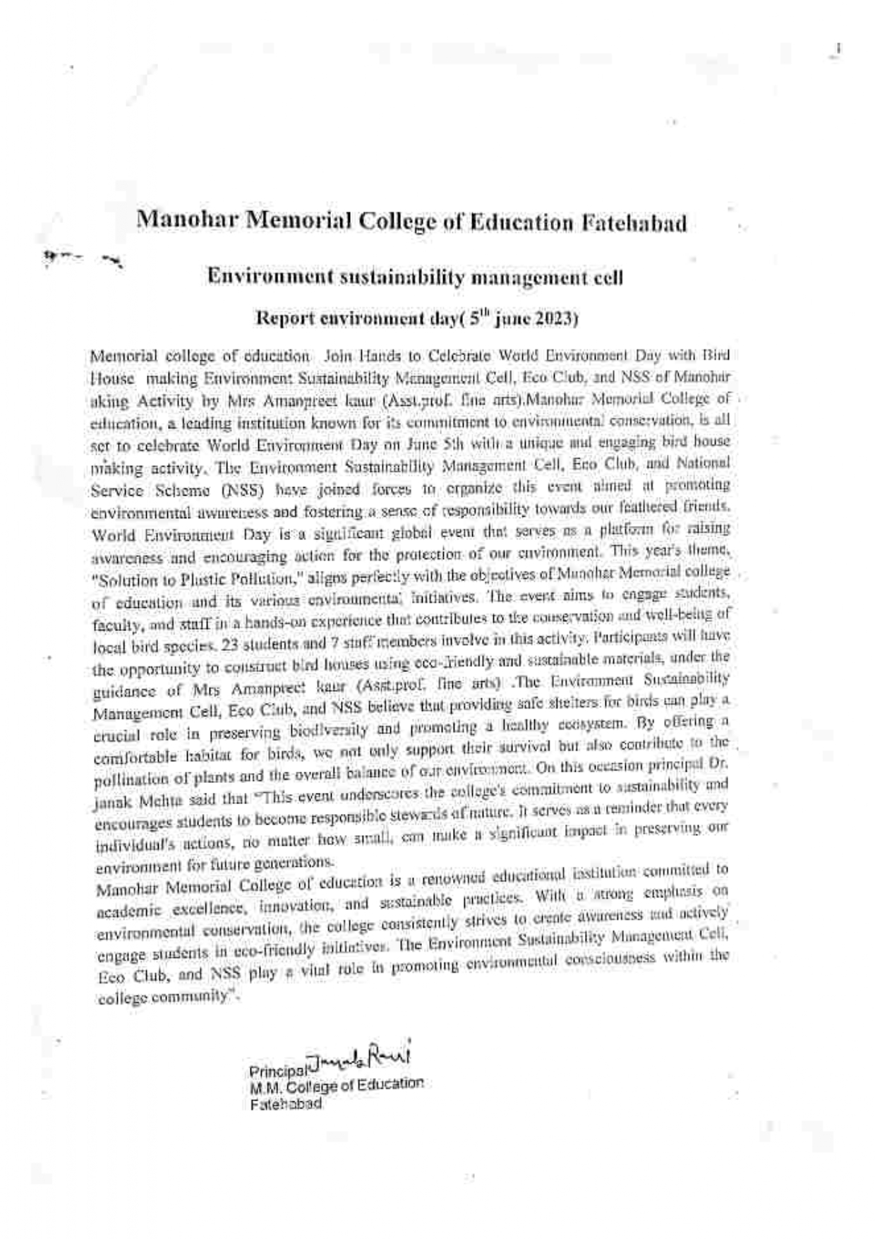
Awareness Lecture on Environment Day byMs. Amanpreetkaur& Ms. Sunita Rani (05.06.2023)

Teacher presented seminars for benefit of teacher & students
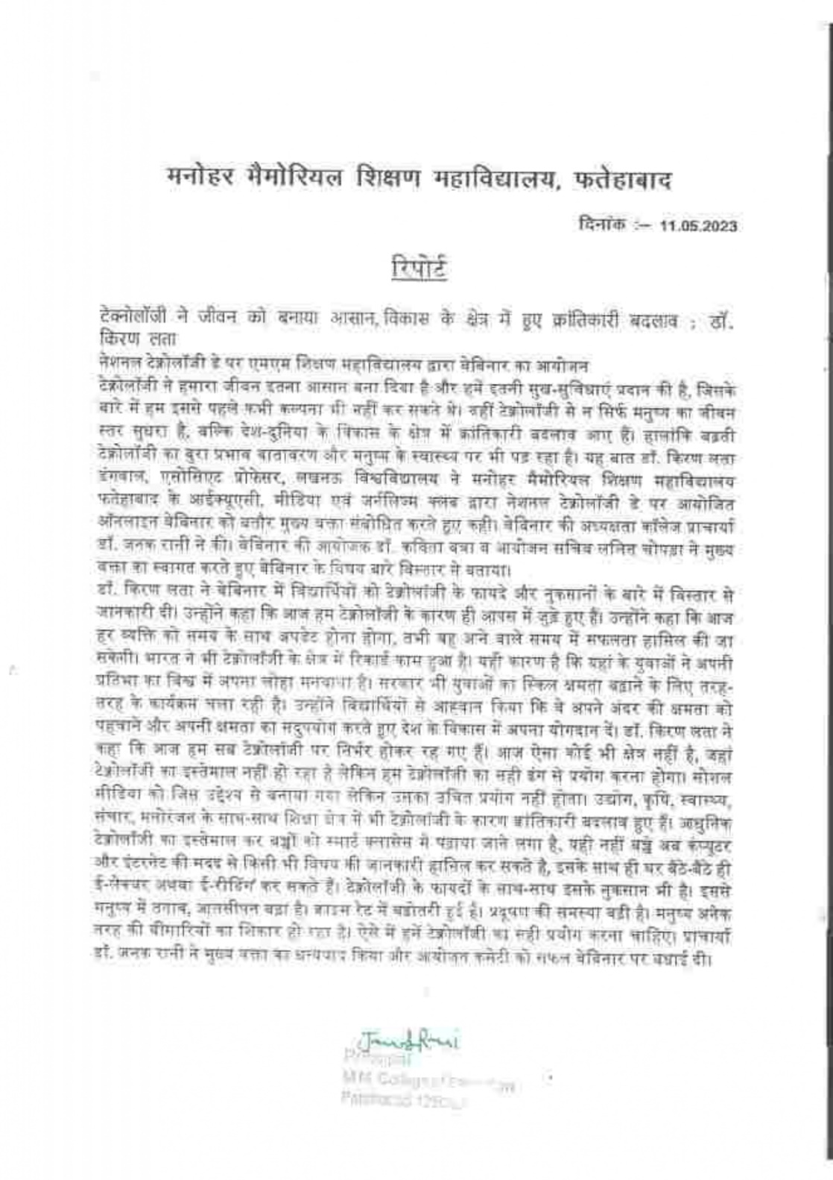
Webinar on Revolutionizing Education Exploring the power of ICT in the classroom by Dr. Kiran Lata (11.05.2023)

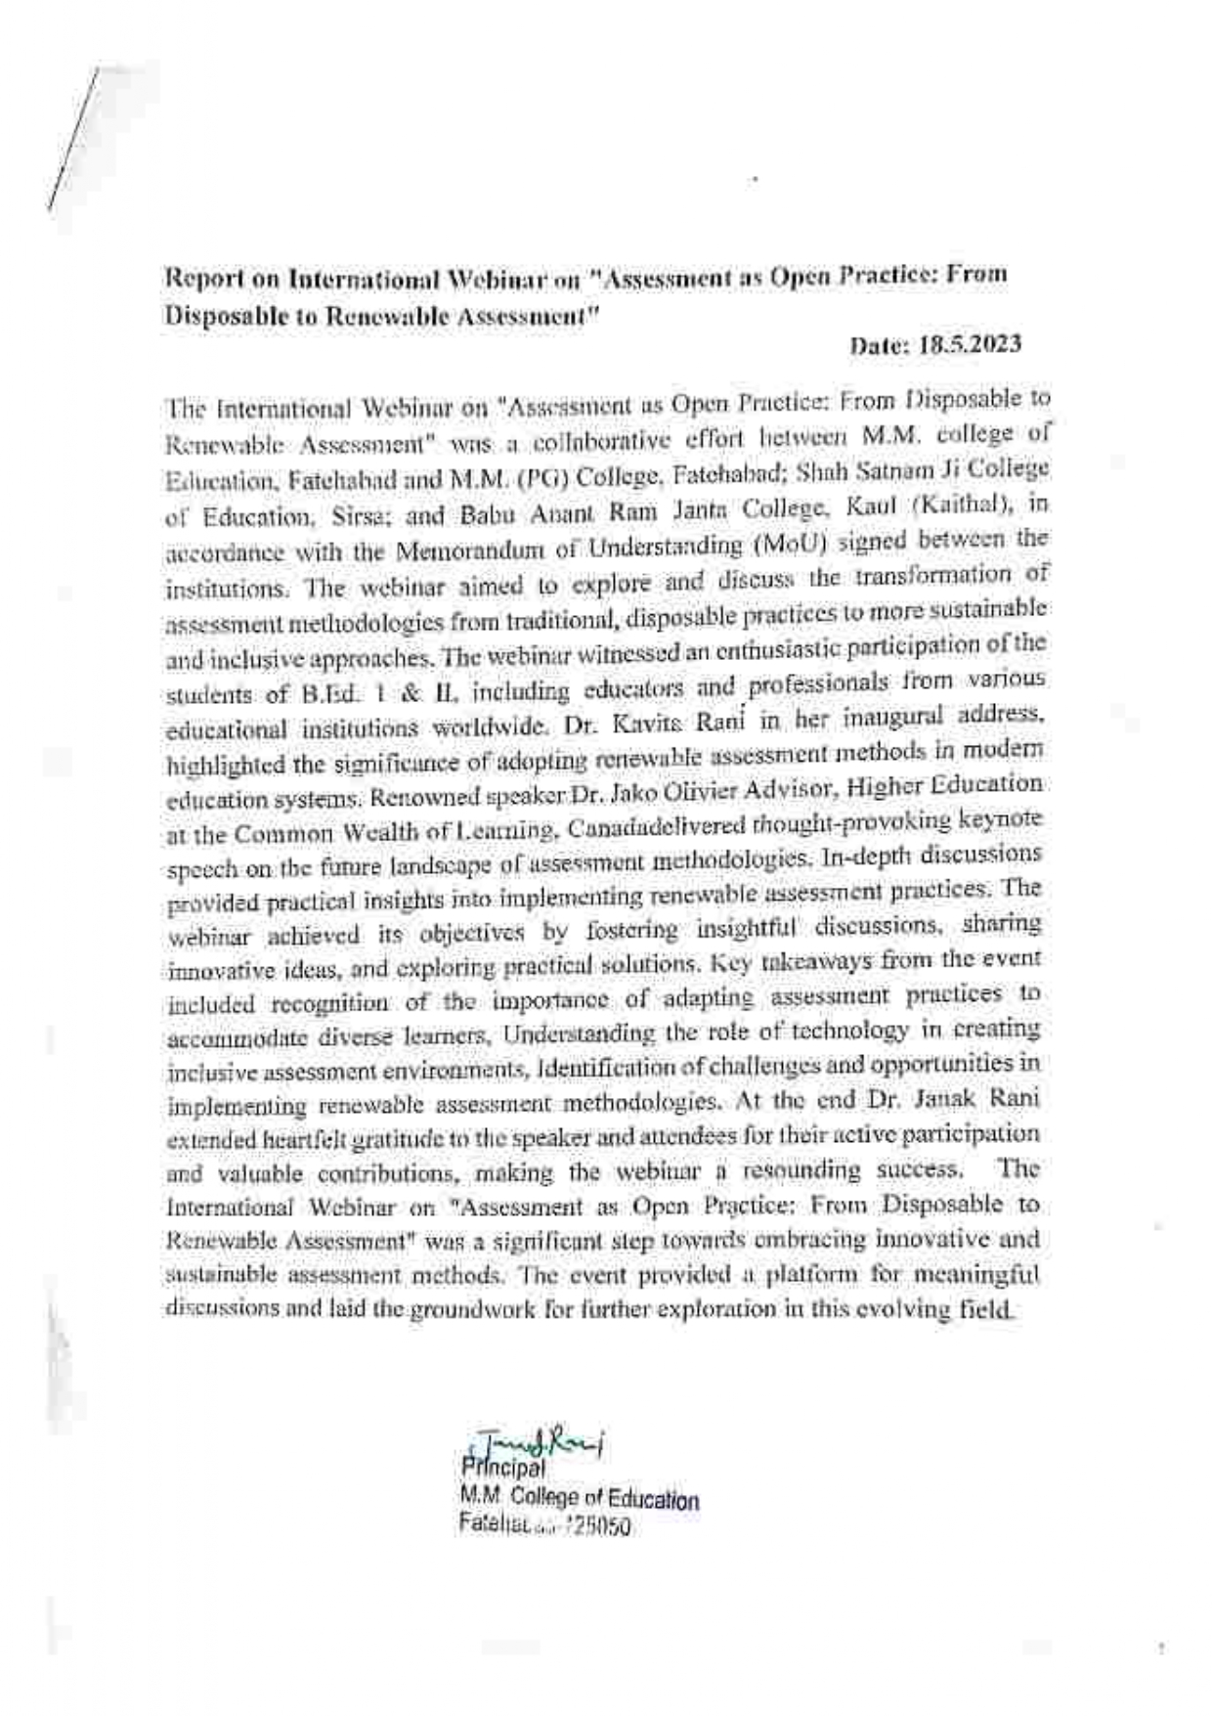
International Webinar on assessment & an open practice for disposable to renewable assessment by Dr.Jako Olivier (18.05.2023)

Media impact for various aspects of education
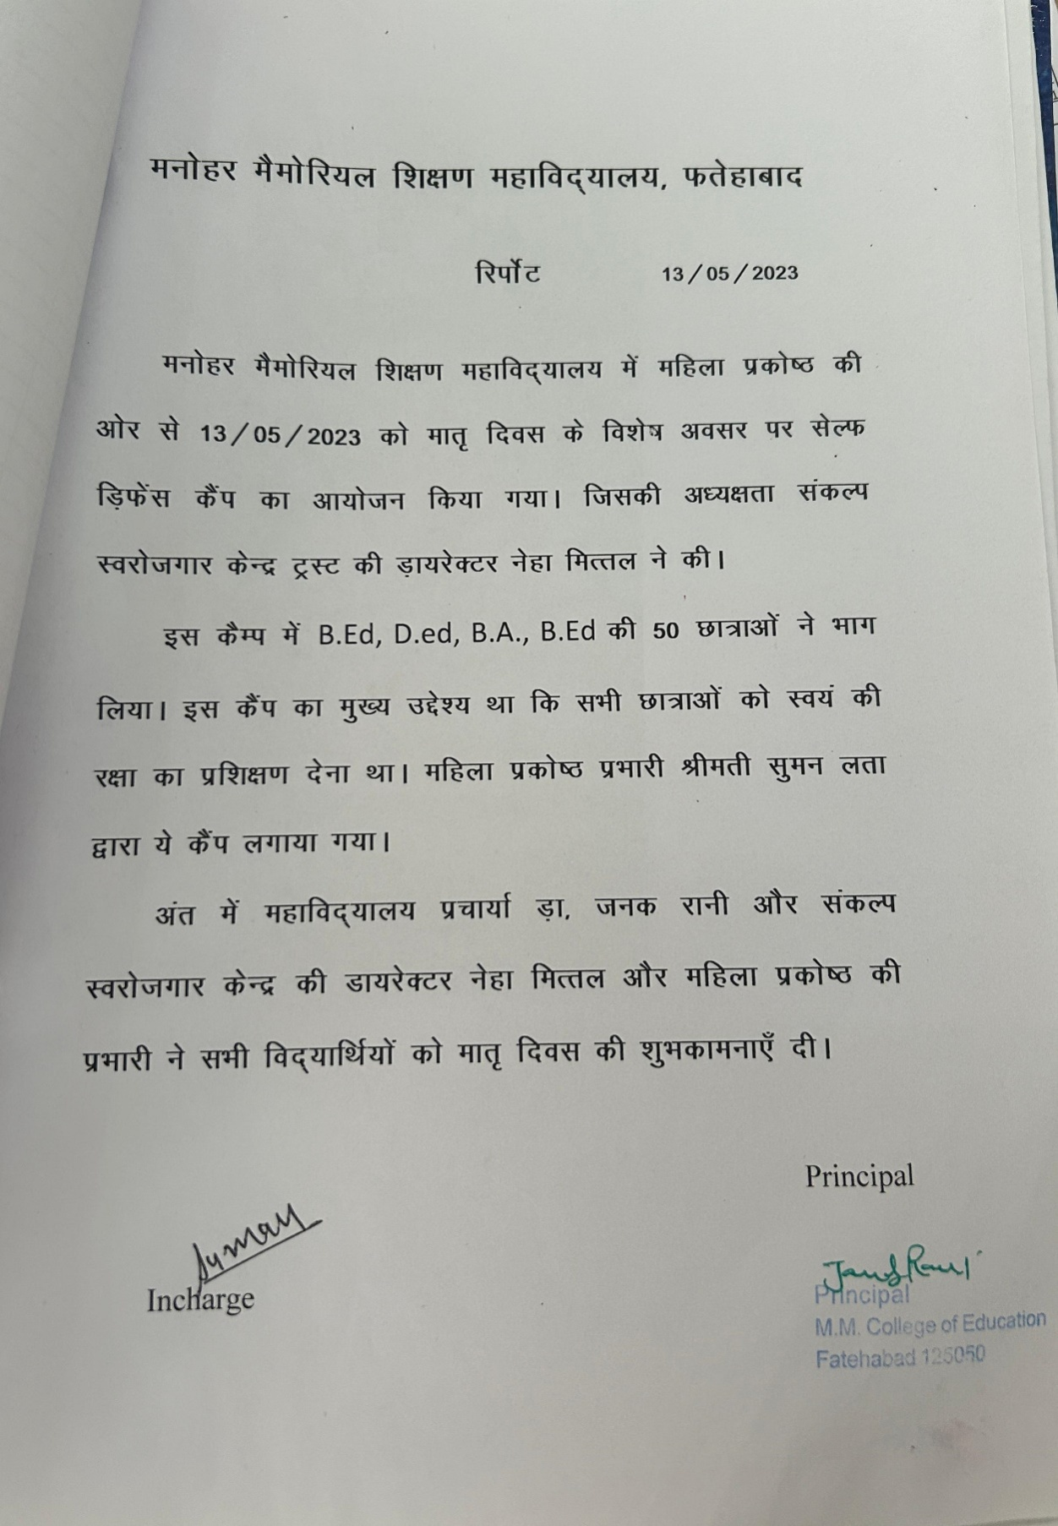

Discussions showcasing the linkages of various context of education from local to regional to national to global
Webinar on Revolutionizing Education Exploring the power of ICT in the classroom by Dr. Kiran Lata (11.05.2023)

LINKS
Sr. No | Programs | Links
1 | Extension Lecture on Inter Disciplinary  Approach in Research & Education | -
2 | Extension Lecture on Outcome  based Education | https://www.facebook.com/share/p/MnkS34jqiQniSiYw/
3 | Extension Lecture on Gender Sensitivity on International Women's Day | -
4 | Extension Lecture on Strategies for promoting active learning the classroom | -
5 | Extension Lecture on Spiritualism & Education | https://www.facebook.com/share/p/KDyaVaQfuhvqyTKA/
6 | International Webinar on web 2.0 tools for Education Journalism | https://www.facebook.com/kavita.rani.5815/posts/pfbid02b2EugcrUmnQj2WER4FsPdsdg8LKhHo3ErHRRTrMPqD4MvCYoXjVTGEWeqQ15aaQpl
7 | Workshop on Action Research | https://www.facebook.com/share/p/7AyWh4Ap6WRBuhos/
8 | Workshop on Social Responsibilities | -
9 | Workshop on Development of Communication Skills in Indian Languages | https://l.facebook.com/l.php?u=https%3A%2F%2Fwww.youtube.com%2Fwatch%3Fv%3DLTSnUlfGRq8&h=AT2ewugdTWVrQf7cHARn25k1yektpjz9Ho4X7K8aaYVwesSo5ejjhFsiTXgoymqQTyL4l7W5Q_22CJeGQ162cObrPxa6-2Pg25iFyCIaRV4_4rF-FCKydOgxuxGzFCm8wb1-&s=1  https://www.facebook.com/share/p/5aEsYGRMgAK3M3Ky/  https://www.facebook.com/share/p/7x5pJ7yoDCVZGvVX/
10 | Workshop on Effective Lesson Planning | https://www.facebook.com/share/p/6zxPDfqcSJk4zeyB/
11 | NAAC Awareness Workshop | https://www.facebook.com/share/p/xwxAY2MeTYuh9PAw/
12 | Two Days Workshop on Interview Skills | https://www.facebook.com/share/p/YKRhkw6SB4x6s7uP/
13 | Workshop on Effective Communication | https://www.facebook.com/share/p/yZUatrVtzKa6YSne/
14 | Workshop on Physical Fitness | https://www.facebook.com/share/p/yZUatrVtzKa6YSne/
15 | Awareness Lecture on Environment Day | https://www.facebook.com/share/p/Bz5U4BGis3DsXtwB/
16 | Webinar on Revolutionizing Education Exploring the power of ICT in the classroom | https://www.facebook.com/share/p/KK4VAR3T8ra4Qbwr/
17 | International Webinar on assessment & An open practice for disposable to renewable assessment | https://www.facebook.com/share/p/oGaApzAmFT1i8gmo/
18 | Self Defence Training | https://www.facebook.com/mmce.fatehabad/posts/pfbid02Z9FR5bGW6qSYo5jn8EdxnYJ2CNCHNQi4K4ivhJLpQ13CGHLZiPCSkBvzgYpH1QZxl
19 | Webinar on National Technology day | https://www.facebook.com/share/p/vE321ToWEPqLKsmf/

