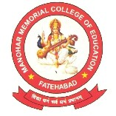
MANOHARMEMORIALCOLLEGEOFEDUCATION
SIRSAROAD,FATEHABAD–125050(HARYANA)
RecognizedbyNCTE,Jaipur
AffliatedtoChaudharyDeviLalUniversity,SirsaandSCERT,Gurugram“B”GradeAccreditedbyNAAC

CRITERION V

5.3.2 AVERAGE NUMBER OF SPORTS AND CULTURAL EVENTS ORGANISED AT THE INSTITUTION DURING THE LAST FIVE YEARS.

DVV Findings:
- Reports of the events along with the photographs and captions and dates
- Copy of circular/Brochure indicating such kind of events

Response of HEI:
As per DVV query, we have provided following documents attached:
- Reports of the events along with the photographs and captions and dates
- Copy of circular/Brochure indicating such kind of events

College : 01667-220136 | E-mail :mmce123@yahoo.com | Website:
Fax : 01667-224997 | mmce0123@gmail.com | www.mmcollegeofeducation.com
FAREWELL PARTY 06.07.2023
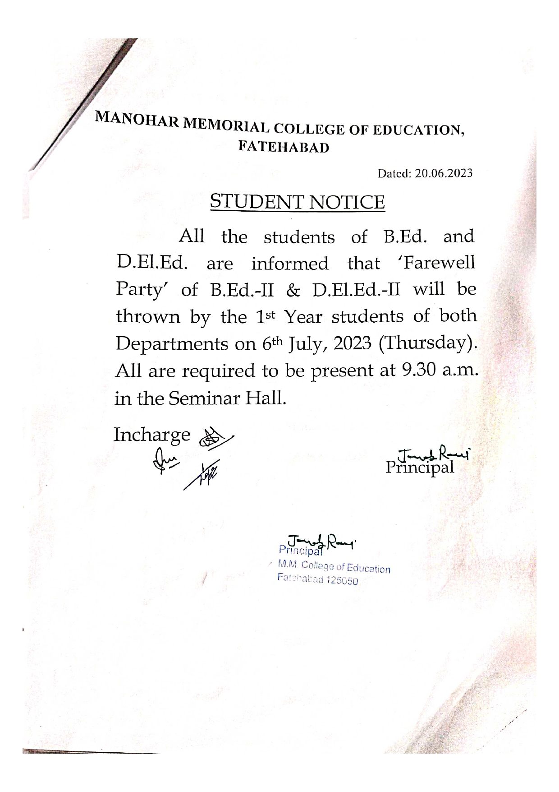

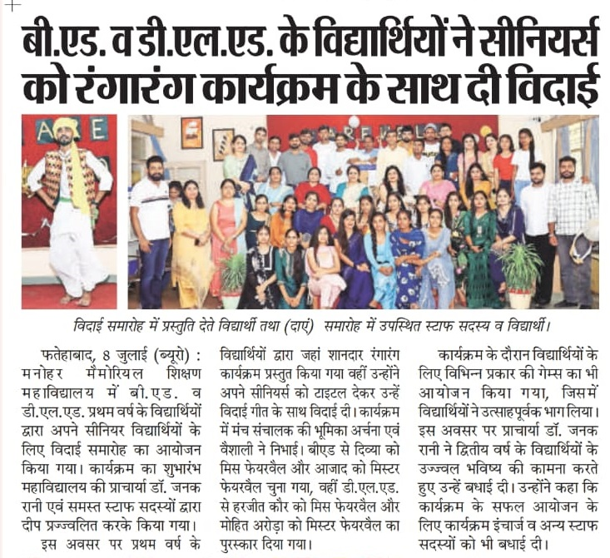
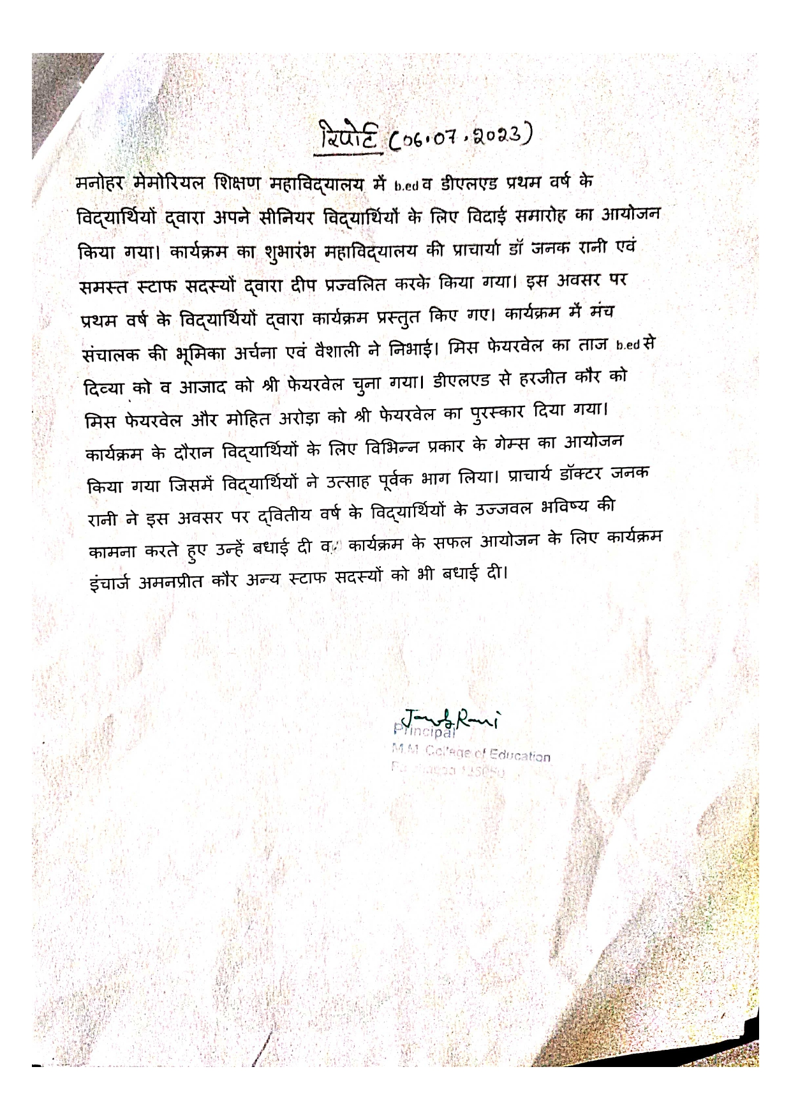
ONE WEEK INTERNATIONAL YOGA CAMP 15.06 TO 21.06.2023
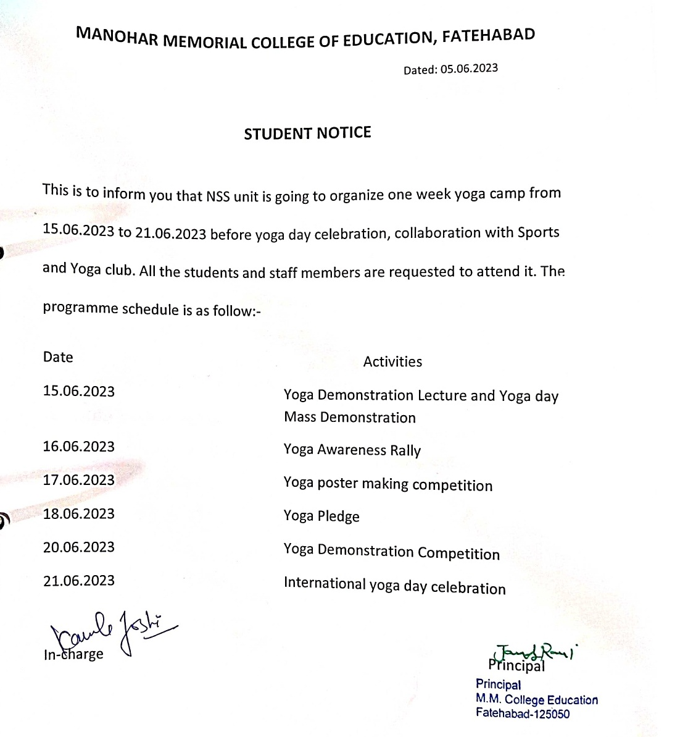

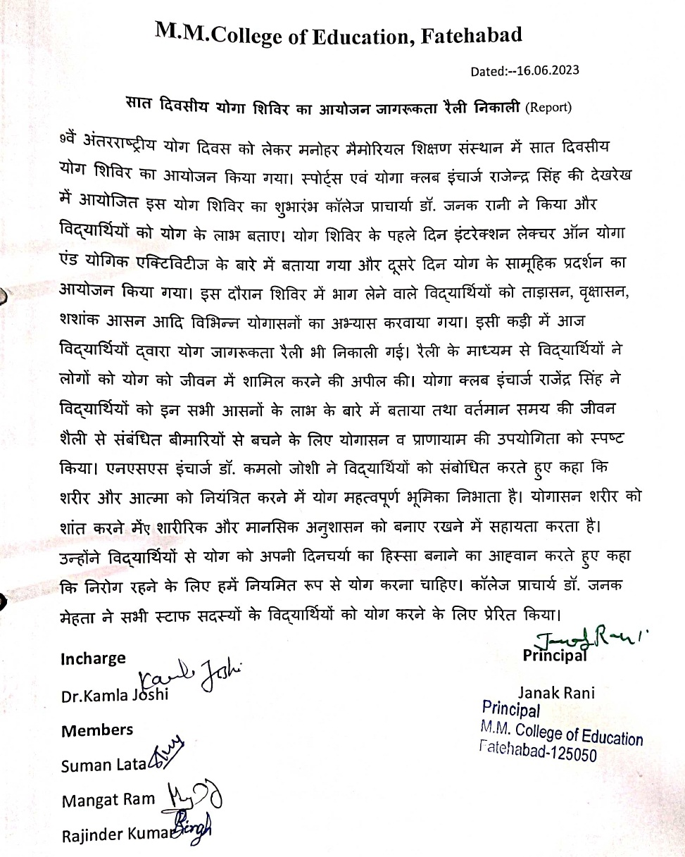
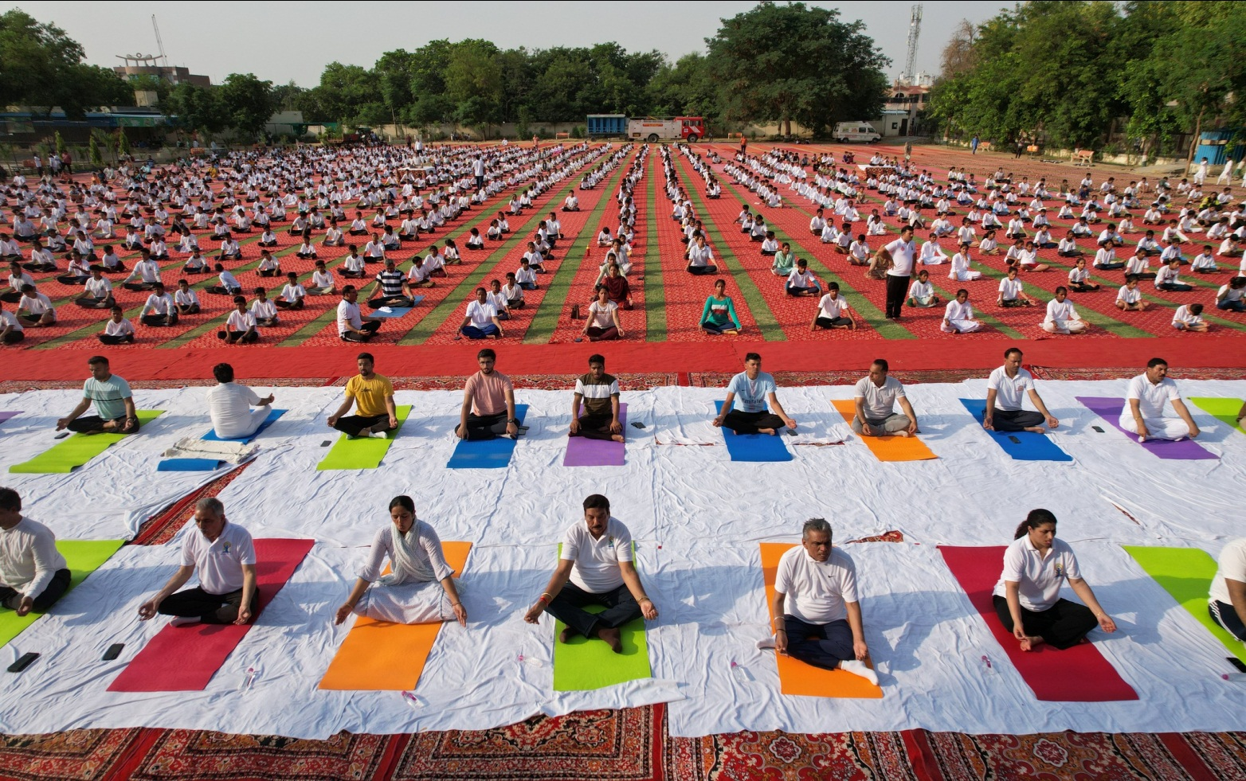
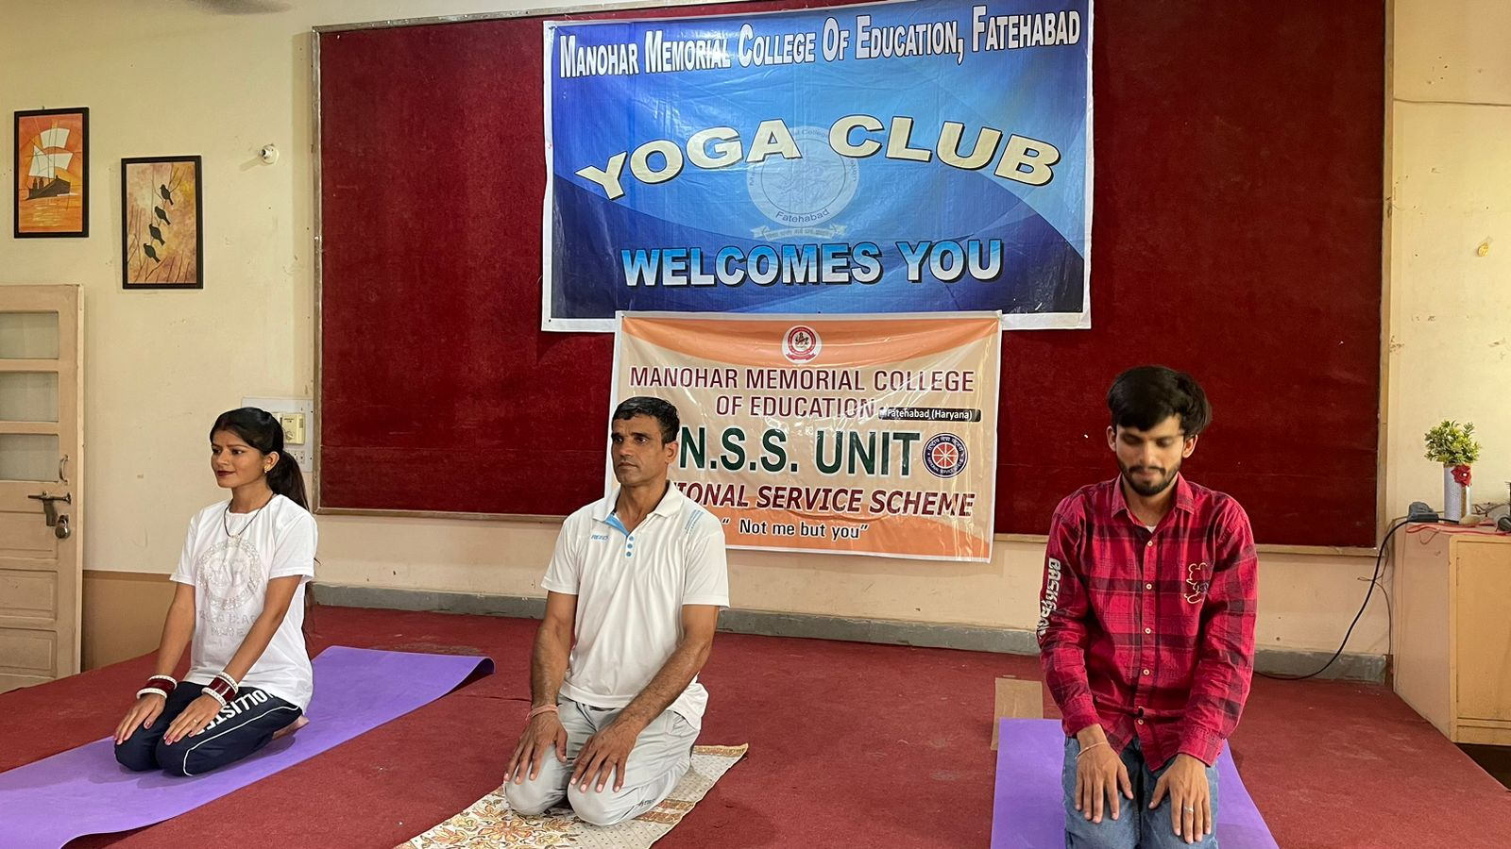
DHAYAN SHIVIR 06.06.2023
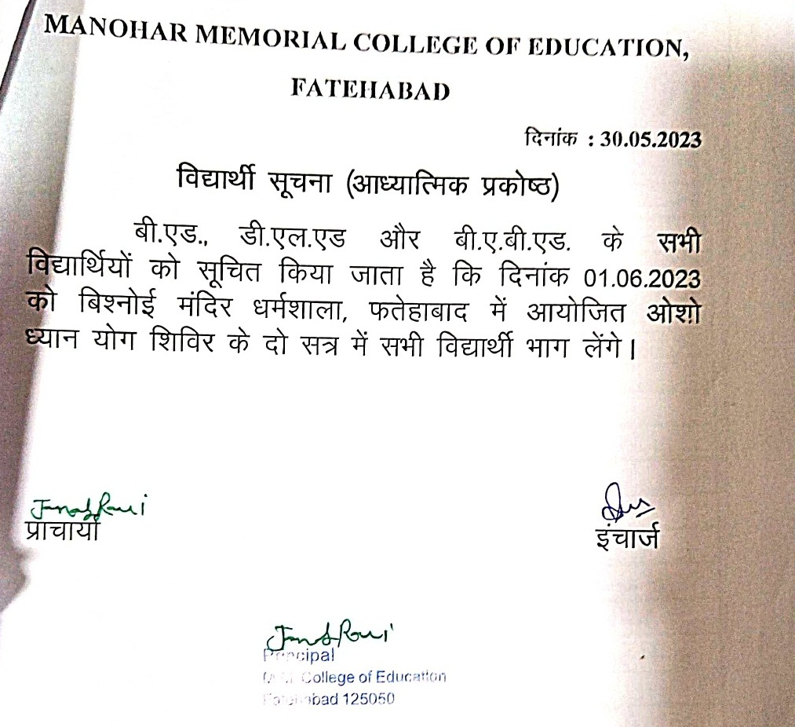

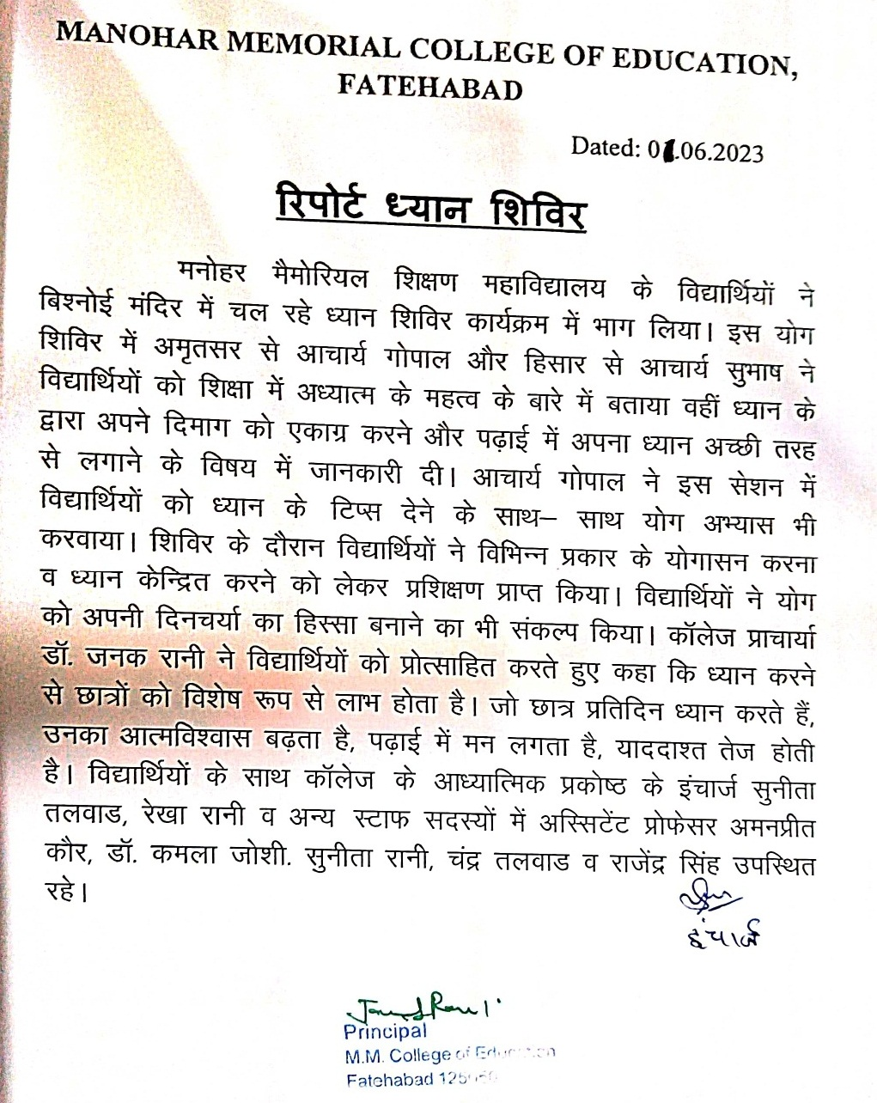
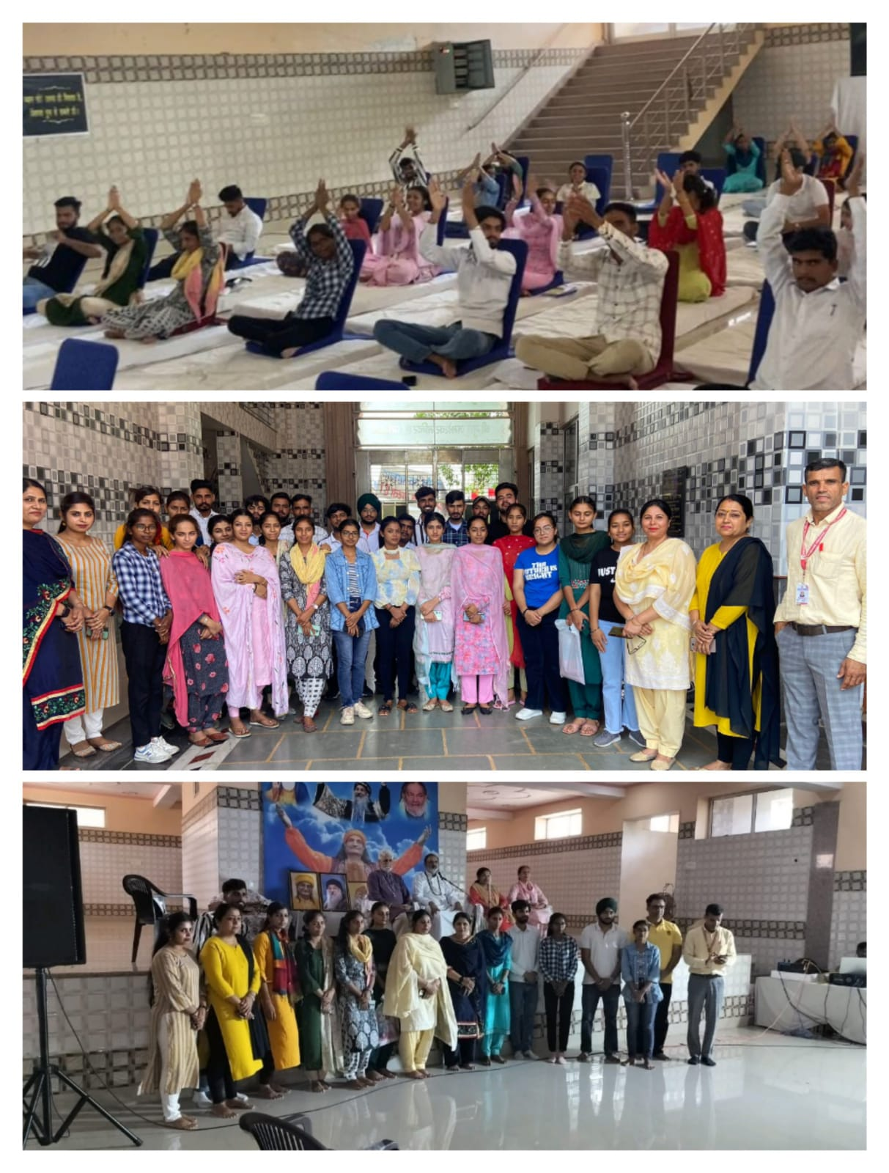
GIFT MAKING COMPETITION FOR MOTHER ON MOTHER DAY 13.05.2023
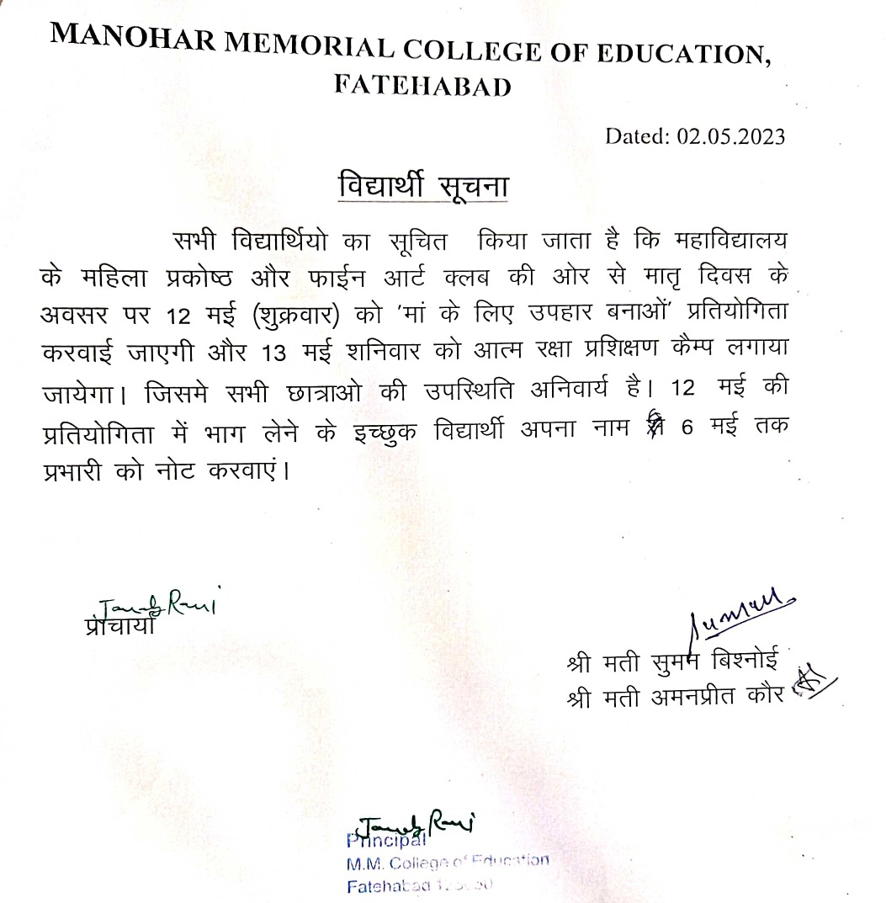
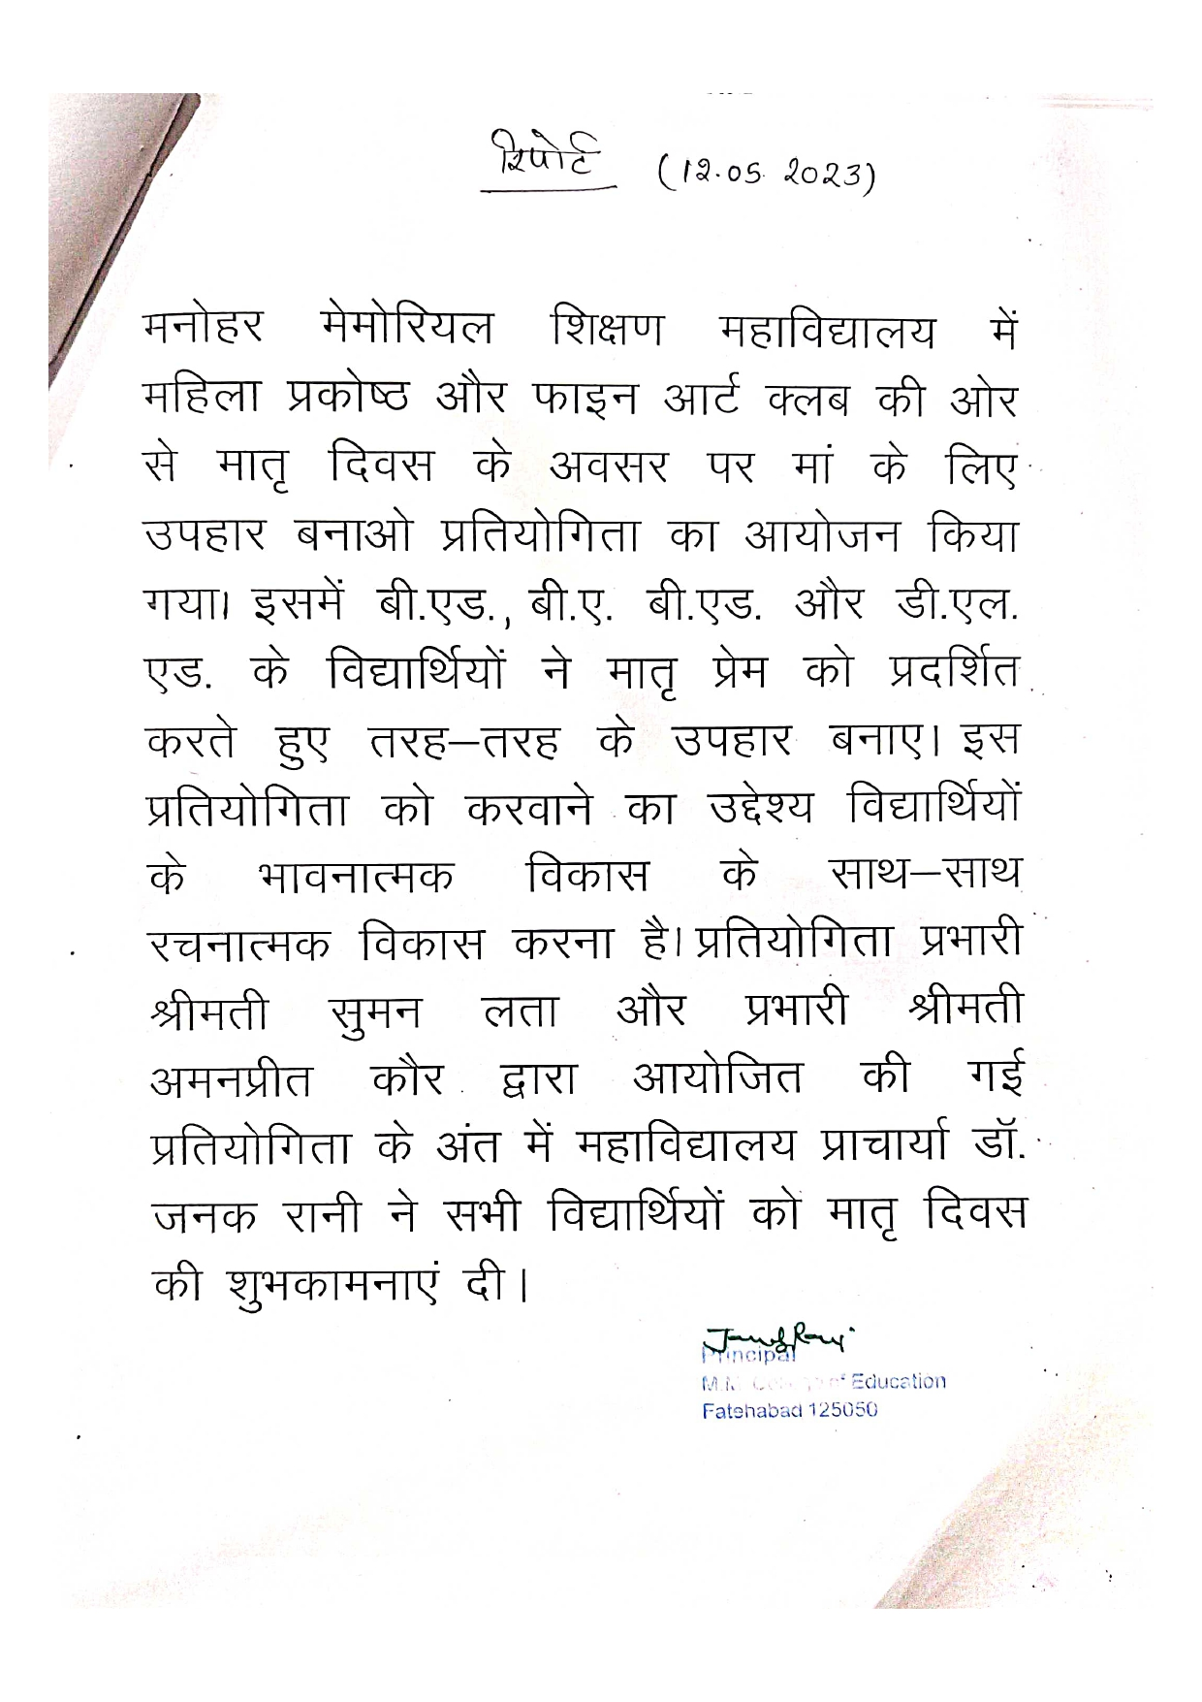

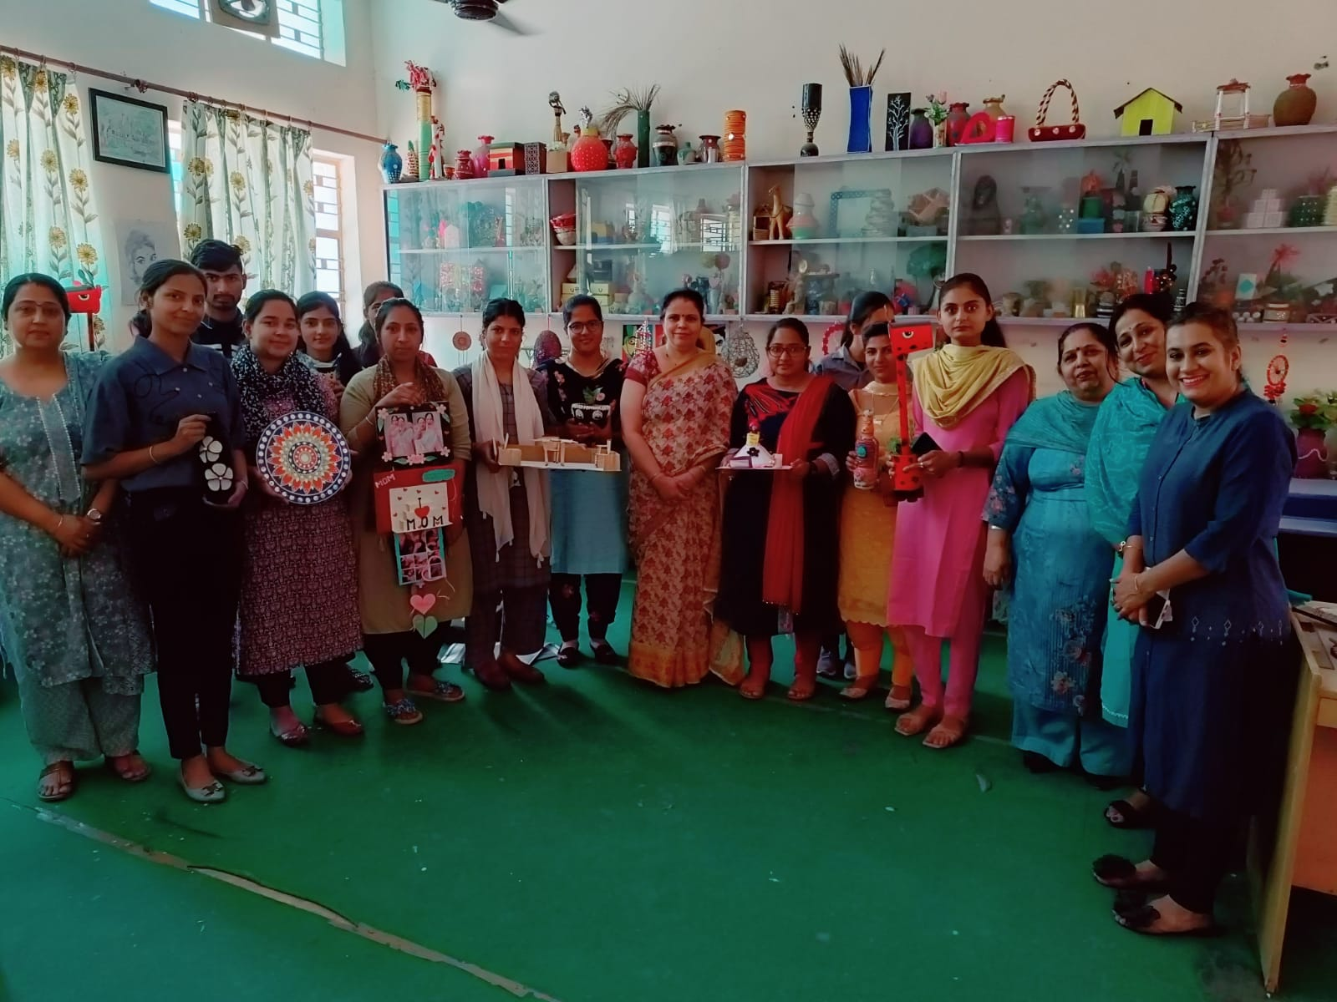
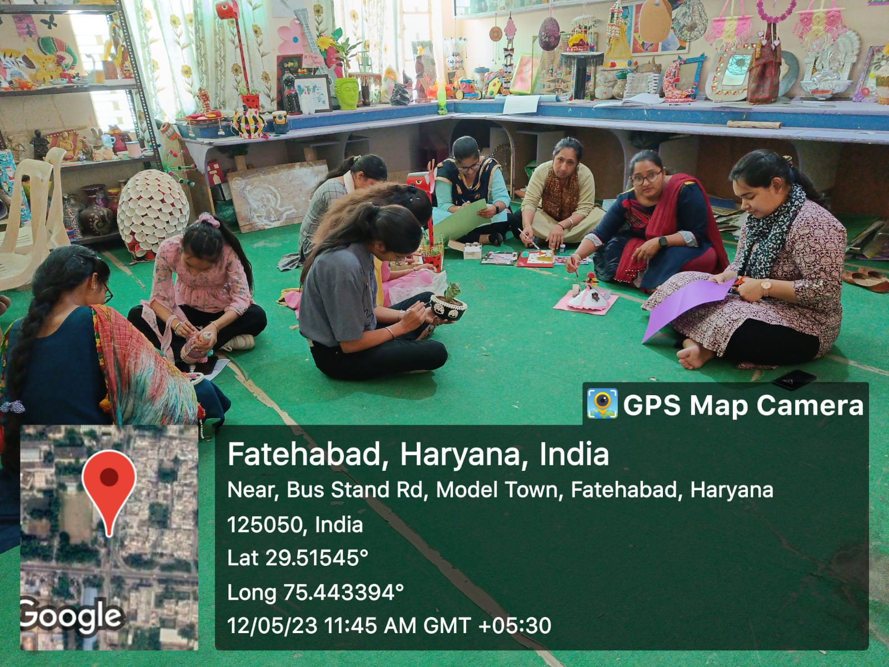
WORKSHOP ON PHYSICAL FITNESS 27.04.2023
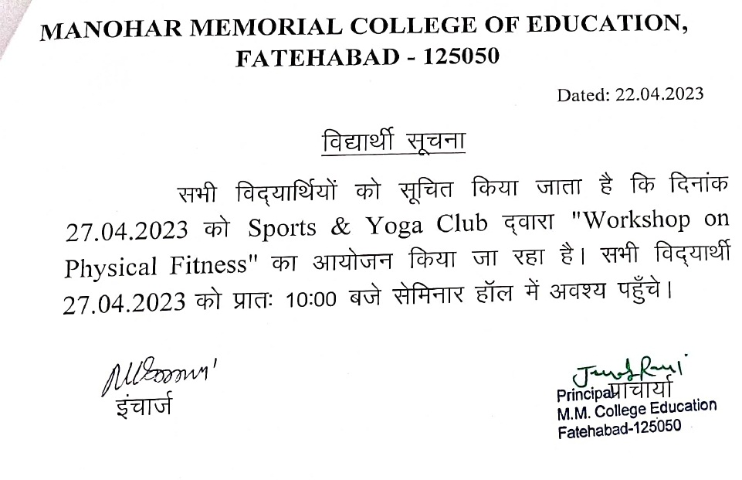

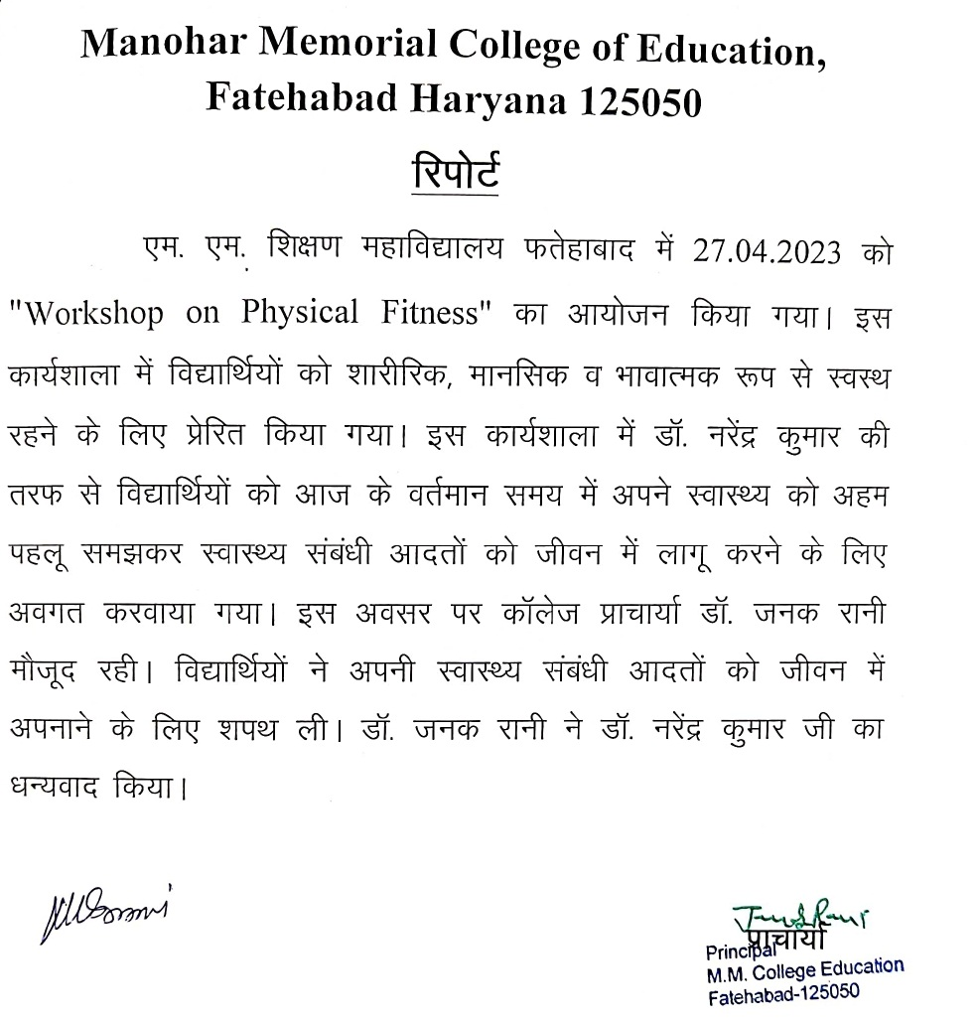

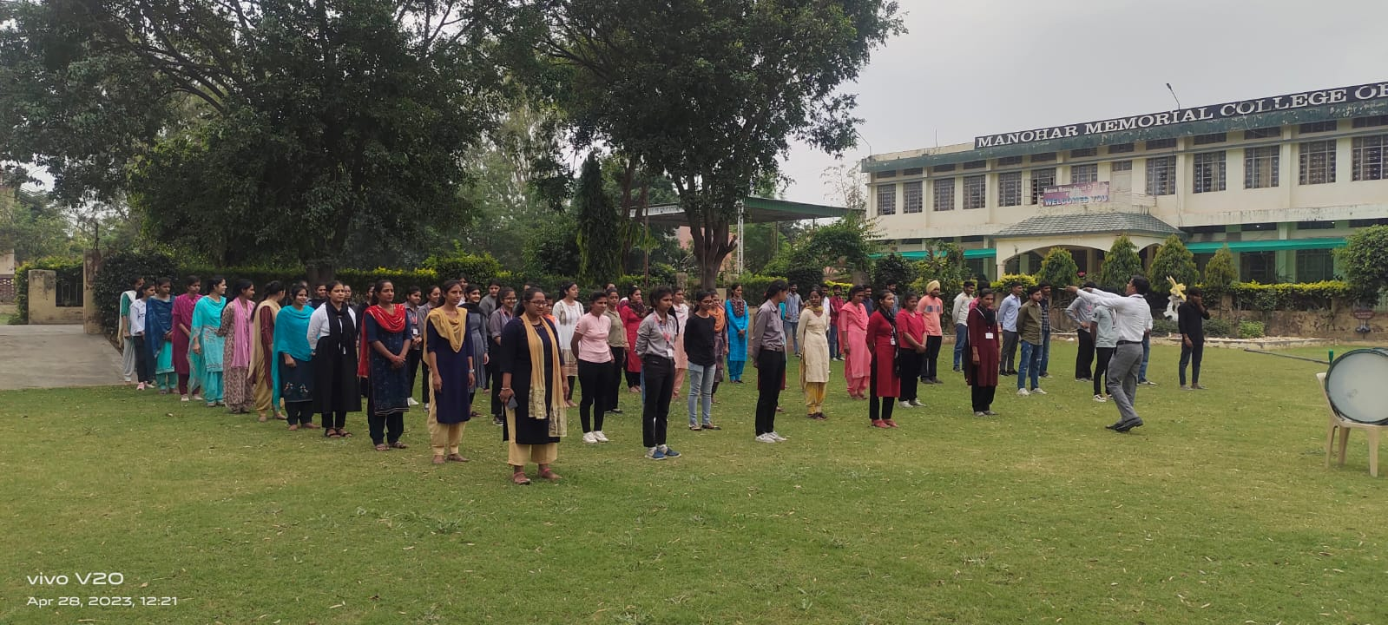
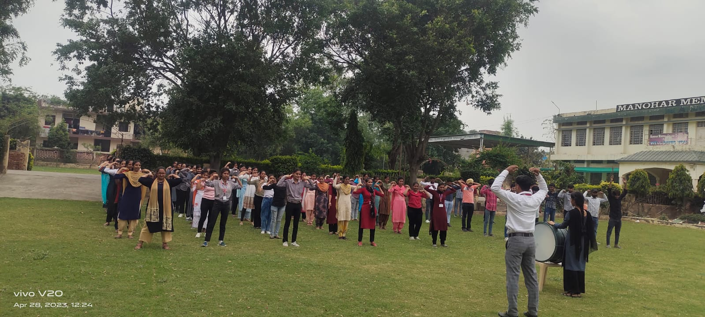
3 DAYS EDUCATIONAL TOUR 14.04 TO 16.04.2023
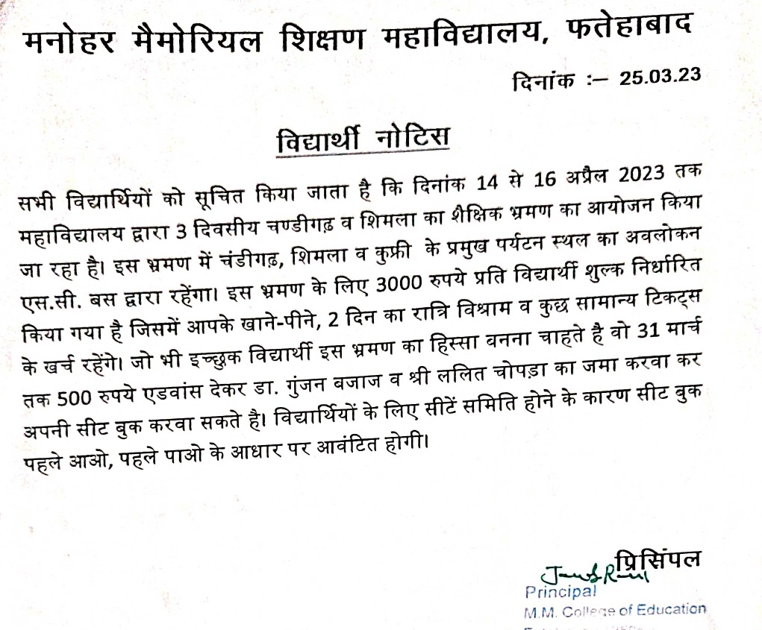

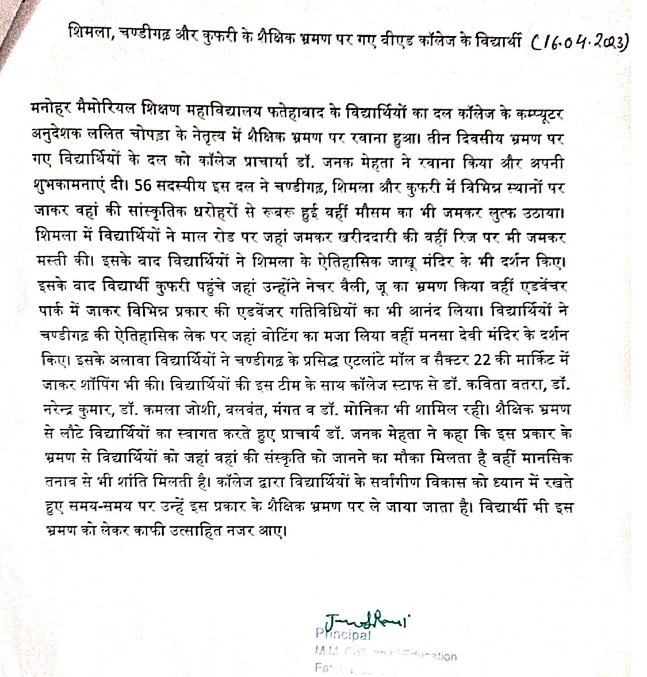

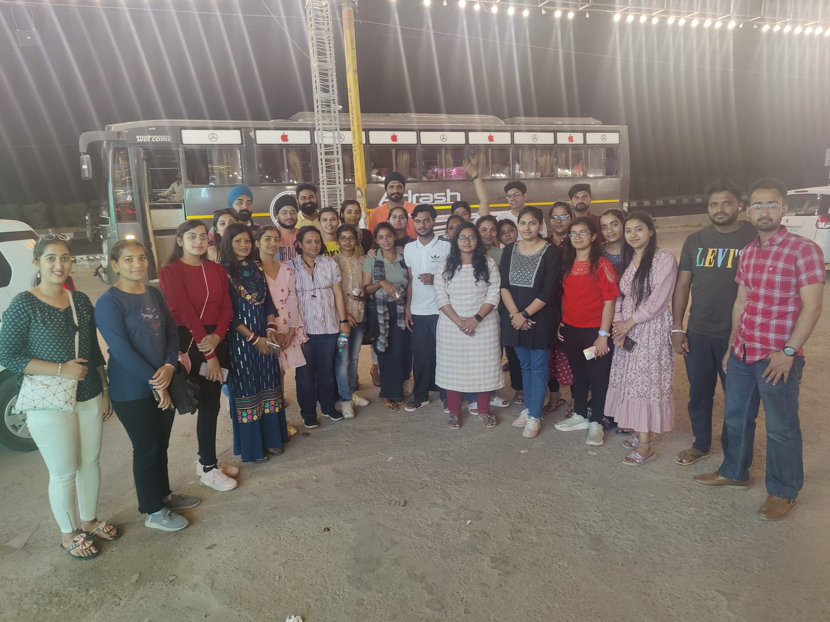
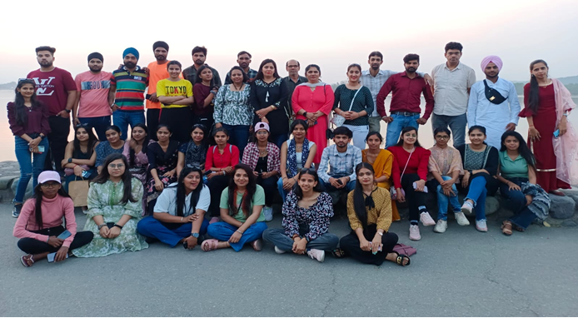
ATHLETIC MEET 20.03.2023
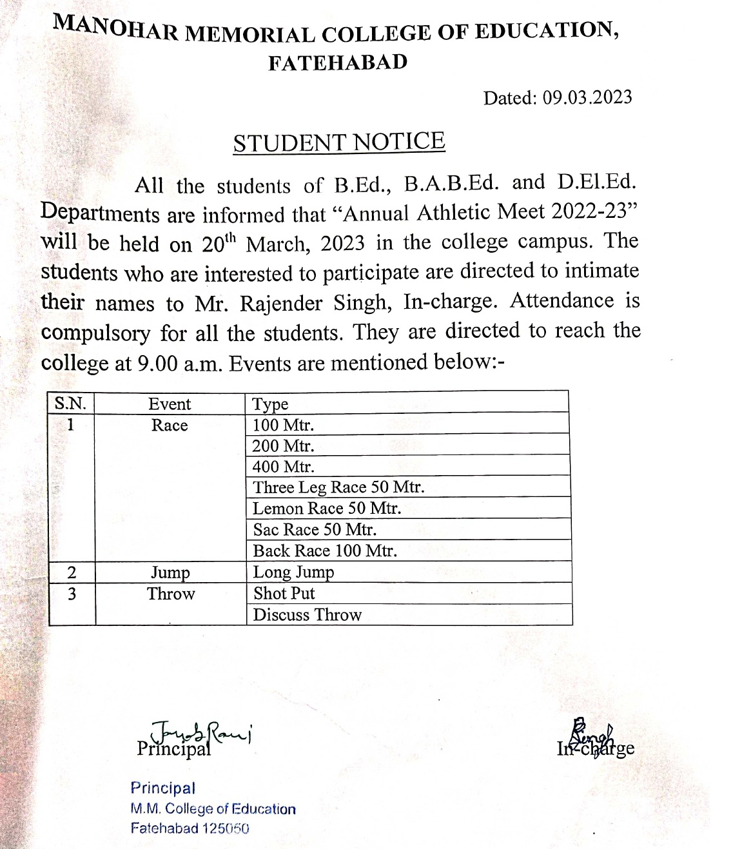
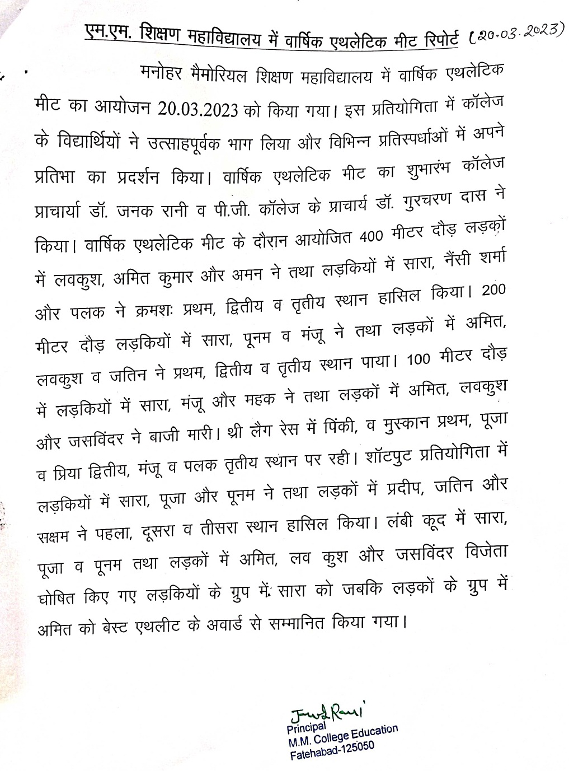
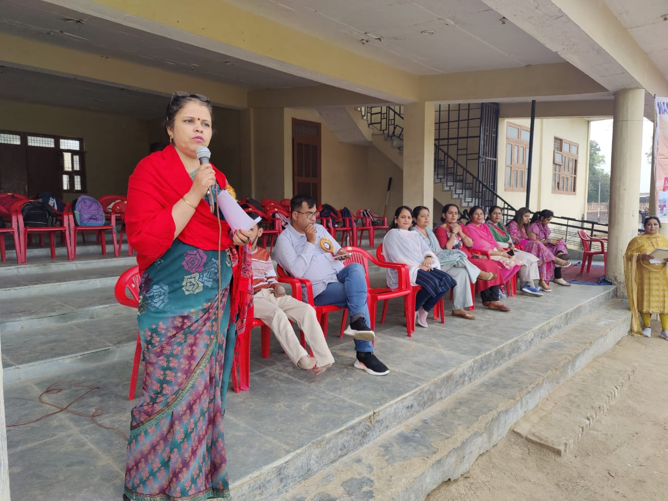
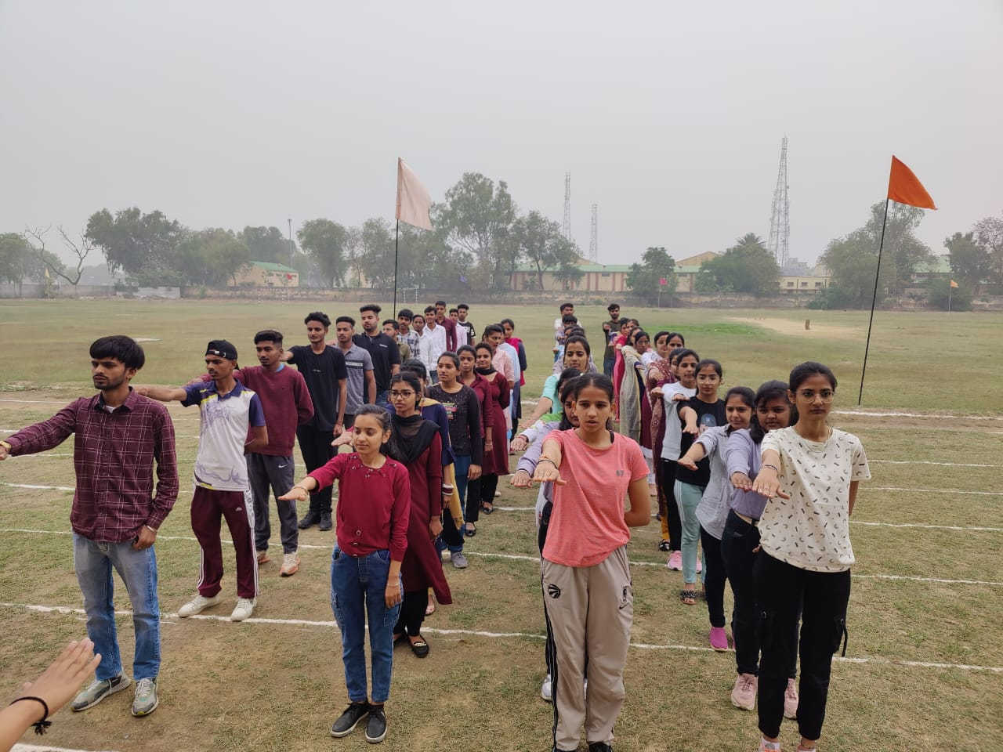
HOLI CELEBRATION 07.03.2023
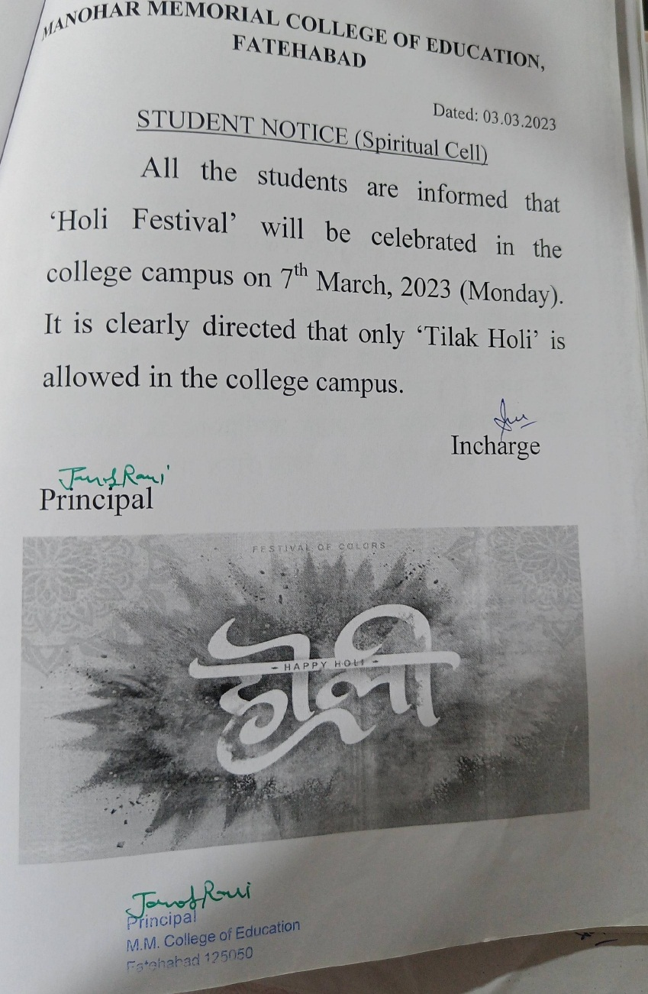
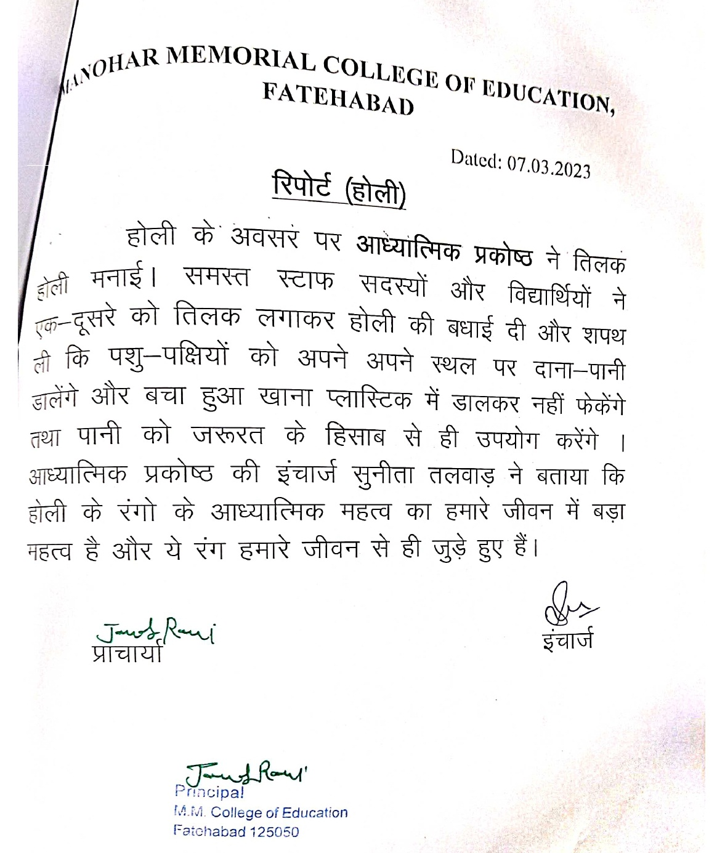
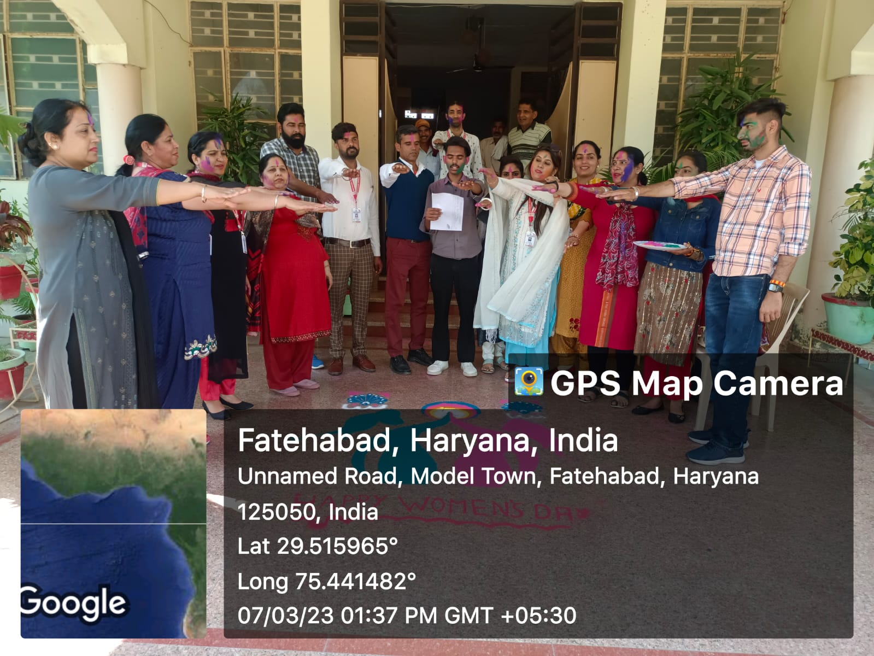

INTERNATIONAL WOMENS DAY 05.03.2023
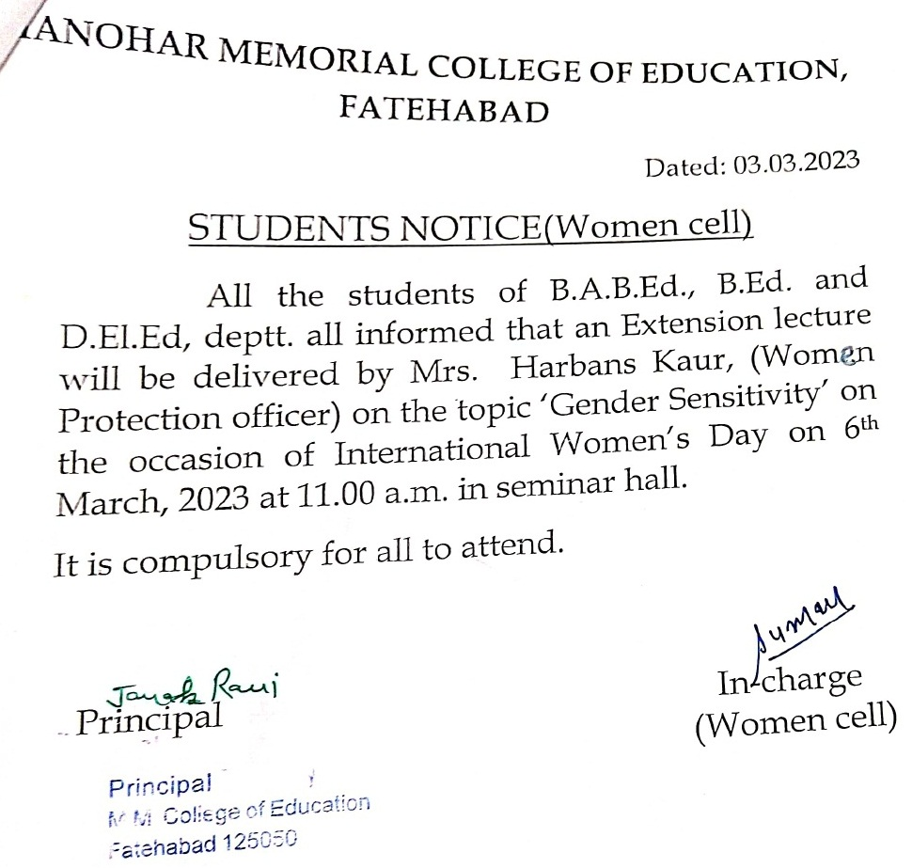

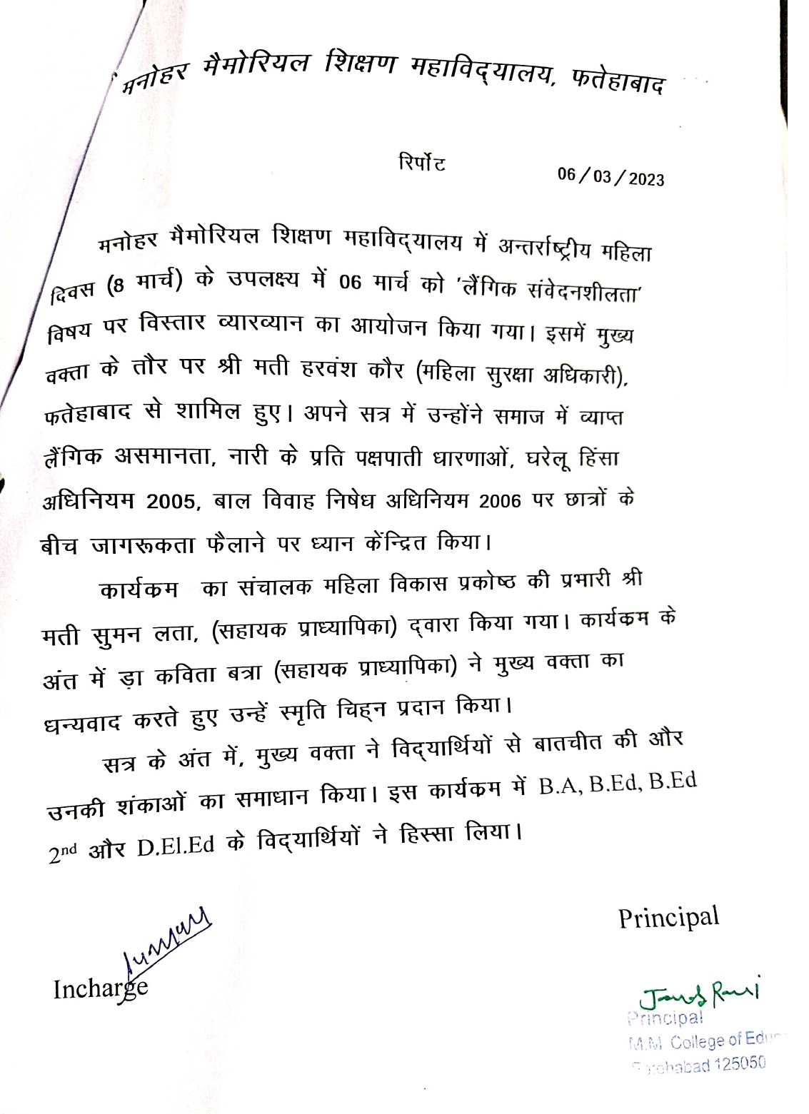
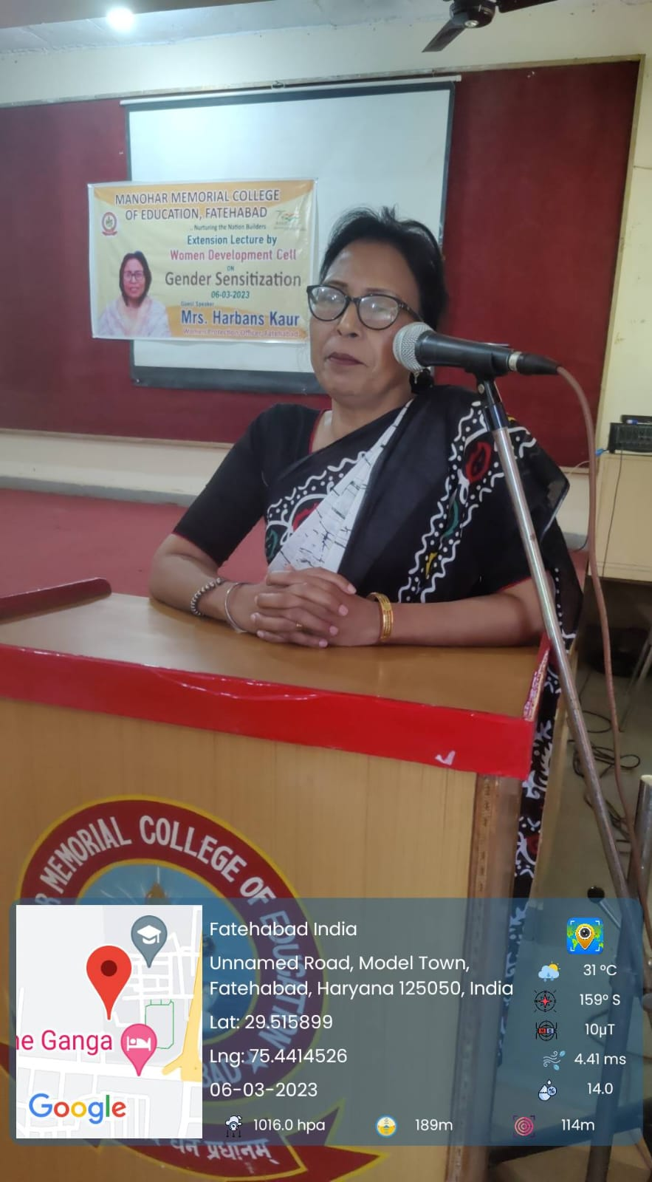
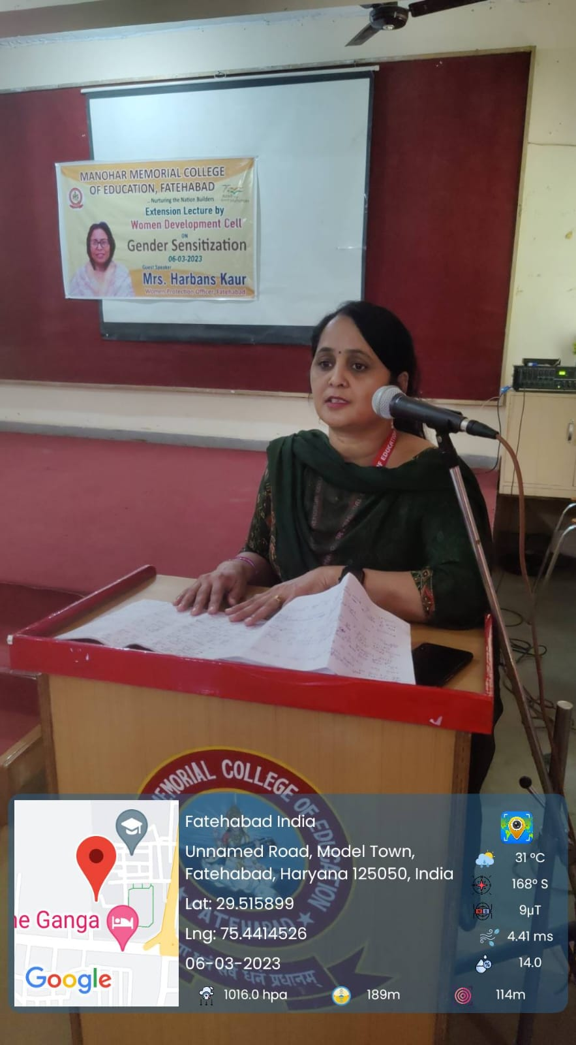
MASTER CHEF COMPETITION 04.03.2023
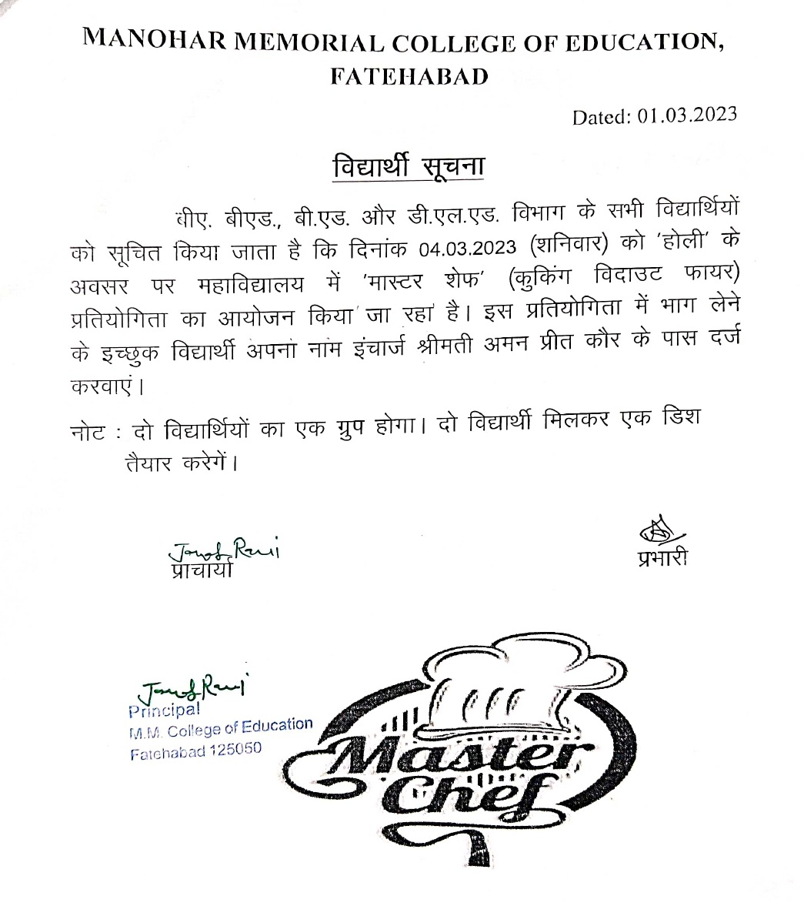
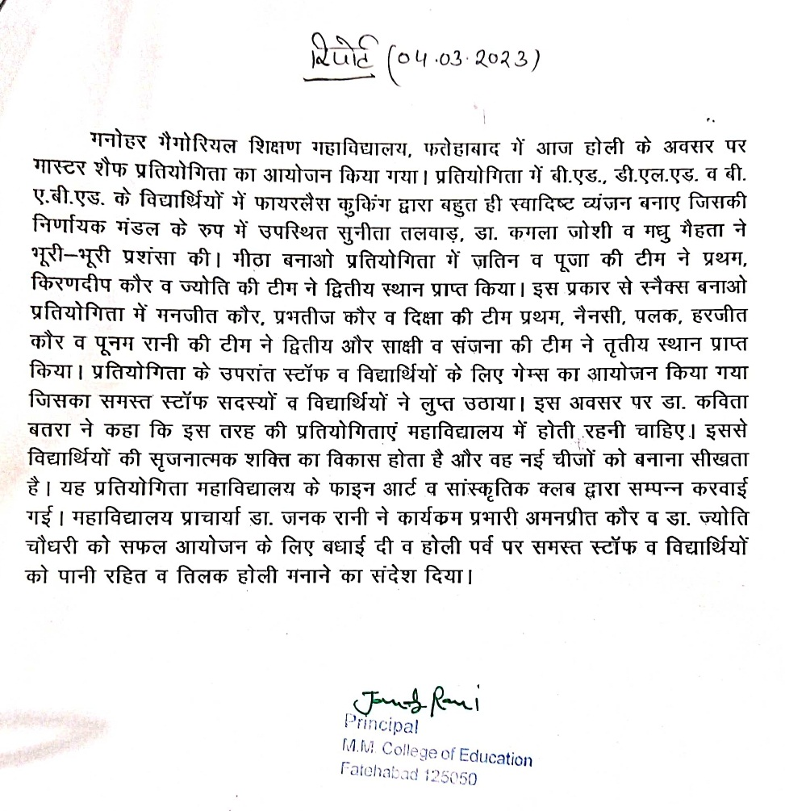
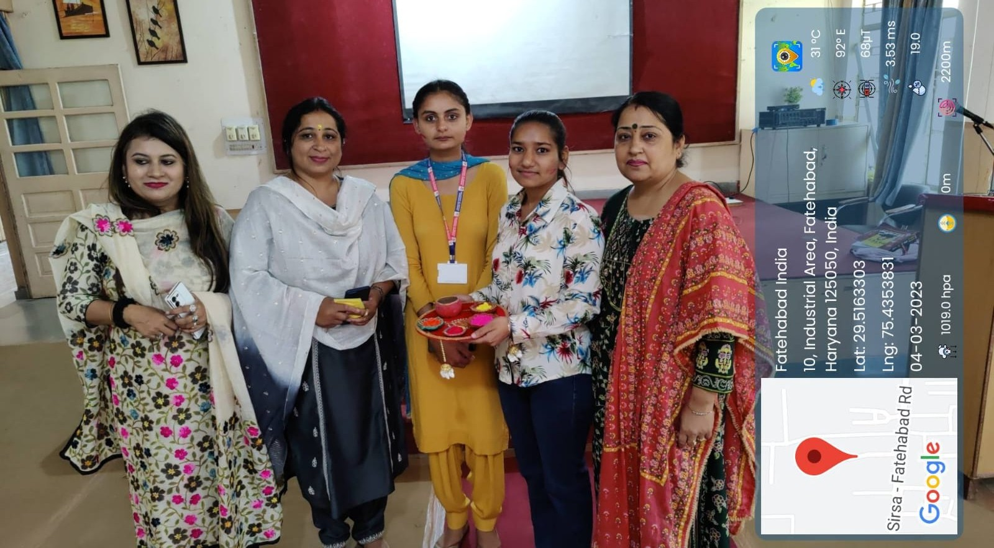
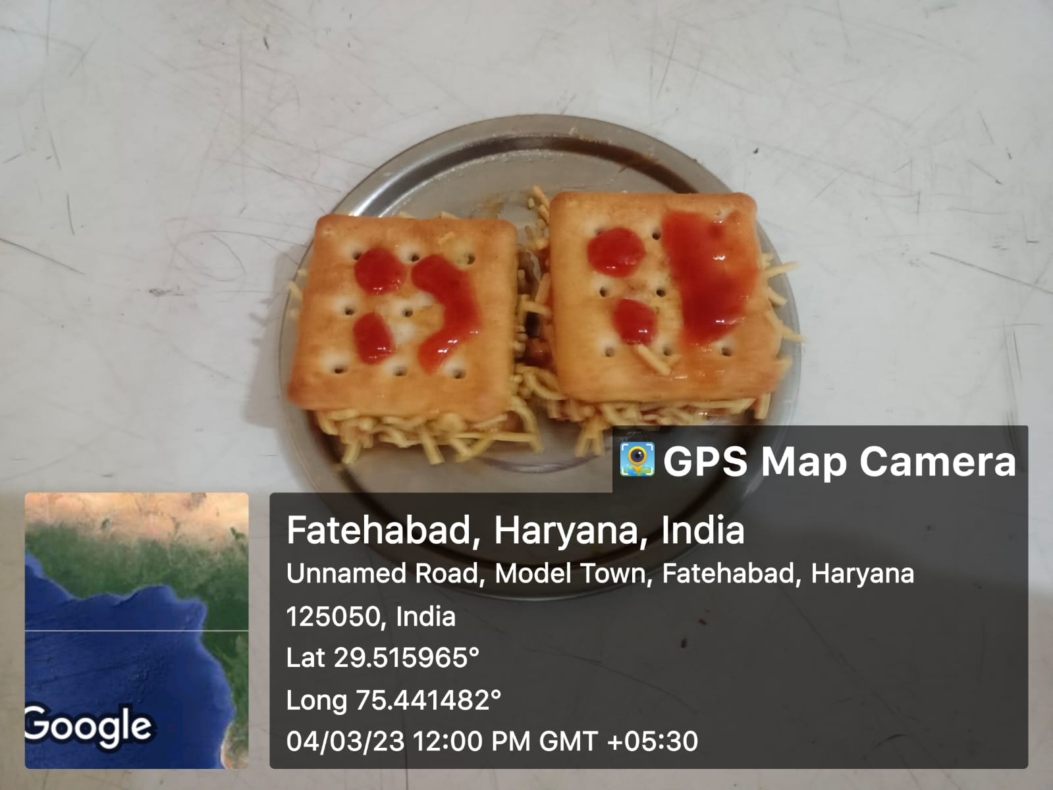
KHATU SHYAM YATRA 17.02 TO 18.02.2023
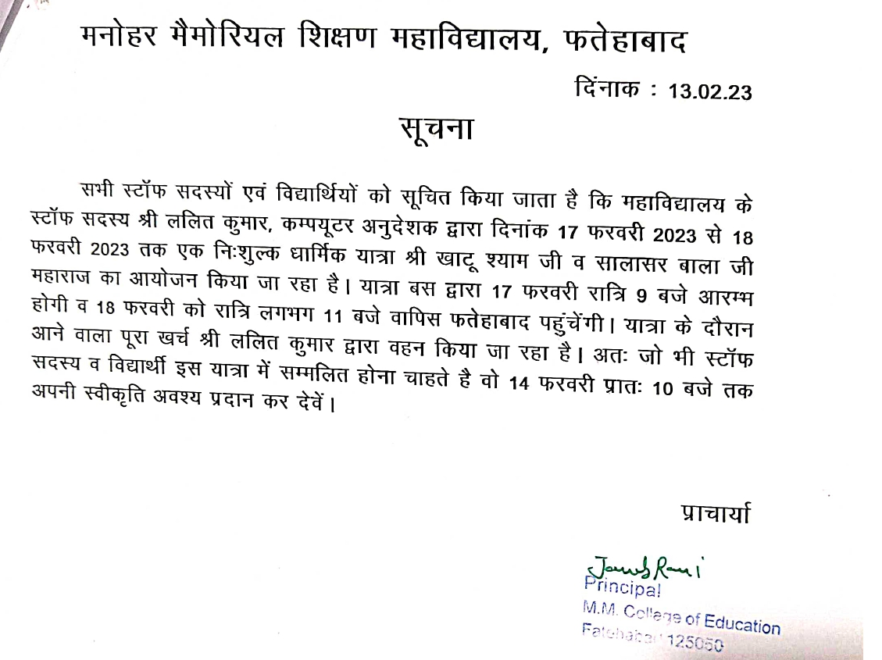

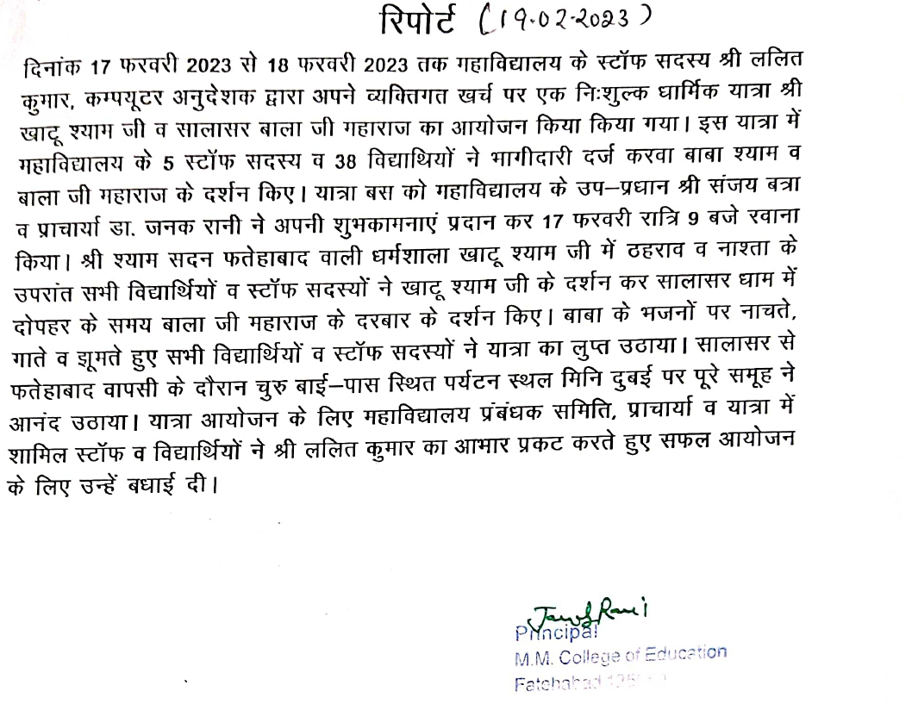

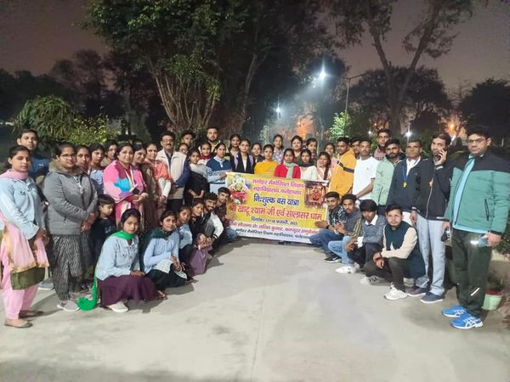
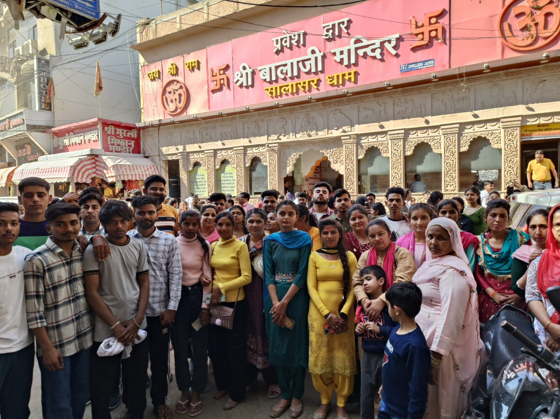
LOHRI CELEBRATION 13.01.2023
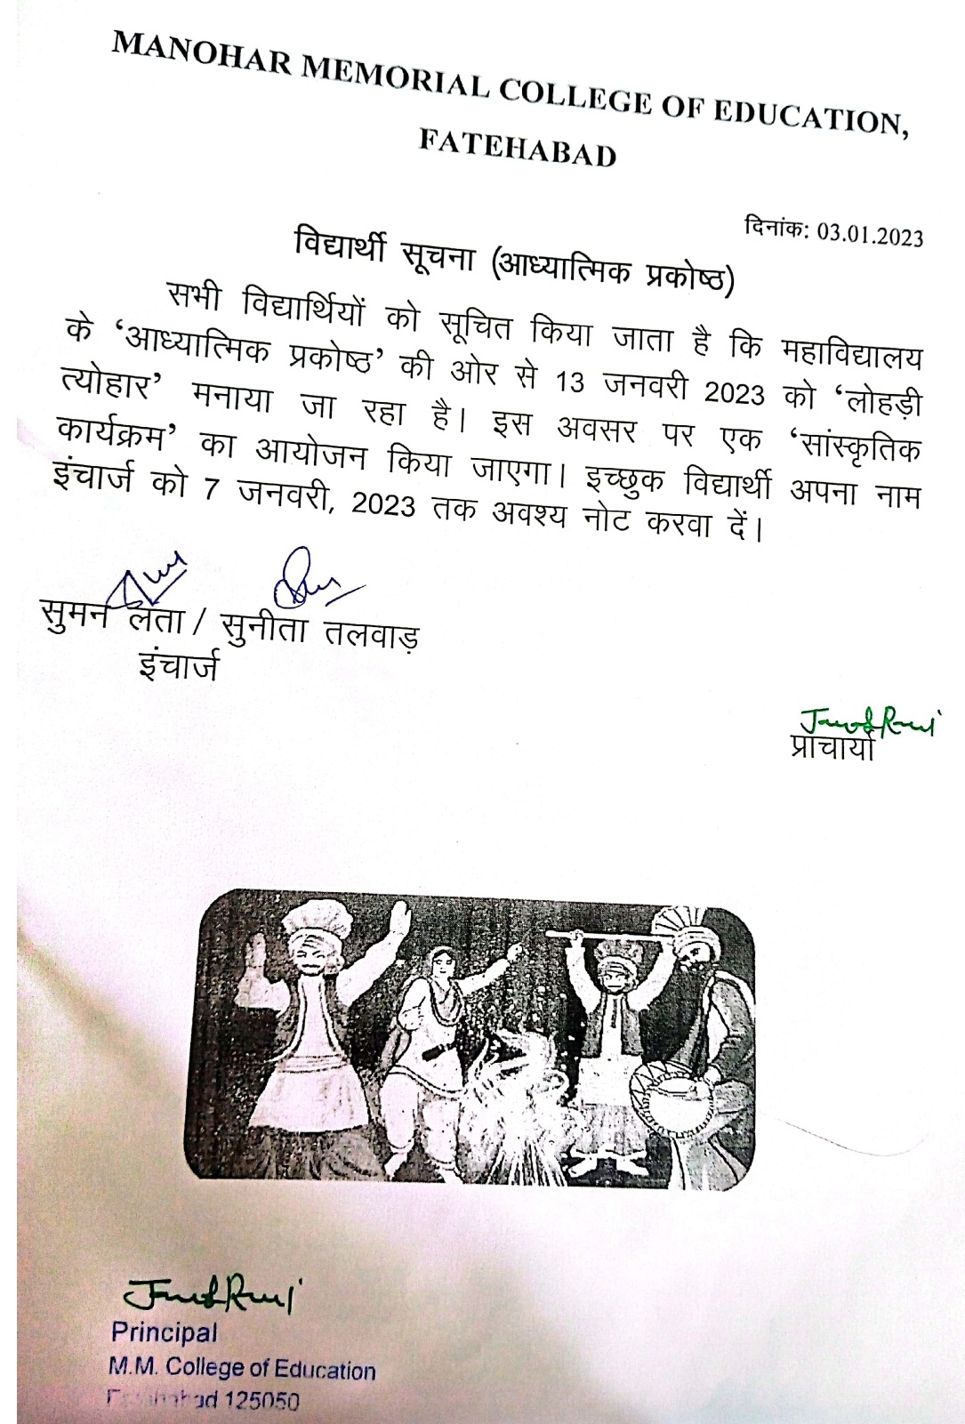

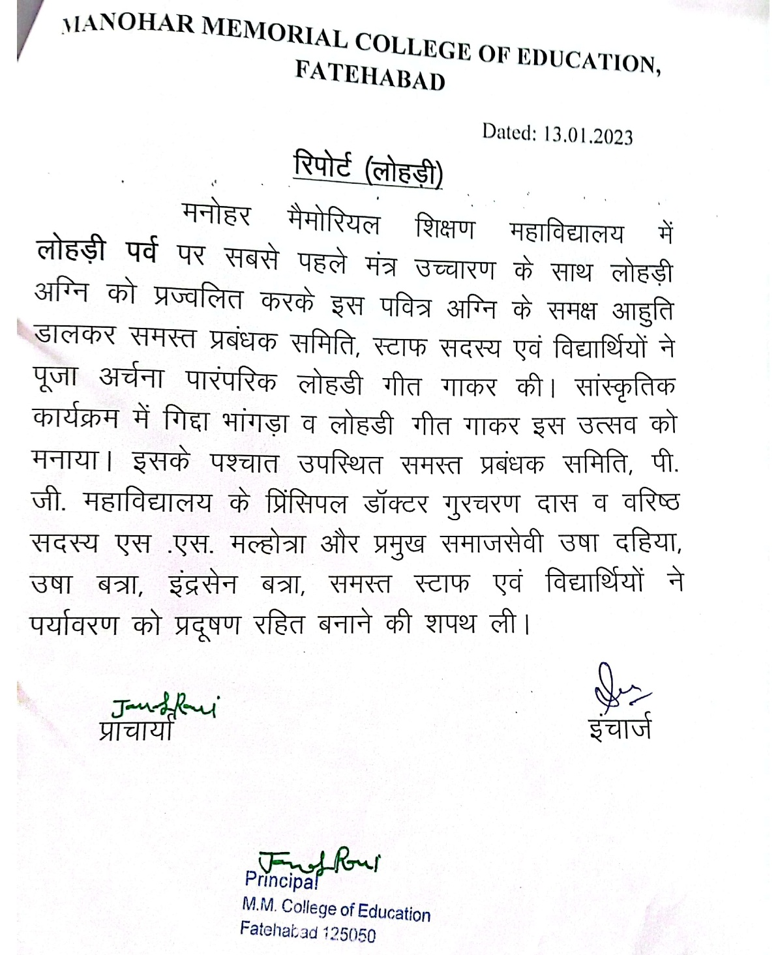
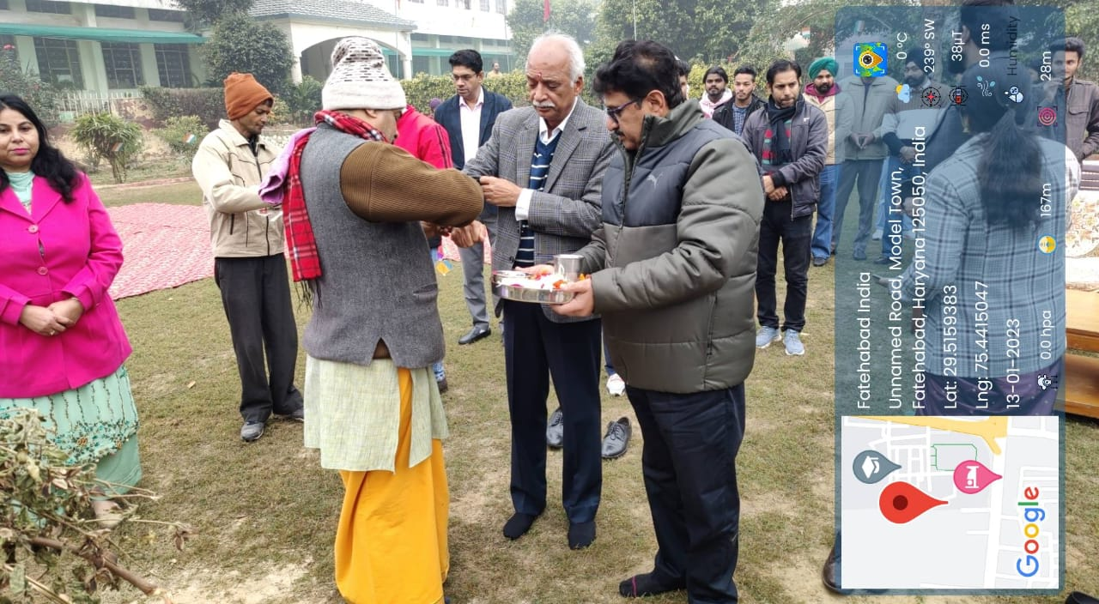
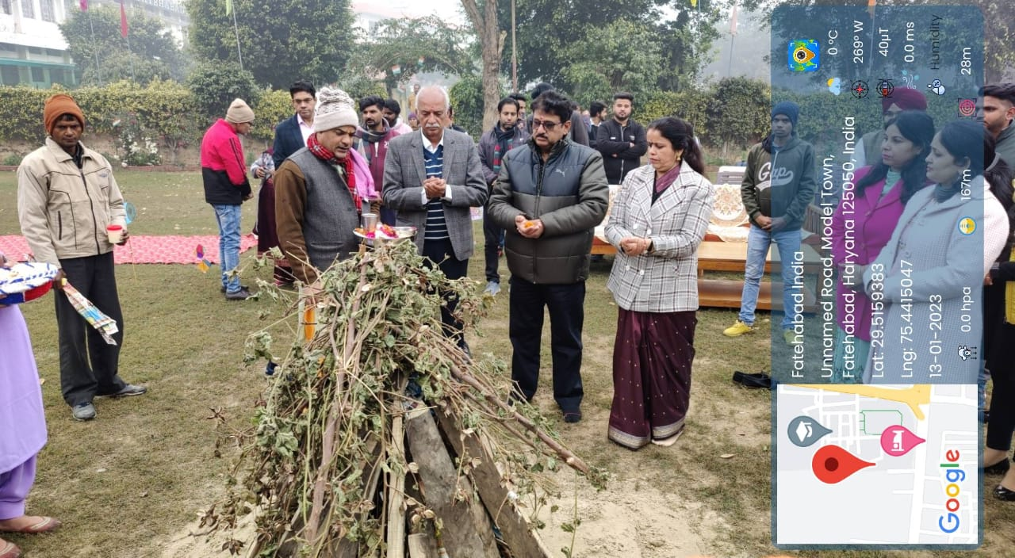
NEW YEAR CELEBRATION 02.01.2023
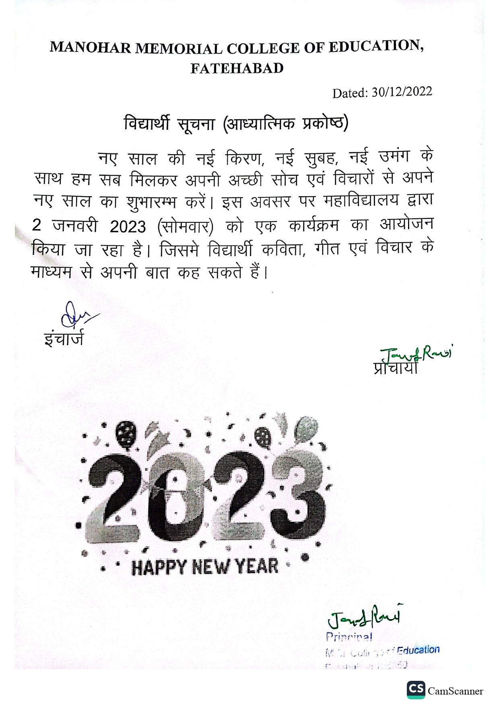

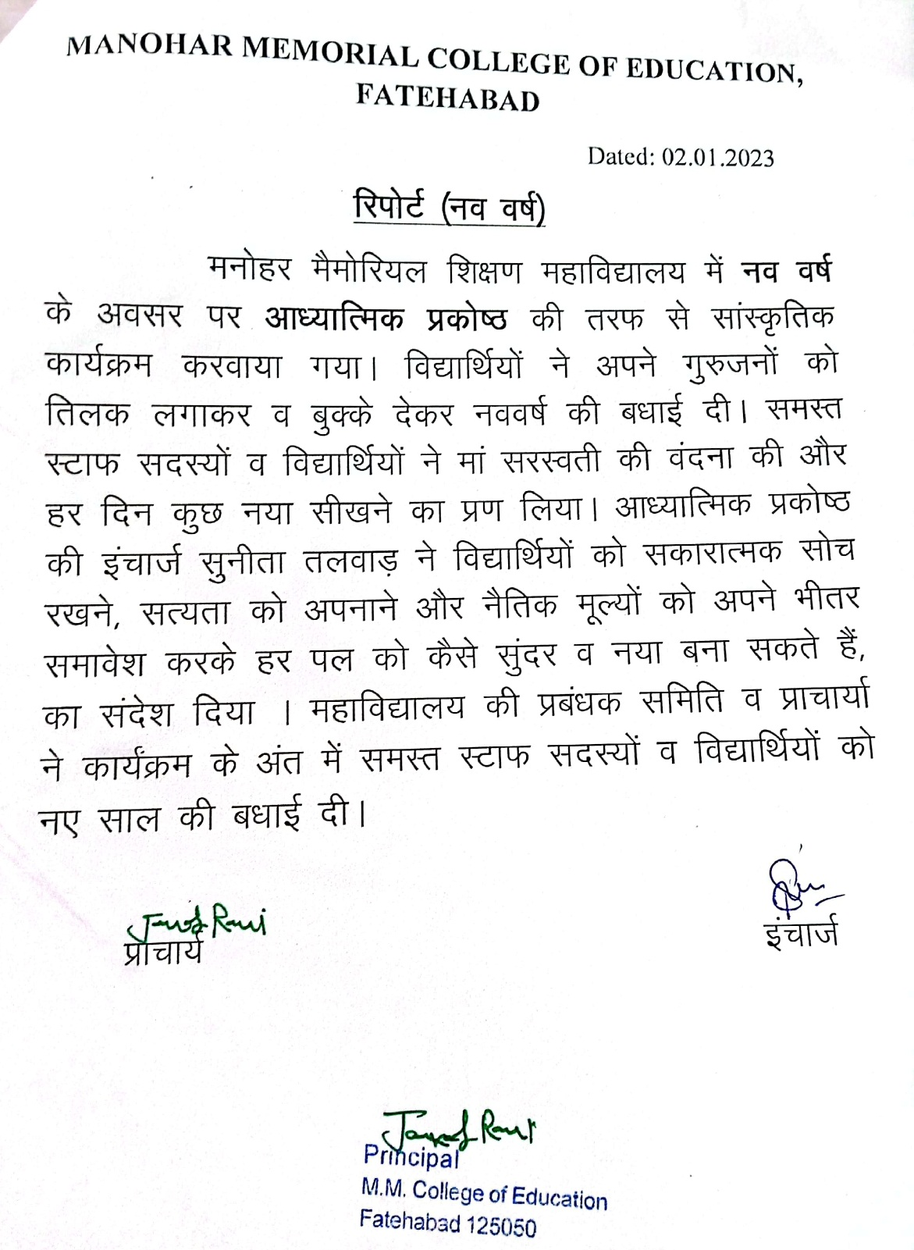
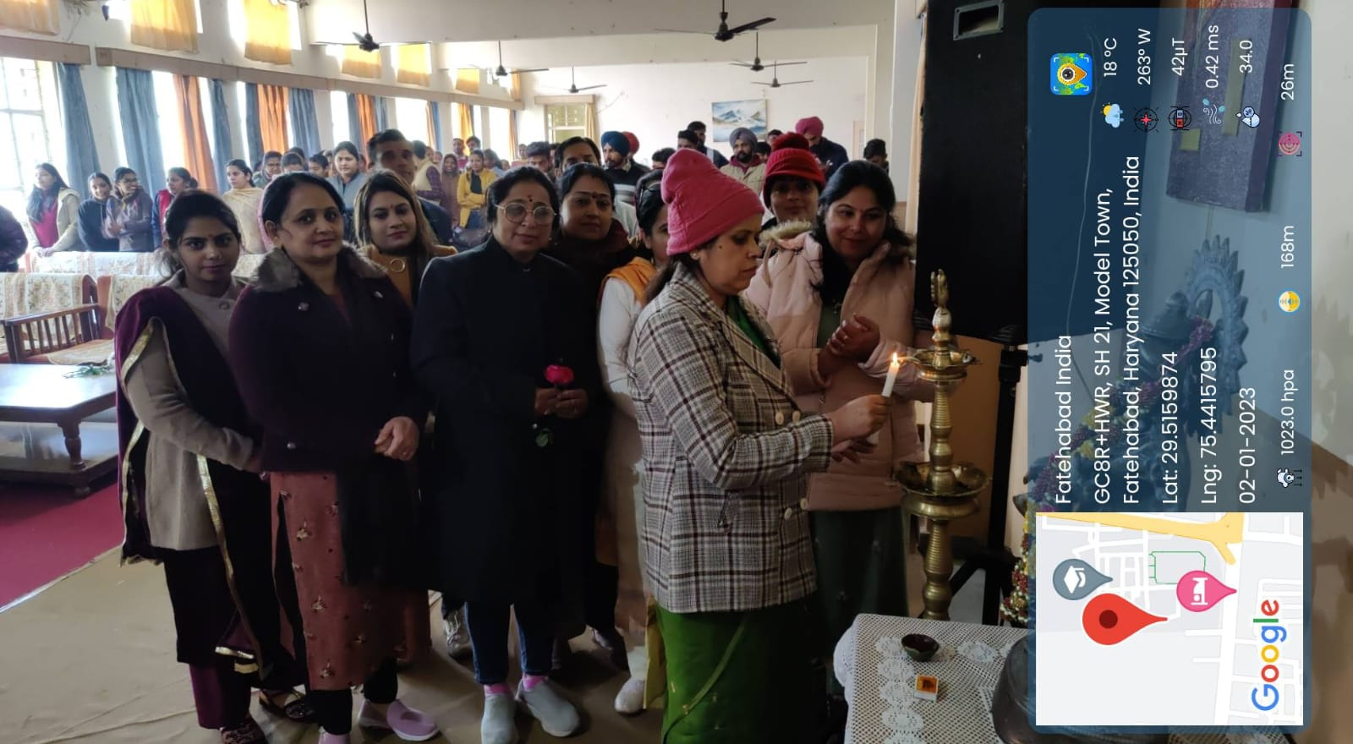
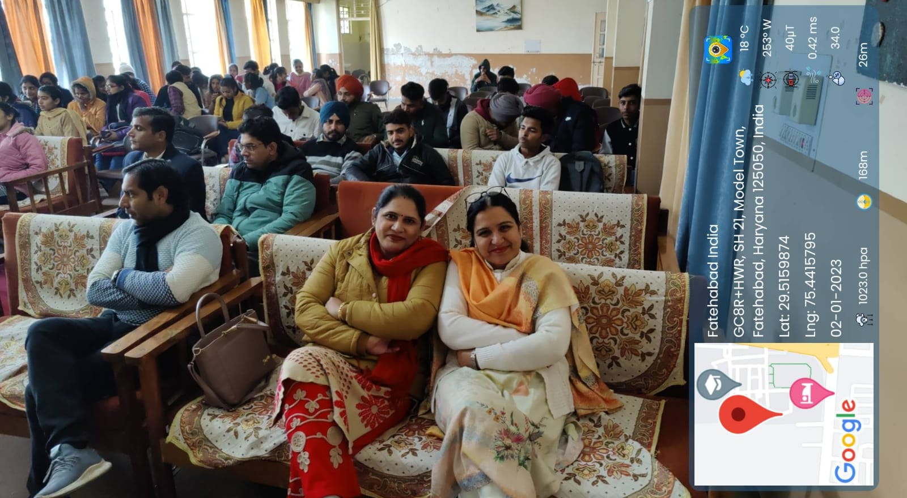
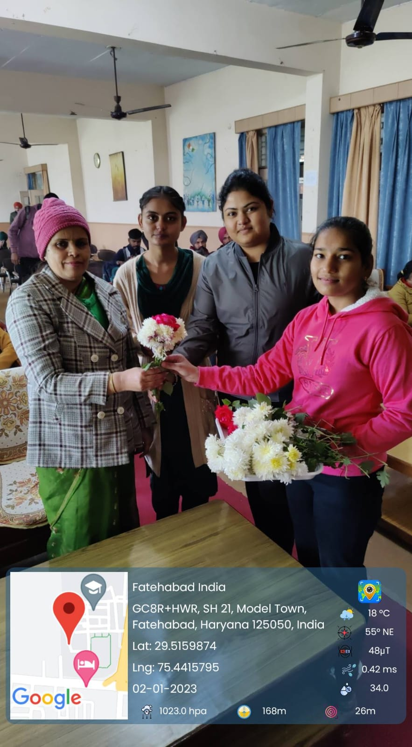
HARYANA RANGOTSAV 31.10.2022
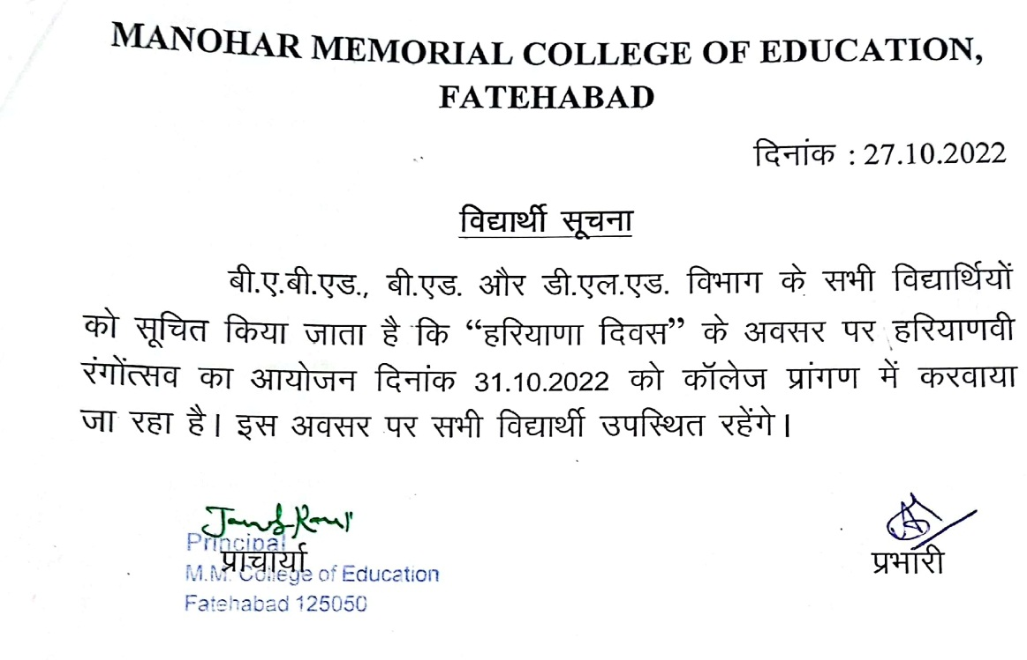

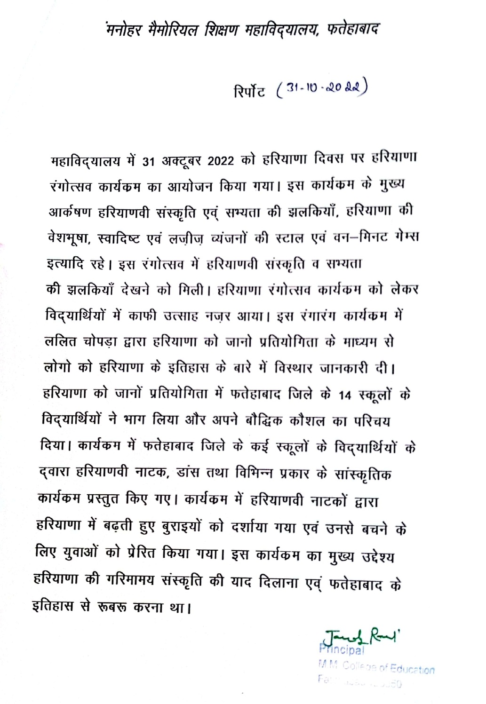
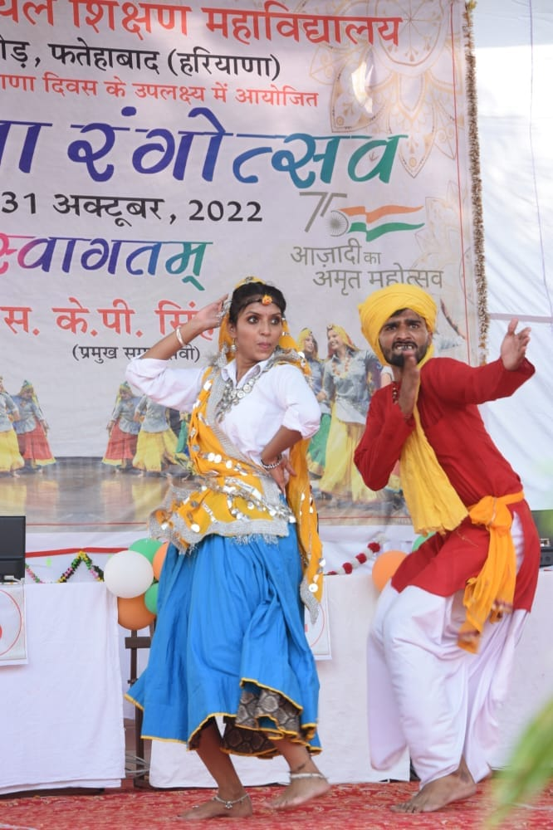
KARWACHOTH CELEBRATION 12.10.2022
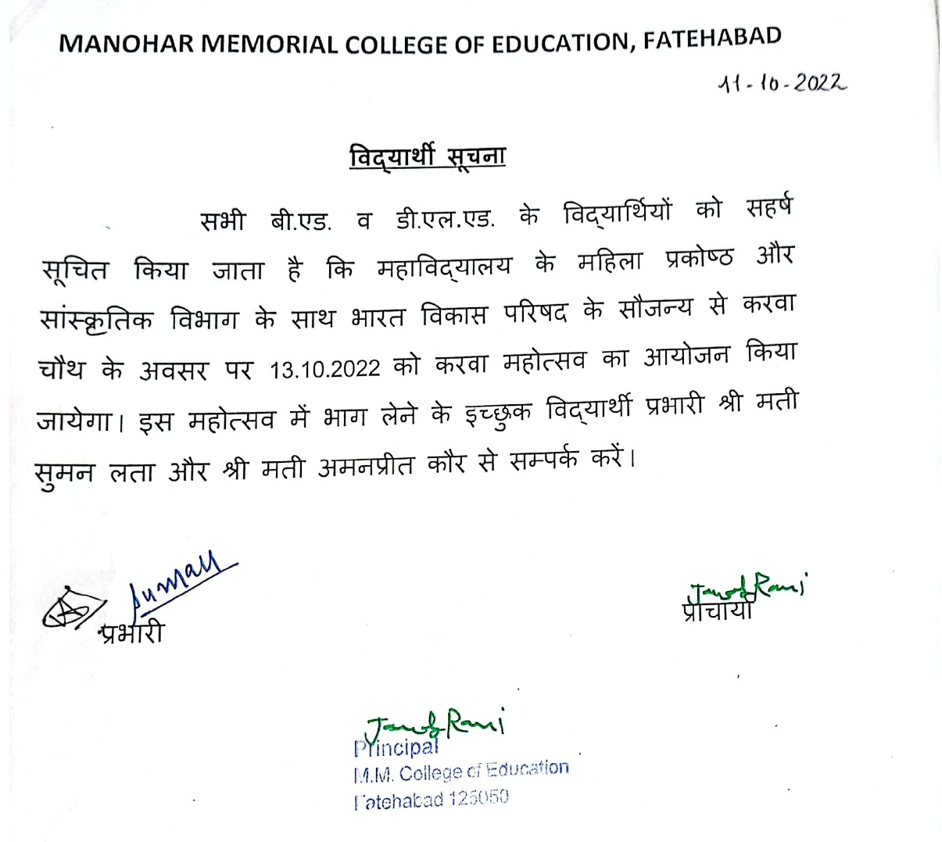

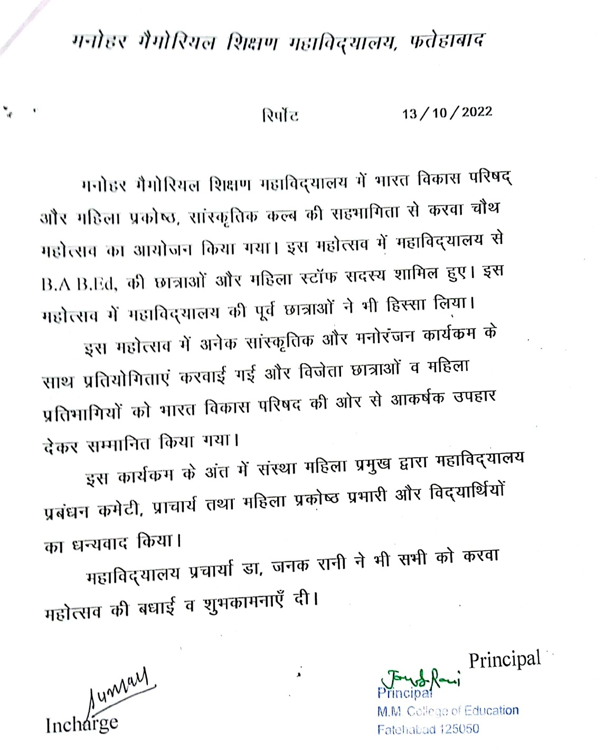
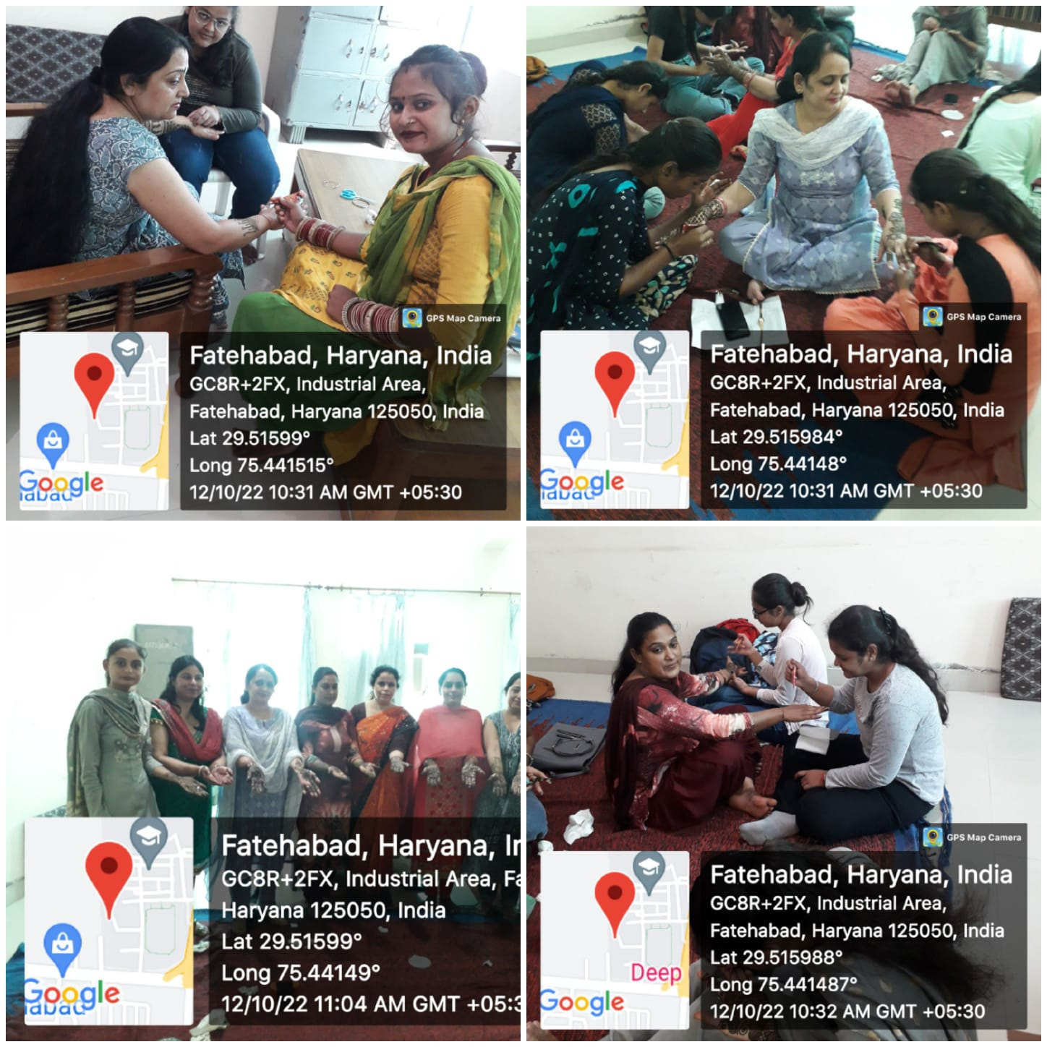
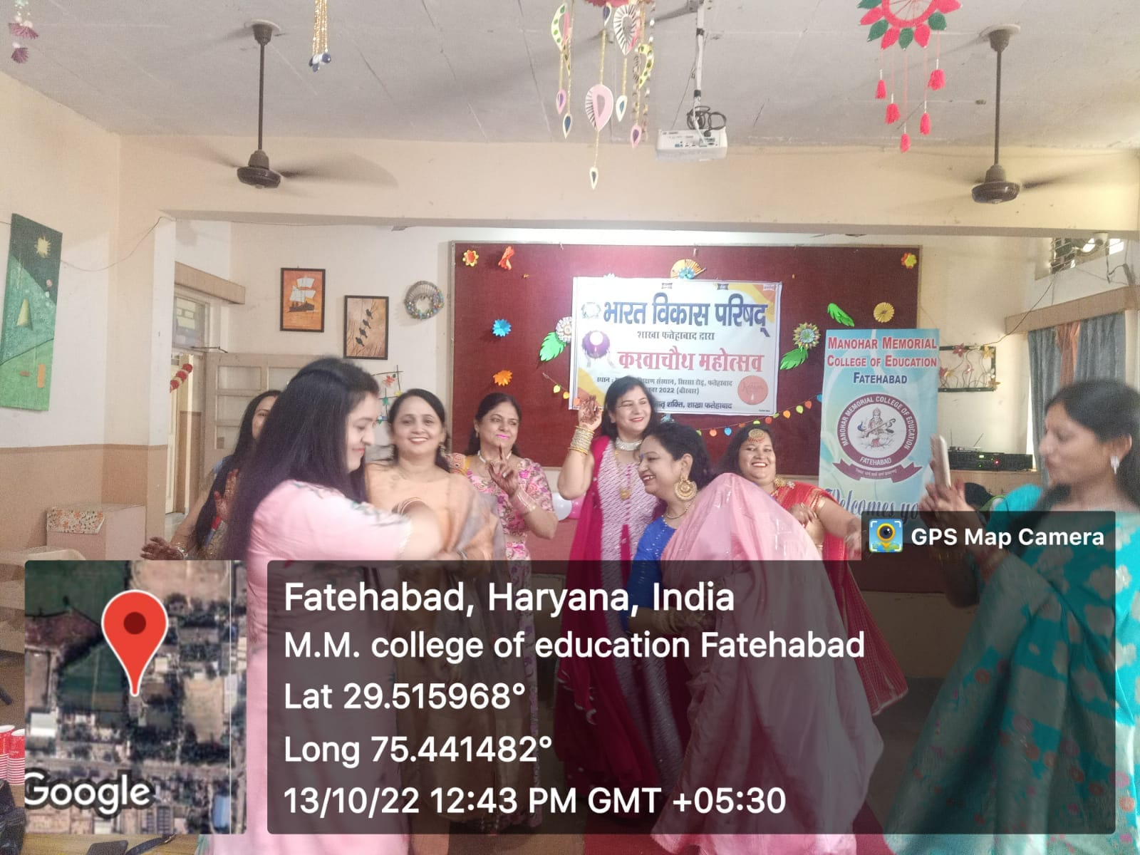
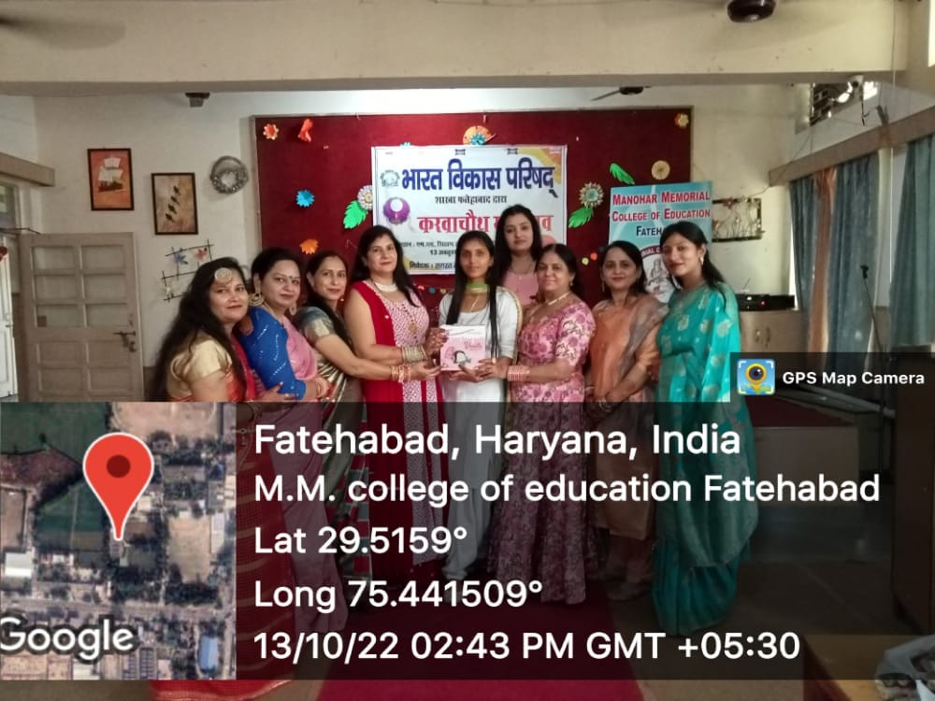
NAVRATRA FESTIVAL CELEBRATION 01.10.2022
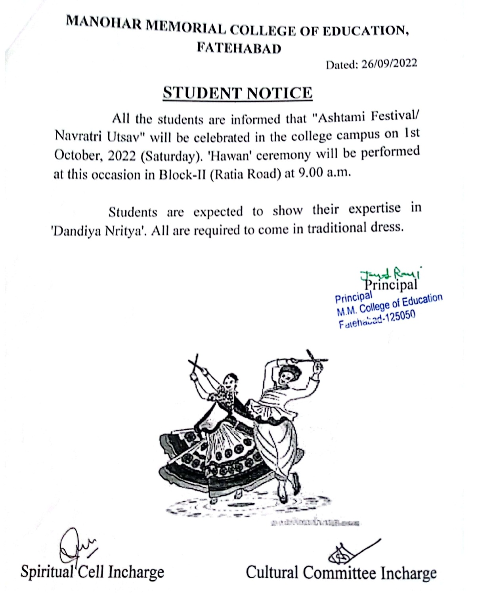
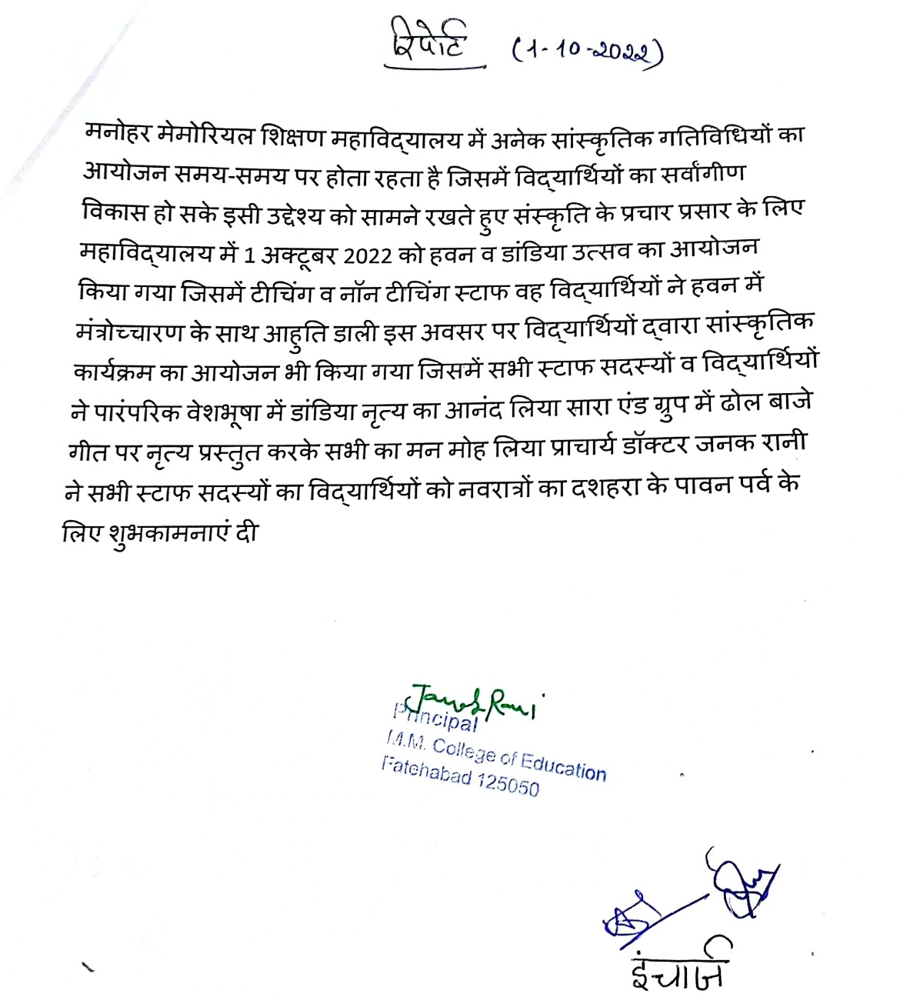
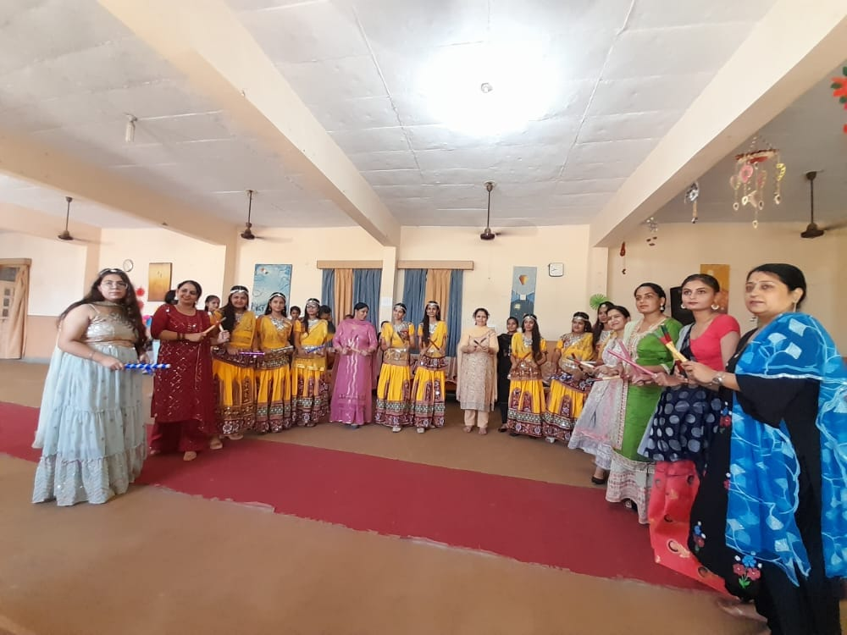
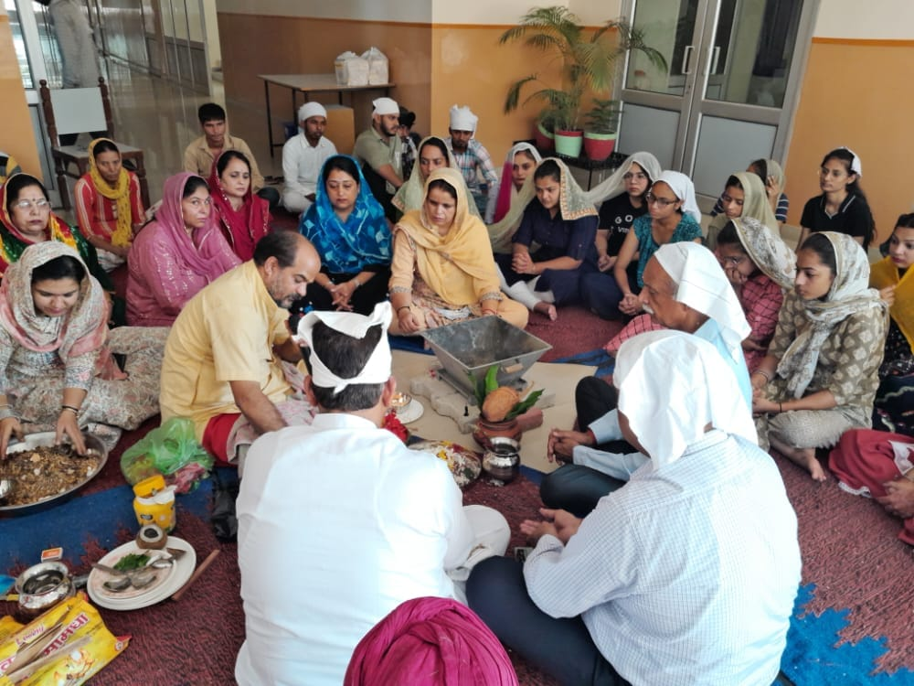
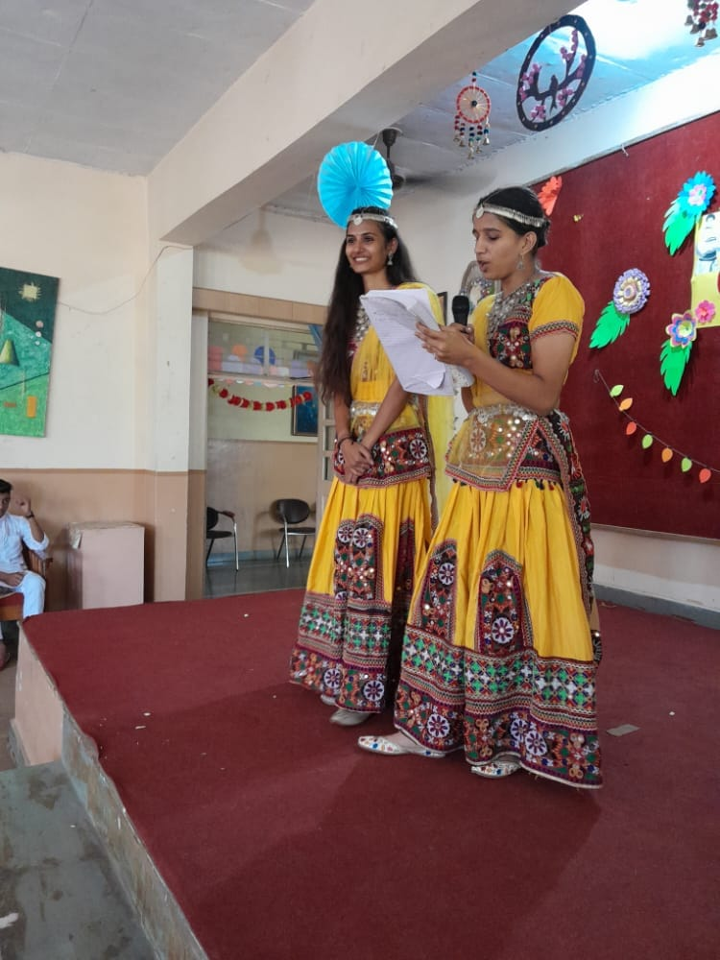
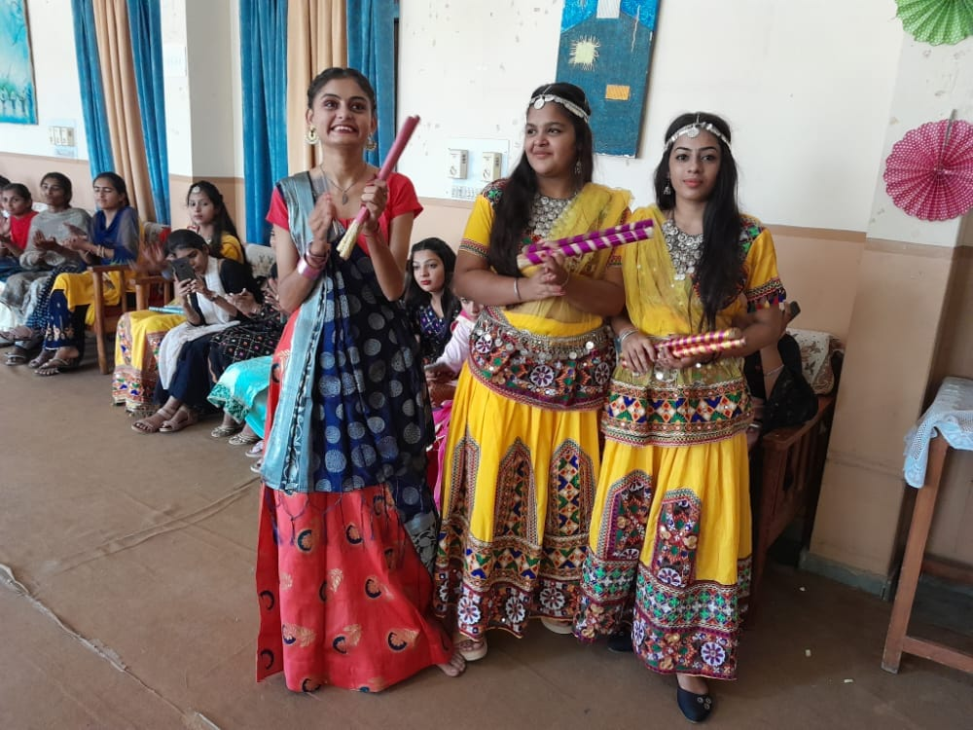
AZADI KA AMRIT MAHOTSAV 15.08.2022
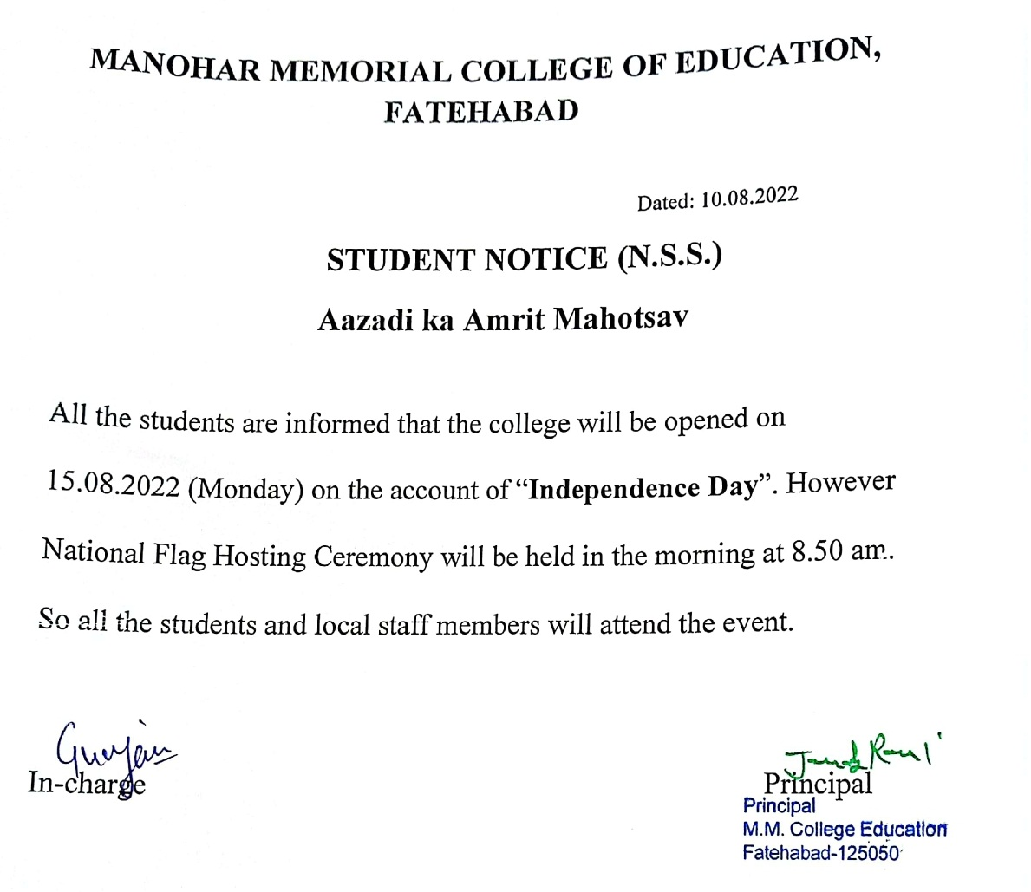
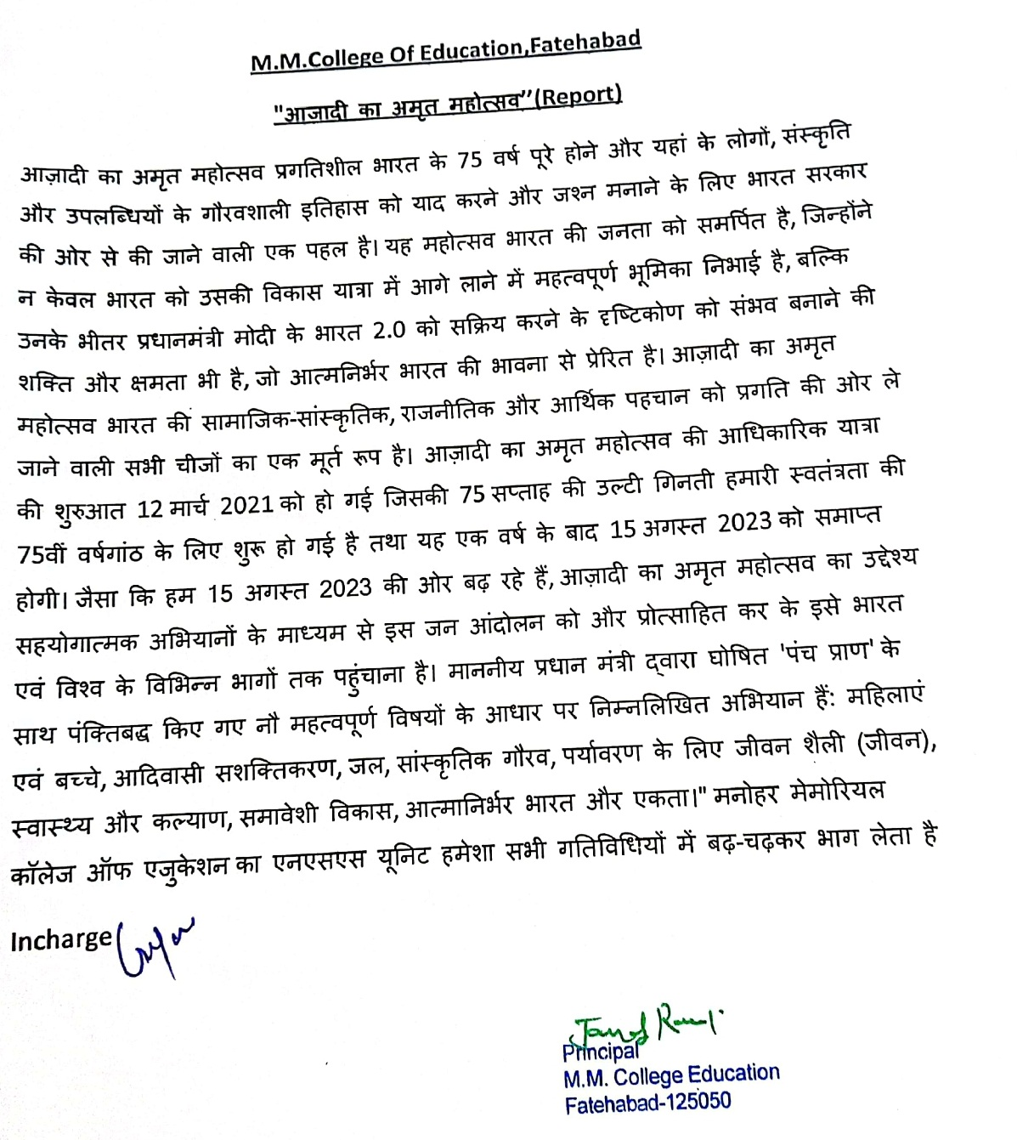
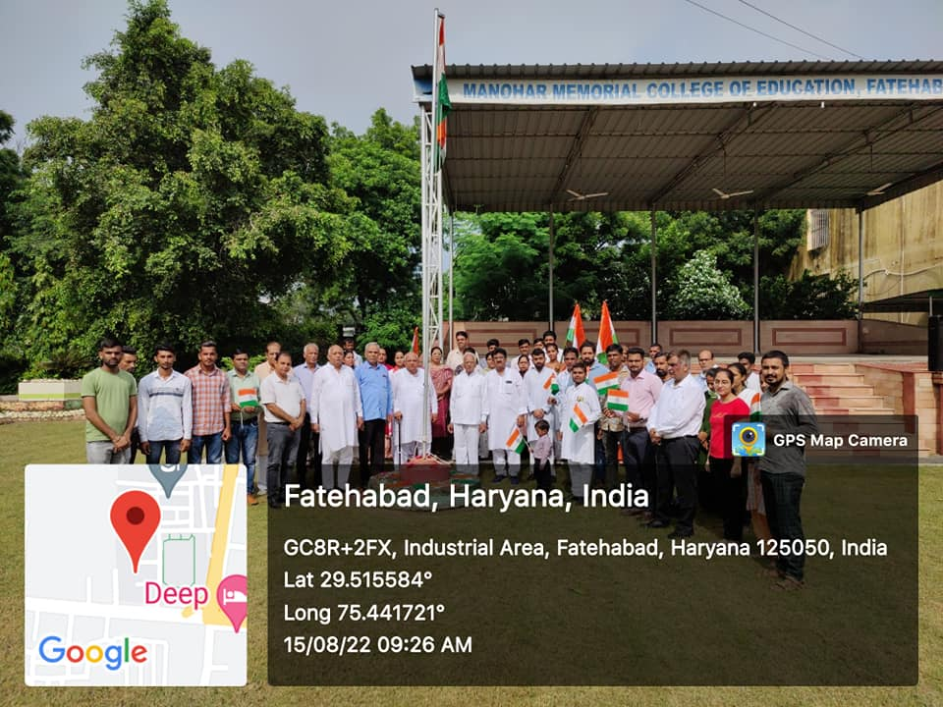
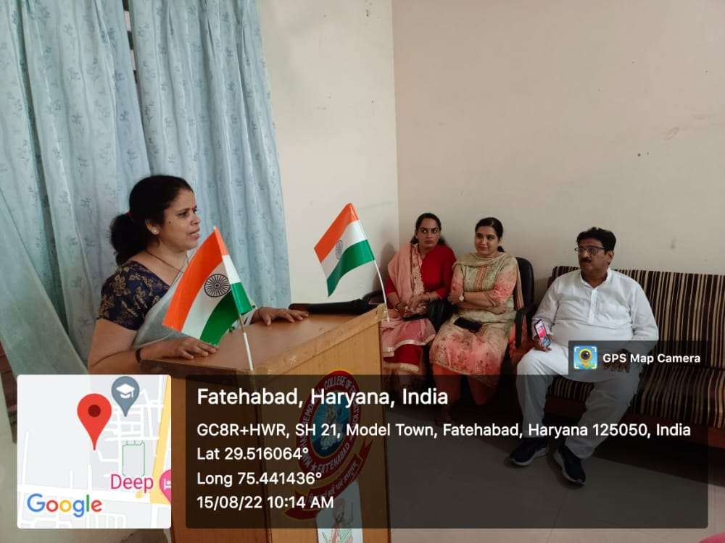
FAREWELL PARTY 19.07.2022
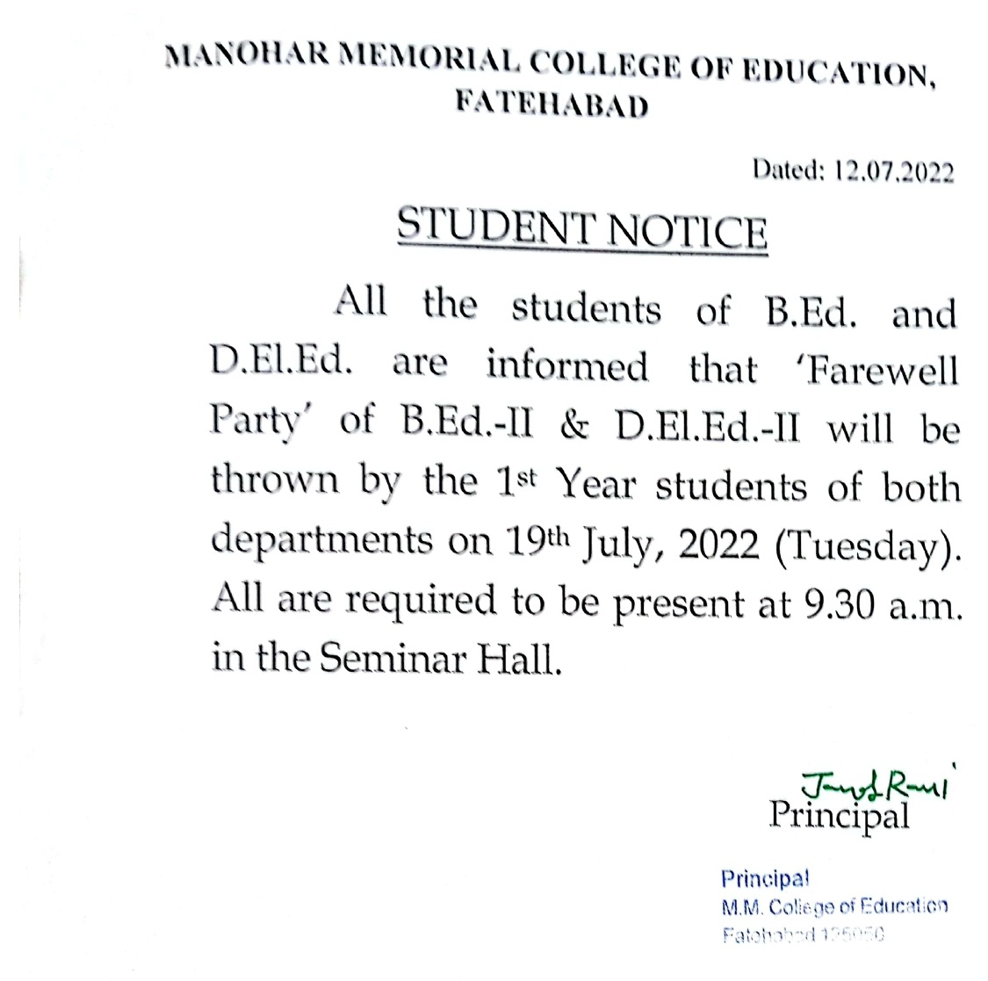

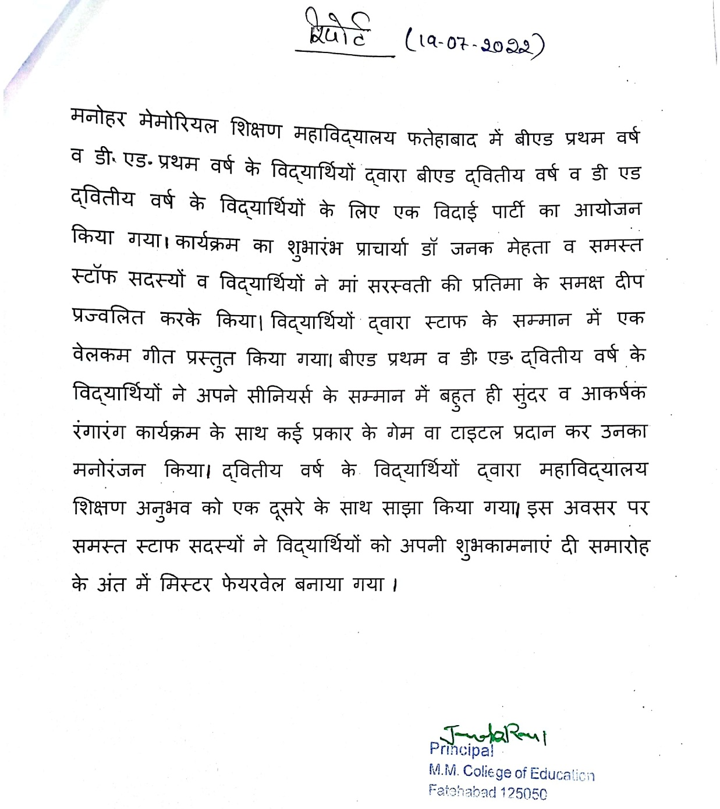

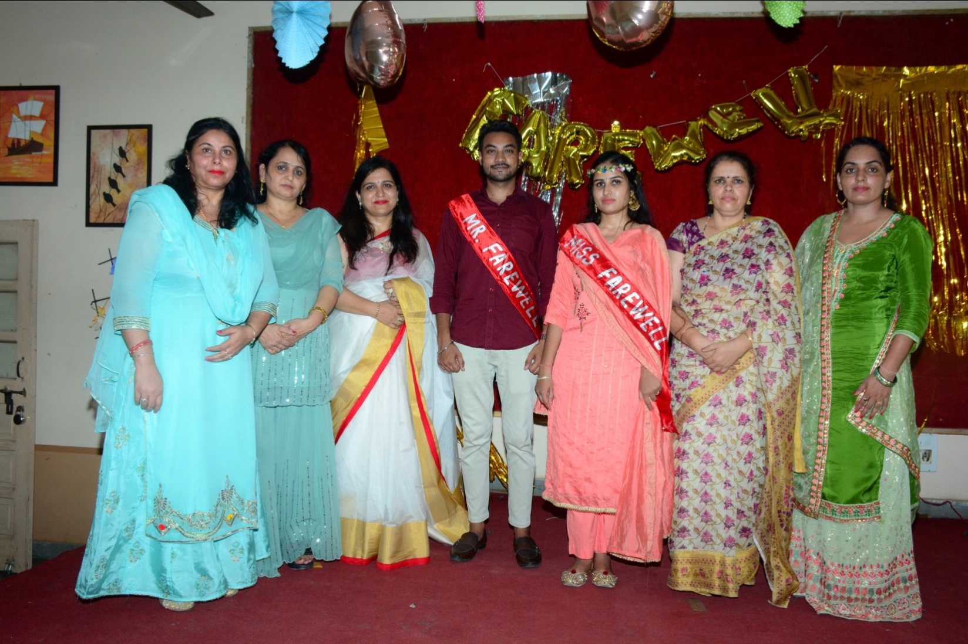
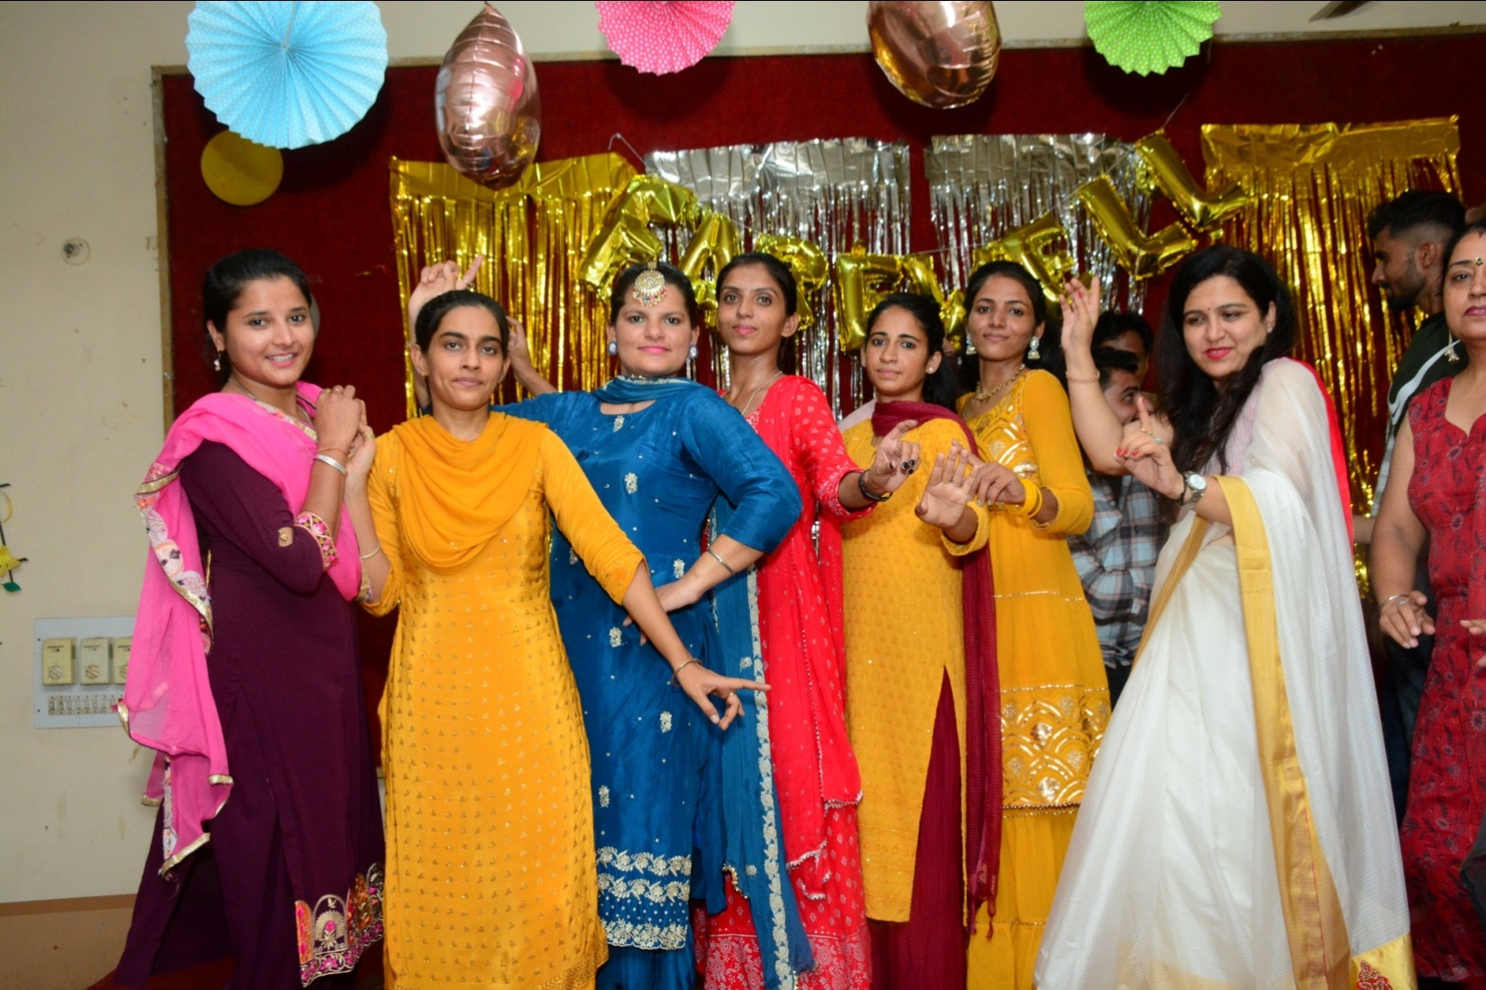
EDUCATIONAL TRIP 16.04 TO 18.04.2022
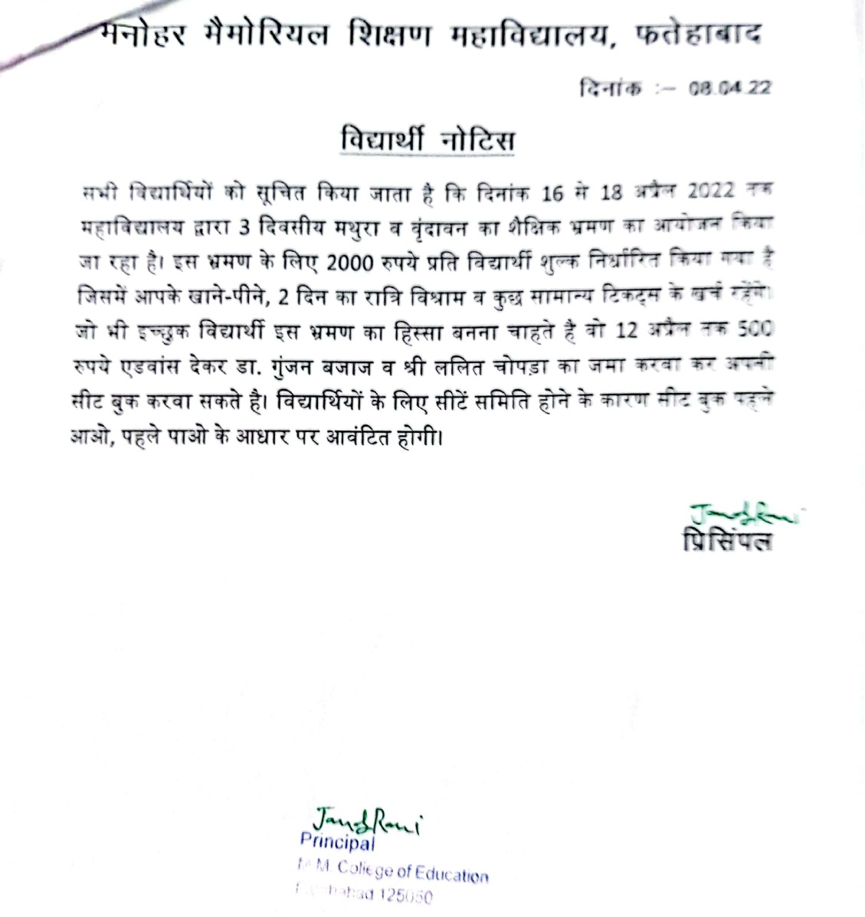

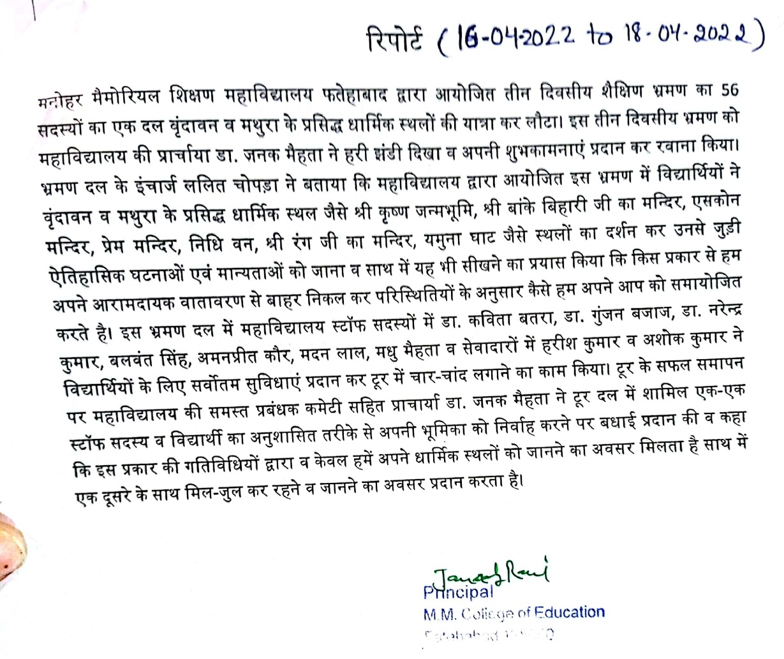

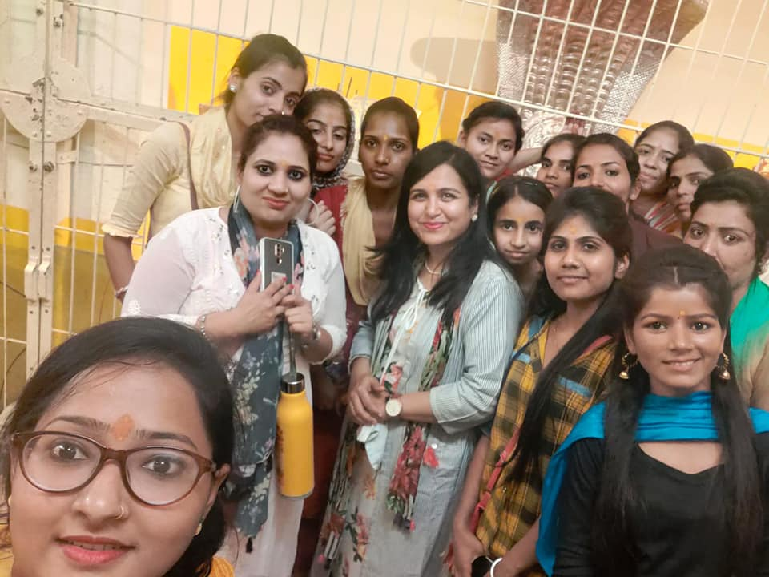
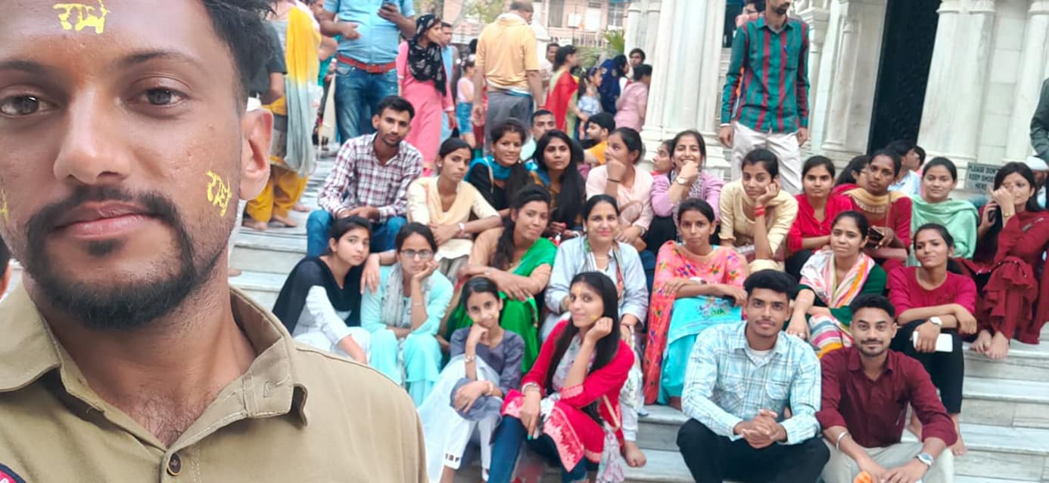
ANNUAL ATHLETIC MEET 15.04.2022
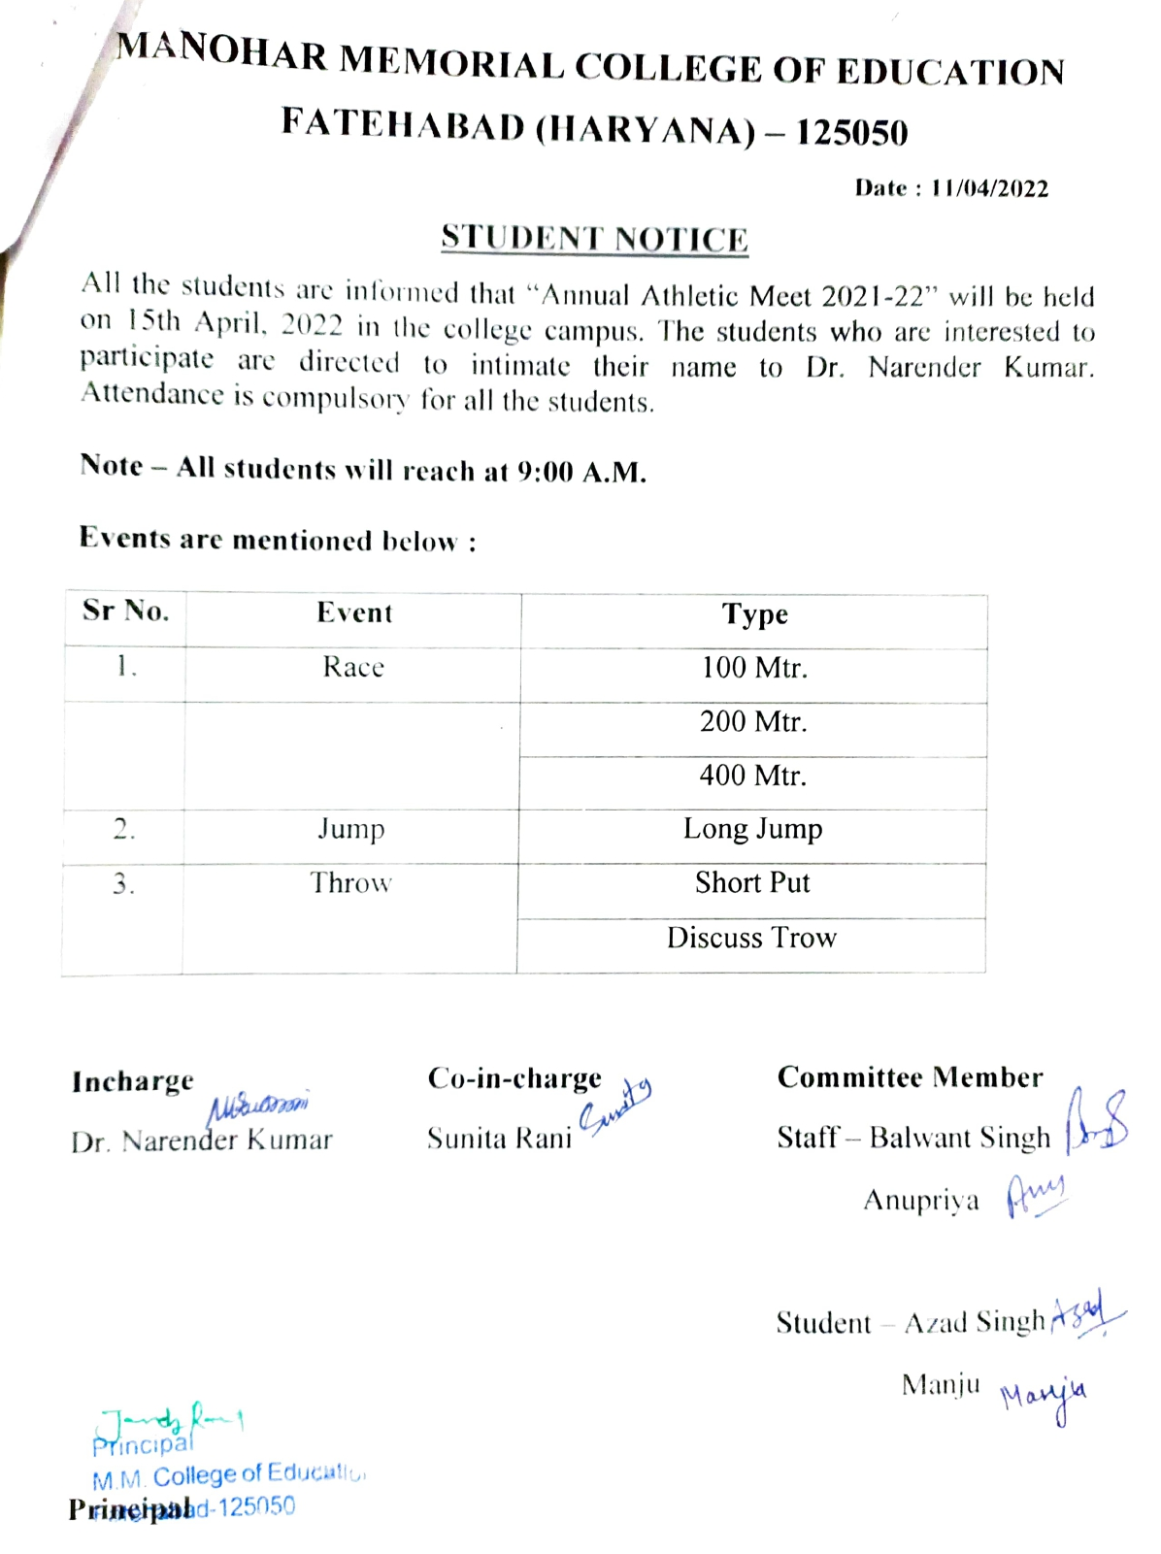
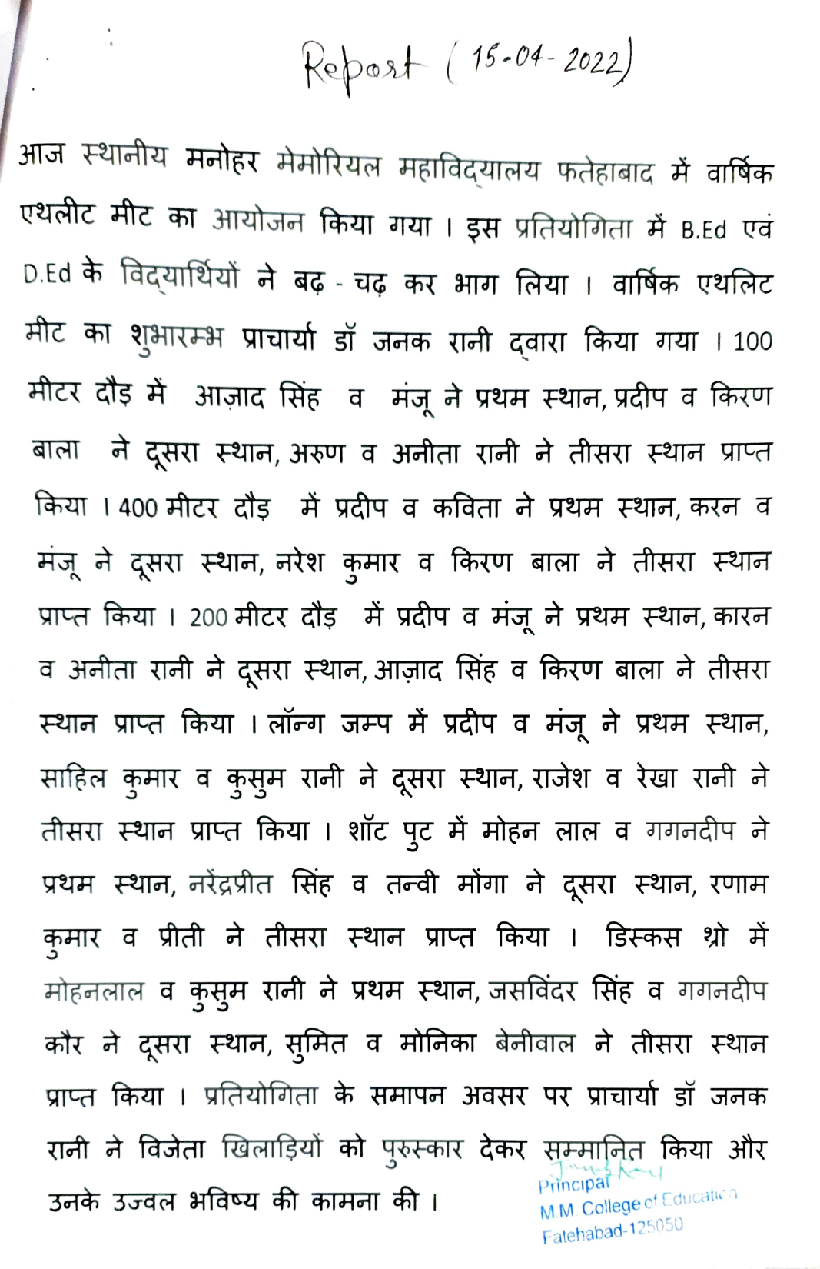
INTERNATIONAL WOMENS DAY 08.03.2022
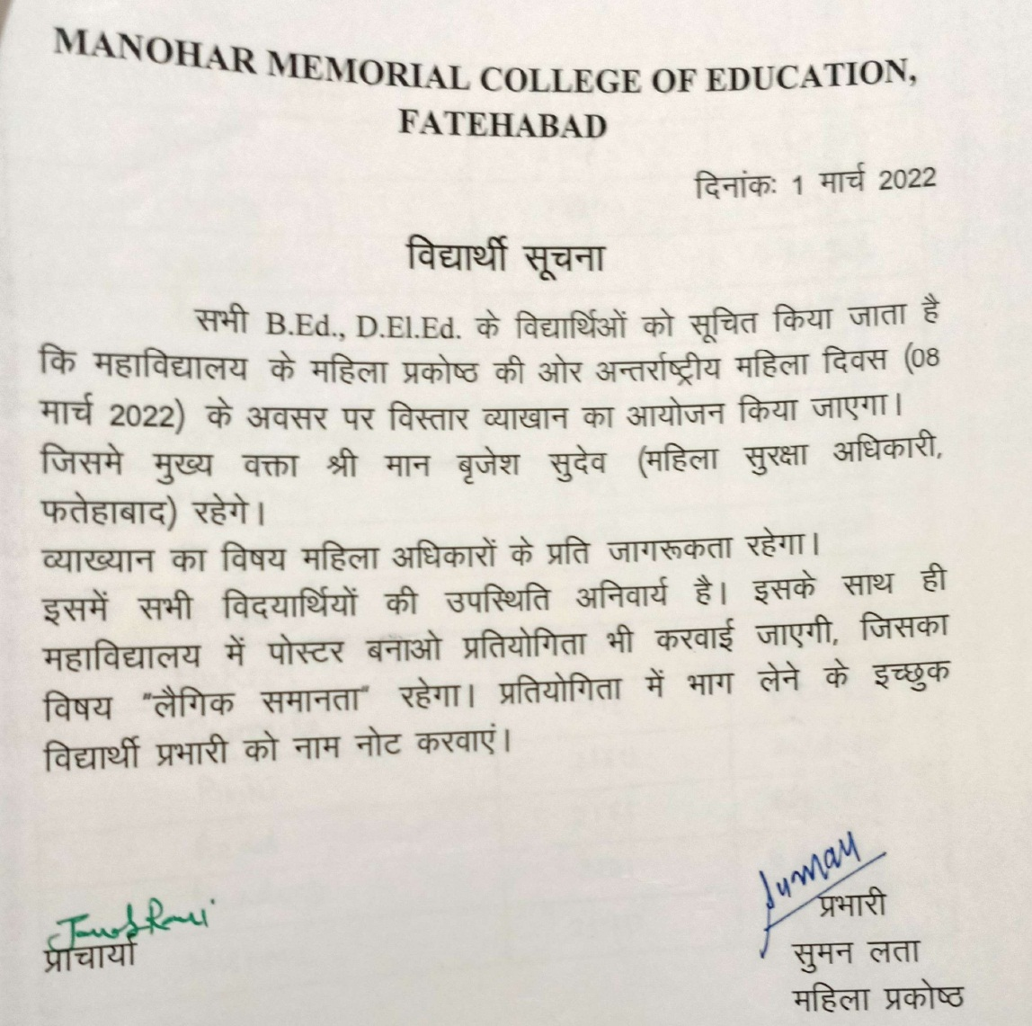
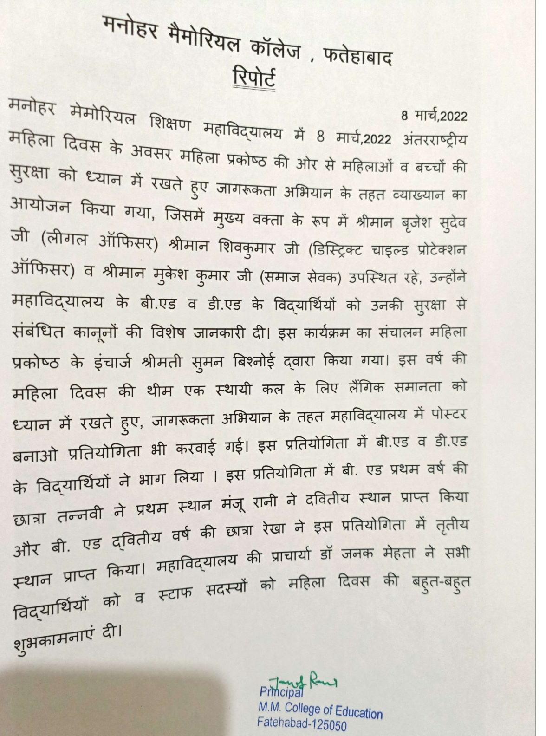
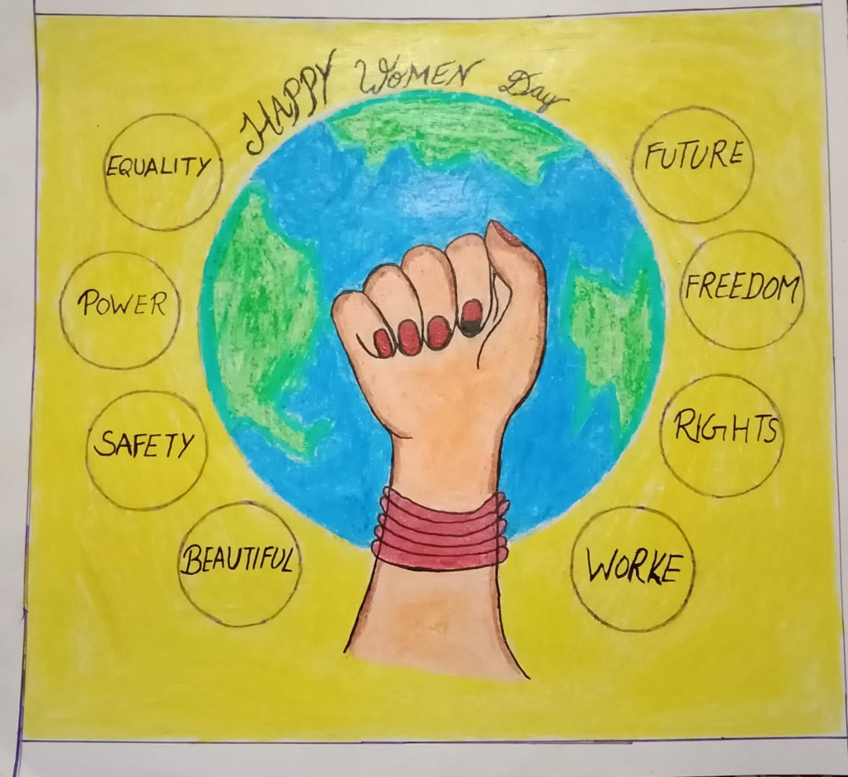
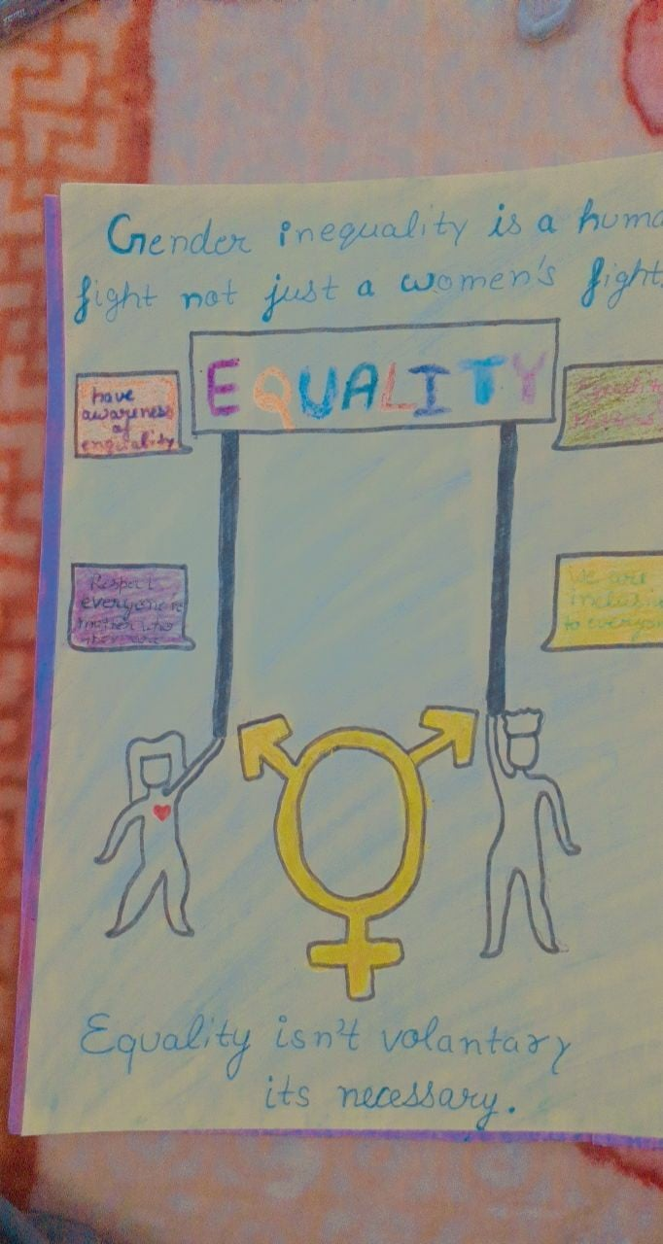
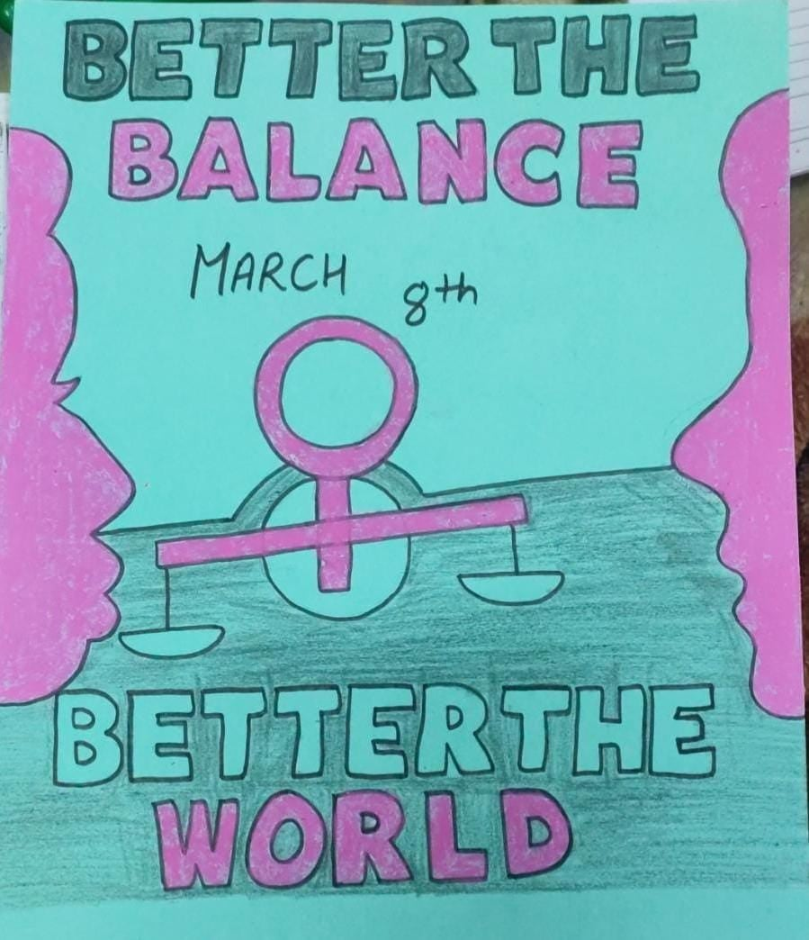
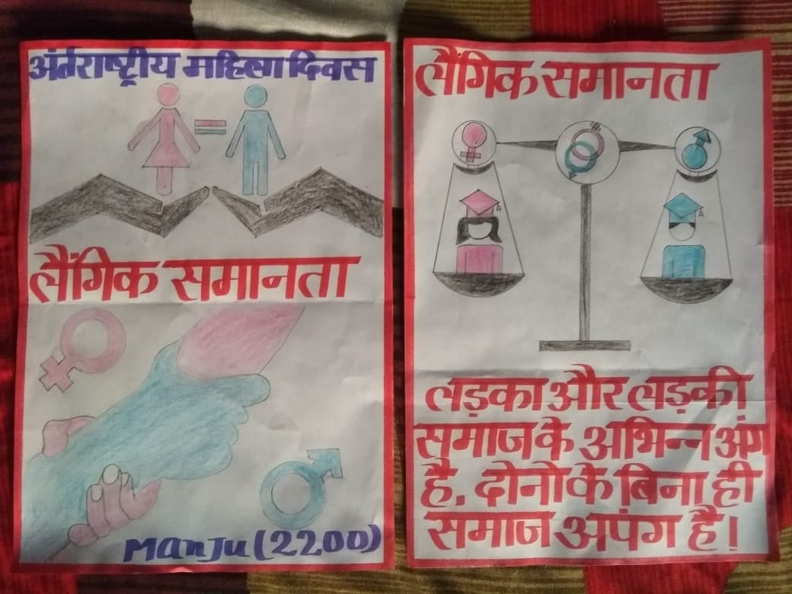

INDEPENDENCE DAY CELEBRATION 25.01.2022
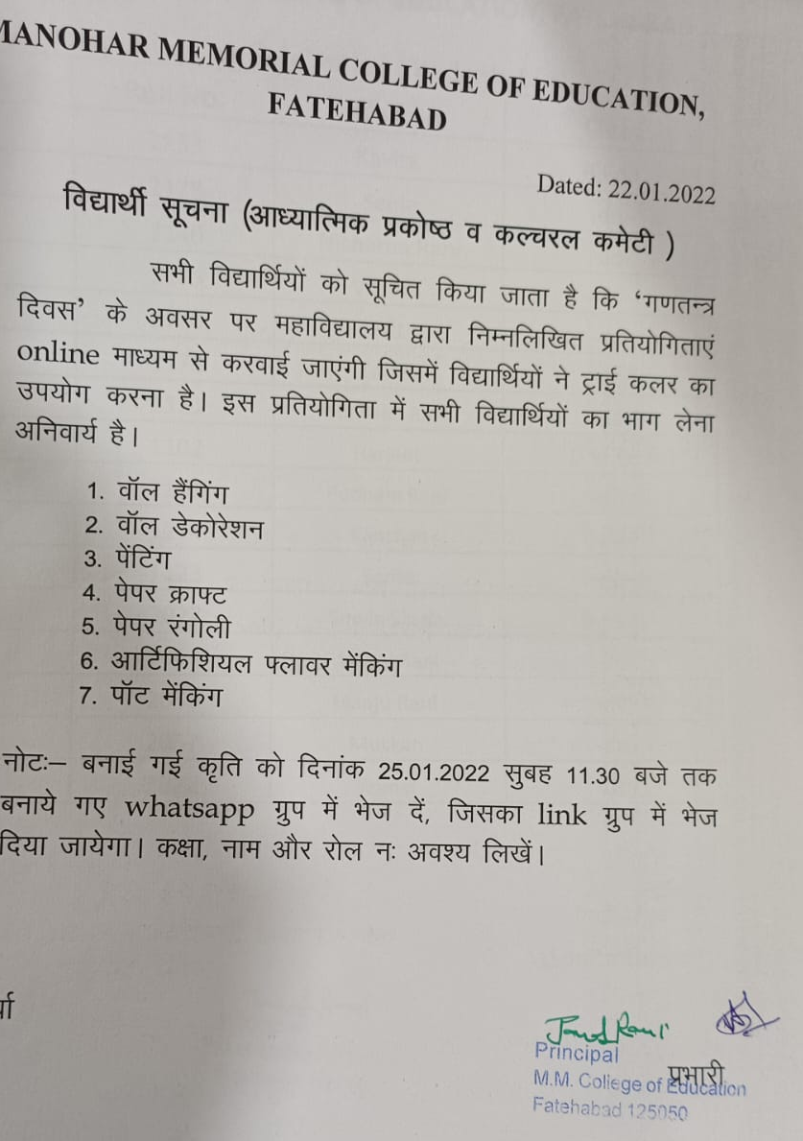
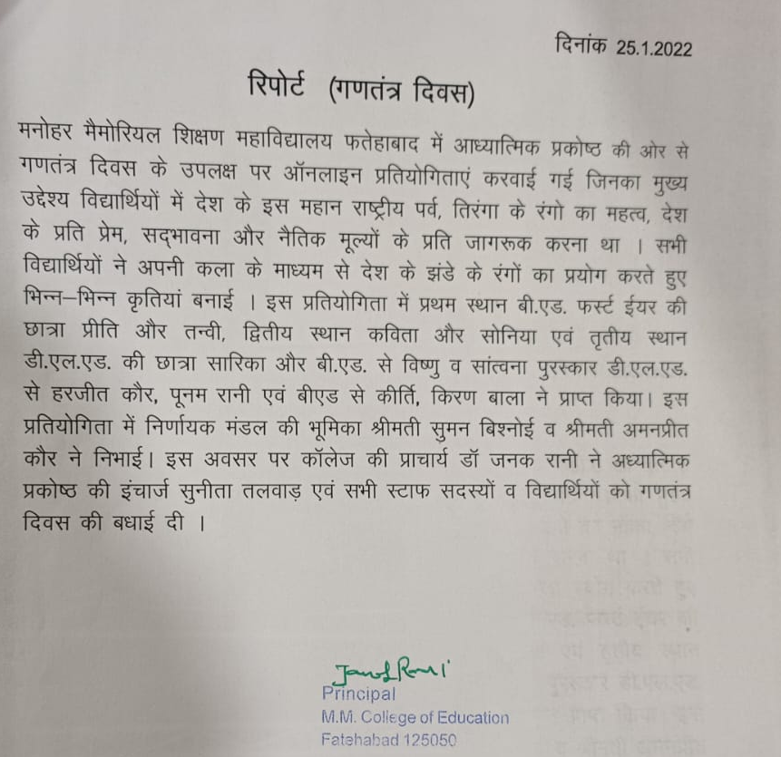

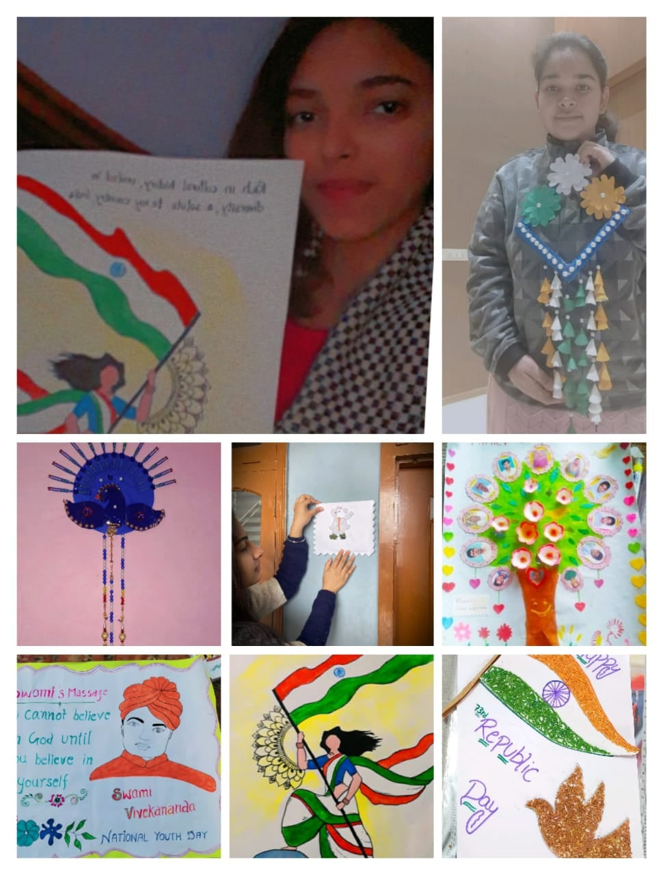
NEW YEAR CELEBRATION 01.01.2022
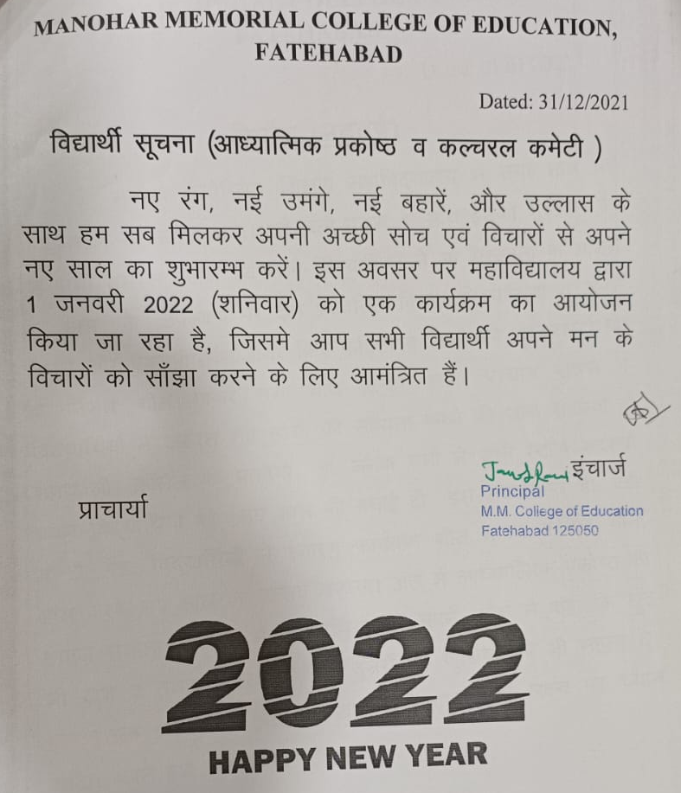
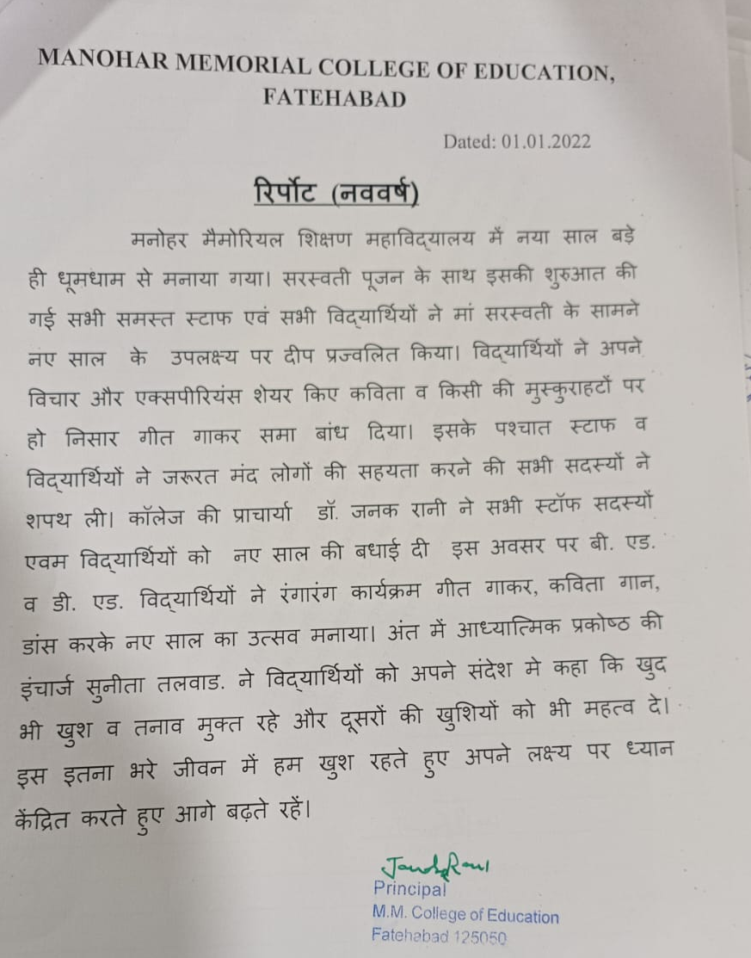
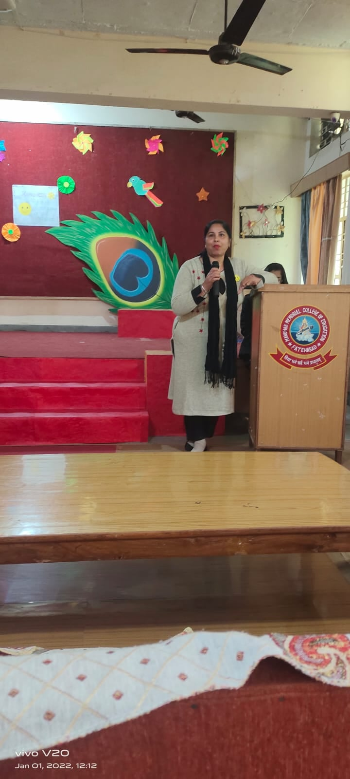
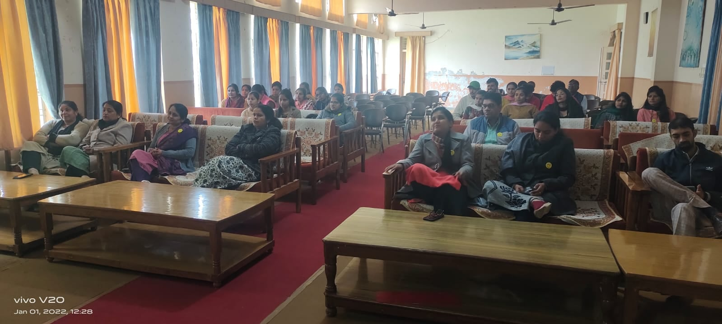

TALENT HUNT COMPETITION 10.12 TO 11.12.2021
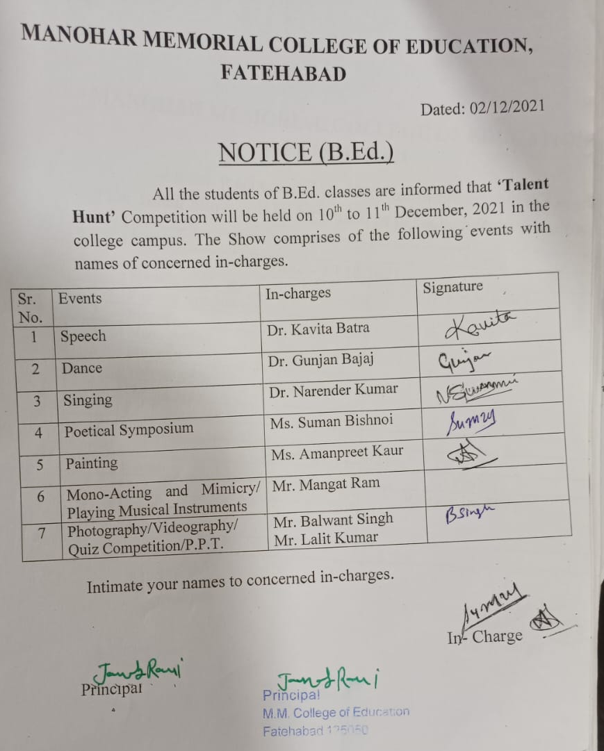
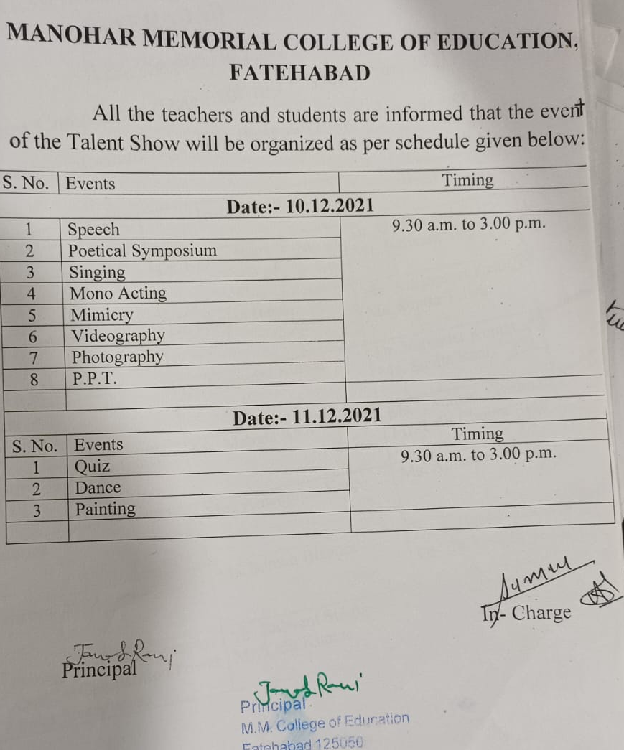
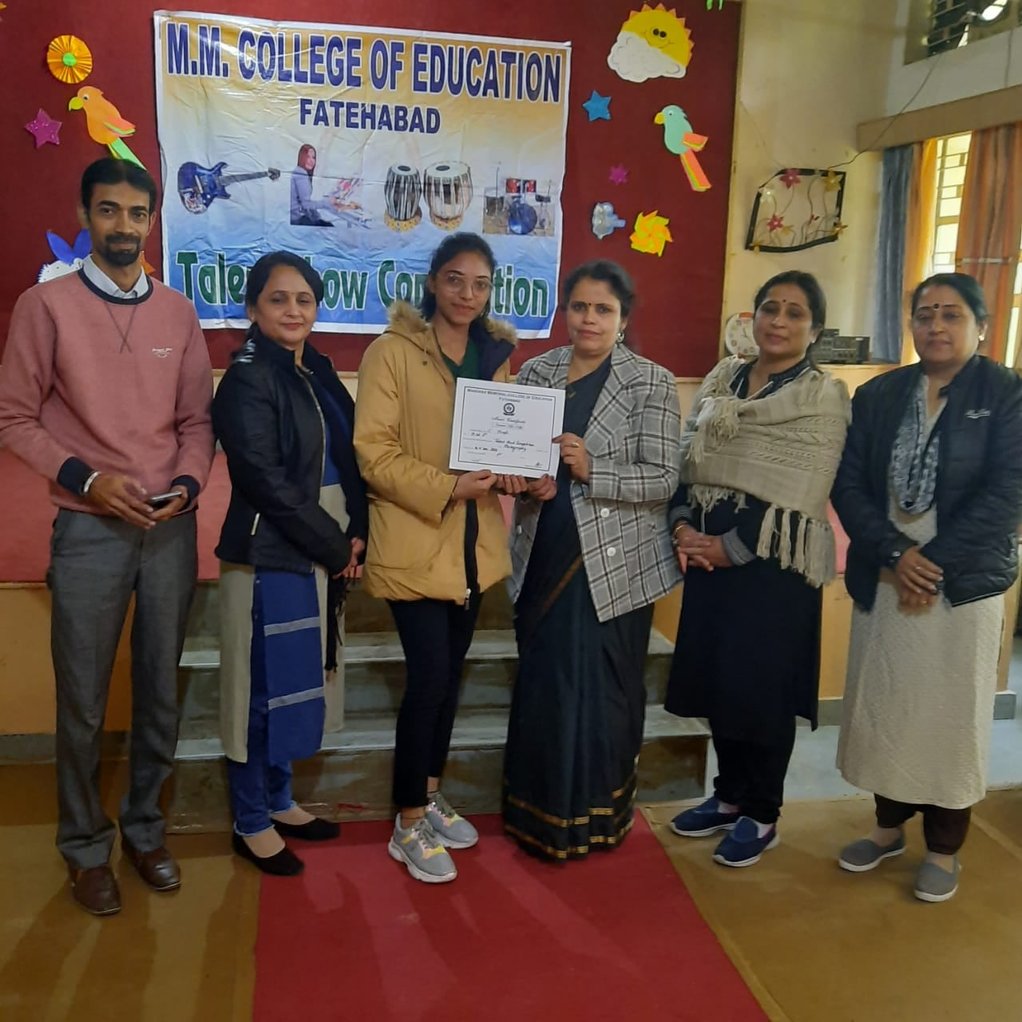
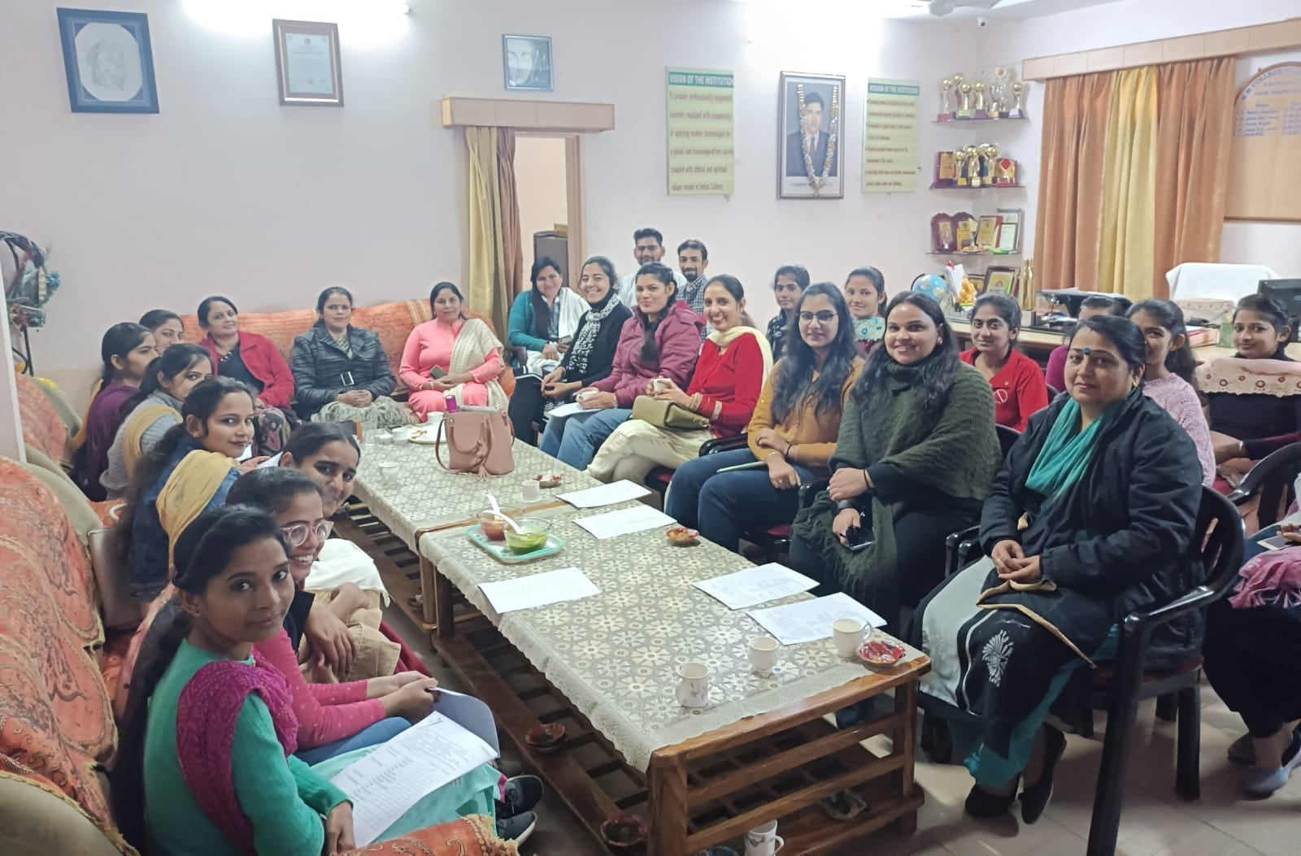
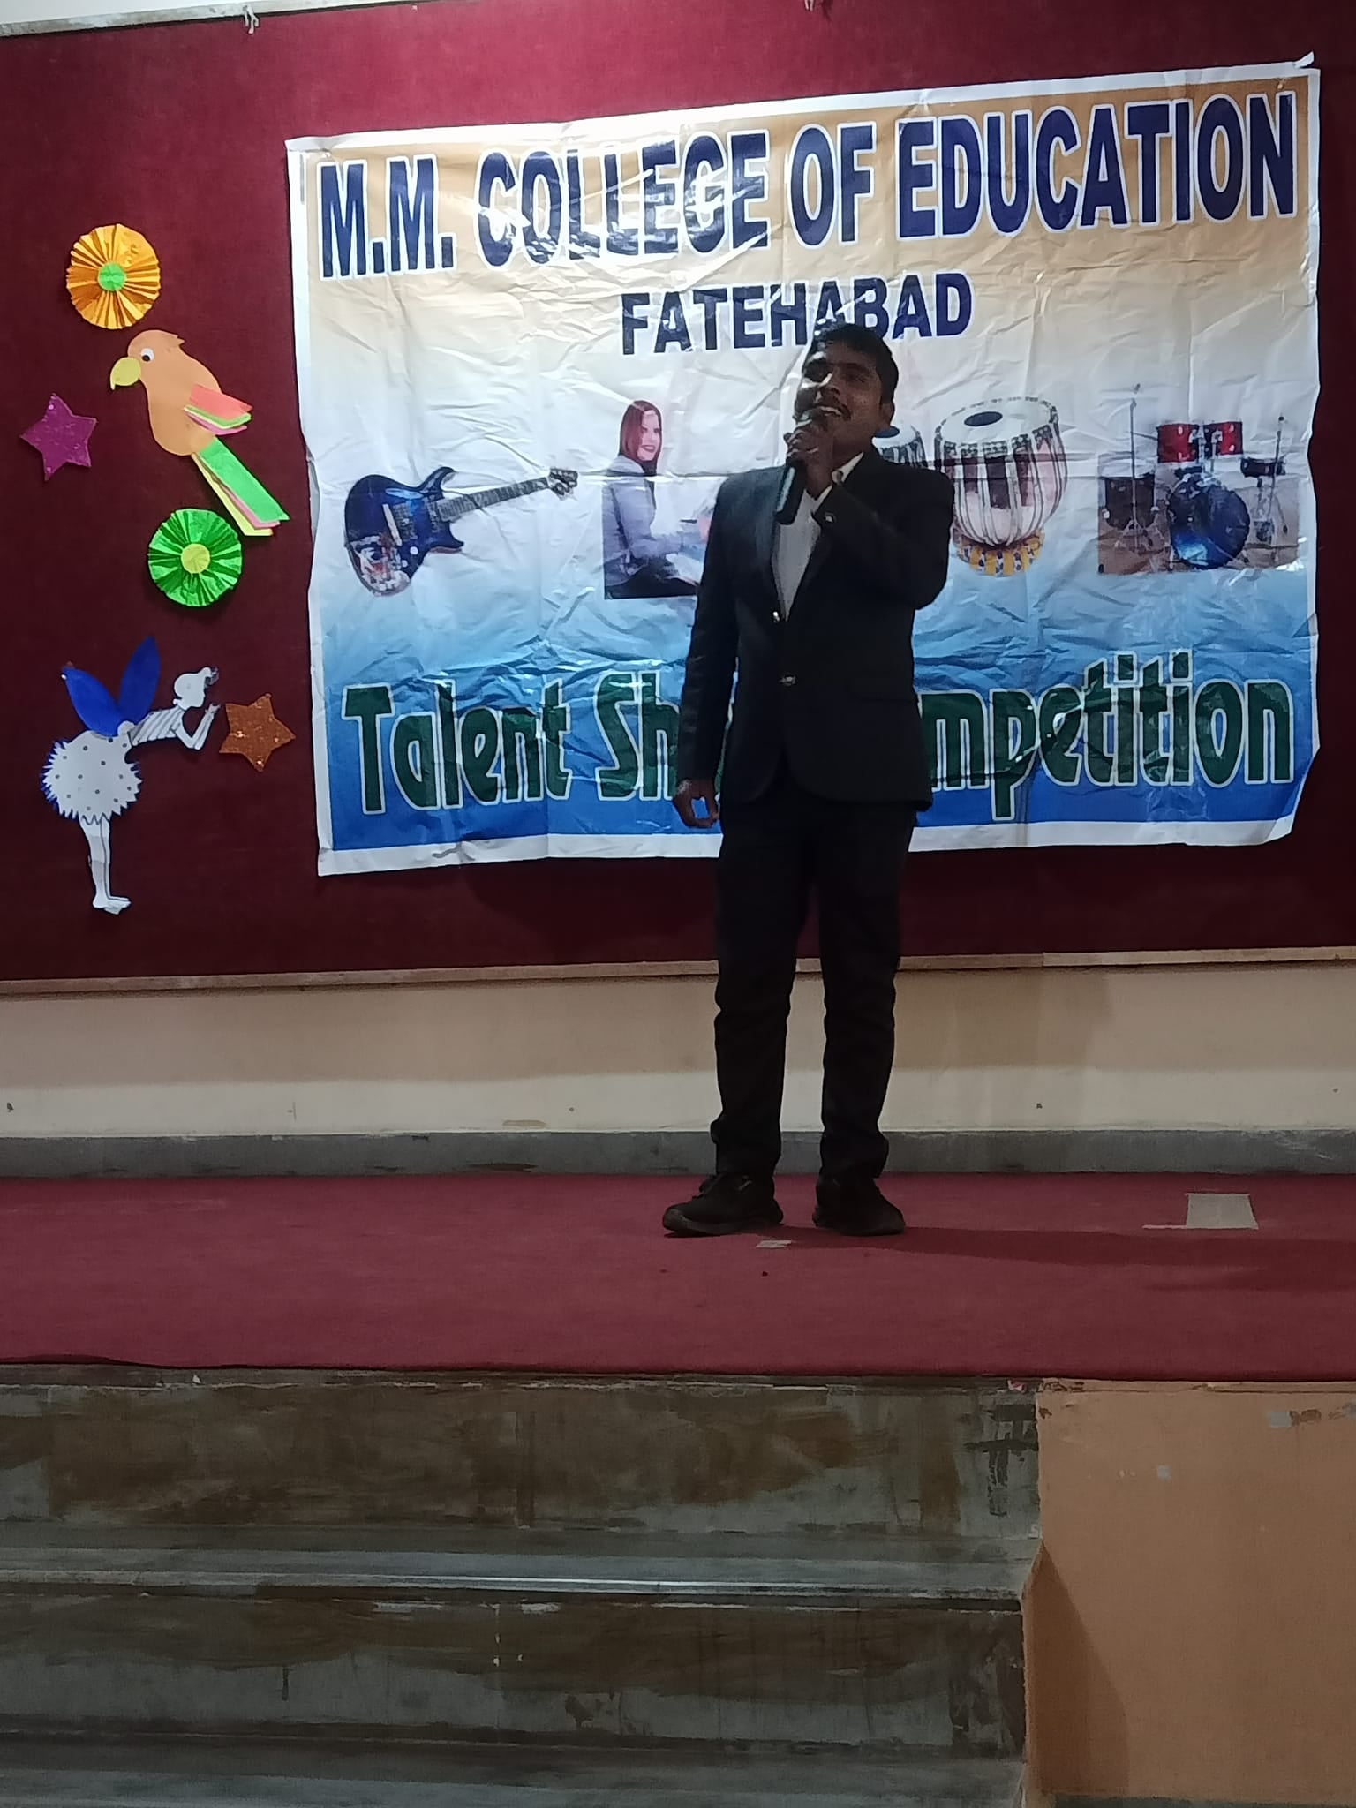
DIWALI CELEBRATION 02.11.2021
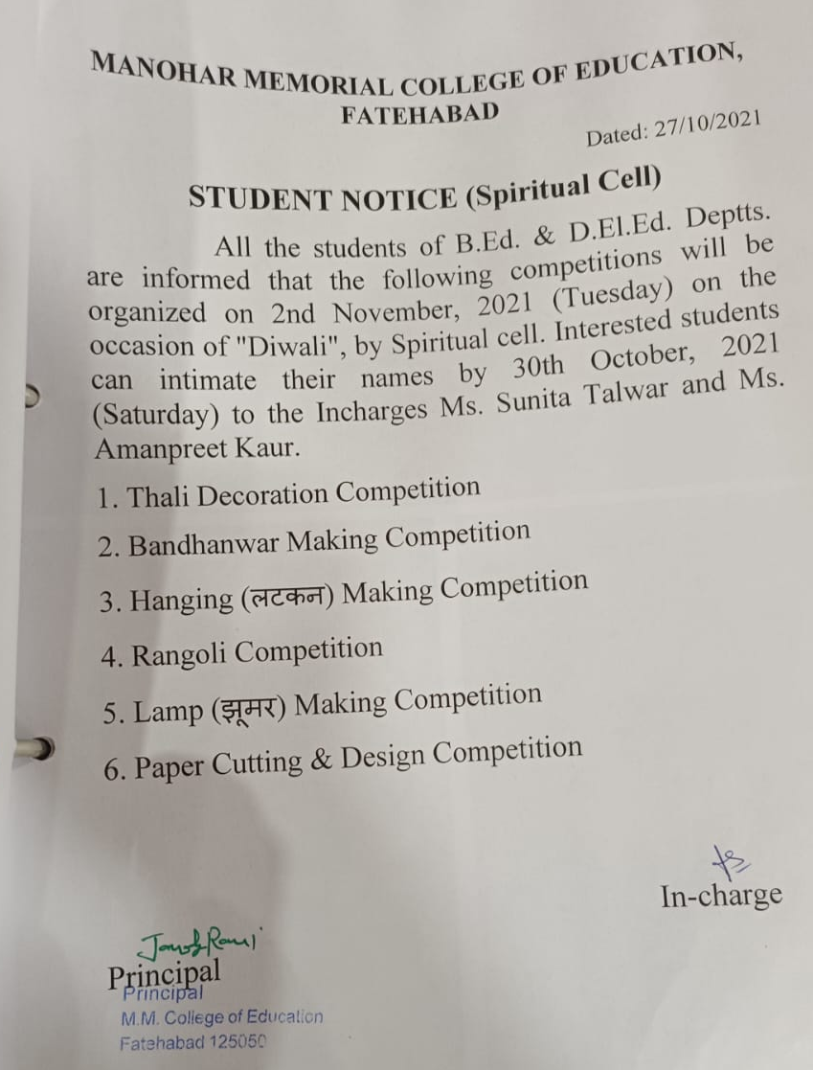
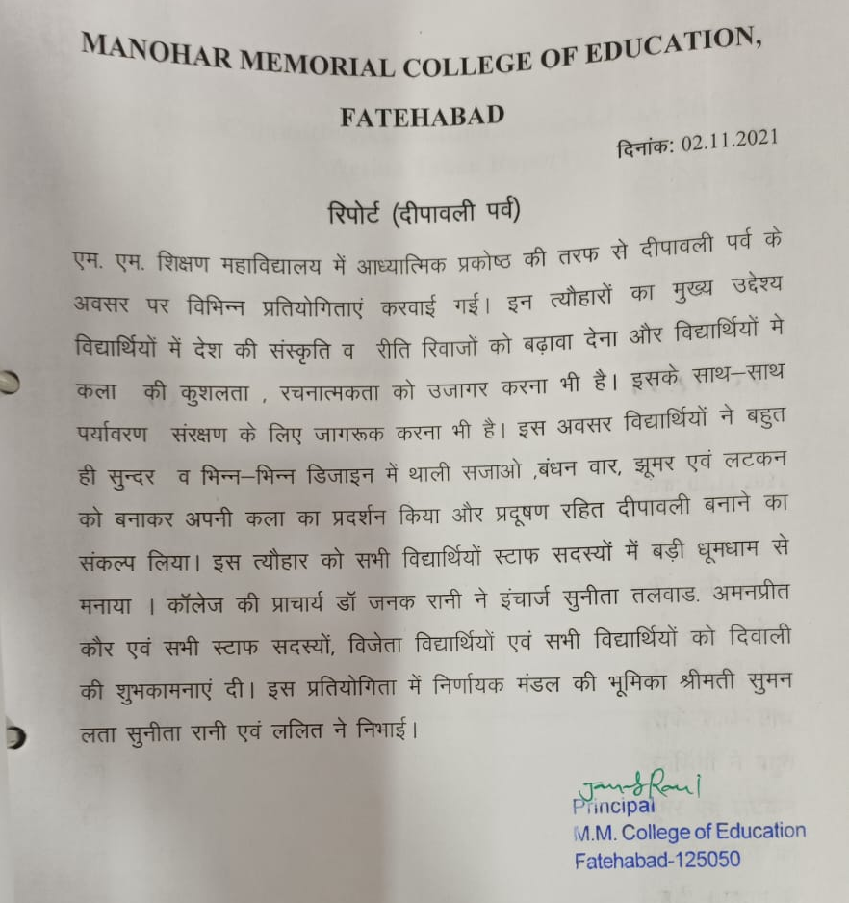
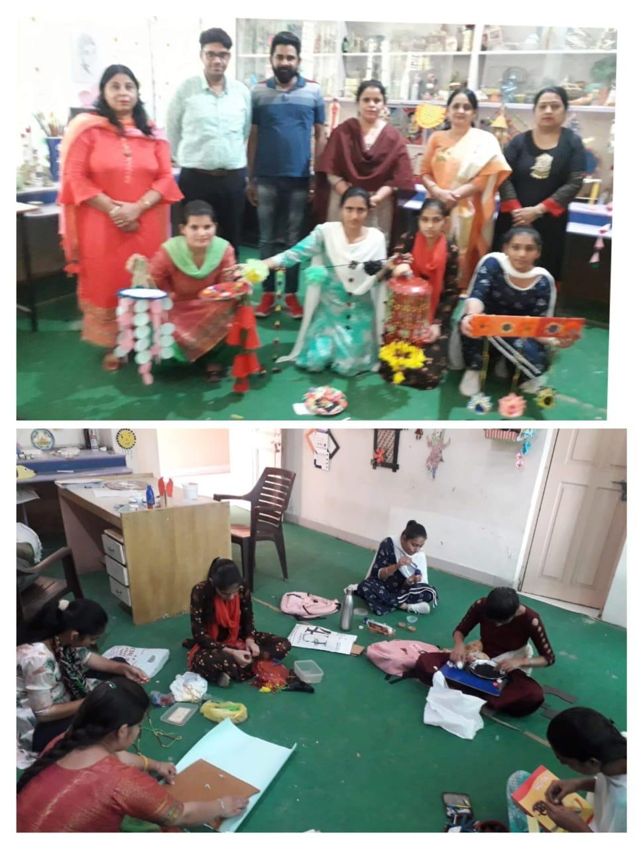
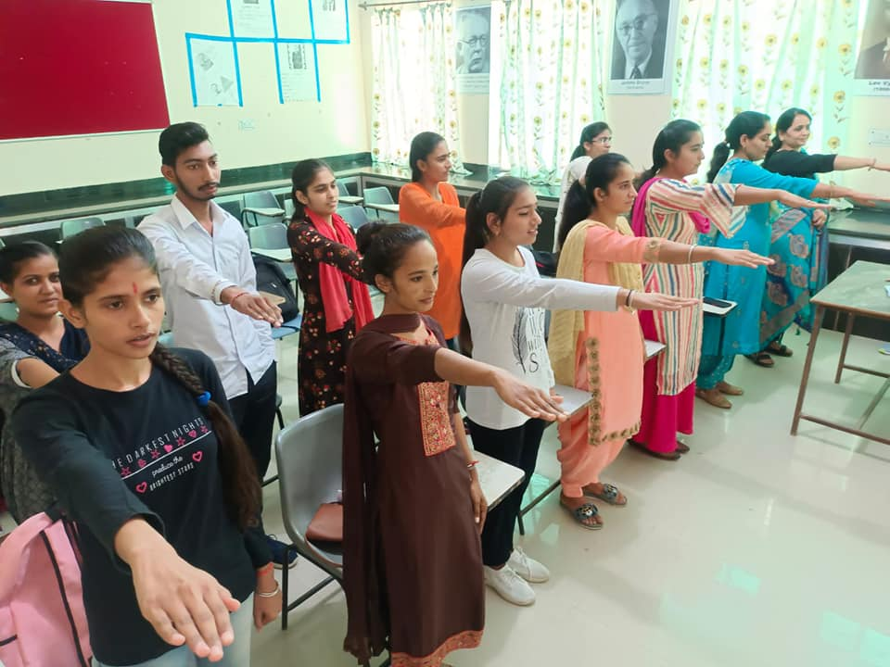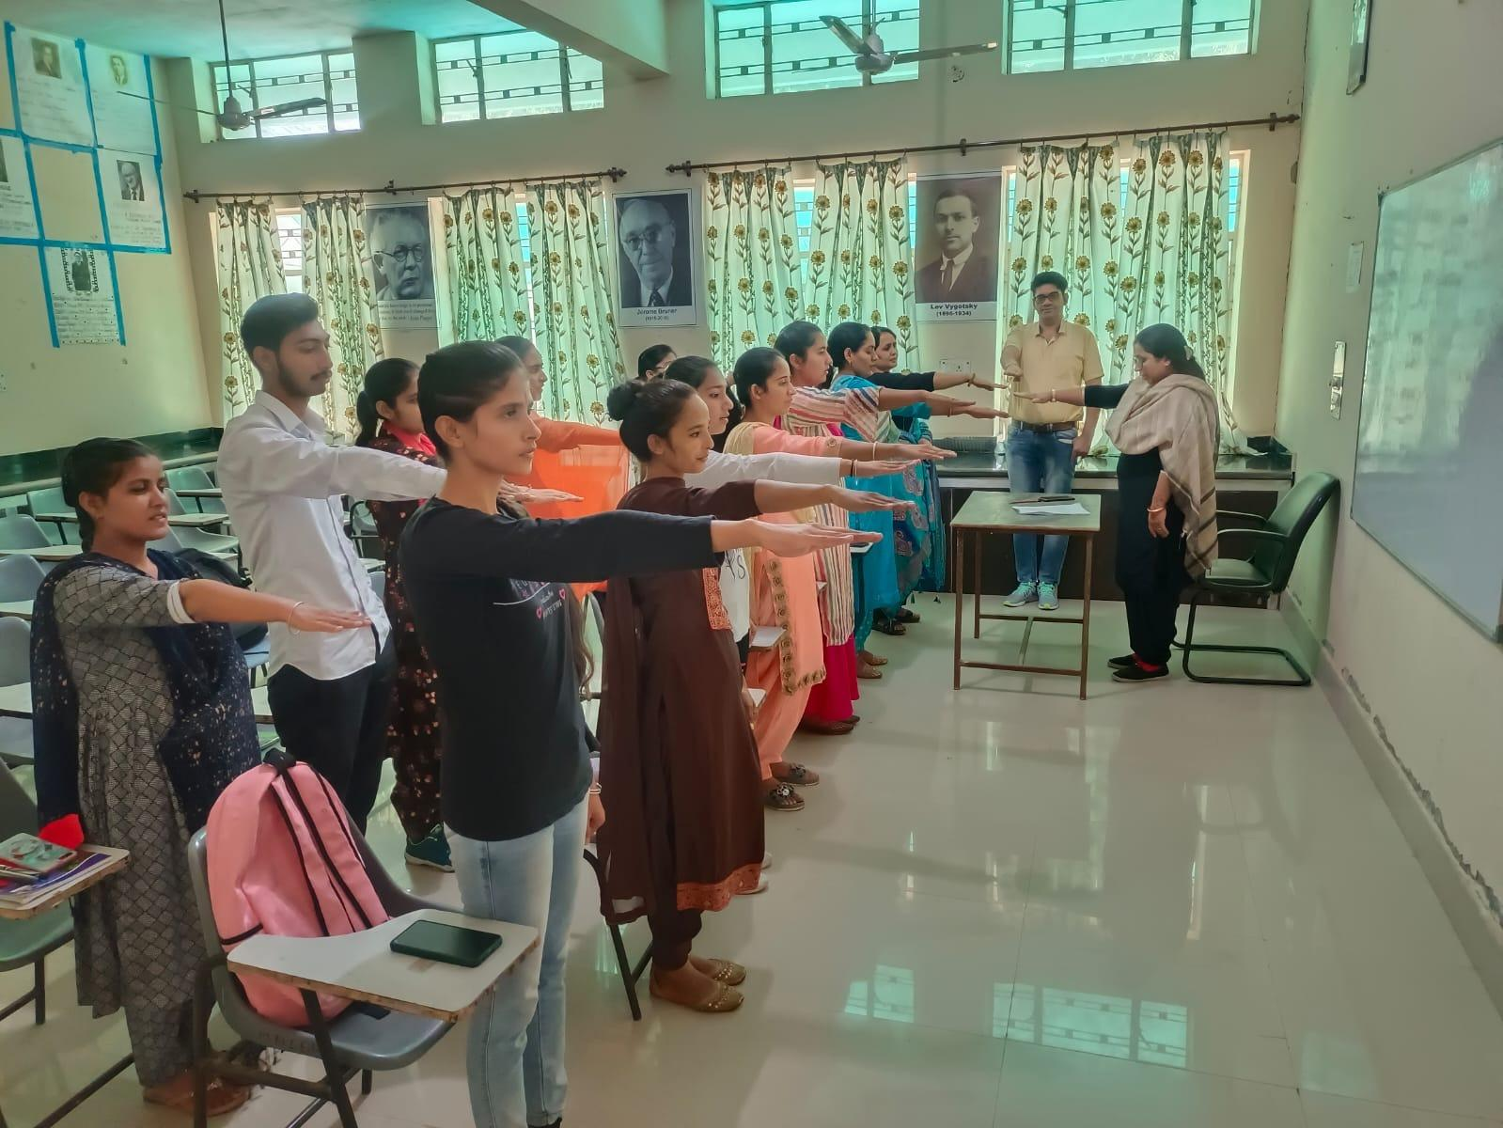
FAREWELL PARTY 09.10.2021
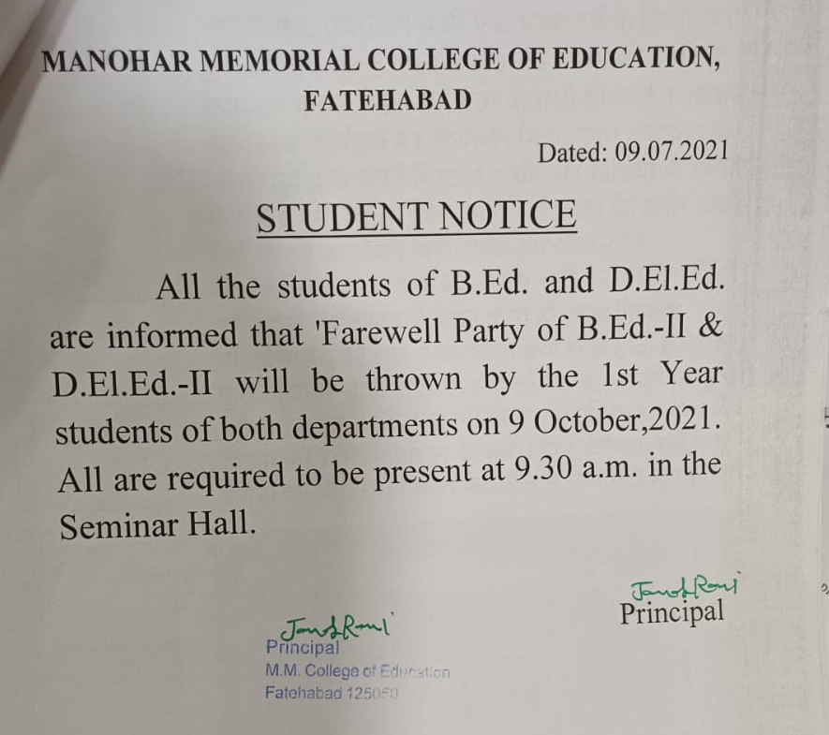

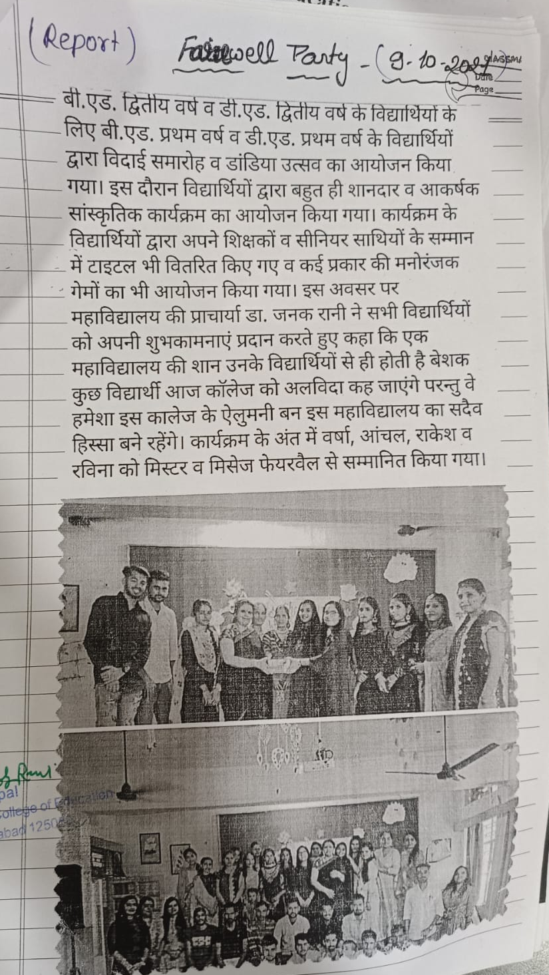
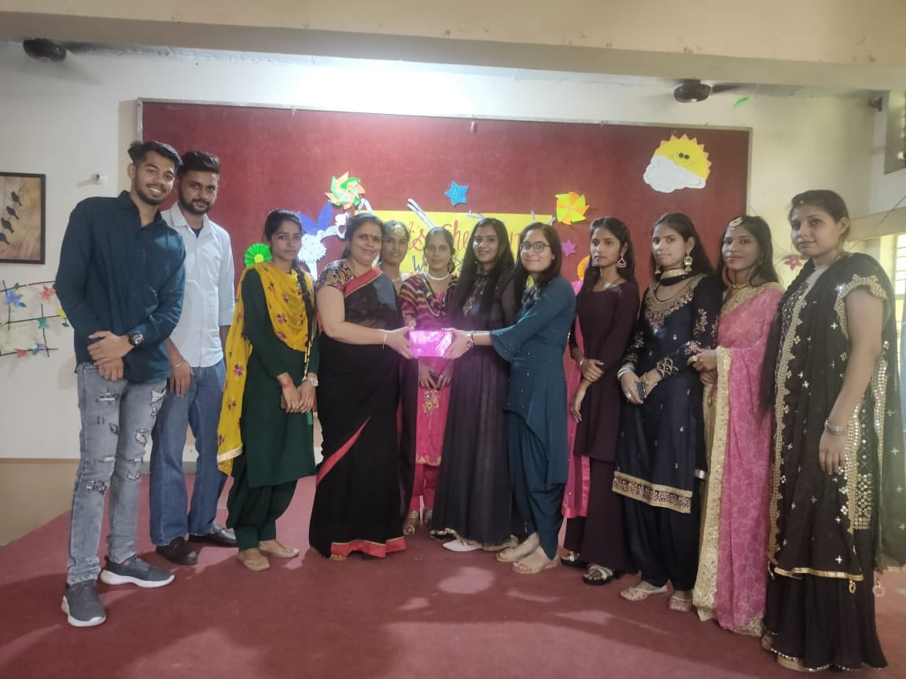
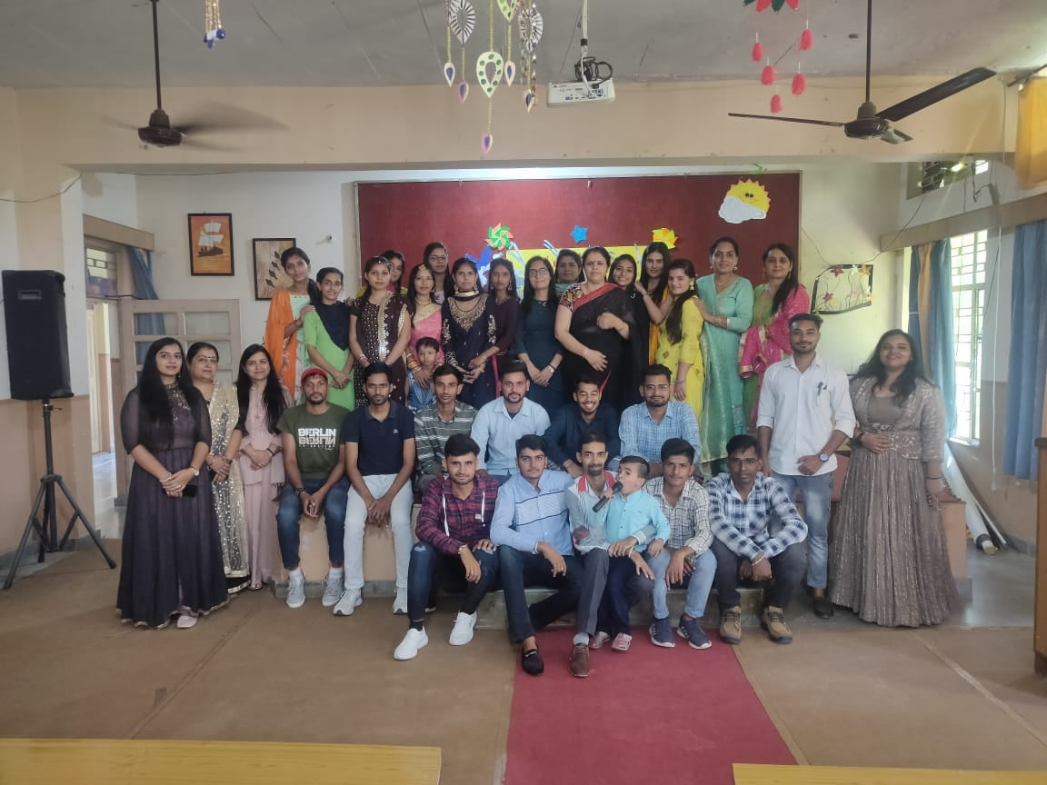
MENTAL HELATH AND WELLBEING OF STUDENTS WEBINAR 18.10.2020
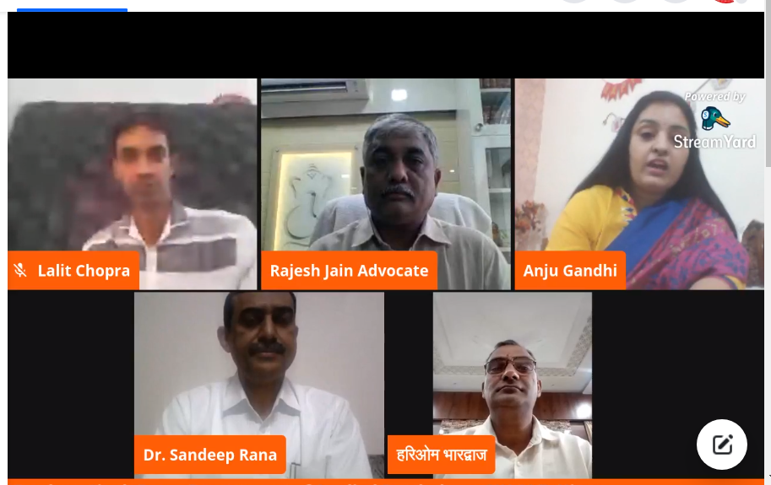

FINE ART TRAINING 08.10.2020
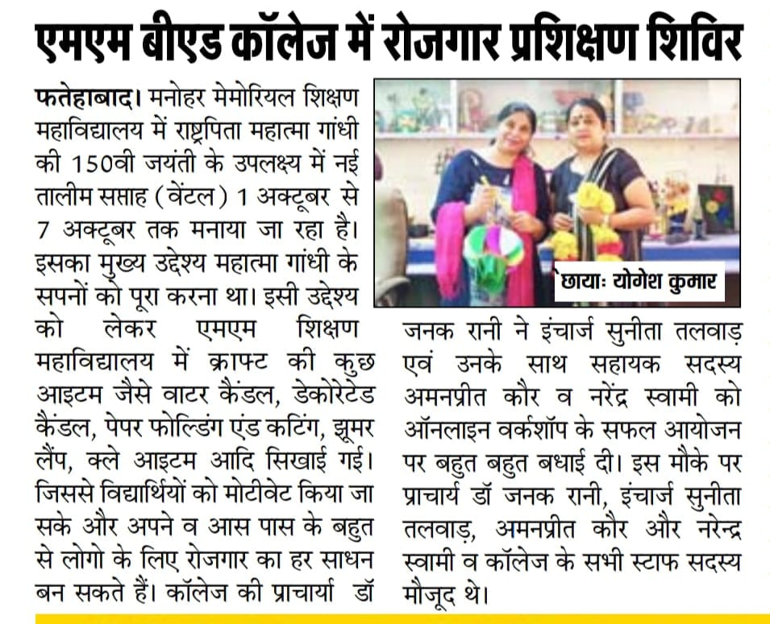
INDEPENDENCE DAY 14.08.2020
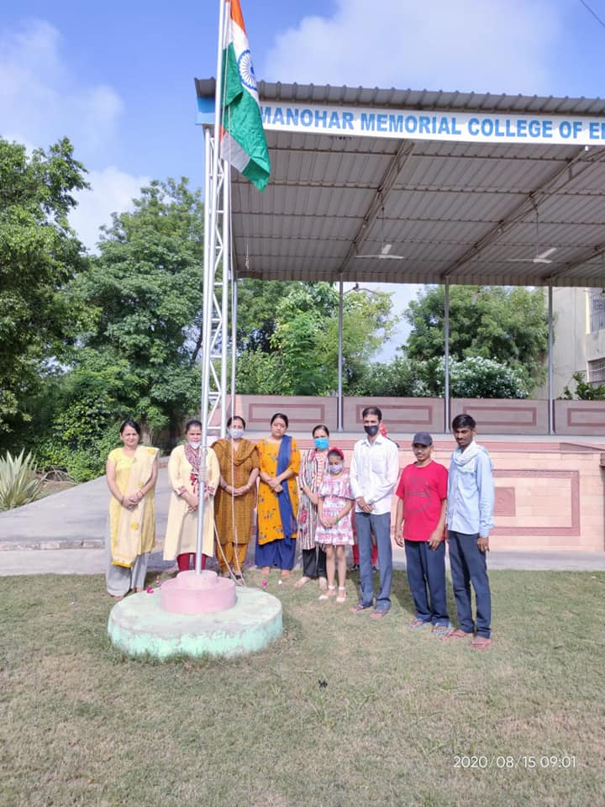
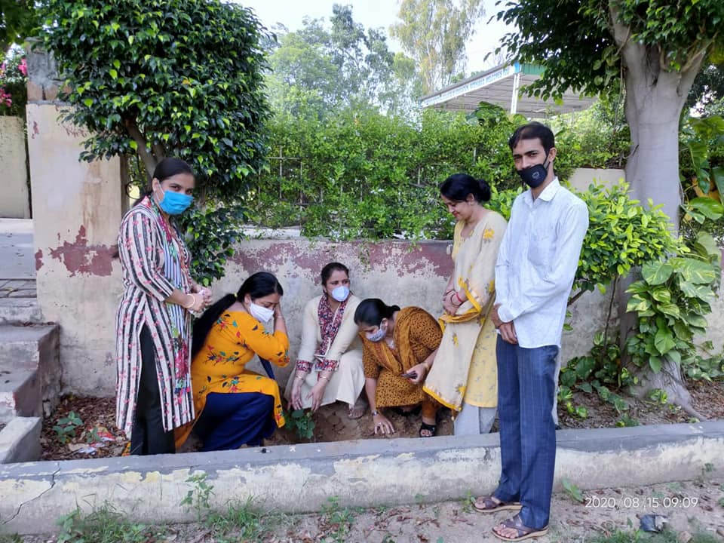 RAKHI COMPETITION 03.08.2020
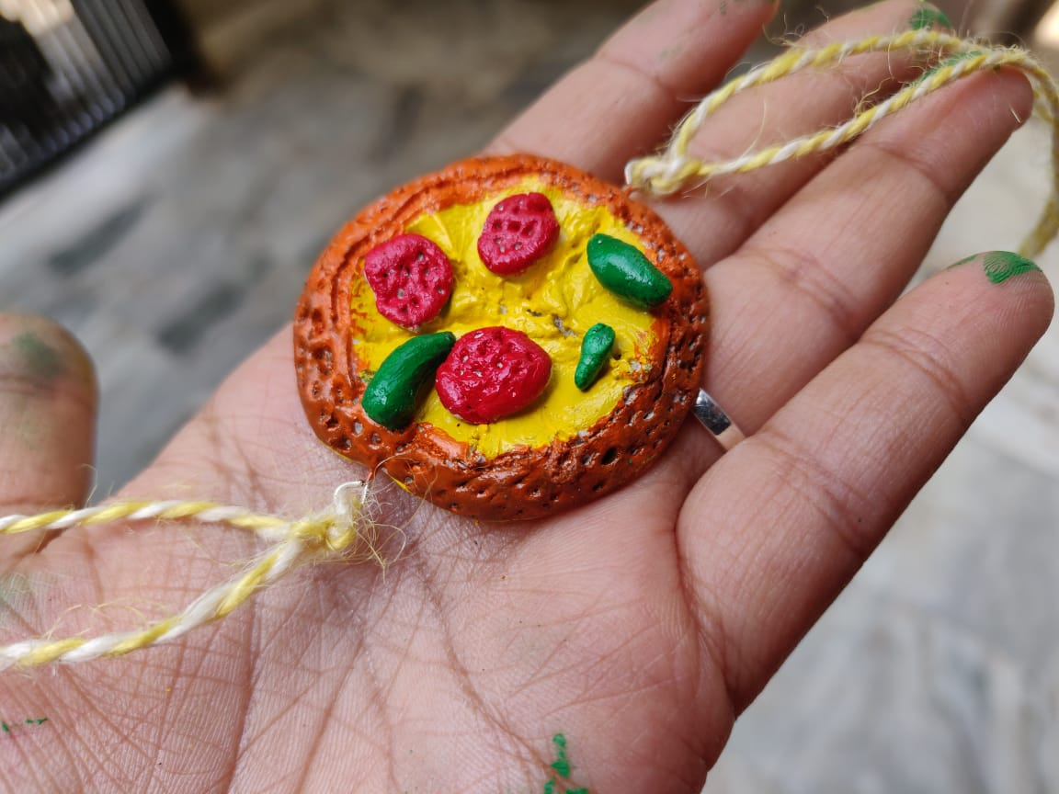
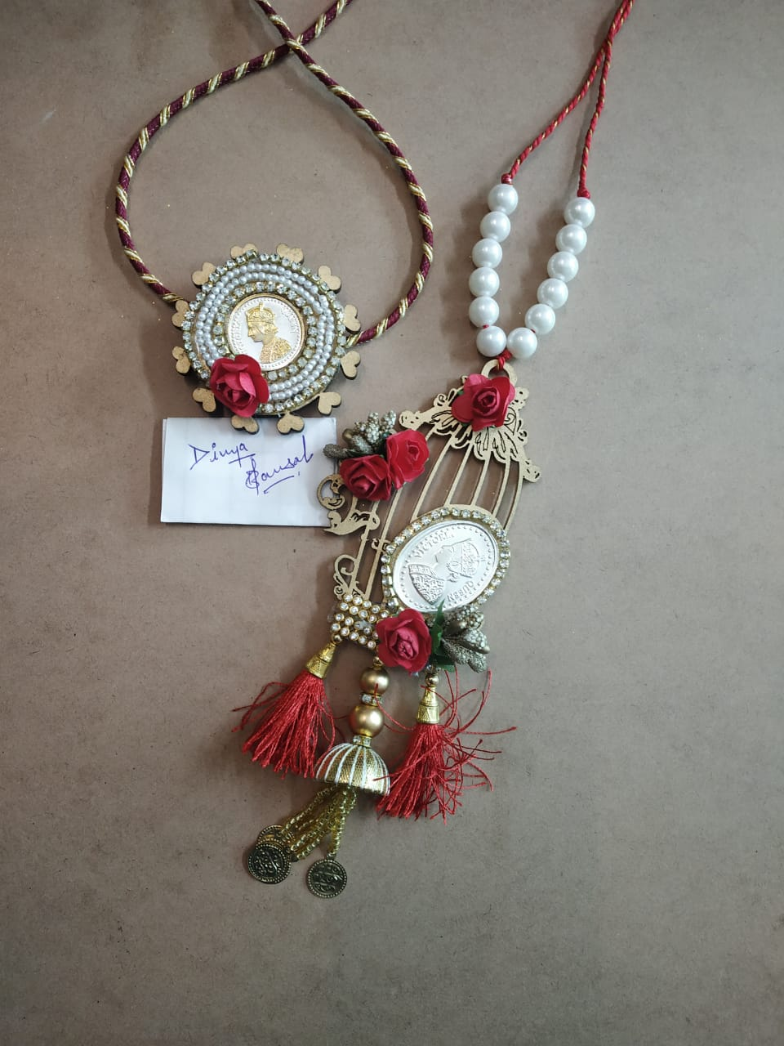
GREETING CARD MAKING COMPETITION 11.05.2020
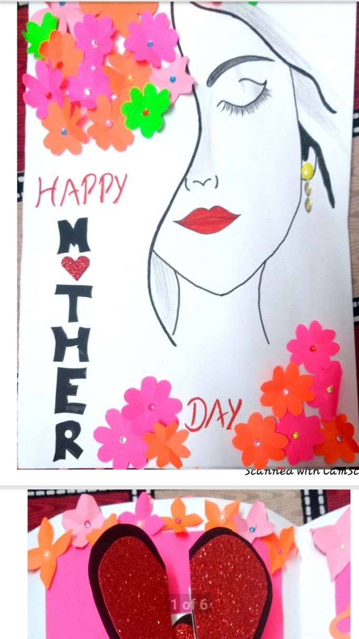
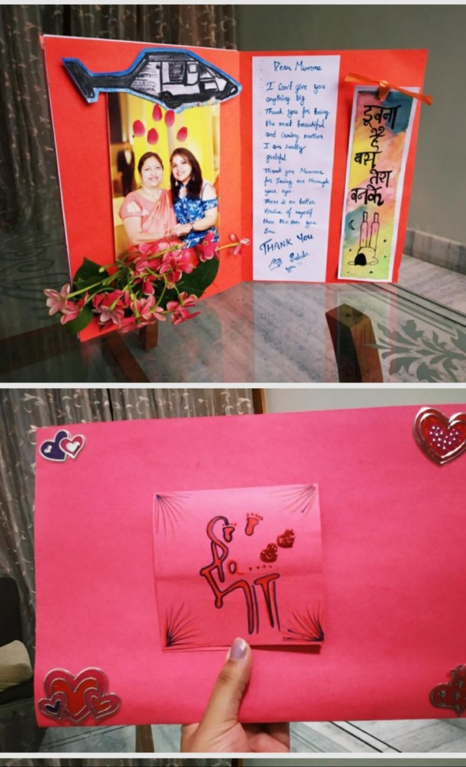
INTERNATIONAL WOMENS DAY 06.03.2020
आजमनोहरमैमोरियलशिक्षणमहाविद्यालयफतेहाबादमेंअंर्तराष्टीयमहिलादिवसकेअवसरपरएस.एन.डी.टी.महिलाविश्वविद्यालयमुम्बईकीशैक्षिकतकनीकीविभागकीडायरेक्टरडा.जयश्रीशिन्देद्वाराविडियोकांफ्रैन्सिगकेमाध्यमसेव्याख्यानकाआयोजनकियागयाजिसमेंविद्यार्थियोंनेउनसेसीधेसंवादकरकेअपनेसंज्ञानमेंवृद्धिकी।डा.शिन्देनेमहिलाओंकीसमाजमेंदशाएवंदिशापरचर्चाकीएवंपुरुषोंऔरमहिलाओंकोएकसमानबतातेहुएदोनोंवर्गोंकोबराबरकेदर्जेकेलिएप्रेरितकिया।उन्होनेविडियोविज्ञापनद्वारामहिलाओंकीसमाजमेंस्थितिवसशक्तिकरणसेअवगतकरवायाऔरछात्राओंकोसमाजमेंशिक्षाएवंसामाजिकगतिविधियोंमेंबढ़-चढ़करभागलेनेकेलिएप्रोत्साहितकिया।अंतमेंमहाविद्यालयकीप्राचार्याडा. जनकमैहताएवंवुमैनसैलकीइंचार्जडा.कविताबतरानेडा.शिन्देकाधन्यावादकिया।इसअवसरपरमहाविद्यालयकासमस्तस्टाॅफउपस्थितथा।
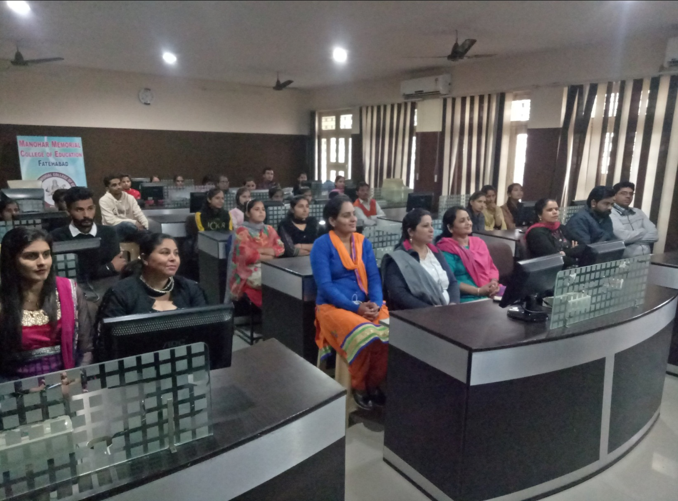
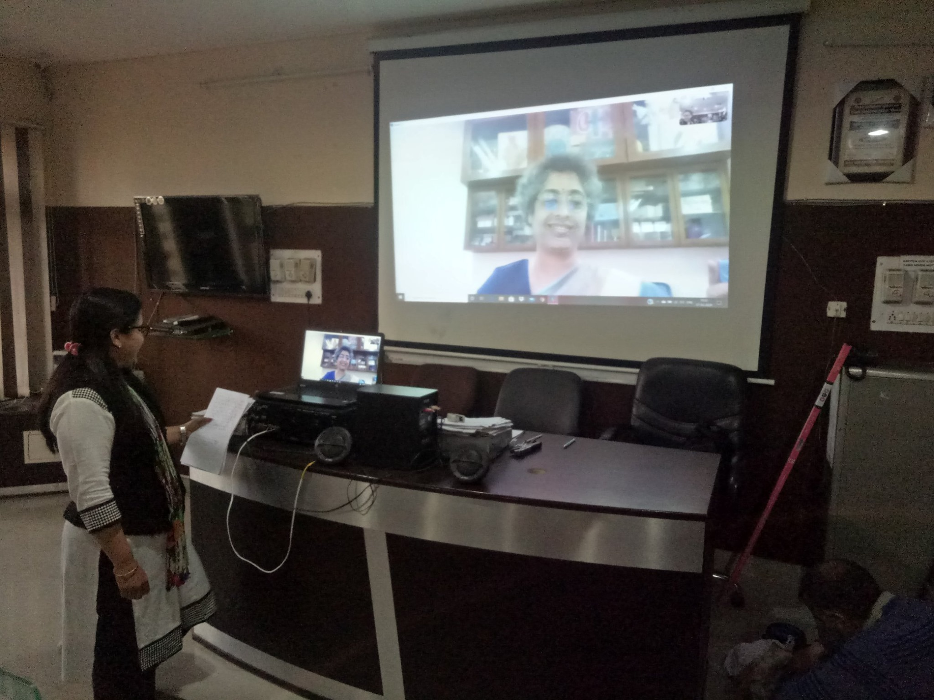
BASANT PANCHMI 28.01.2020
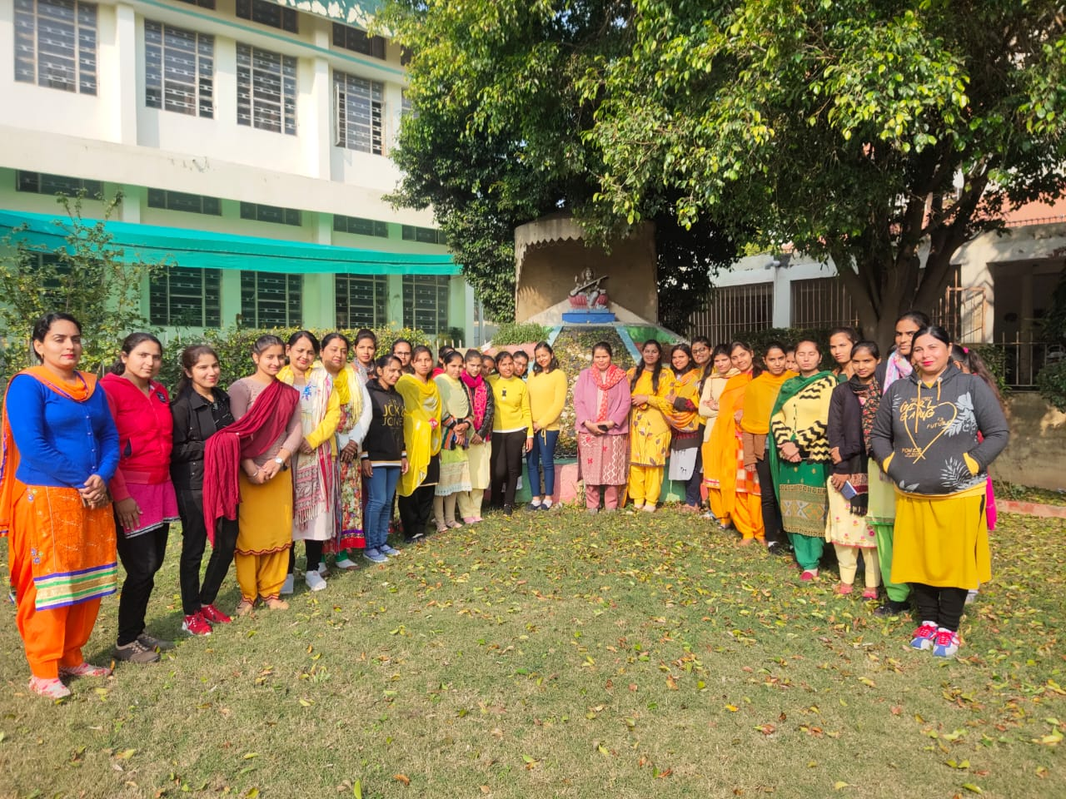
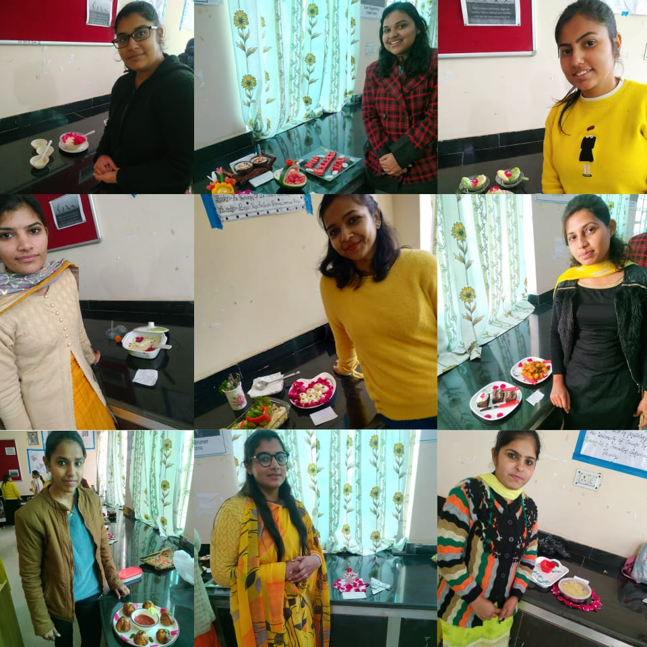
DIWALI CELEBRATION 23.10.2019
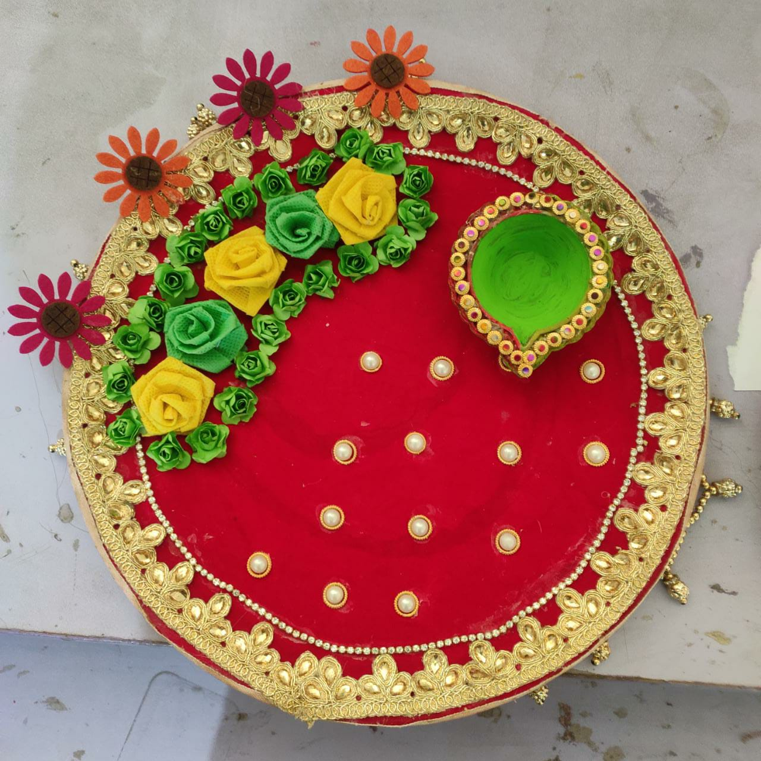
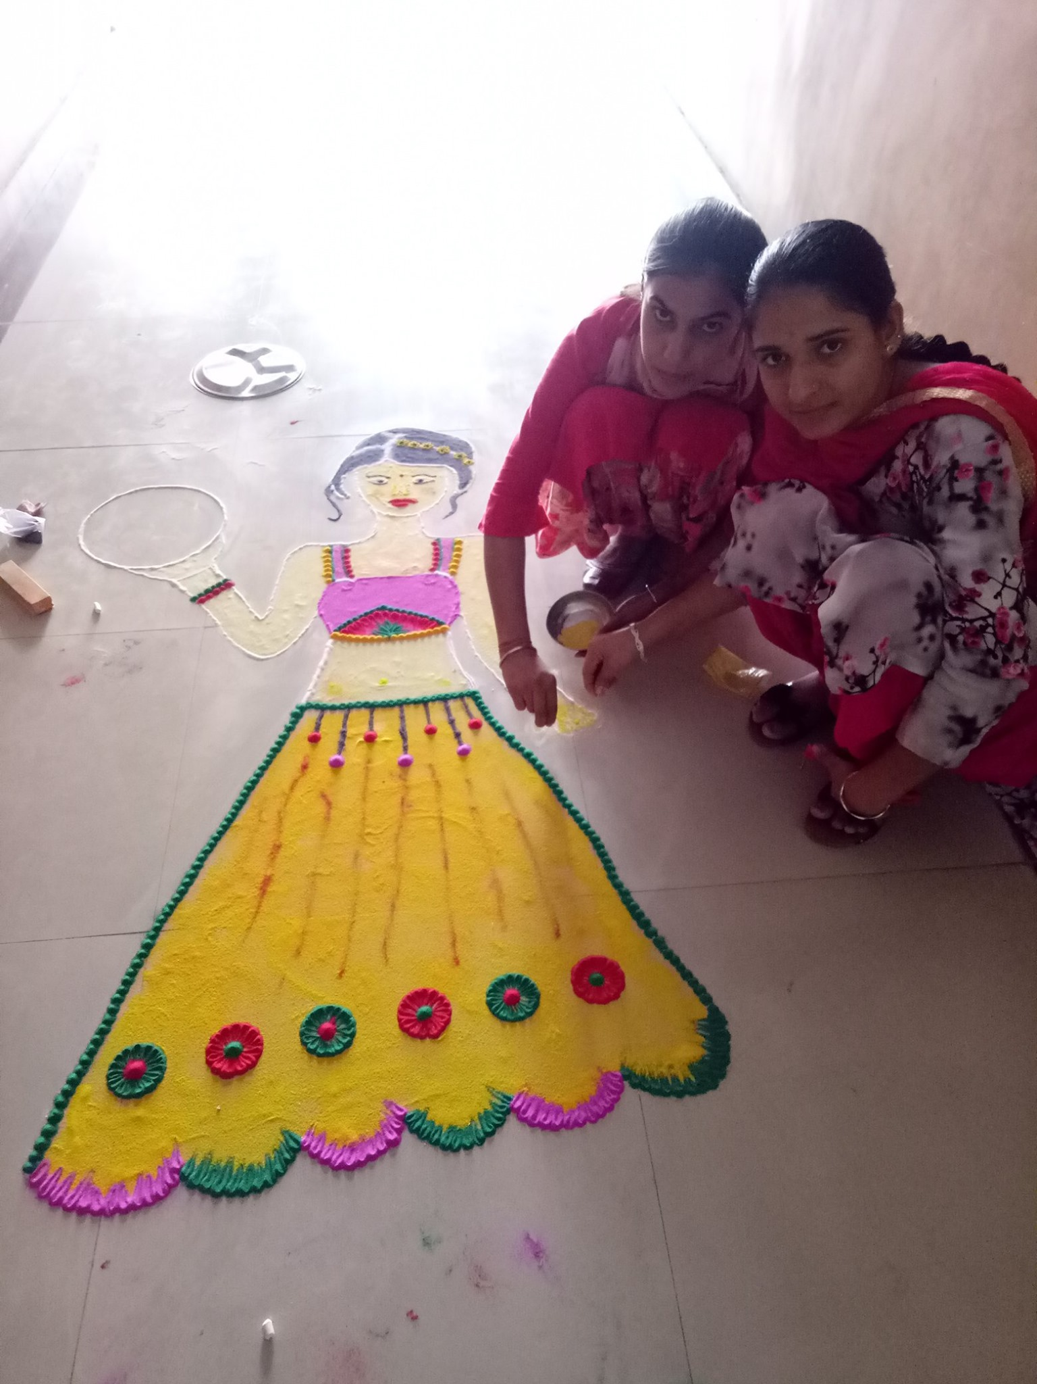
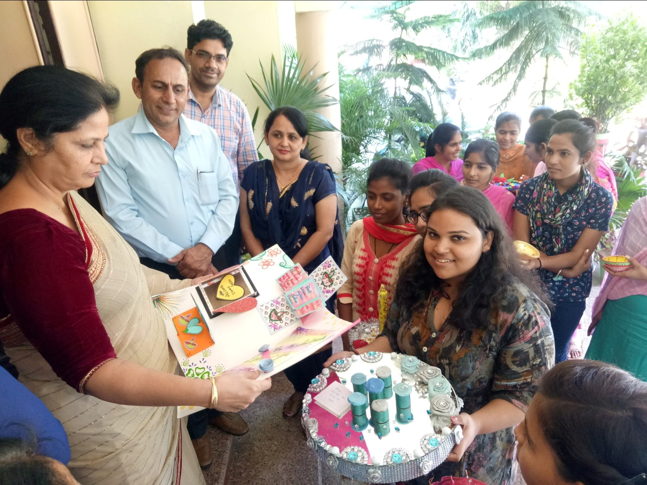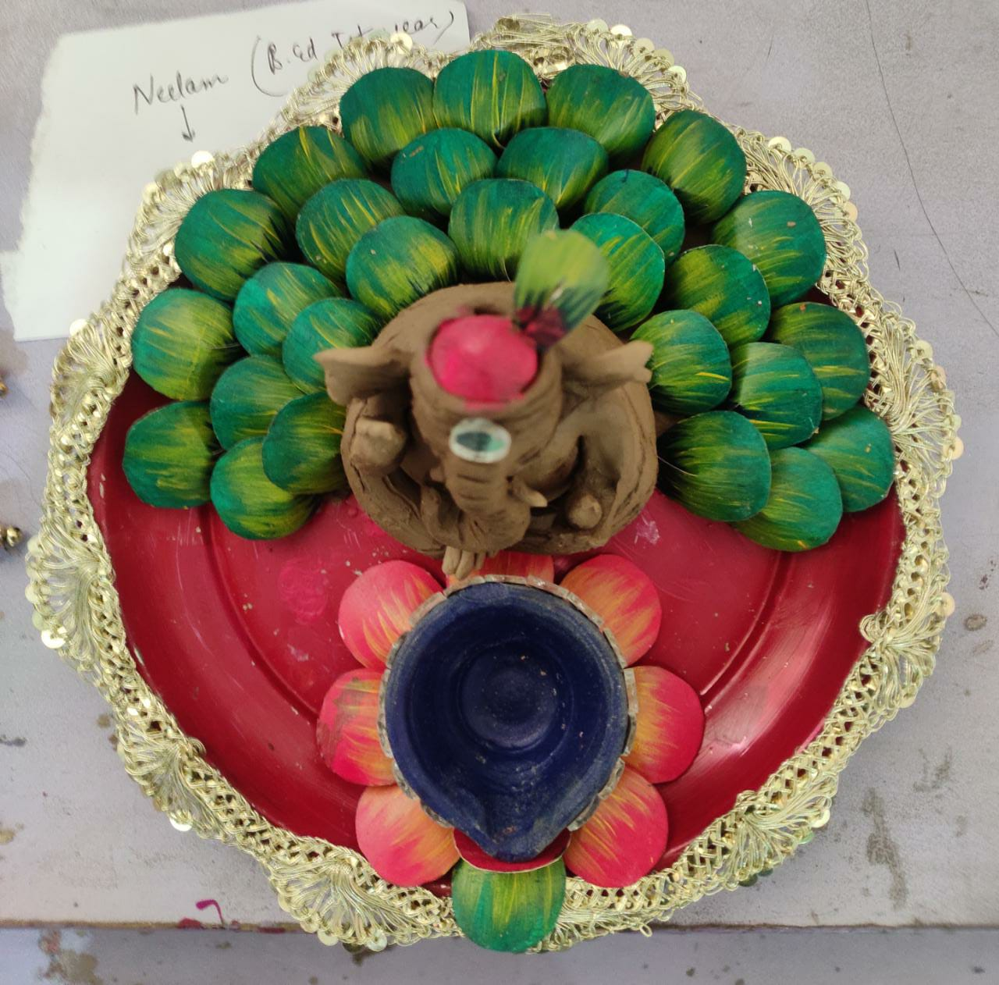
KARWACHOUTH CELEBRATION 16.10.2019
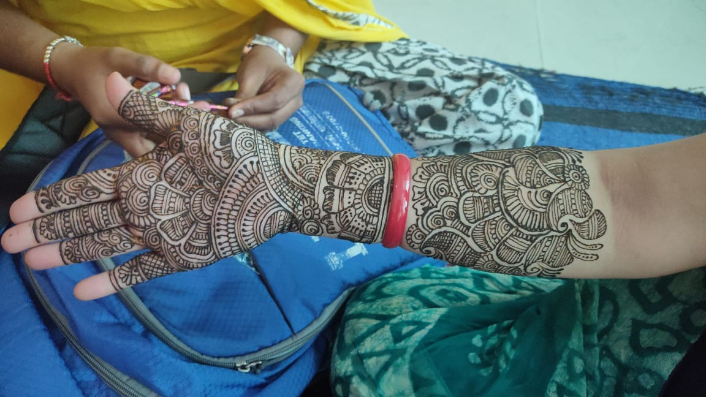
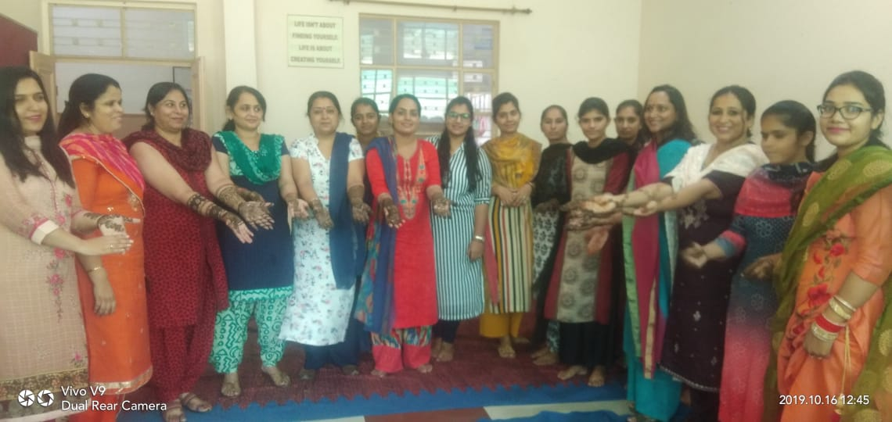
DANDIYA UTSAV 06.10.2019
मनोहरमैमोरियलशिक्षणमहाविद्यालयफतेहाबादमेंमहाविद्यालयकेआध्यातमिकप्रकोष्ठद्वाराइंचार्जसुनीतातलवाड़औरअमनप्रीतकौरकेनेतृत्वमेंडांडियाउत्सवकाआयोजनकियागया।स्टाफसदस्योंवविद्यार्थियोंद्वारापारम्परिकवेशभूषामेंडांडियानृत्यइसकार्यक्रमकामुख्यआकर्षणरहा।इसअवसरपरप्राचार्याडा. जनकमैहतानेसभीस्टाफसदस्योंऔरविद्यार्थियोंकोनवरात्रोंऔरदशहराकेपावनत्यौहारकेलिएअपनीशुभकामनाएंप्रदानकी।
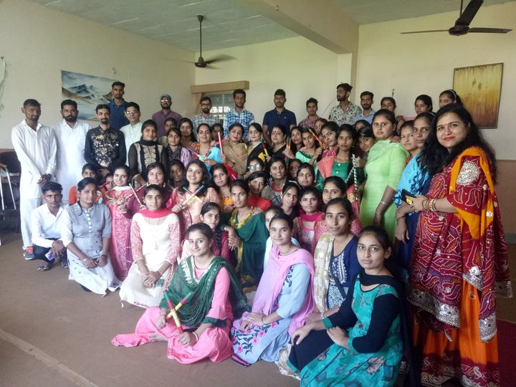
TALENT HUNT COMPETITION 05.10.2019
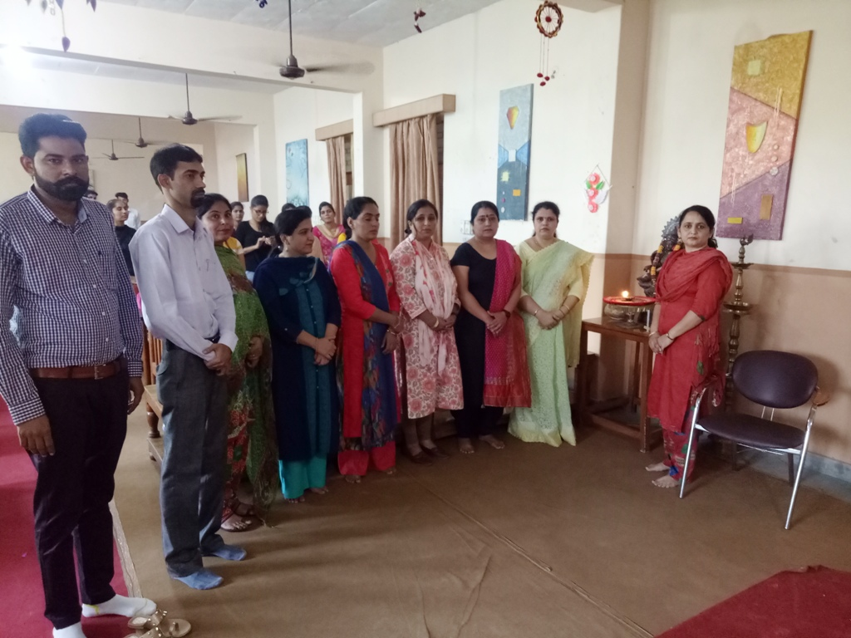
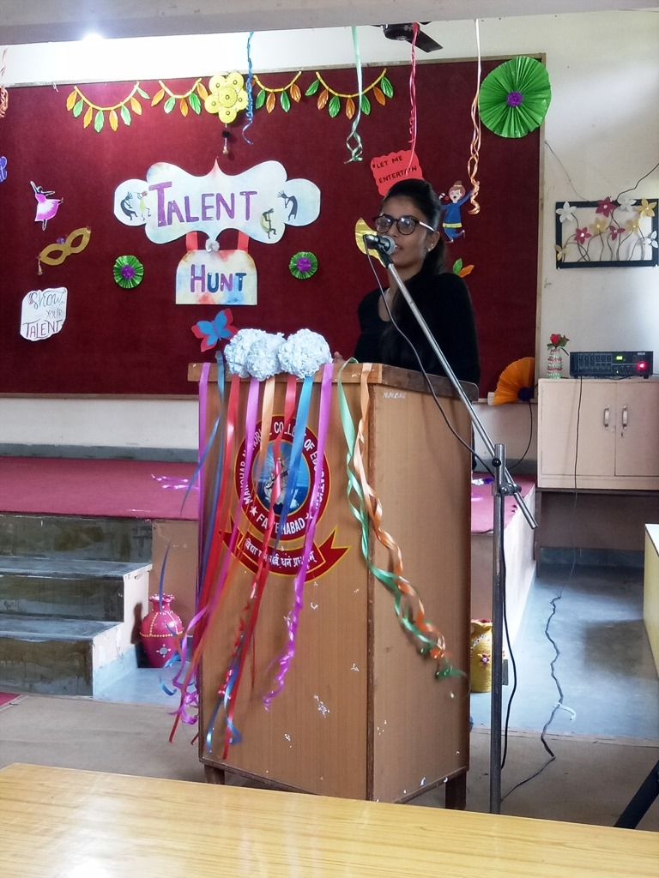
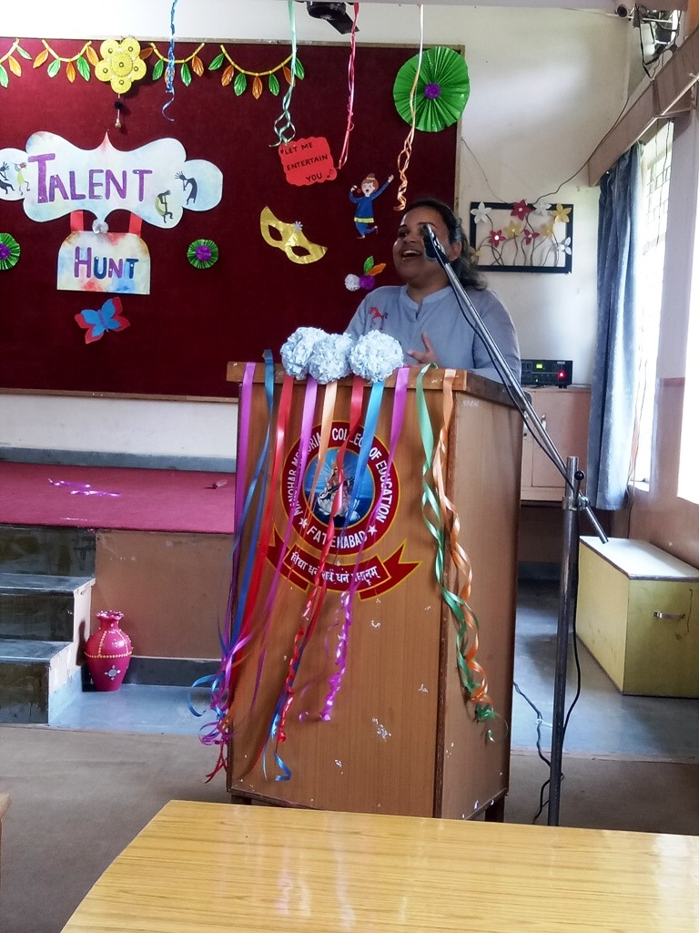

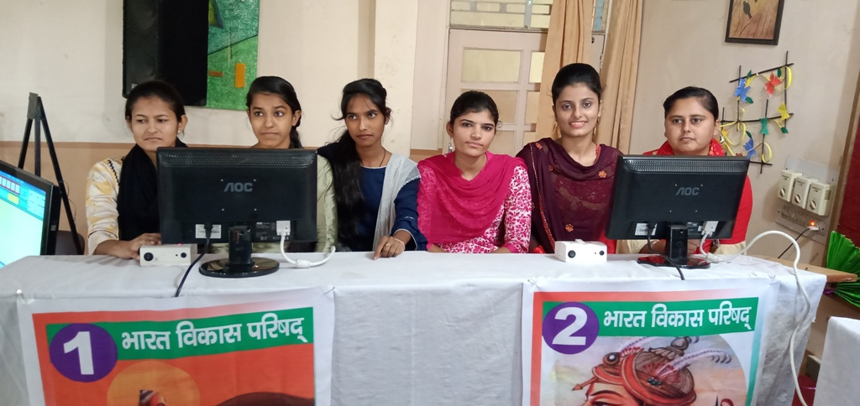
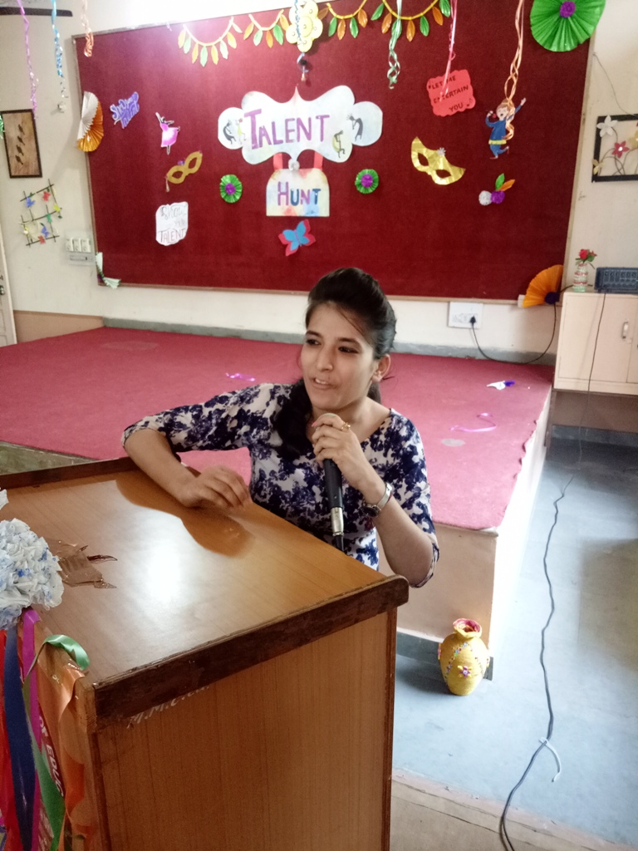
JANMASHTMI CELEBRATION 24.08.2019
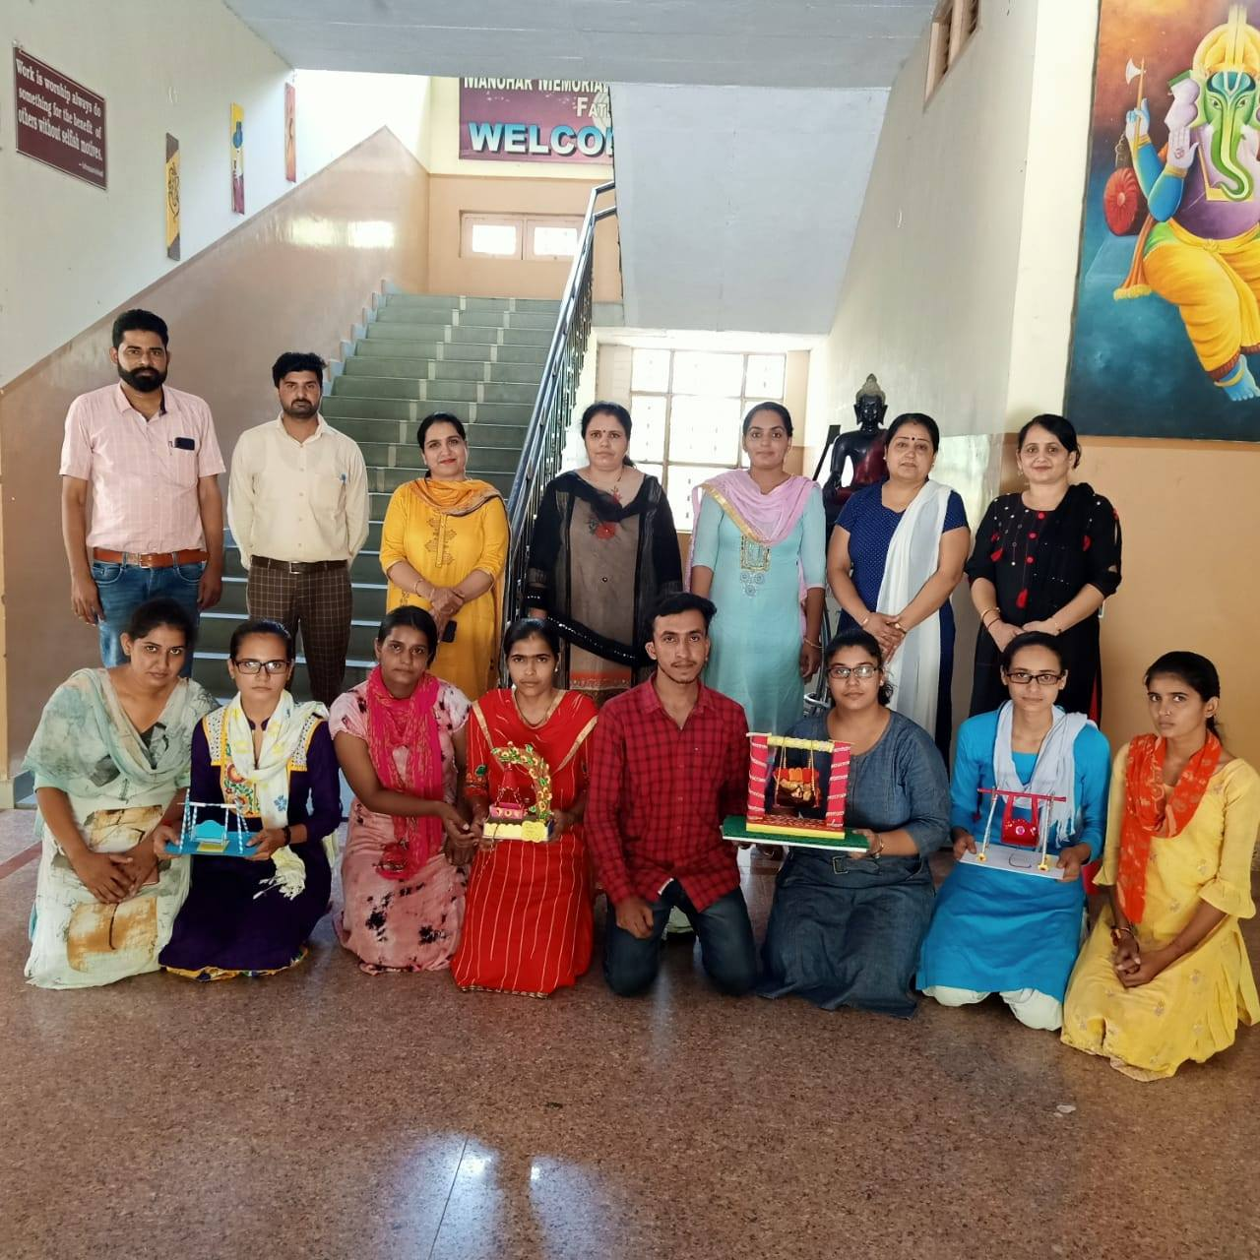
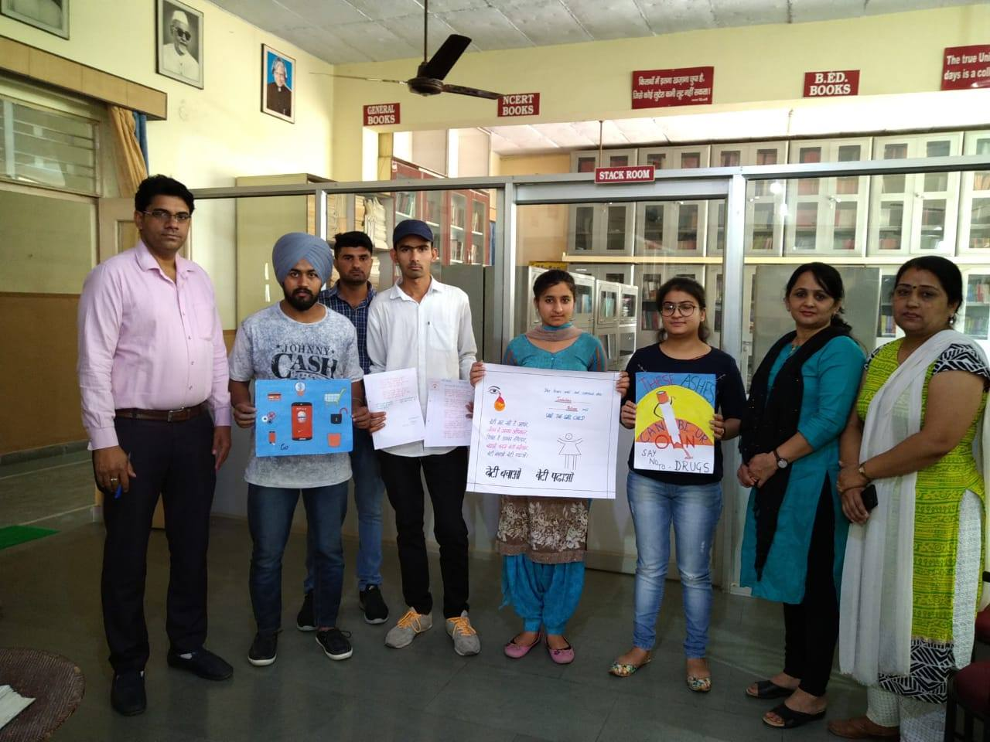
FAREWELL PARTY 30.05.2019
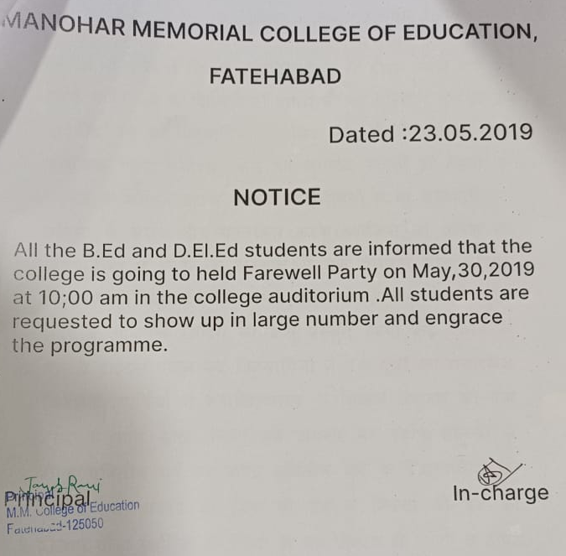

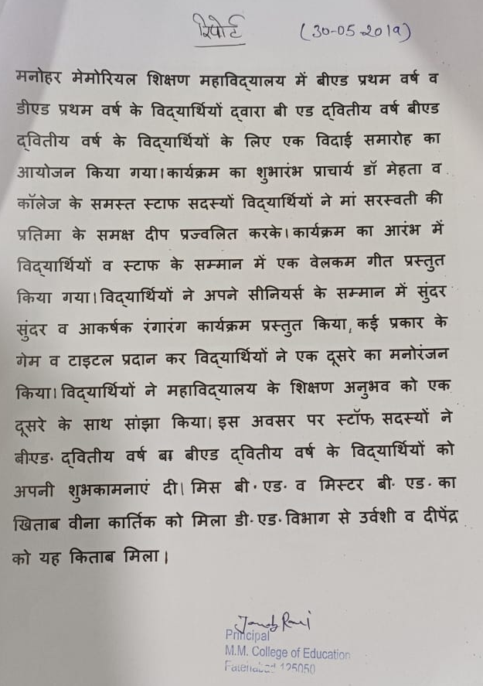
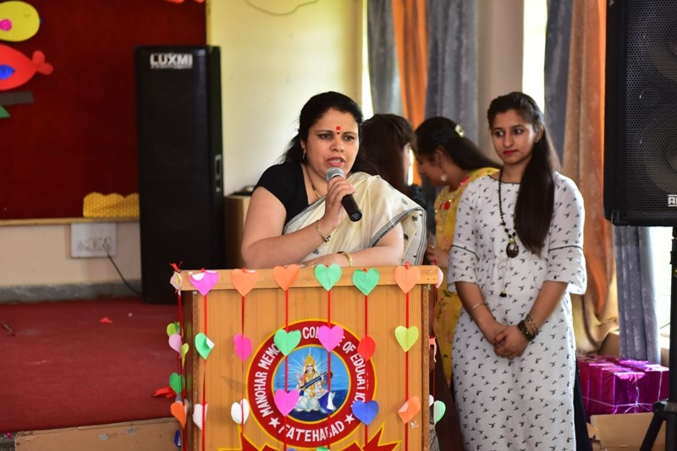
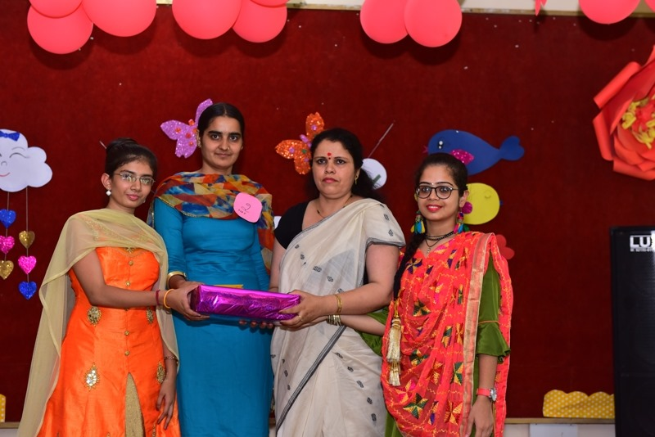
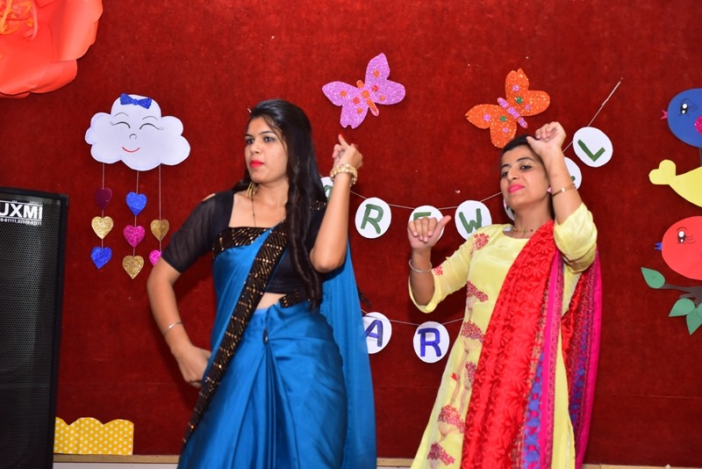
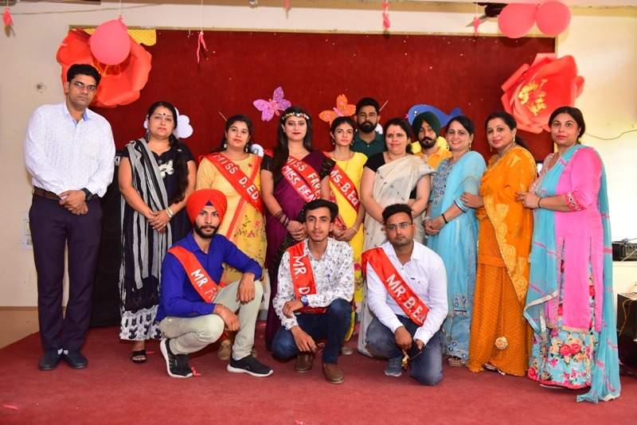
ONE DAY EDUCATIONAL TRIP 06.04.2019

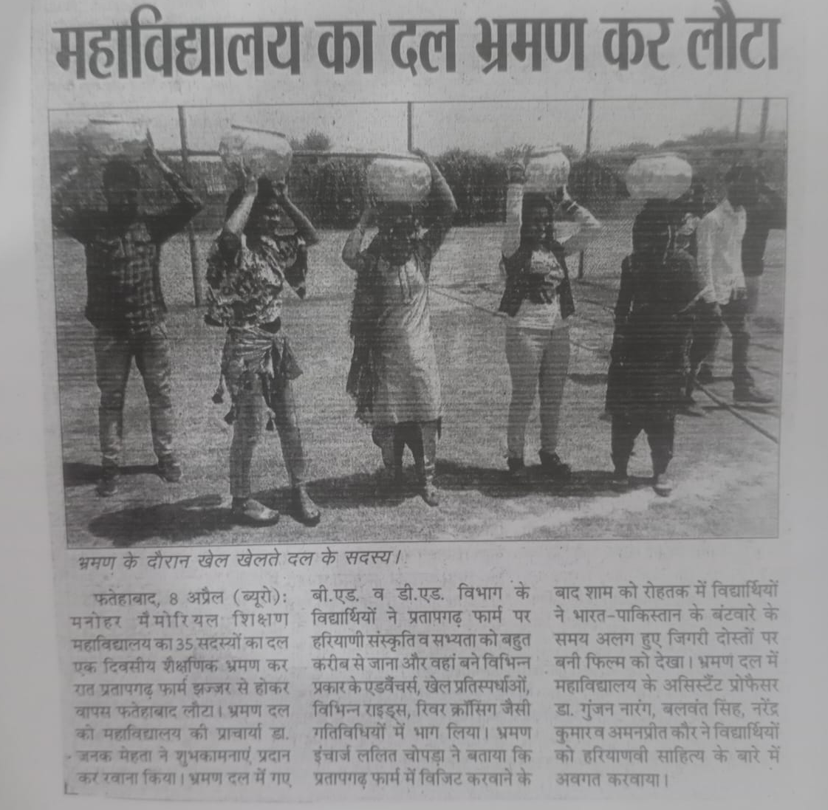
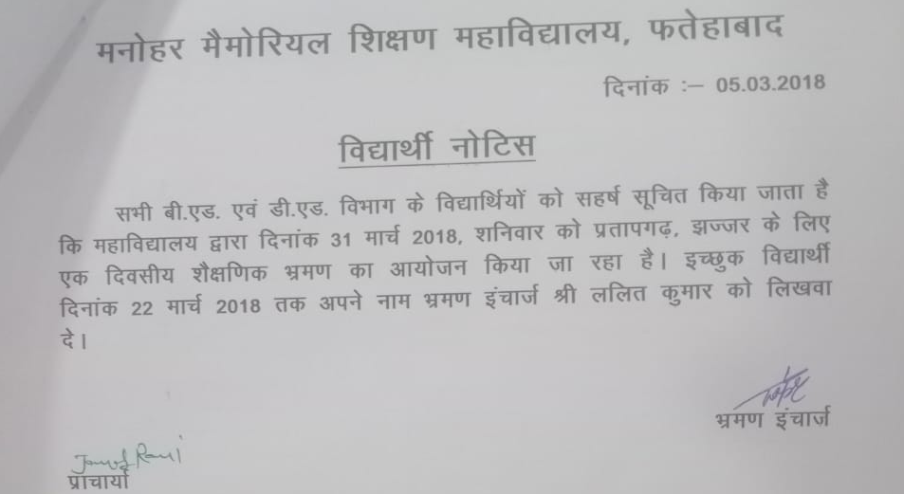

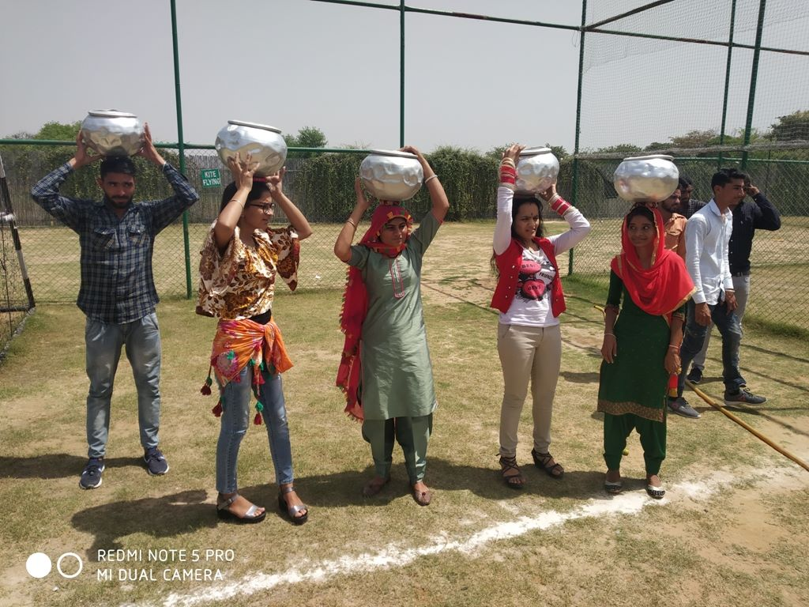

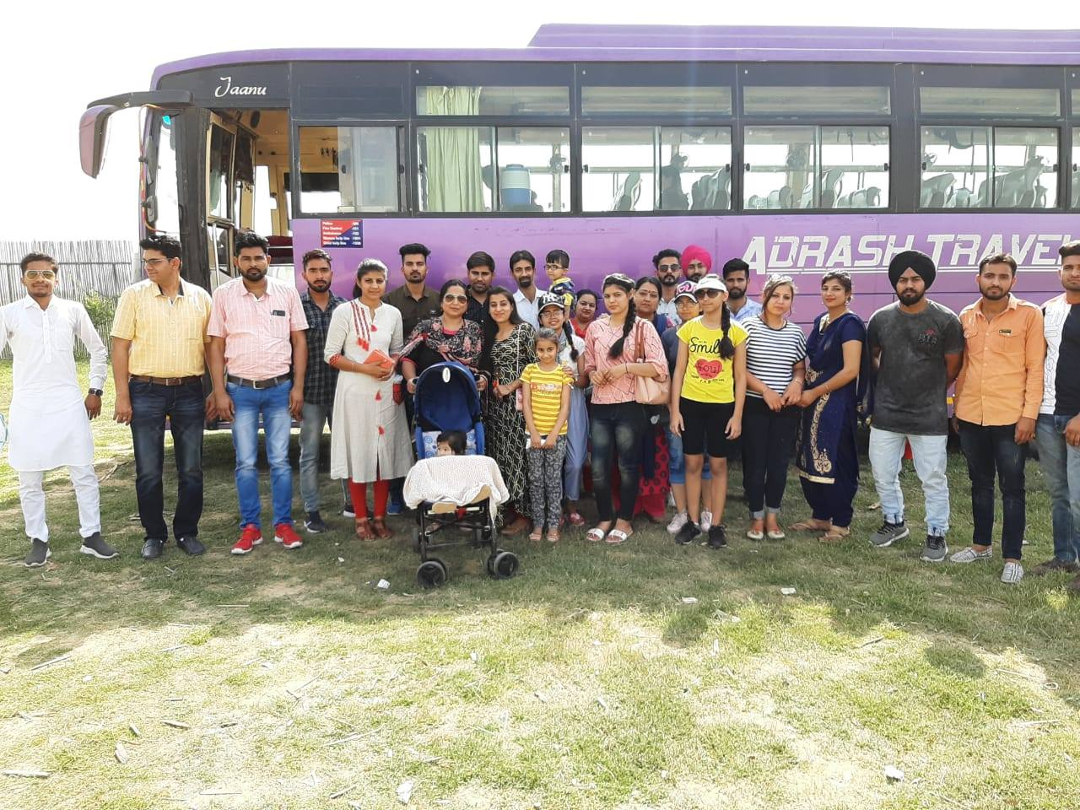
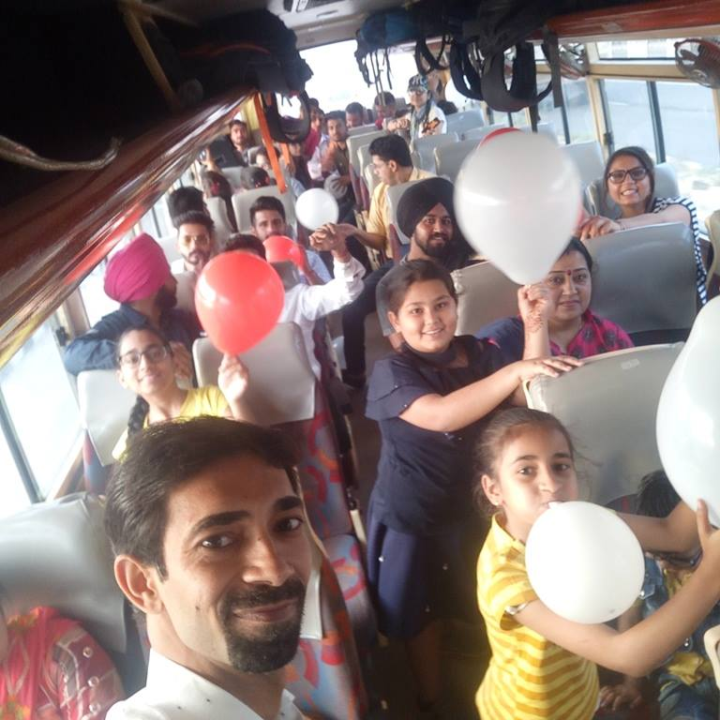

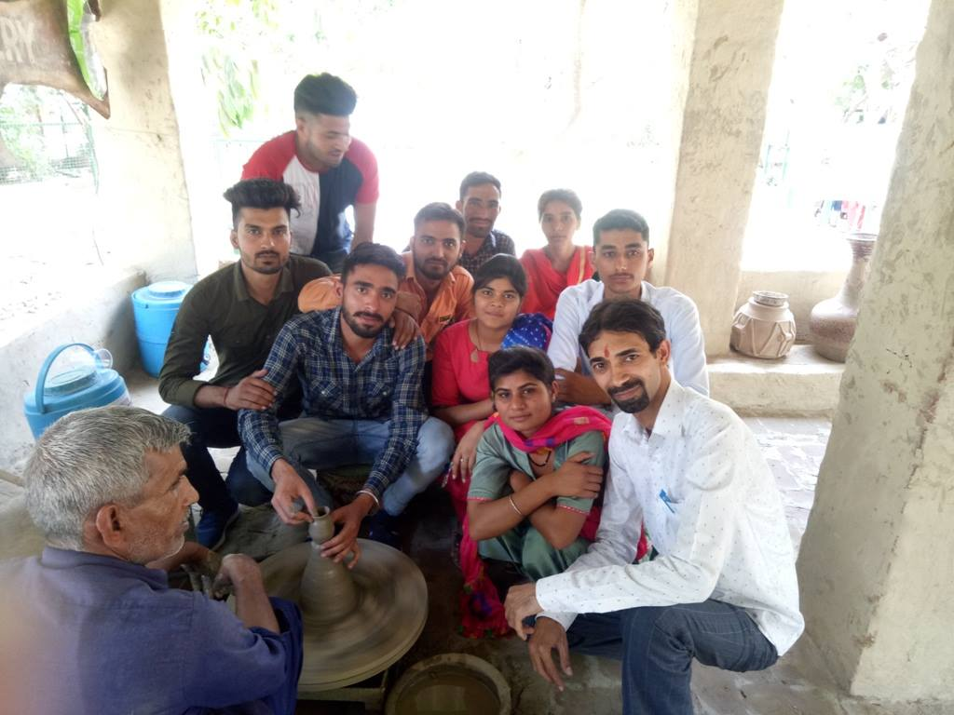
FRESHER/GET TOGETHER PARTY 28.01.2019
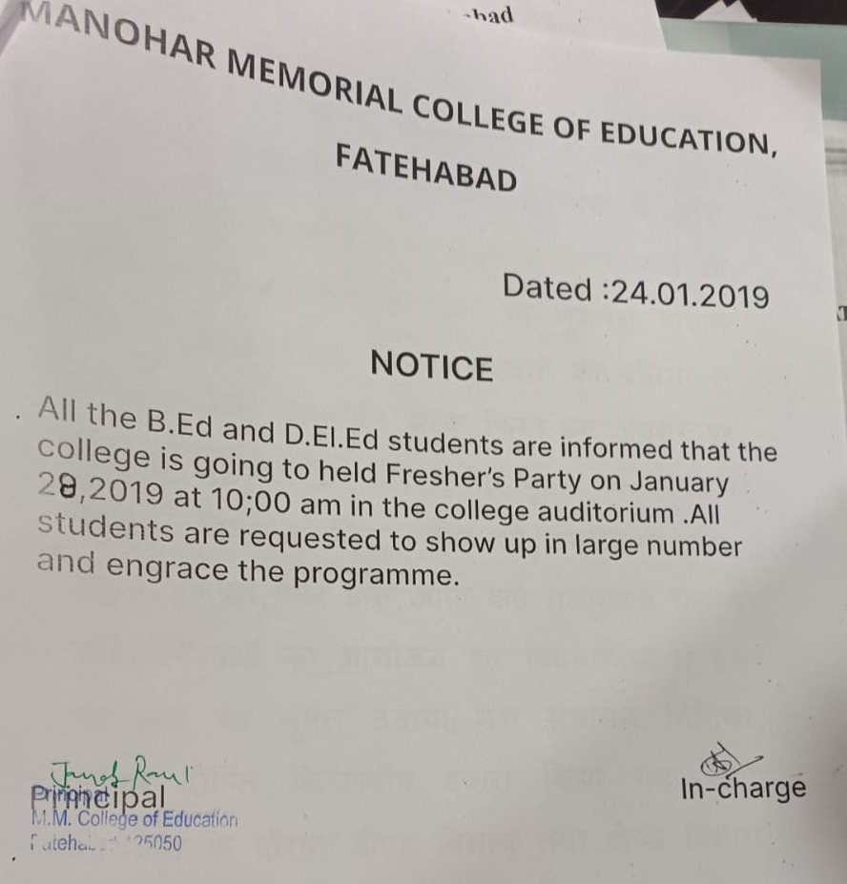
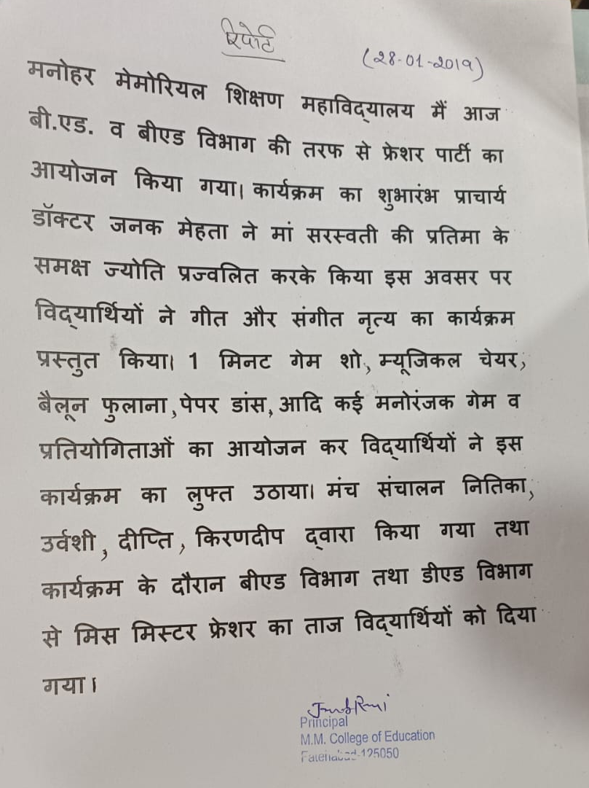
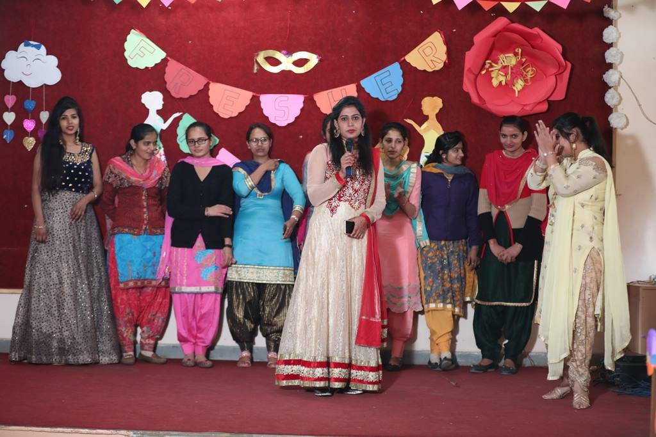
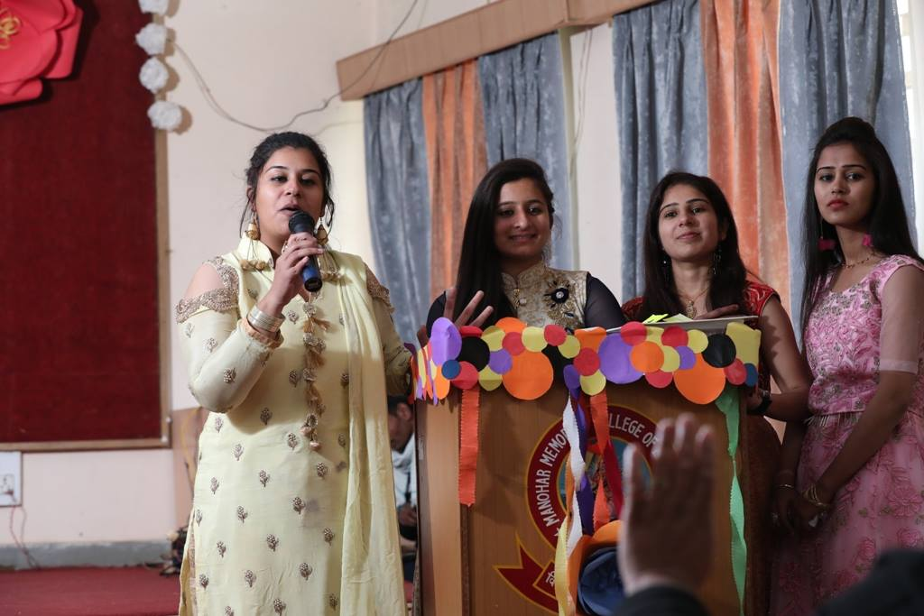
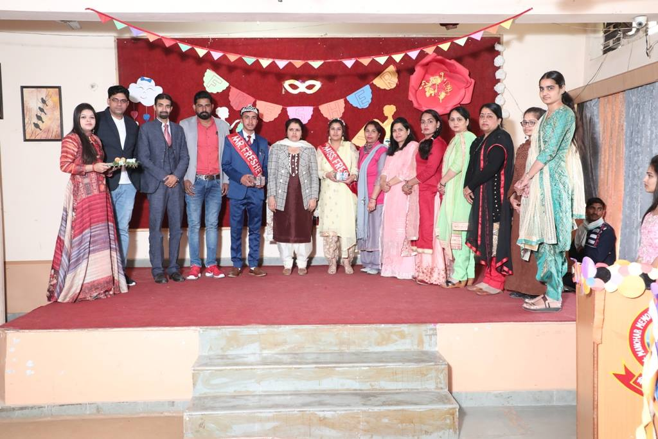
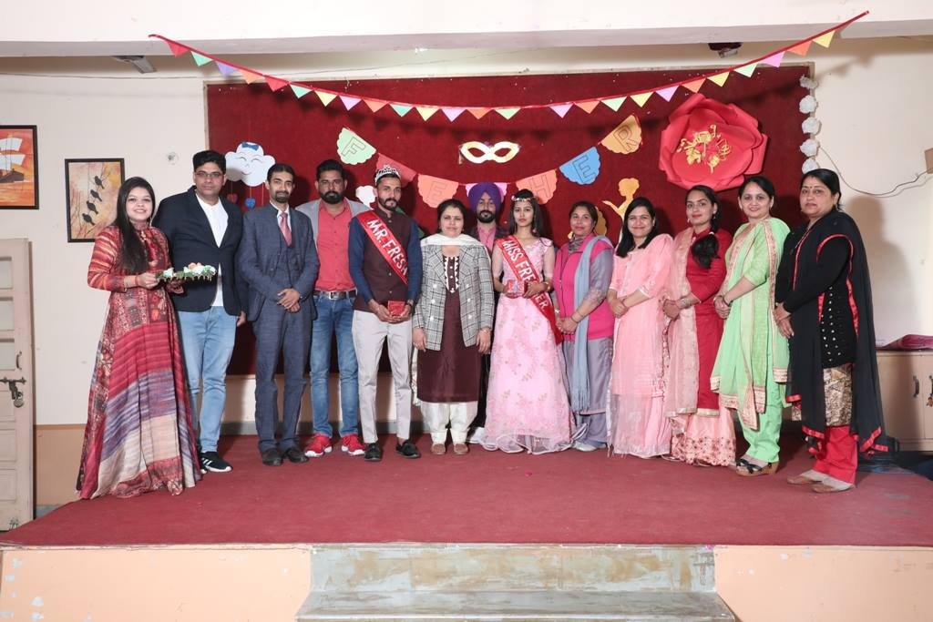
NAVRATRI UTSAV 15.10.2018
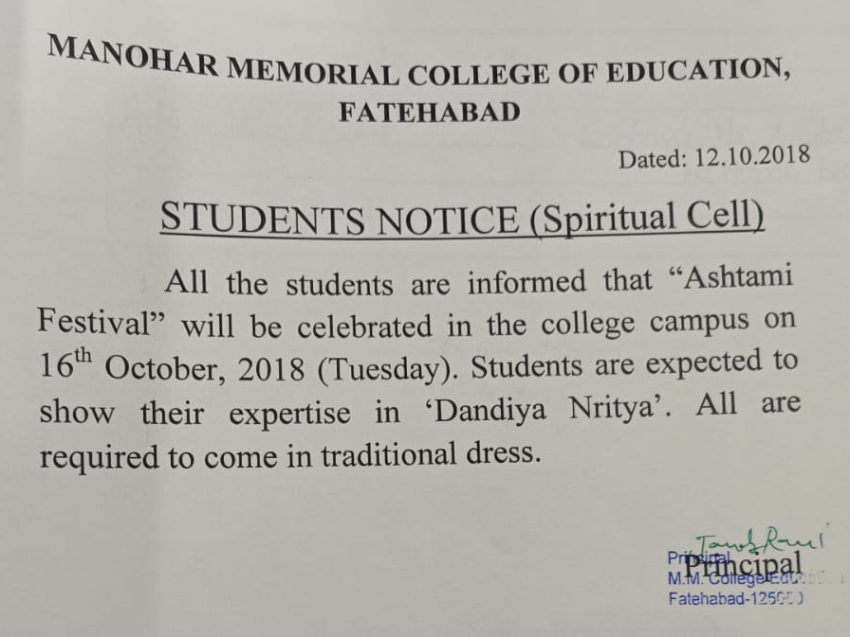

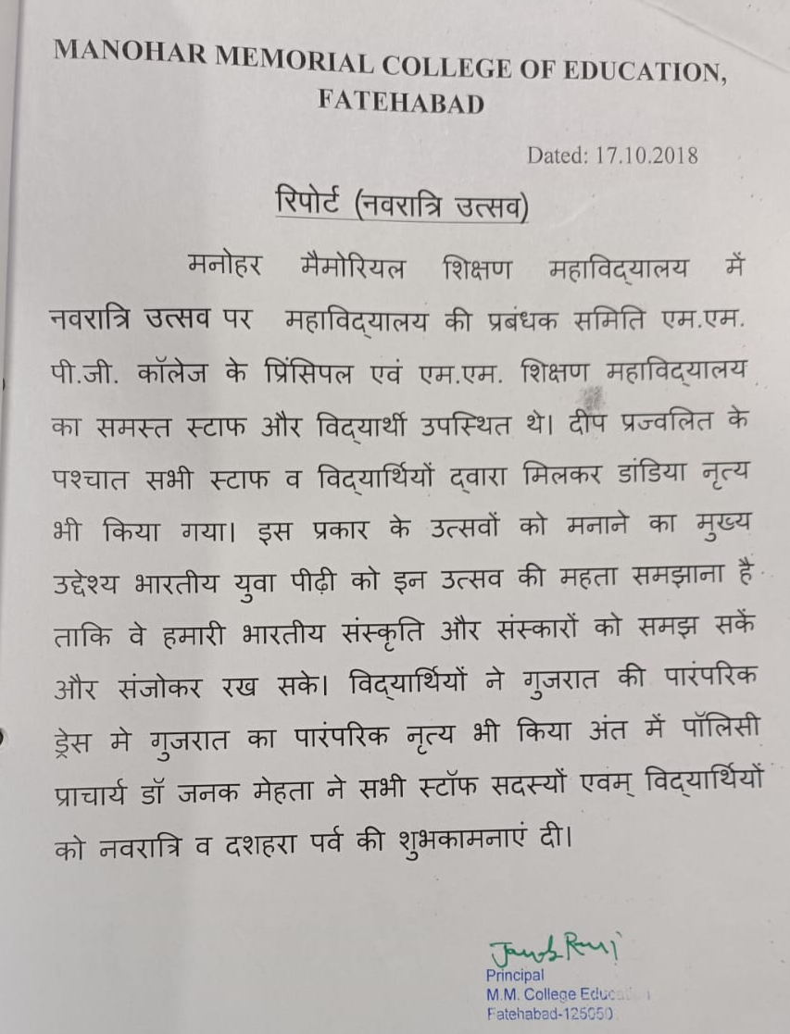
TALENT HUNT COMPETITION 05.10 TO 06.10.2018
